Finding Jesus in the Old Testament
Introduction

Christ said in Matthew 5:17, “Do not think that I have come to abolish the Law or the Prophets; I have not come to abolish them but to fulfill them.” Christ is referring to the entirety of the Old Testament Scriptures. He didn’t come to set them aside, but to fulfill them.

The Spirit of Prophecy
Indeed, Revelation 19:10 we are told that “the testimony of [about] Jesus is the spirit of prophecy.” In other words, the very nature and purpose of prophecy, and all of Scripture for that matter, is to reveal and testify of Jesus Christ. Obviously, due to the fall and need of man, Christ is the theme of both the Old and New Testaments for it is only through Him that we can have both eternal life and life abundantly (John 10:10).

How to Understand the Hard Parts of the Bible…
We are currently encouraging our whole congregation to read through the Bible in a year or less. Whenever someone is thwarted from reading the Bible they usually get discouraged by the book of Leviticus. The question always comes, “How did you get through the book of Leviticus?” That’s a very important question. Are there parts of the Bible that are meant to remain in mystery? Does God make us read what we cannot understand? How are we to answer this question? What are we supposed to be learning from Leviticus and other very hard parts of the Bible any way?

The Road to Emmaus
I have come to know the answer to that question. It has come to me not through others who were having trouble understanding the Old Testament. We find them on the Road to Emmaus in Luke 24:13-35.

“A Stranger joined them. He asked them about the things they had been through, and they began to explain. They were heartbroken because their Master and Friend in whom they had put all their hopes was dead. But the Stranger said some strange things to comfort them. Instead of sympathizing, He said, “O foolish ones, and slow of heart to believe all that the prophets have spoken!” (Luke 24:25, ESV).”

The Real Problem
The real problem was not with a dead Master, but with themselves. They didn’t understand the Old Testament, so the Stranger helped them to understand. Luke 24:27 , “And beginning with Moses and all the Prophets, he interpreted to them in all the Scriptures the things concerning Himself.”

What did He tell them on that road? We can’t know for sure, but the summary of what he said is found in verse 26: Luke 24:26 , “Was it not necessary that the Christ should suffer these things and enter into his glory?” So the essence of the message of the Old Testament is two fold:
- The substitutionary atonement of Christ
- The glory of Christ

A Remarkable Transformation
Even before Jesus was done speaking, a remarkable transformation began to take place in the hearts of Jesus’ hearers. Luke 24:32 , “They said to each other, “Did not our hearts burn within us while he talked to us on the road, while he opened to us the Scriptures?” As the Old Testament Scriptures were opened up, they were awed, amazed, and overwhelmed all at once!

The Disciples, the Apostles, and Jesus
These disciples shortly after met with the Apostles and Jesus appeared to them to further open up the Old Testament to them.

Luke 24:33-49 , “And they rose that same hour and returned to Jerusalem. And they found the eleven and those who were with them gathered together, 34 saying, “The Lord has risen indeed, and has appeared to Simon!” 35 Then they told what had happened on the road, and how he was known to them in the breaking of the bread. 36 As they were talking about these things, Jesus himself stood among them, and said to them, “Peace to you!” 37 But they were startled and frightened and thought they saw a spirit. 38 And he said to them, “Why are you troubled, and why do doubts arise in your hearts? 39 See my hands and my feet, that it is I myself. Touch me, and see. For a spirit does not have flesh and bones as you see that I have.” ….

Verse 44, “Then he said to them, “These are my words that I spoke to you while I was still with you, that everything written about me in the Law of Moses and the Prophets and the Psalms must be fulfilled.” 45 Then he opened their minds to understand the Scriptures, 46 and said to them, “Thus it is written, that the Christ should suffer and on the third day rise from the dead, 47 and that repentance and forgiveness of sins should be proclaimed in his name to all nations, beginning from Jerusalem. 48 You are witnesses of these things. 49 And behold, I am sending the promise of my Father upon you. But stay in the city until you are clothed with power from on high.”

The Message of the Old Testament: The Gospel
Christ enabled them to understand not just a few implications from a few verses here and there from the Old Testament, but He opened up the entire Old Testament “Scriptures” to them. He promises to give them the meat of what the Old Testament says. And Jesus explains the message of the Old Testament in verses 46-47, “Thus it is written, that the Christ should suffer and on the third day rise from the dead, 47 and that repentance and forgiveness of sins should be proclaimed in his name to all nations, beginning from Jerusalem.”

The whole Old Testament finds its focus in Jesus Christ, His death, resurrection, and proclamation to all the nations. This proclamation comes through the Jews, this is why Paul always says, “to the Jew first, and then to the Greek”. God used the Jews as His promised people to proclaim the Gospel to all nations.

Tonight we are going to answer four questions:
1. What was the Bible at the time of Jesus & the Apostles?
2. Why Study the Old Testament?
3. What are the Basic Rules for Understanding the Old Testament?
4. How do we see Christ in the Old Testament?

=================================
1. What was the Bible at the time of Jesus & the Apostles?
=================================
The division of the Hebrew Canon in the day of Jesus and the Apostles was in three sections: Moses, the Prophets, and the Writings (referred to sometimes as simply “the Psalms”)
- The Torah (Pentateuch or 5 books of Moses)
  - Genesis, Exodus, Leviticus, Numbers, Deuteronomy

- The Prophets (Historical books and Prophecy, 29 books)
Historical Books - 12 books
Prophetic books- 17 books
  - Historical Books: Joshua, Judges, Ruth, First Samuel, Second Samuel, First Kings, Second Kings, First Chronicles, Second Chronicles, Ezra, Nehemiah, Esther.
  - Major Prophets - Isaiah, Jeremiah, Lamentations, Ezekiel, Daniel
  - Minor Prophets - Hosea, Joel, Amos, Obadiah, Jonah, Micah, Nahum, Habakkuk,
Zephaniah, Haggai, Zechariah, Malachi.

- The Writings or simply “Psalms” (The Poetical books, 5 books)
  - Job, Psalms, Proverbs, Ecclesiastes, Song of Solomon

Today’s Divisions are the Same except we divide the Historical books from the Prophets

Today’s Division of the Old Testament
Like the New Testament, the Old Testament is divided into four parts.
Old Testament
(four-fold division)
Law—the Foundation for Christ  History—Preparation for Christ  Poetry—Aspiration for Christ  Prophecy—Expectation of Christ | Preparation  &  Foundation | The Old Testament in its four-fold division lays the foundation for the coming of the Messiah Savior anticipating Him as Prophet, Priest, and King and as the suffering Savior who must die for man’s sin before He reigns.
New Testament
(four-fold division)
Gospels | Manifestation | Tells the story of the coming of the long-anticipated Savior and His person and work.
Acts | Propagation | Through the work of the Holy Spirit, Acts proclaims the message of the Savior who has come.
Epistles | Explanation  &  Application | Develops the full significance of the person and work of Christ and how this should impact the walk of the Christian as Christ’s ambassador in the world.
Revelation | Consummation | Anticipates the end time events and the return of the Lord, His end time reign, and the eternal state.

Let’s Look a Little Closer
Law—the Foundation for Christ
The Law is the five books of Moses: Genesis, Exodus, Leviticus, Numbers, and Deuteronomy.

The Law—the Foundation for Christ
Genesis | Beginnings –promise of the Seed | Election of an unworthy people
Exodus | Redemption – redemption of the Seed | Redemption of an unworthy people
Leviticus | Holiness – holy standard of the Seed | Sanctification of an unworthy people
Numbers | Wandering – the number of those who would not accept the Seed | Direction of an unworthy people
Deuteronomy | Review & Reiteration of the Promised Seed | Instruction to an unworthy people

History—Preparation for Christ
Interesting fact: The books of 1 & 2 Samuel and 1 & 2 Kings used to be all one book. It used to be called Kingdoms. In the LXX it was divided up into four books: 1,2,3,4th Kingdoms.
  - Historical Books: Joshua, Judges, Ruth, First Samuel, Second Samuel, First Kings, Second Kings, First Chronicles, Second Chronicles, Ezra, Nehemiah, Esther.

The historical books tell us about the settling of the nation and the raising up of a king for Israel that will picture our King of kings, the Lord Jesus Christ.

Poetry—Aspiration for Christ
The Poetic and Wisdom writings include Job, Psalms, Proverbs, Ecclesiastes, and Song of Solomon.

Interesting facts:
- The Psalms of Asaph are not all by one man. They are penned by Asaph and his family over a period from the time of David to the return from the Exile (almost 500 years).
- David wrote about half (73) of the Psalms and maybe more. 73 are attributed to him!
- Many of the Davidic Psalms are what we call “imprecatory Psalms”. This is where we see David praying for his enemies to “go down to the pit”.
Major Imprecatory Psalms include Psalm 69 and Psalm 109, while Psalms 5, 6, 11, 12, 35, 37, 40, 52, 54, 56, 58, 79, 83, 137, 139, and 143 are also considered imprecatory

We have to realize that God does not want us to pray for our enemies to “go down into the pit”. These prayer point to the true king David in Scripture, Jesus the Christ. He is the one who will put all of his enemies “under his feet”. He will “dash them in pieces like a potter’s vessel”.

- The five books of the Psalms is to mirror the Torah or Pentateuch.

So we could say the Psalms are really five books in one. Each of the following book division concludes with a doxology while Psalm 150 occupies the place of the doxology and forms an appropriate conclusion to the entire collection.
Epiphanius said, “The Hebrews divided the Psalter into five books so that it would be another Pentateuch.” The Midrash of Psa. 1:1 states, “Moses gave the Israelites the five books of the Law, and to correspond to these David gave to them the Book of the Psalms in five books.”

This correspondence to the Pentateuch may be seen in the following outline:
- Psalms about man and creation (1-41)—corresponds to Genesis.
- Psalms about Israel and redemption (42-72)—corresponds to Exodus.
- Psalms about worship and the Temple (73-89)—corresponds to Leviticus.
- Psalms about our sojourn on the earth (90-106)—corresponds to Numbers.
- Psalms about praise and the Word of God (107-150)—corresponds to Deuteronomy.

Prophecy—Expectation of Christ
  - Major Prophets - Isaiah, Jeremiah, Lamentations, Ezekiel, Daniel
  - Minor Prophets - Hosea, Joel, Amos, Obadiah, Jonah, Micah, Nahum, Habakkuk,
Zephaniah, Haggai, Zechariah, Malachi.

=================================
2. Why Study the Old Testament?
=================================
  - It is the only Bible that Jesus knew and the Apostles knew for most of their ministry.
  - Jesus based His office of Messiah upon it.
  - The Apostles went everywhere proving from the Old Testament that Jesus was the Christ.

-----------------------------------
JESUS AND THE APOSTLES PREACHING FROM MOSES AND THE PROPHETS
-----------------------------------

Jesus Ministry
    - To the Rich Man: Luke 16:31, “He [Abraham] said to him [the rich man in hell], ‘If they do not hear Moses and the Prophets, neither will they be convinced if someone should rise from the dead.’”

    - On the Road to Emmaus: Luke 24:27, “And beginning with Moses and all the Prophets, he [Jesus] interpreted to them [the two disciples] in all the Scriptures the things concerning himself.”

    - To the Jews in John 5:39, 46-47, “You search the Scriptures because you think that in them you have eternal life; and it is they that bear witness about me,… 46 If you believed Moses, you would believe me; for he wrote of me. 47 But if you do not believe his writings, how will you believe my words?

Paul’s Ministry
- Paul’s ministry to Thessalonians in Acts 17:1-2 , “they [Paul and his companions] came to Thessalonica, where there was a synagogue of the Jews. 2 And Paul went in, as was his custom, and on three Sabbath days he reasoned with them from the Scriptures, 3 explaining and proving that it was necessary for the Christ to suffer and to rise from the dead,”

- Paul’s Ministry to King Agrippa in Acts 26:22 , “To this day I have had the help that comes from God, and so I stand here testifying both to small and great, saying nothing but what the prophets and Moses said would come to pass.”

- Paul’s Ministry to the Roman soldiers and to various guests in Acts 28:23 . Paul was under house arrest, yet he was allowed to have many visitors: We read about it in Acts 28:23-“When they had appointed a day for him, they came to him at his lodging in greater numbers. From morning till evening he expounded to them, testifying to the kingdom of God and trying to convince them about Jesus both from the Law of Moses and from the Prophets.”

=================================
3. What are the Basic Rules for Understanding the Old Testament?
=================================
- The Bible was written for the common man—for all men. God wants us to understand it. Peter tells that we can become born again through the Old Testament promises. 2 Peter 1:3-4, “His divine power has granted to us all things that pertain to life and godliness, through the knowledge of him who called us to his own glory and excellence, 4 by which he has granted to us his precious and very great promises, so that through them you may become partakers of the divine nature, having escaped from the corruption that is in the world because of sinful desire.”

- The Old Testament must be interpreted in light of the New Testament. 1 Peter 1:10–12 , “Concerning this salvation, the prophets who prophesied about the grace that was to be yours searched and inquired carefully, 11 inquiring what person or time the Spirit of Christ in them was indicating when he predicted the sufferings of Christ and the subsequent glories. 12 It was revealed to them that they were serving not themselves but you, in the things that have now been announced to you through those who preached the good news to you by the Holy Spirit sent from heaven, things into which angels long to look.” Jesus and the Apostles guide our interpretation. For example, Mal. 4 gives the promise of Elijah, but Jesus says in Matthew 11:13–14 , “For all the Prophets and the Law prophesied until John, 14 and if you are willing to accept it, he is Elijah who is to come.”

- We must always interpret in light of the Context
  - Historical Context
  - Literary Context (in light of the book you are studying and in light of the entire Bible)

- The Clear interprets the Unclear

- The Bible interprets the Bible

- Every part of the Bible points in some way to Jesus Christ. Christ can be seen in:
  - Christophanies
  - Theophanies
  - Types & Shadows (People, Ceremonies, Historical Events)
  - Direct Prophecies
  - Laws & Regulations

=================================
4. How do we see Christ in the Old Testament?
=================================
  - Promises & Prophecies
    - Genesis 3:15, chs 12, 15, 17, 50, promise of the Seed that would “bless all nations”
  - Shadows
    - Christophanies, i.e. the Angel of Yahweh, the Angel of God
    - The Red Sea Crossing – Picture of Redemption
    - The Tabernacle / Temple
    - The Sacrifices: 5 OT Sacrifices that picture specific aspects of Christ’s atonement

  - Types
    - Adam – Jesus is the “Second Adam” who is without sin. Under Him is a New Humanity (Eph. 2).
    - Noah’s Ark – Jesus is the True Ark that saves His people from judgment
    - Melchizedek – Jesus is the True Priest who has no beginning and no end
    - Isaac – Jesus is the True Promised Son of a miraculous birth; See Gen. 22 and Abraham offering His Son, a picture of Christ’s Sacrifice.
    - Moses – Jesus is the New Moses who gives the true sense of the Law (Matt. 5-7)
    - Joshua – Jesus is the True Deliverer. Jesus is Ἰησοῦς or the greek translation of the Hebrew: YESHUA
    - David: Jesus is the True King that would come
    - All the Prophets: Jesus is the True Prophet, the Messenger of the Lord, the Word who became flesh who perfectly exegetes the Father (John 1:18).

  - Law & Regulations
    - Jesus is the only perfect man that can fulfill all of God’s perfect standards of righteousness
    - Many of the laws are to show an example of holiness verses unholiness
      - No mixed fabrics
      - No beards or clothing like the heathen (separation from the world)
      - No eating of unclean animals that chew the cud but do not part the hoof (picture of hypocricy – they chew the word but walk in a double minded way).

- Basic Presuppositions before we study.

Although I can never be totally objective, I can become a better reader of the Bible. I can limit my biases by identifying them and acknowledging their presence. I am not yet free of them, but I have confronted my own weaknesses. The interpreter is often the worst enemy of good Bible reading!

Therefore, let me list some of the presuppositions I bring to my study of the Bible so that you, the reader, may examine them along with me:

- I believe the Bible is the only inspired self-revelation of the one true God. Therefore, it must be interpreted in light of the intent of the original divine author through a human writer in a specific historical setting.

- I believe the Bible was written for the common man—for all men! God accommodated Himself to speak to us clearly within a historical and cultural context. God does not hide truth—He wants us to understand! Therefore, it must be interpreted in light of its day, not ours. The Bible cannot mean to us what it never meant to those who first read or heard it. It is understandable by the average human mind and uses normal human communication forms and techniques.

- I believe the Bible has a unified message and purpose. It does not contradict itself, though it does contain difficult and paradoxical passages. Thus, the best interpreter of the Bible is the Bible itself.

- I believe that every passage (excluding prophesies) has one and only one meaning based on the intent of the original, inspired author. Although we can never be absolutely certain we know the original author's intent, many indicators point in its direction:

- the genre (literary type) chosen to express the message

- the historical setting and/or specific occasion that elicited the writing

- the literary context of the entire book as well as each literary unit

- the textual design (outline) of the literary units as they relate to the whole message

- the specific grammatical features employed to communicate the message

- the words chosen to present the message

The study of each of these areas becomes the object of our study of a passage. Before I explain my methodology for good Bible reading, let me delineate some of the inappropriate methods being used today that have caused so much diversity of interpretation, and that consequently should be avoided:

- Ignoring the literary context of the books of the Bible and using every sentence, clause, or even individual words as statements of truth unrelated to the author's intent or the larger context. This is often called "proof-texting."

- Ignoring the historical setting of the books of the Bible by substituting a supposed historical setting that has little or no support from the text itself.

- Ignoring the historical setting of the books of the Bible and reading it as the morning hometown newspaper written primarily to modern individual Christians.

- Ignoring the historical setting of the books of the Bible by allegorizing the text into a philosophical/theological message totally unrelated to the first hearers and the original author's intent.

- Ignoring the original message by substituting one's own system of theology, pet doctrine, or contemporary issue unrelated to the original author's purpose and stated message. This phenomenon often follows the initial reading of the Bible as a means of establishing a speaker's authority. This is often referred to as "reader response" ("what-the-text-means-to-me" interpretation).

- The New Testament tells us how to interpret the Old Testament.

- Understand the Sections in the Old and New Testaments
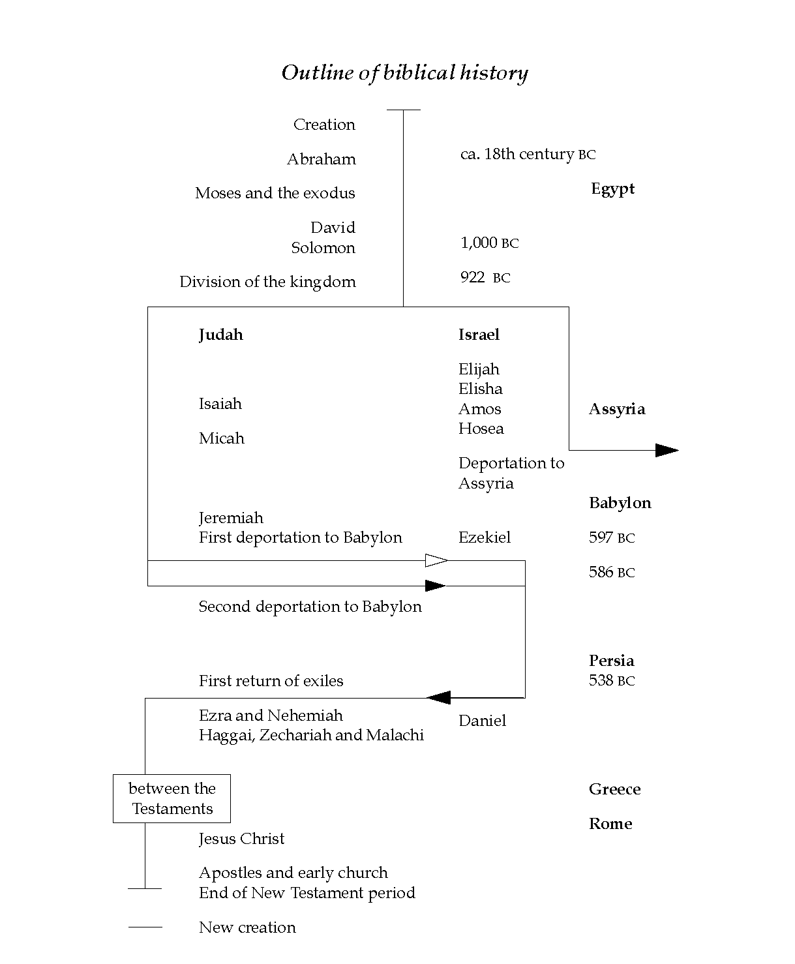
Finding Jesus in the Old Testament: LAW

What is the Difference between the Old and New Testaments?
The Old is a Shadow of things to come.
- Hebrews 10:1 (ESV), “For since the law has but a shadow of the good things to come instead of the true form of these realities, it can never, by the same sacrifices that are continually offered every year, make perfect those who draw near.”
- 1 Corinthians 10:11 (ESV), “Now these things [in the Old Testament] happened to them as an example, but they were written down for our instruction, on whom the end of the ages has come.”
- Colossians 2:16–17 (ESV), “Therefore let no one pass judgment on you in questions of food and drink, or with regard to a festival or a new moon or a Sabbath. 17 These are a shadow of the things to come, but the substance belongs to Christ.”

The Old is the Shadow and the New is the Reality.

There is a threefold purpose of the Old Covenant (the Law).
- Shadow – Ceremonies and events point us to Christ
- Civil (Preserving order & health) – Laws preserve the people through whom the Seed comes
- Quarantine laws
- Bathing / Purification laws
- Health laws – don’t touch dead bodies, etc.
- Moral – Laws that perscribe justice for wrongs, protection for strangers and the oppressed, and laws for moral living, esp. 10 Commandments, point us to our need for Christ, the perfect Savior.

The Sign of the Old Covenant
The sign of the covenant: circumcision. This points to the need for regeneration.
Deuteronomy 30:6 (ESV), “And the LORD your God will circumcise your heart and the heart of your offspring, so that you will love the LORD your God with all your heart and with all your soul, that you may live.”

1. LAW – the Five Books of Moses, Pentateuch

Books: Genesis, Exodus, Leviticus, Numbers, Deuteronomy

Author: Moses

Date: 1450-1410 B.C.
Summary: Key Words and Themes to Remember
Genesis | Beginnings of Christ (Seed) | Election of the nation
Exodus | Redemption by Christ | Redemption of the nation
Leviticus | Holiness through Christ | Sanctification of the nation
Numbers | Wandering / Failure to Trust Christ | Direction of the nation
Deuteronomy | Rededication of the 2nd Generation | Instruction of the Nation

Author of the Pentateuch is Moses
OT authors attribute the Pentateuch (Torah) to Moses:
Joshua 8:31
II Kings 14:6
Ezra 6:18
Nehemiah 8:1; 13:1-2
II Chronicles 25:4; 34:12; 35:12
Daniel 9:11
Malachi 4:4

Jesus attributes quotes from the Pentateuch (Torah) to Moses:
Matthew 8:4; 19:8
Mark 1:44; 7:10; 10:5; 12:26
Luke 5:14; 16:31; 20:37; 24:27, 44
John 5:46-47; 7:19, 23

BOOK SUMMARIES

GENESIS (The Book of Beginnings)

Theme: The Seed of the woman that will save humanity is promised and preserved.
Key verse: Genesis 15:6 – Abraham justified by grace through faith in the promised Seed.

Christ as Seen in Genesis
Prophetically: Immediately after the fall, the promise of salvation is given in the seed of the woman (3:15), but then the Messianic links are made clear throughout Genesis: the line of Seth (4:25), the offspring of Shem (9:26), the family of Abraham (12:3), the seed of Isaac (26:3), the sons of Jacob (46:3), and the tribe of Judah (49:10).
Typologically: There are several key types that portray the Savior in Genesis.
- Adam is a type of Christ (Rom. 5:14). As Adam is the head of the old creation, so Christ is the head of the new spiritual creation.
- Abel’s offering of a blood sacrifice points to Christ who would die for us.
- Melchizedek is a type of Christ, who like Mel. has no beginning and no end (see Heb. 7:3; Psalm 110, Gen. 13).
- Joseph, who was loved dearly by his father, betrayed by his brothers, and yet became the means of their deliverance typifies Christ.

Outline:
The book easily falls into two major sections: Four Events and Four People
I. Four Events (Gen. 1-11).
A. Creation: The creation of the world and man (1-2)
B. Fall: The corruption of man, the fall (3-5)
C. Flood: The destruction of man, the flood (6-9)
D. Babel: The dispersion of man, the nations (10-11)
II. Four People: the election of a nation and the preparation for the redeemer (Gen. 12-50)
A. Abraham (the father of faith and of the nation Israel) (12-23)
B. Isaac (the beloved son of promise) (24-26) – Isaac a type of Christ
C. Jacob/ Israel (scheming and chastening) (27-36) – Israel a type of Christ
D. Joseph (suffering and glory) (37-50) – Joseph a type of Christ

Key Passages:
The first mention of the Gospel of Christ: Genesis 3:15
The promise of Christ to Abraham: Genesis 12:1-3; 15:1-21; 17:1-9.

EXODUS (The Book of Redemption)

Theme: God makes Abraham a great nation (gestating in Egypt), and once great, redeems the nation to further preserve the Promised seed.
Key verses: Exodus 6:6 – the promise of a great redemption, 19:5-6 – the promise that they will be a kingdom of priests and a holy nation.
Mt 2:15, “[Jesus] remained there until the death of Herod. This was to fulfill what the Lord had spoken by the prophet, “Out of Egypt I called my son.”

Christ as Seen in Exodus
- Moses is a type of Christ. Deuteronomy 18:15-16 shows that Moses, as a prophet, anticipates Christ. Both are kinsman-redeemers who were endangered in infancy, renounced their power to serve others, and functioned as mediators, lawgivers, and deliverers.
- The Passover is a very specific type of Christ as the sinless Lamb of God (John 1:29, 36; 1 Cor. 5:7).
- The Seven Feasts, each of which portray some aspect of the Savior.
- The Exodus, which Paul connects with baptism, pictures our identification with Christ in His death, burial, and resurrection (1 Cor. 10:1-2; Rom. 6:2-3).
- The Manna and Water are both portrayed as pictures of Christ (John 6:31-35, 48-63; 1 Cor. 10:3-4)
- The Tabernacle portrays the Savior in its material, colors, furniture, arrangement, and the offerings sacrificed there (Heb. 9:1-10:18).
- The High Priest quite clearly foreshadows the person and ministry of Christ (Heb. 4:14-16; 9:11-12, 24-28).

Outline:
I. Redemption From Egypt (1-18)
A. In Bondage (Subjection) (1-12)
B. Out of Bondage (Redemption by blood and power) (12-14)
- 10 plagues mirror and mock Egypts false gods
- Key Verse Romans 9:14–16 (ESV), “What shall we say then? Is there injustice on God’s part? By no means! 15 For he says to Moses [speaking of Pharoah], “I will have mercy on whom I have mercy, and I will have compassion on whom I have compassion.” 16 So then it depends not on human will or exertion, but on God, who has mercy.”
C. Journeying to Sinai (Education) (15-18)

II. Revelation From God (19-40)
A. The Giving of the Law (19-24) – righteousness only Christ can fulfill
B. The Institution of the Tabernacle (25-31) –many types of Christ
C. The Breaking of the Law (32-34) – Even in the golden calf incident, after judgment, God demonstrates mercy. The Pillar of God’s glory decends with Moses at his “tent of meeting” (Moses’ tent) and all the people see and worship…
D. The Construction of the Tabernacle (35-40)

LEVITICUS (The Book of Holiness)
Leviticus receives its name from the Septuagint and means “relating to the Levites.” The Levites were the priests who were chosen of God to minister to the nation. The book of Leviticus contains many of the laws given by God to direct them in their work as priests for the worship of God.

Theme and Purpose: A true walk with the Lord produces a transformed life of holiness
Leviticus 11:45 says, “Be holy, because I am holy.” The directives given in the book of Leviticus showed Israel was to walk before God as a holy people. Leviticus was designed to teach Israel (1) how to worship and walk with God and (2) how the nation was to fulfill its calling as a nation of priests. The great theme of Leviticus is holiness. A holy God can only be approached on the basis of sacrifice through the mediation of a priest.

Key Word: “Holiness.”

Key Verses:
20:7-8 You shall consecrate yourselves therefore and be holy, for I am the Lord your God. 8 And you shall keep My statutes and practice them; I am the Lord who sanctifies you (see also 11:45).
1 Peter 1:15–16 (ESV), “but as he who called you is holy, you also be holy in all your conduct, 16 since it is written, “You shall be holy, for I am holy.”
1Co 5:7, “Christ, our Passover lamb, has been sacrificed.”

Key Chapter:
Chapter 16 deals with the Day of Atonement, which became the most important day in the Hebrew calendar because it was the only day the high priest was allowed to enter into the Holy of Holies in order to make atonement for the people. “… for it is on this day that atonement shall be made for you to cleanse you; you shall be clean from all your sins before the Lord” (16:30).

Christ as Seen in Leviticus
Similar to Exodus, a number of types of Christ are evident in Leviticus.
(1) The Five Offerings all typify the person and work of Christ in His sinless life, submission to the Father that we might have fellowship with God.
(2) The High Priest as mentioned above is a very prominent type of Christ in Leviticus.
(3) The Seven Feasts, again, as mentioned (Lev. 23), also form a type of the Savior.

Outline:
Leviticus falls into two clear divisions: Sacrifice and Sanctification
I. Sacrifice (1-17)
A. The Laws of Sacrifice for Approach to God (1-7)
- Access/Relationship to God: The Burnt Offering (Lev. 6:8–13)
- Fellowship with God: The Grain Offering (Lev. 6:14–18)
  - Ordination Offering (Lev. 19-23) – leaders break the bread!
- Forgiven by God: The Sin Offering – own your sin (Lev. 6:24–30)
- Reconciled with God and others: The Guilt Offering – forsake sin (Lev. 7:1–10)
- Peace with God: The Peace Offering (wave offering) – celebrate! (Lev. 7:11–21)
  - Dick AverbeckDr. Richard Averbeck, a Hebrew scholar at Trinity Evangelical Divinity School mentioned that it is no coincidence that this Peace Offering was waved in the shape of a cross.
B. The Laws of the Priests (8-10)
C. The Laws Regarding Purity & health (11-15)
D. The Laws of National Atonement (16-17)
II. Sanctification (18-27)
A. The Laws of Sanctification for God’s People (18-20)
B. The Laws of Sanctification for God’s Priests (21-22)
C. The Laws of Sanctification in Worship (23-24)
D. The Laws of Sanctification in the Land of Canaan (25-26)
E. The Laws of Sanctification and Vows (27)

The 7 OT Feasts in Leviticus 23…
Purpose: To spend more time with God/looking to Jesus.

The Spring Feasts picture Christ as Suffering Servant
- Passover
- Unleavened Bread
- First Fruits
- Pentecost

The Fall Feasts picture Christ as Conquering Savior
- Trumpets
- Atonement (Yom Kippur)
- Tabernacles
SPRING FESTIVALS

Feast | Meaning | OT History | Details
Passover  1Cor. 5:7  Christ Crucified | Salvation – Christ our Passover Lamb  Jesus Crucified on Passover | Release from Egypt | “When I see the blood I will pass over you”
Unleavened Bread  Christ Buried, Accepted by the Father | Satisfaction – Christ, the Bread of Life, born in Bethlehem, “House of Bread”  Jesus Buried during Unleavened Bread | Israel was to eat while dressed for journey  Lasts for one week, occurs immediately after Passover. | Jesuus is the Bread of life. Born in Bethlehem, “House of Bread”
First Fruits  Christ Resurrection | Resurrection, Easter, Jesus is the Resurrection & Life  Jesus Raised on First Fruits | First crop of Spring. | Jesus is the Firstfruits.
Pentecost  (The Feast of Weeks)  Birth of Church | Marks the Summer Harvest  Old Testament:  Recalling the giving of the Law at Sinai 50 days after crossing the Red Sea and thankfulness for the Lord's blessings and birth of the O.T. Church.  N.T.=birth of New Covenant Church  Jesus sends Spirit on Pentecost | A festival of joy; mandatory and voluntary offerings including the wheat harvest. (Exodus 34:26, Lev 23:10-14, Num 28:26-31). | They would eat bread with Leaven. Pictures Jews and Gentiles together in one Bread.
FALL FESTIVALS
Trumpets (Rosh Hoshanna)  Second Coming | Old Testament: First day of Jewish New Year. Ingathering of the nation of Israel. The Shofars are blown at the Western wall, and it begins ten days known as “the days of awe”. This is a rememberance of coronation day, the coronation of God as King of Israel.  Signifies Jesus’ Second Coming. | The trumpet was the signal for the field workers to come into the Temple. The high priest actually blew the trumpet so that the faithful would stop harvesting to worship. | Now, when the trumpet sounds in accordance with 1 Corinthians 15:51-3, living believers will cease their harvest and rise from the earth.
Day of Atonement (Yom Kippur)  Final Redemption | Signifies our Final acceptance with God  Signifies Final Salvation in Christ! | The Lamb would be slain on behalf of the nation. | Once a year the high priest would go into the holy of holies with bells around his garment.
Tabernacles  The Tabernacle of God is with men!  New Heaven and New Earth | Signifies God finally and eternally tabernacling with us! "I saw no temple in the city, for its temple is the Lord God the Almighty and the Lamb" (Rev. 21:22).  Points to our Inheritance in the New Heaven and New Earth | The people of Israel would camp out in tents as they did in the wilderness. | Jesus is our Tabernacle and Temple! He is our inheritance!

NUMBERS (Wilderness Wanderings)
Numbers gets its name from the two accounts in chapters 1 and 26 of the numbering or counting of the people of Israel first at Mount Sinai and second on the plains of Moab.

Key Word:
“Wanderings.”

Key Verses:
14:22-23 Surely all the men who have seen My glory and My signs, which I performed in Egypt and in the wilderness, yet have put Me to the test these ten times and have not listened to My voice, 23 shall by no means see the land which I swore to their fathers, nor shall any of those who spurned Me see it.
20:12. But the Lord said to Moses and Aaron, “Because you have not believed Me, to treat Me as holy in the sight of the sons of Israel, therefore you shall not bring this assembly into the land which I have given them.”
1Co 10:4 and all drank the same spiritual drink. For they drank from the spiritual Rock that followed them, and the Rock was Christ.

Key Chapters – Going to the very Edge of the Promised Land!
Chapters 13-14 stand as the key chapters because these chapters record a critical turning point for the nation. Here, at Kadesh-Barnea (32:8), after receiving the evil report from 10 of the 12 spies whom Moses sent to spy out the land, with the exception of Joshua and Caleb Israel focused on the giants in the land, failed to believe God, and refused to enter to possess and conquer the land, a Land that flowed with milk and honey. See commentary in Hebrews 4:1-3a, “Therefore, while the promise of entering his rest still stands, let us fear lest any of you should seem to have failed to reach it. 2 For good news came to us just as to them, but the message they heard did not benefit them, because they were not united by faith with those who listened. 3 For we who have believed enter that rest, as he has said, “As I swore in my wrath, ‘They shall not enter my rest,’”

Christ as Seen in Numbers
- Perhaps no place is there a clearer portrait of Christ and His crucifixion than in the serpent lifted up on the standard (cf. Num. 21:4-9 with John 3:14).
- The Promised Land (Numbers 13-14) was not entered into by faith is a type of Christ.
- The rock that quenched the thirst of the people is a type of Christ (1 Cor. 10:4).
- The daily manna pictures Christ as the bread come down from heaven (John 6:31-33).
- The pillar of cloud and fire portray the guidance of Christ and the cities of refuge certainly portray Christ as our refuge from judgment.
- Finally, the red heifer is also a type of Christ (ch. 19).

Outline:
Numbers divides into three sections: Preparation at Sinai, Failure of the Old Generation, and Preparation of the New Generation.
I. Preparation at Sinai (Old Generation) (1-10)
A. The Position and Numbering of the People (1-4)
B. The Precepts of God and Sanctification of the People (5:1-9:14)
C. The Pilgrimage Toward the Promised Land (9:15-10:36)
II. Failure of the Old Generation (11-25)
A. Discontent Along the Way (11-12)
B. Disbelief at Kadesh-Barnea (13-14) – on the edge of the Promised Land, the children of Israel waver in unbelief. They are not allowed to enter the Land, but must spend 1 year for each day.
C. Discipline from the Lord (15-25)
- Korah’s Rebellion (Num 16)
- Balaam’s Donkey (Num 22)
III. Preparation of the New Generation (26-36)
A. Reorganization (numbering) of Israel (26-27) – 600,000 perish, see below.
B. Regulation of Offerings and Vows (28-30)
C. Regionalization of the Land (31-36)

600,000 to Die in the Wilderness
600,000 were numbered in chapter 1 and 600,000 are numbered again in chapter 26. Key verse Numbers 26:65, “For the LORD had said of them, “They shall die in the wilderness.” Not one of them was left, except Caleb the son of Jephunneh and Joshua the son of Nun.”

DEUTERONOMY (Covenant with 2nd Generation)
The English title, which comes from the Septuagint, means “second law-giving”. It is the Law giving to the 2nd generation, the children of those who died in the wilderness.

Theme and Purpose: Watch yourself lest you forget. After forty years of wandering in the wilderness, the Israelites were on the eve of entering the promised land. Before they did, it was necessary (lest they forget what God had done and who they were) that they be reminded about all that God had done for them and about God’s holy law which was so vital to their ability to remain in the land and function as God’s holy nation and as a kingdom of priests to the nations (Deut. 4:1-8). As a part of this theme or purpose, the book also emphasizes the vital necessity of teaching children to love and obey God. Deuteronomy ends with the renewal of God’s covenant with Israel (chapter 29), Joshua’s appointment as the new leader (chapter 31), and Moses’ death (chapter 34).

Key Word: “Covenant” (occurring some 27 times)

Key Verses:
30:19-20 I call heaven and earth to witness against you today, that I have set before you life and death, the blessing and the curse. So choose life in order that you may live, you and your descendants, 20 by loving the Lord your God, by obeying His voice, and by holding fast to Him; for this is your life and the length of your days, that you may live in the land which the Lord swore to your fathers, to Abraham, Isaac, and Jacob, to give them.

Key Chapters:
Chapter 27 is key because in it there is a formal ratification of Israel’s covenant as Moses and the levitical priests call upon all Israel to take heed and listen, for in verses 9-10 it is declared, “This day you have become a people for the Lord your God. You shall therefore obey the Lord your God, and do His commandments and His statutes which I command you today.”
Chapters 28-30 are also key because of the promises regarding Israel’s near and distant future as it pertains to blessing for obedience or cursing for disobedience.

Christ as Seen in Deuteronomy
The True Prophet to Come
The statement about Moses in Deut 18:15 is one of the clearest portraits of Christ. It reads, “The Lord your God will raise up for you a prophet like me from among you, from your countrymen, you shall listen to him.” Further, Moses, as a type of Christ, is the only figure other than Christ to fill all three of the offices of prophet (34:10-12), priest (Ex. 32:31-35), and king (although Moses was not king, he functioned as ruler of Israel; 33:4-5).

Outline: Deuteronomy divides into three sections –
Preamble (1:1-5)
I. Review of Israel’s Wanderings—Historical (1:6-4:43)
II. Rehearsal of Israel’s Law—Legal (4:44-26:19)
III. Ratification of Israel’s Covenant—Motivational (27:1-30:20)
Conclusion (31:1-34:12)

Summary: Key Words and Themes to Remember
Genesis | Beginnings of Christ (Seed) | Election of the nation
Exodus | Redemption by Christ | Redemption of the nation
Leviticus | Holiness through Christ | Sanctification of the nation
Numbers | Wandering / Failure to Trust Christ | Direction of the nation
Deuteronomy | Rededication of the 2nd Generation | Instruction of the Nation

Finding Jesus in the Old Testament
Historical Books
- Historical books comprise 12 books (see chart below)
- Covering about 800 years of Israel’s history, these twelve books tell about the conquering and possession of Canaan, the reigns of the judges, the establishment of kings, the division of Israel into the northern and Southern Kingdoms, the fall of the Northern Kingdom to Assyria, the exile of the Southern Kingdom into Babylon, and the return to Jerusalem under the leadership of men like Nehemiah and Ezra. Even as we consider the historical books we see that the Old is a Shadow of things to come.
  - Hebrews 10:1 (ESV), “For since the law has but a shadow of the good things to come instead of the true form of these realities, it can never, by the same sacrifices that are continually offered every year, make perfect those who draw near.”
  - 1 Corinthians 10:11 (ESV), “Now these things [in the Old Testament] happened to them as an example, but they were written down for our instruction, on whom the end of the ages has come.”
  - See also Colossians 2:16–17

As these books prepare us for the coming of Christ, the Messiah, they can be seen as follows:

The Historical Books
Historical Books: The Preparation for Christ
Joshua  Judges-Ruth | the destruction of God’s enemies & the high places – establishing the nation  the compromise of the nation | The Theocracy: These books cover the period when Israel was ruled by God (1405-1043 B.C.).
1 Samuel  2 Samuel  1 Kings 1-10  1 Kings 11-22  2 Kings 1-17  2 Kings 18-25  1 Chronicles  2 Chronicles | the stabilization of the nation – Samuel / Saul  the expansion of the nation – David  the glorification of the nation – Solomon  the division of the nation – Rehoboam / Jer. I  the deterioration of the Northern Kingdom  the deportation of the Southern Kingdom  the preparation of the Temple  the destruction of the Temple | The Monarchy: These books trace the history of Israel’s monarchy from its establishment to its destruction in 586 B.C.
Ezra  Nehemiah  Esther | the restoration of the Temple  the reconstruction of the city  the protection of the nation’s people | The Restoration: These books describe the return of a remnant to the land after 70 years of captivity (605-536 B.C.).
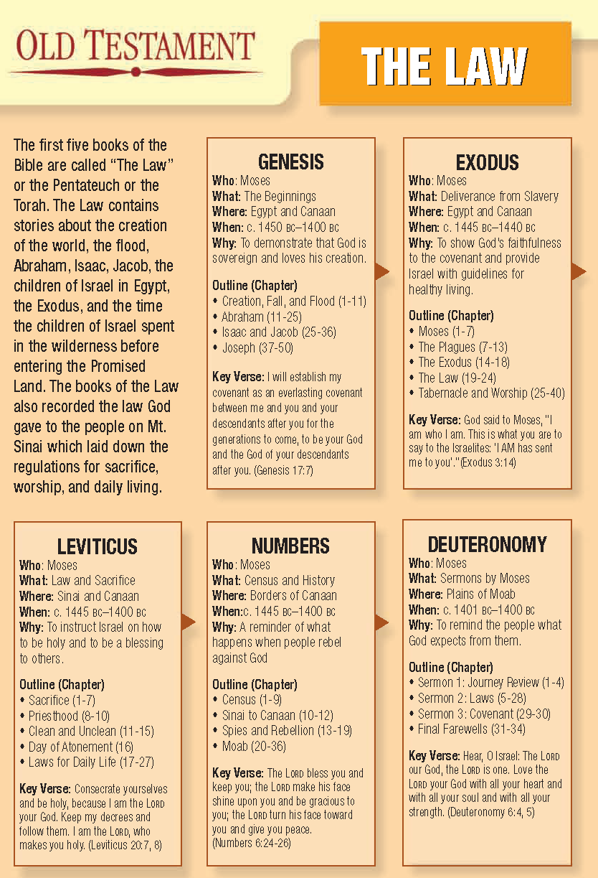

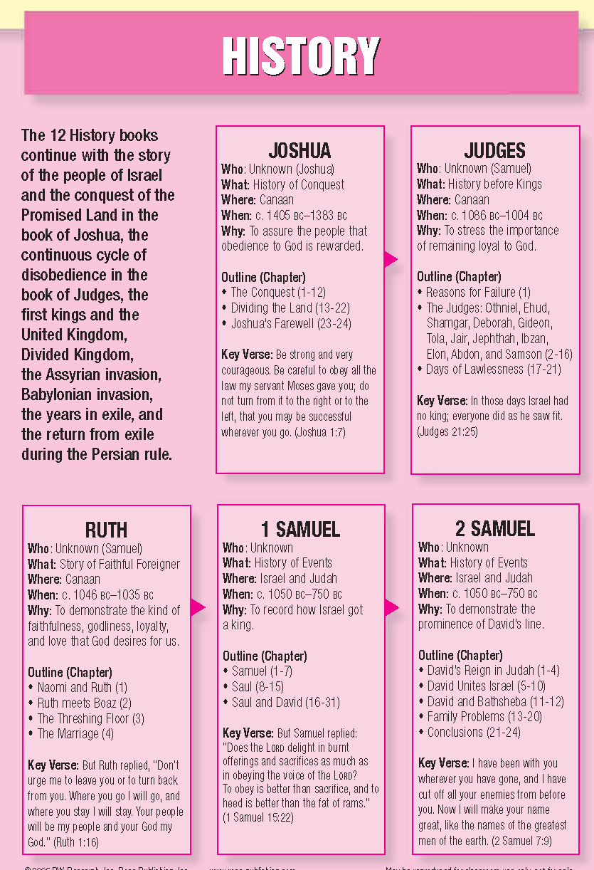

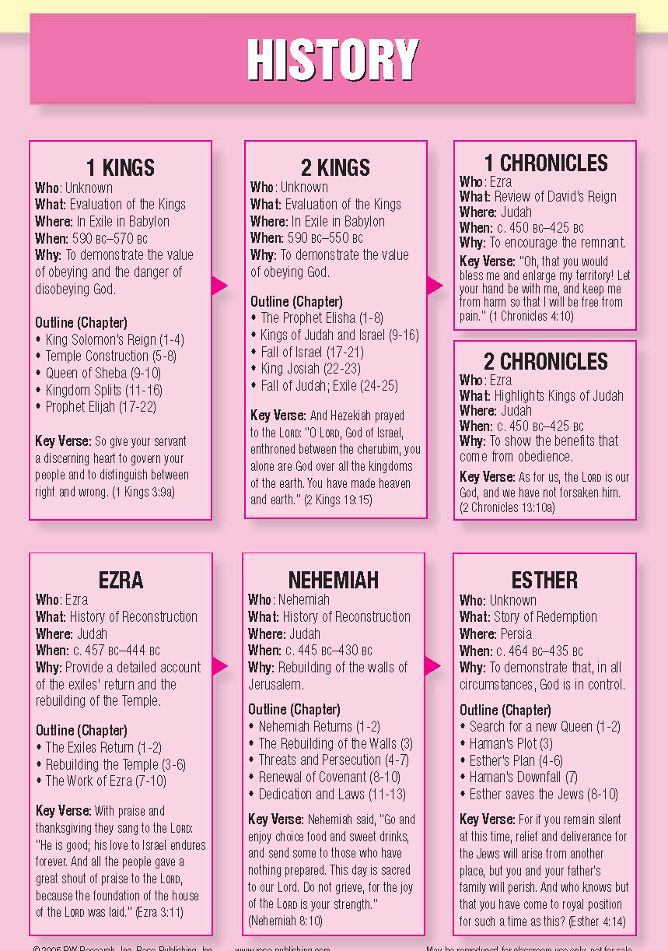

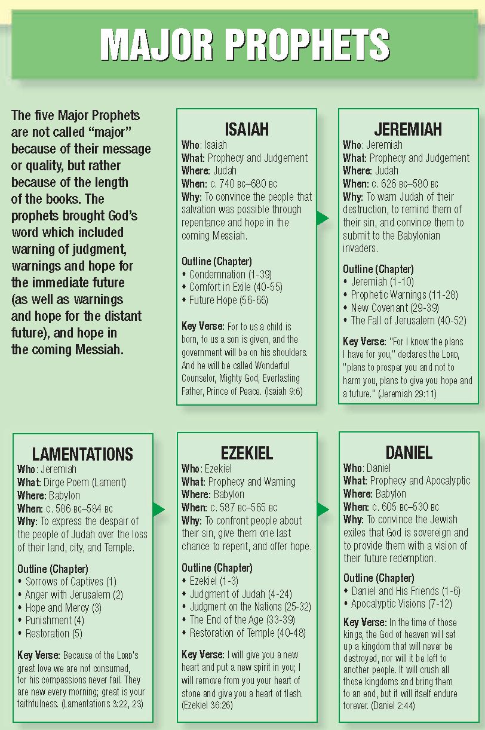
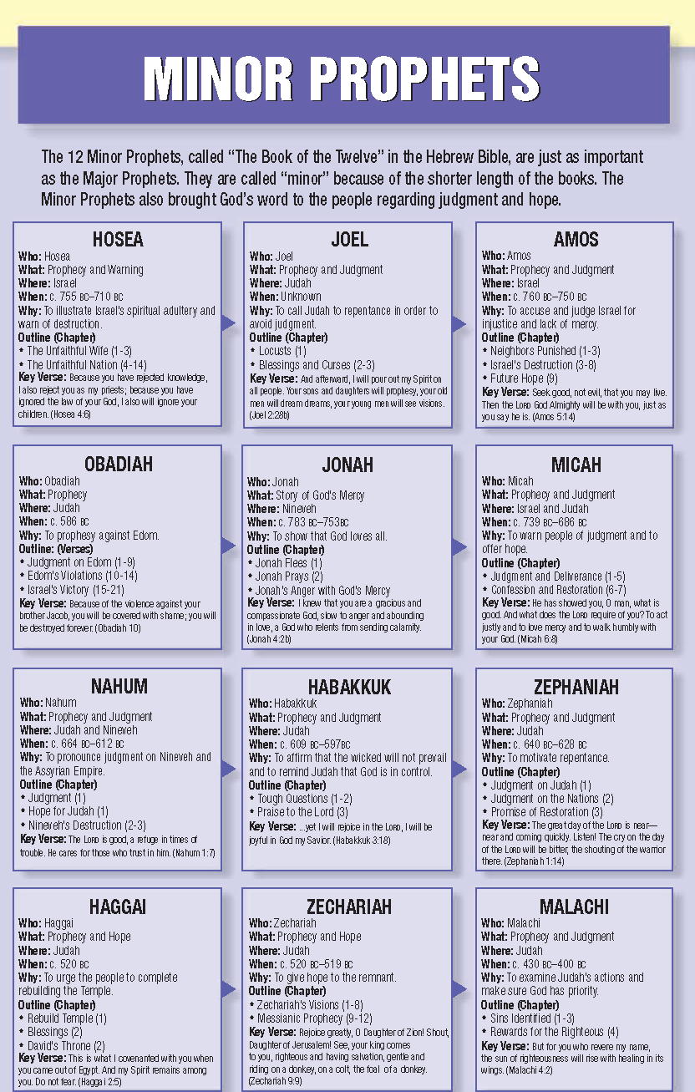
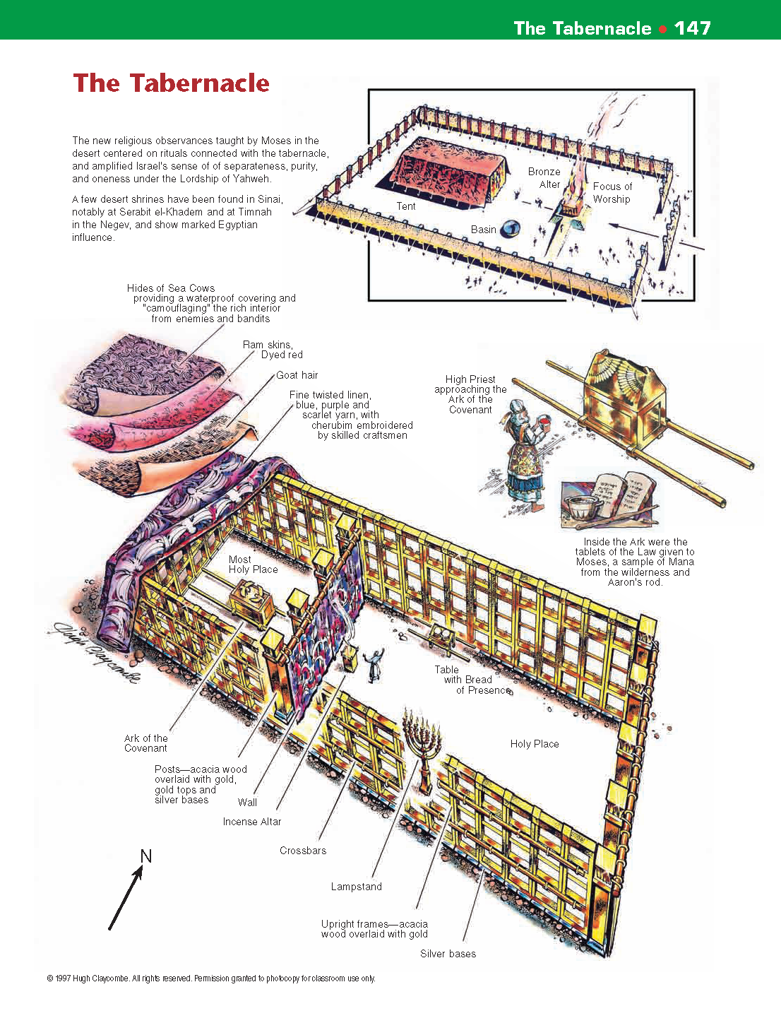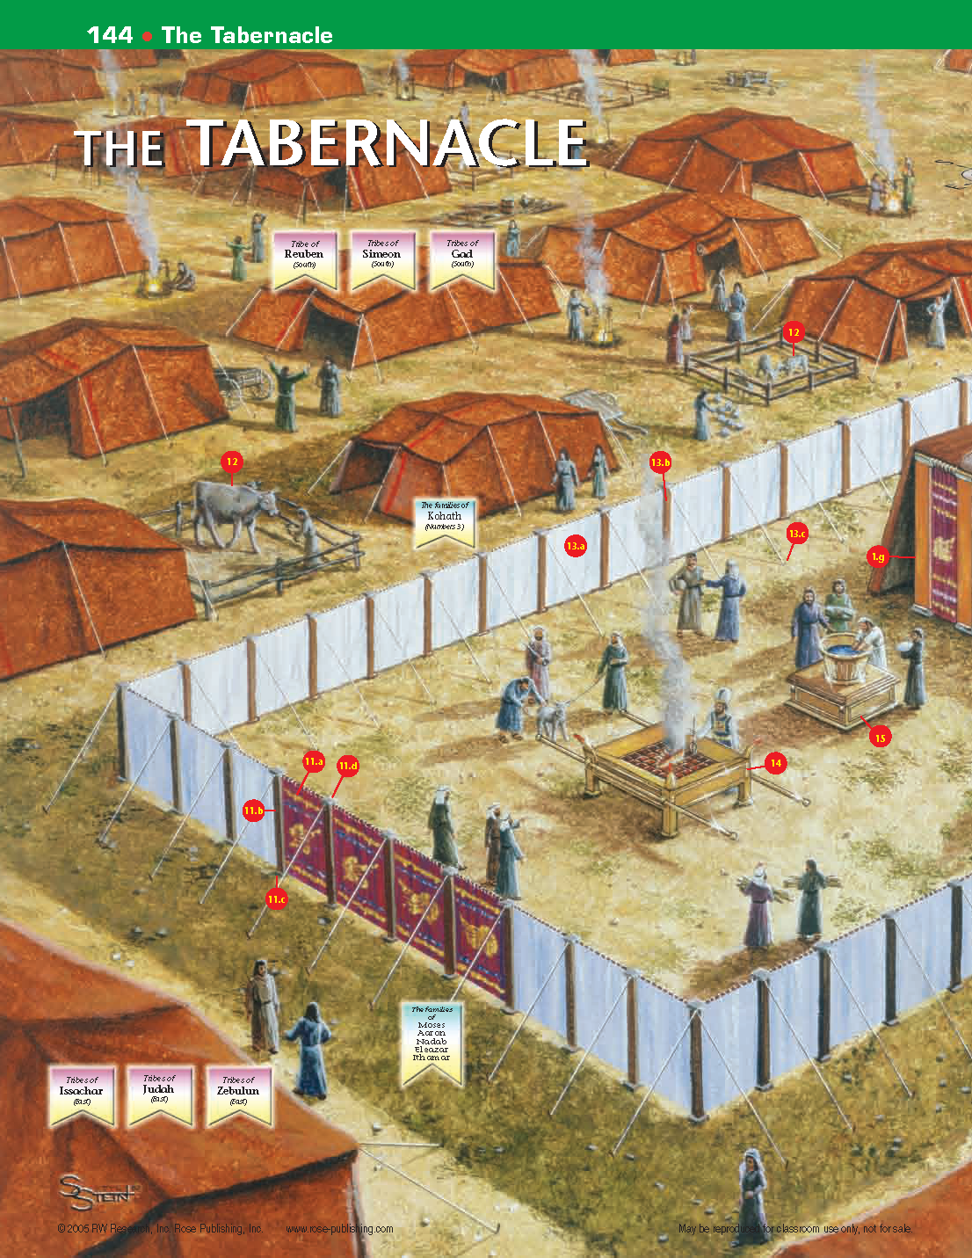

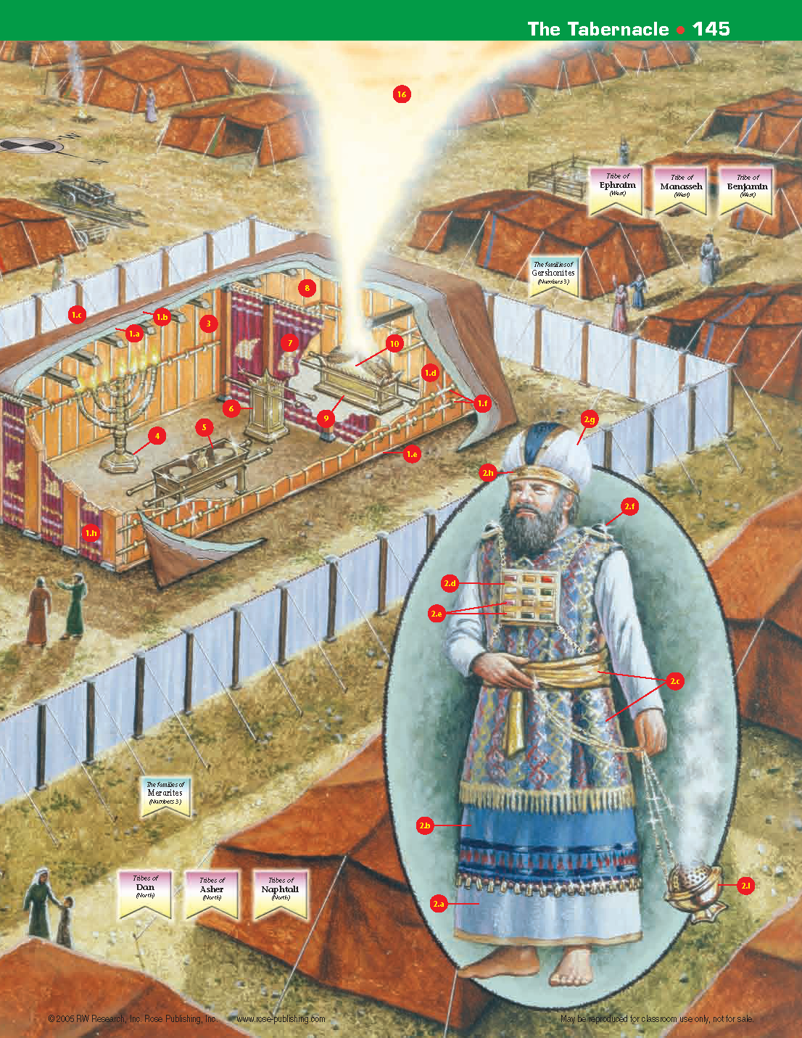

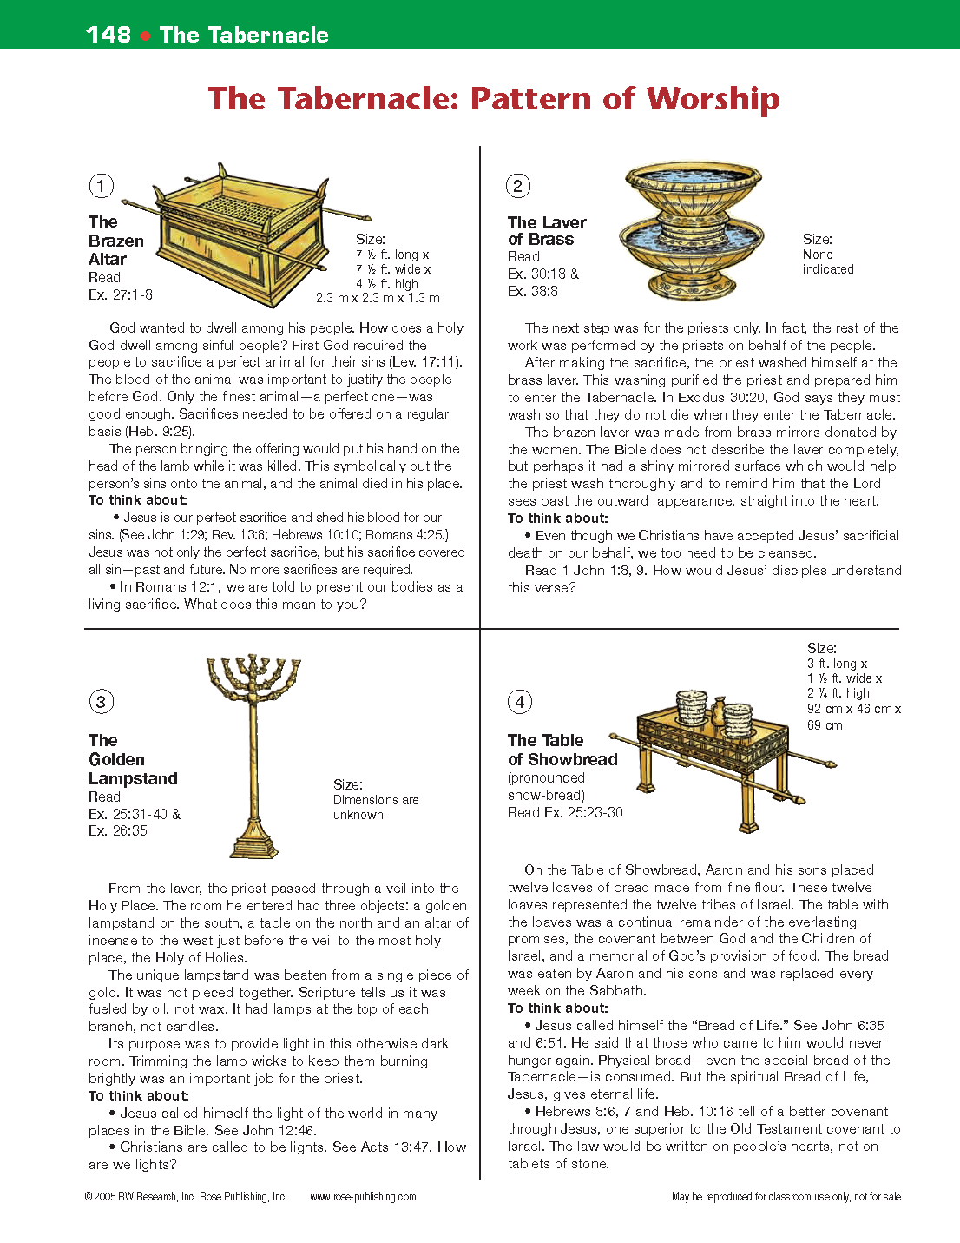

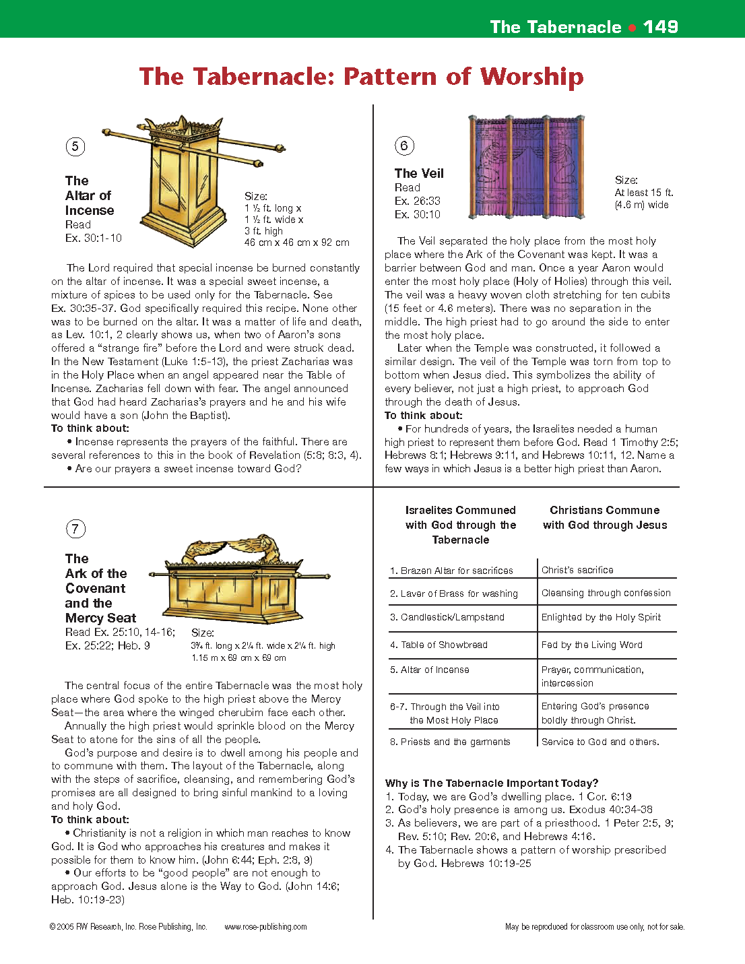

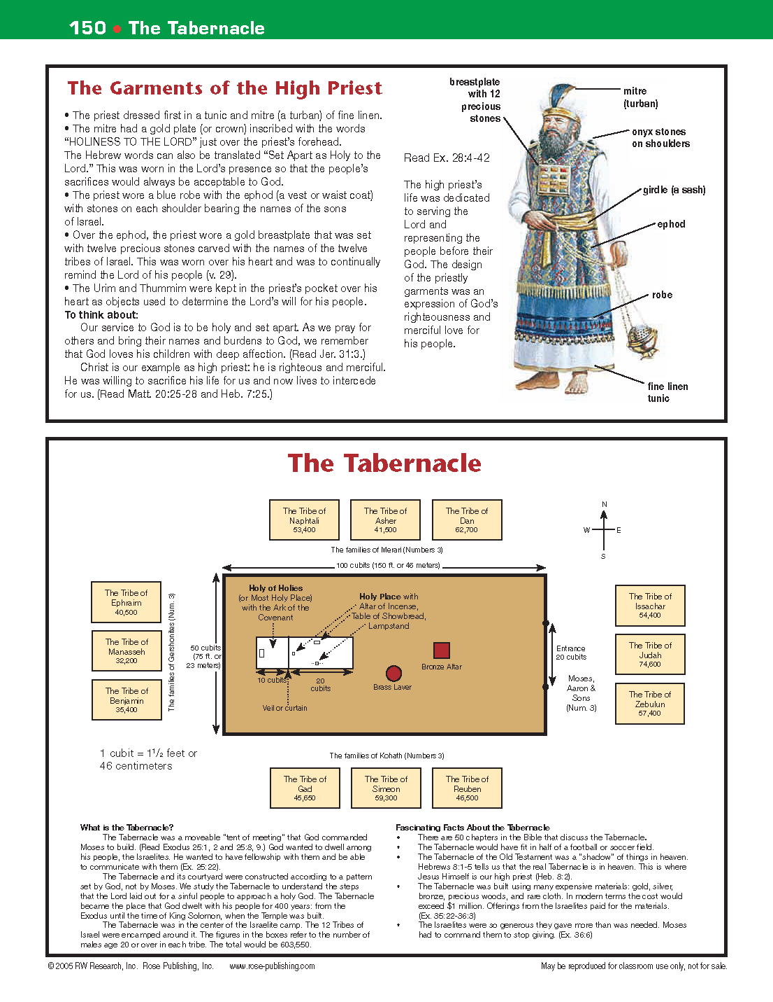

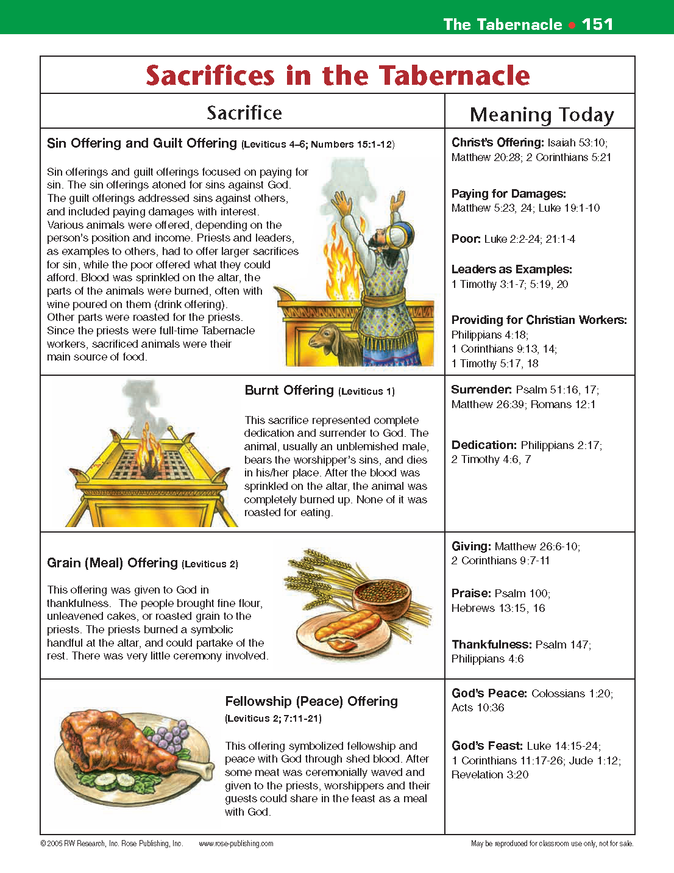
Joshua
(Possession and Conquest of the Inheritance)
Ephesians 1:11–14, “In him [our Yeshua] we have obtained an inheritance…”

Author: Joshua, 1250 BC

Outline of Joshua
I. The Invasion of Canaan (1:1-5:12)
II. The Conquest of Canaan (5:13-12:24)
III. The Division of Canaan (chaps. 13-21)
IV. Conclusion (chaps. 22-24)

Themes:
Possessing, conquering, and dividing of the Promised Land is the theme and purpose of Joshua. The book of Joshua is designed to show God’s faithfulness to His promises, doing for Israel exactly as He had promised (cf. Gen. 15:18 with Josh. 1:2-6 and 21:43-45). Against all odds, they are to inherit the Promised Land. The fulfillment of God’s promises, as so evident in the birth of Isaac to Abraham and Sarah and in possessing the land with its fortified cities, is the work of God and that which man could never do no matter how hard he might try (see Rom. 4).
Another prominent theme is that they are to destroy the gods and idols of the land and not worship like the heathen, but to worship God at His Tabernacle as His people.

Keys for Christians: Victory and blessing always come from obeying God!
- Example: the Sin of Achan
Joshua 7 describe the sin of Achan who took some of the things that were to be devoted to destruction. Achan says in Joshua 7:21, “when I saw among the spoil a beautiful cloak from Shinar, and 200 shekels of silver, and a bar of gold weighing 50 shekels, then I coveted them and took them. And see, they are hidden in the earth inside my tent, with the silver underneath.”
So the children of Israel could not defeat the city of Ai until the sin of Achan had been dealt with.
- The point of conquering the land was so that they might worship the Lord.
  - Exodus 33:11 (ESV), “Thus the LORD used to speak to Moses face to face, as a man speaks to his friend. When Moses turned again into the camp, his assistant Joshua the son of Nun, a young man, would not depart from the tent.
  - Joshua 18:1 (ESV), “Then the whole congregation of the people of Israel assembled at Shiloh and set up the tent of meeting there. The land lay subdued before them.”

- Joshua (a type of Christ) would give the children of Israel their inheritance. Joshua 1:3 Every place on which the sole of your foot treads, I have given it to you, just as I spoke to Moses. [In this regard, Joshua compares to Ephesians 1:3 in the New Testament, “… blessed with every spiritual blessing in the heavenlies.”]
- Joshua is seen as a type of Christ in his work of leading Israel triumphantly into the rest of their promised possession, the land of Canaan (cf. Heb. 4:8). This is but a foretaste of the rest we enter by faith in Christ. He surely foreshadows the Savior who leads “many sons to glory” (Heb. 2:9-10).
- The power of conquest was not in their weapons, but in the Word of God. Joshua 1:8-9 This book of the law shall not depart from your mouth, but you shall meditate on it day and night, so that you may be careful to do according to all that is written in it; for then you will make your way prosperous, and then you will have success. 9 Have I not commanded you? Be strong and courageous! Do not tremble or be dismayed, for the Lord your God is with you wherever you go.
- Rahab’s scarlet cord (2:21) portrays salvation through the blood and death of Christ (cf. Heb. 9:19-22). This Gentile prostitute heard of the mighty works of God, believed, hid the spies, was delivered when Jericho was destroyed, and is found in the genealogy of Christ (Matt. 1:5).
- Joshua is met by the Commander of the Lord’s army in 5:13-15. This is undoubtedly a Christophany, a preincarnate appearance of Christ who was there to teach Joshua that He had come not to take sides, but to take over as commander.
- God keeps His Word! Joshua 11:23 So Joshua took the whole land, according to all that the Lord had spoken to Moses, and Joshua gave it for an inheritance to Israel according to their divisions by their tribes. Thus the land had rest from war.
- Victory over God’s enemies brings blessings. Joshua 24:14-15 Now, therefore, fear the Lord and serve Him in sincerity and truth; and put away the gods which your fathers served beyond the River and in Egypt, and serve the Lord. 15 And if it is disagreeable in your sight to serve the Lord, choose for yourselves today whom you will serve: whether the gods which your fathers served which were beyond the River, or the gods of the Amorites in whose land you are living; but as for me and my house, we will serve the Lord.
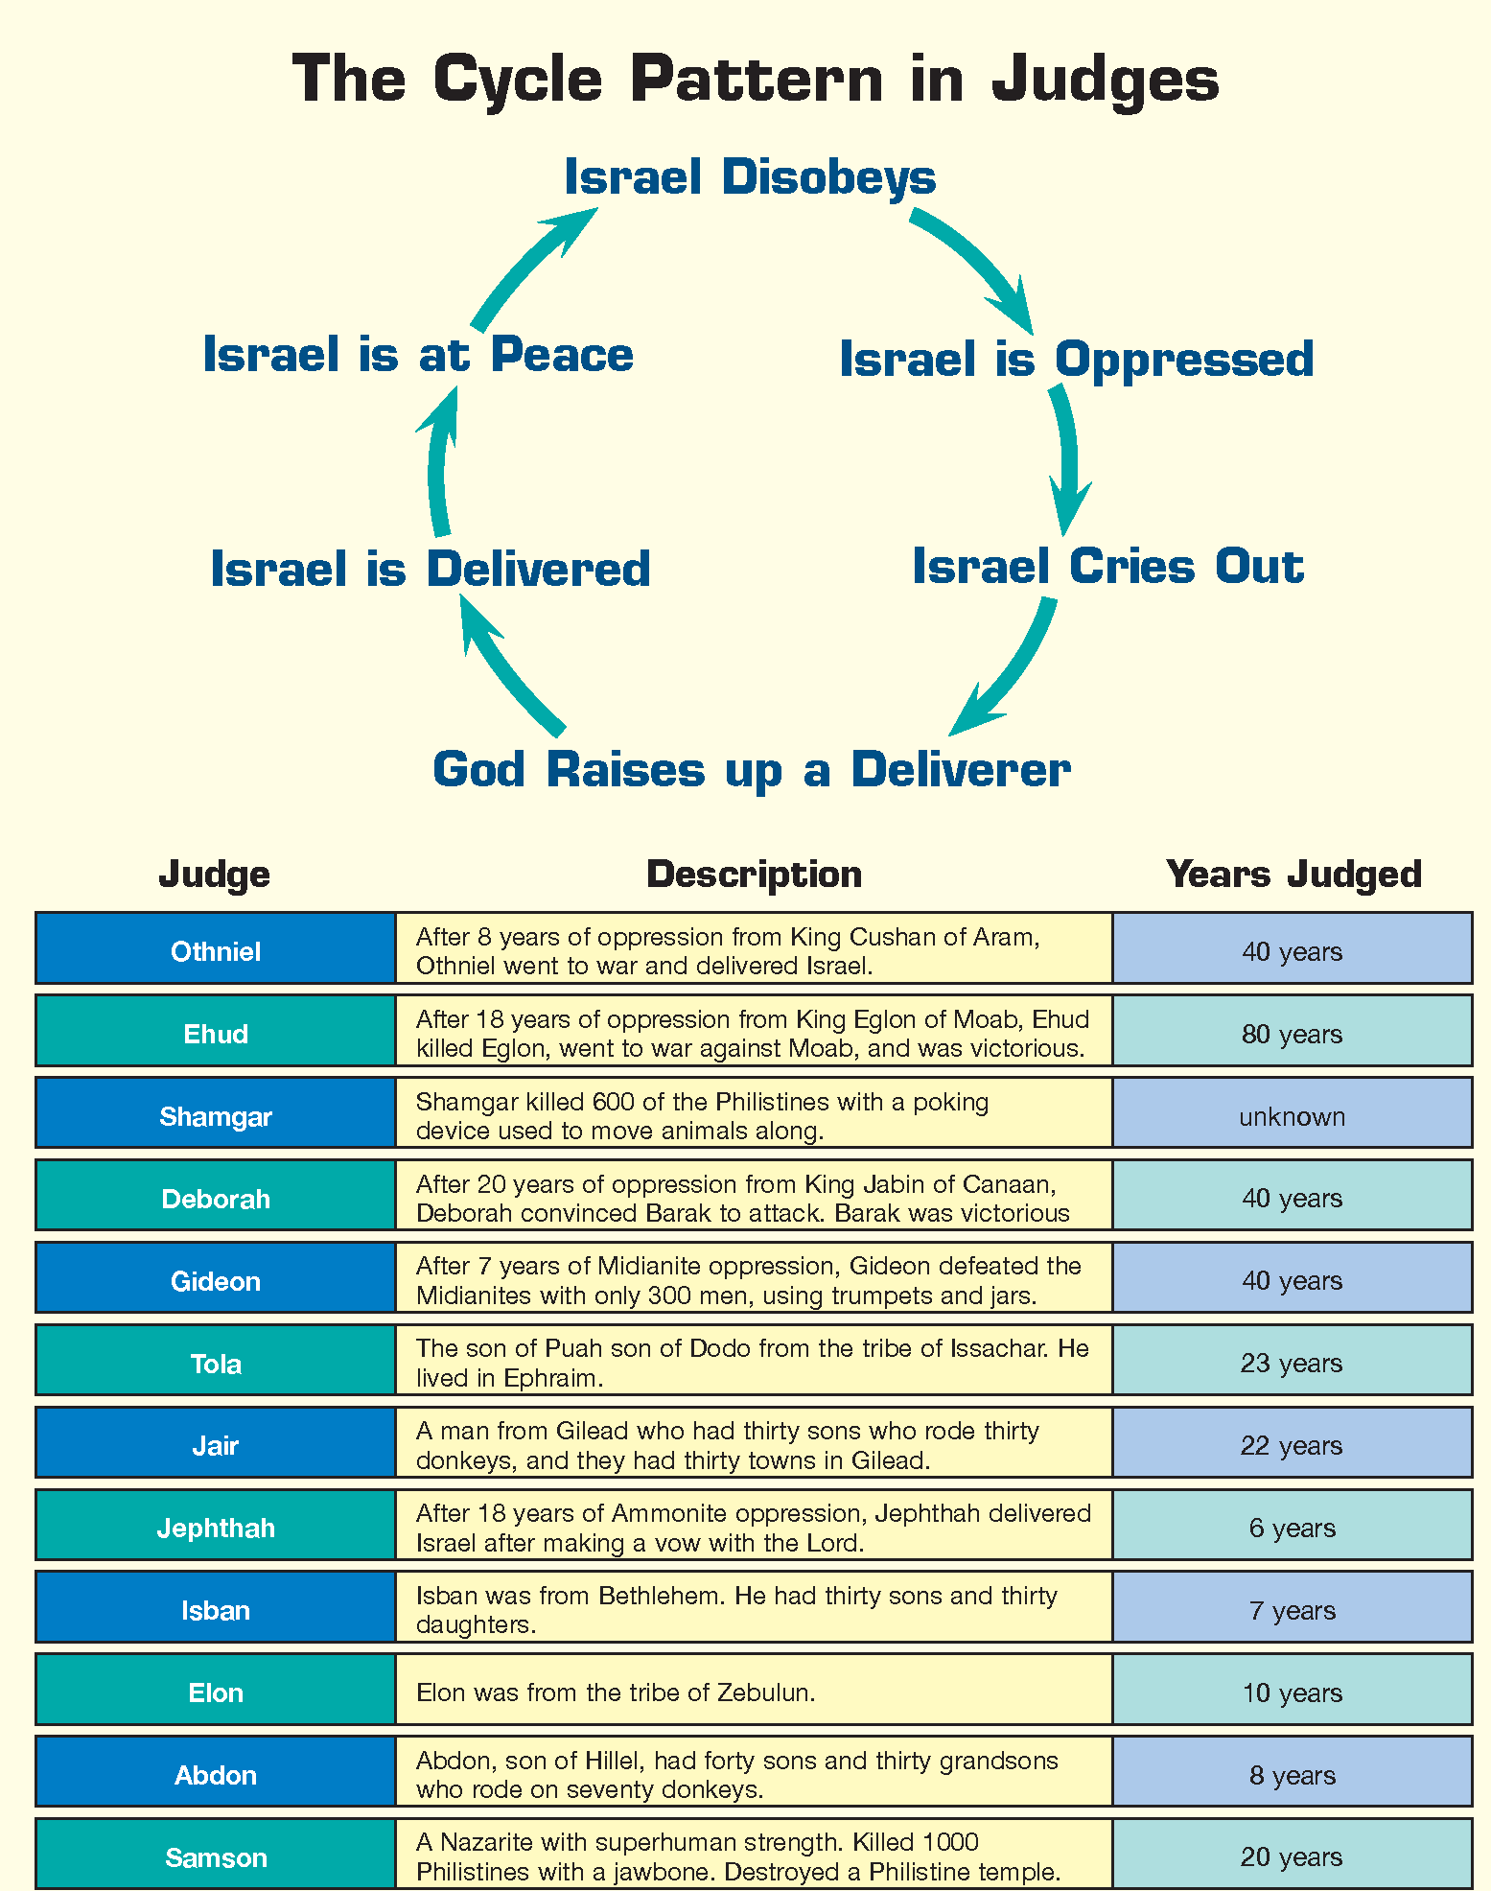
FINDING JESUS
There is a beautiful Cristophany in Judges 13 where the Angel of the Lord is taken up in the sacrifice.
Judges

(Repentance & Salvation vs. Apostasy)

Author: likely Samuel, c. 1380 B.C. to 1045 B.C.
Hebrews 3:12, “Take care, brothers, lest there be in any of you an evil, unbelieving heart, leading you to fall away from the living God.”

Outline of Judges
I. Deterioration—An Introduction, the Reason for the Period of the Judges (1:1-3:6)
II. Deliverance—The History and Rule of the Judges (3:7-16:31)
III. Depravity—Apostasy and Anarchy, the Ruin (17:1-21:25)

Theme: The theme of Judges is “the Canaanization of Israel.” Its overall message is that God’s people self-destruct when they disobey God and get their values instead from their pagan neighbors. Every one in Israel it seemed “did that which was right in his own eyes”.

Keys for Christians
1. God providentially brings about his eternal good purposes to redeem a people for himself and restore his fallen creation, to the praise of his glorious grace.
We see this in Judges 2:16, “Then the Lord raised up judges who delivered them from the hands of those who plundered them.” Ultimately, however, Christ is Israel’s Judge and Deliverer because it was God Himself who would first allow the times of oppression as divine discipline for Israel’s repeated apostasy, and then raise up judges to bring deliverance after the nation repented and cried out for help (cf. 11:27 and 8:23) pointing to Christ.

2. Warnings of Apostasy and Discipline. Hebrews 6, 10, and 11 give us warnings of those who are tempted to fall away, but that God in His love will always bring His true people back to Himself.

3. With every man doing that which was right in his own eyes (21:25), the nation needed the leadership of a righteous king. The true righteous king that the nation waits for is Christ.

Doctrine: Doctrinally, Judges draws our attention to a number of important truths.
- Disobedience brings discipline. As God had warned in Deuteronomy, obedience brings blessing, but disobedience results in God’s discipline and oppression.
- God responds to our repentance. But Judges also reminds us that when people will turn to the Lord, cry out to Him and repent, God, who is long-suffering and gracious, responds in deliverance. Judges unfolds its theme by describing cycles of apostasy followed by oppression as a form of divine discipline followed by supplication and repentance by the people followed by judges whom God raised up to deliver the nation.

Key Verses: Judges 2:20–23 (ESV), “Because this people have transgressed my covenant that I commanded their fathers and have not obeyed my voice, 21 I will no longer drive out before them any of the nations that Joshua left when he died…”

Christ as Seen in Judges:
Since each judge functioned as a ruler-deliverer, they served as pictures of the Savior in His work as Savior and Lord, the Righteous Deliverer King. In Judges 13, we see the Angel of the Lord, a pre-incarnate appearance of Christ being taken up in the sacrifice of burnt offering by Samson’s parents at the announcement of Samson’s birth.

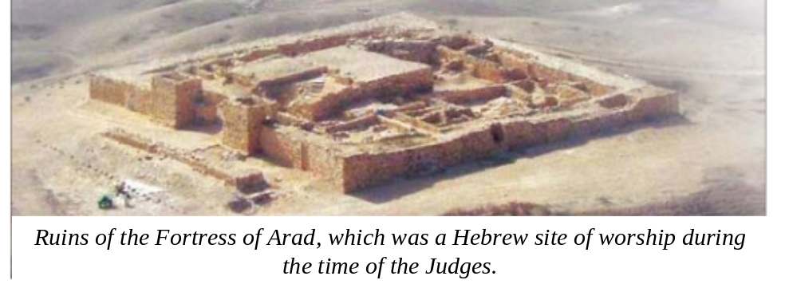

Ruth

(Redeemed!)
1 Peter 1:18–19 (ESV), “knowing that you were ransomed from the futile ways inherited from your forefathers, not with perishable things such as silver or gold, 19 but with the precious blood of Christ, like that of a lamb without blemish or spot.”

Author: likely Samuel and perhaps later Ezra, approx. 1100 BC

Outline of Ruth
I. The Resolve and Return of Ruth (1:1-22)
II. The Reaping Rights of Ruth (2:1-23)
III. The Request of Ruth (3:1-18)
IV. The Reward of Ruth (4:1-22)
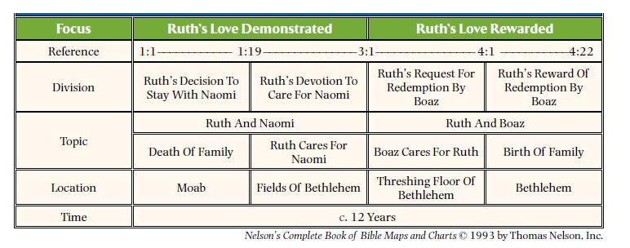
Keys for Christians
1. Christ is our Kinsman-Redeemer! The concept of the kinsman-redeemer is an important portrayal of the work of Christ. In the Old Testament, if a person or an estate were sold into bondage, they could be redeemed if certain requirements were met by what is called the Kinsman-Redeemer or goel, “close relative.” This is a perfect illustration of the redemptive work of the Savior. The goel must:
The kinsman-redeemer must
- be related by blood to those he redeems (Deut. 25:5, 7–10; John 1:14; Rom. 1:3; Phil. 2:5–8; Heb. 2:14, 15) – so Christ became human flesh to redeem us!
- be able to pay the price of redemption (Ruth 2:1; 1 Pet. 1:18, 19) – so Christ in his perfection was able to pay the infinite price of redemption for sinful humanity.
- be willing to redeem (Ruth 3:11; Matt. 20:28; John 10:15, 18; Heb. 10:7) – so for the joy set before Him, He went to the Cross for us!
- be free himself, as Christ was free from the curse of sin, being without sin (2 Cor. 5:21; 1 Pet. 2:22; 1 John 3:5).

2. Ruth is a picture of God’s desire to save the nations. Ruth is a Moabitess widow. She is helpless and seemingly rejected, but is drawn in to the love of her kingsman-redeemer, Boaz. Since Ruth was a Gentile, the book illustrates God’s desire to bring the Gentile world into the family of God. Like a brilliant diamond against black velvet, Ruth sparkles against the dark days of the book of Judges. Ruth is the story of loyalty, purity, and love in a day when anarchy, selfishness, and depravity was generally the rule. As such, Ruth serves as a positive picture of faith and obedience in the midst of apostasy and shows how such faith brings blessing.

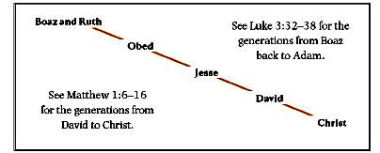
3. Ruth also serves as an important link in the ancestry of King David and, as mentioned, is found in the line of Messiah. The book of Ruth gets its name from one of its main characters, a young woman of Moab, the great-grandmother of David and one who is in the genealogical line of the Savior (Matt 1:5). Consider Ruth 4:13, 14, 17, “So Boaz took Ruth, and she became his wife. And he went in to her, and the LORD gave her conception, and she bore a son. 14 Then the women said to Naomi, “Blessed be the LORD, who has not left you this day without a redeemer, and may his name be renowned in Israel! … 17 And the women of the neighborhood gave him a name, saying, “A son has been born to Naomi.” They named him Obed. He was the father of Jesse, the father of David.”
.

4. Ruth is saved by faith. 1:15-17 Then she said, “Behold, your sister-in-law has gone back to her people and her gods; return after your sister-in-law.” 16 But Ruth said, “Do not urge me to leave you or turn back from following you; for where you go, I will go, and where you lodge, I will lodge. Your people shall be my people, and your God, my God. 17 Where you die, I will die, and there I will be buried. Thus may the Lord do to me, and worse, if anything but death parts you and me.”

1 Samuel

(Preparation for the Kingdom)
Matthew 3:3 For this is he who was spoken of by the prophet Isaiah when he said, “The voice of one crying in the wilderness: ‘Prepare the way of the Lord; make his paths straight.’”

Authors: Samuel, Nathan, and Gad (prophets, see 1 Samuel 10:25; 1 Chronicles 29:29)

Date: 930 B.C. and later.

Outline of 1 Samuel
I. Samuel, the Last Judge (1:1-8:22)
II. Saul, the People’s King (9:1-15:35)
III. David, God’s King (16:1-31:13)

Interesting fact: The books of 1 & 2 Samuel and 1 & 2 Kings used to be all one book. It used to be called Kingdoms. In the LXX it was divided up into four books: 1,2,3,4th Kingdoms. It was at another time split into two books: Samuel and Kings. The title of the book has varied from time to time, having been designated “The First and Second Books of Kingdoms” (Septuagint), “First and Second Kings” (Vulgate) and “First and Second Samuel” (Hebrew tradition and most modern versions). Most importantly, though the titles have varied the content has stayed the same!!
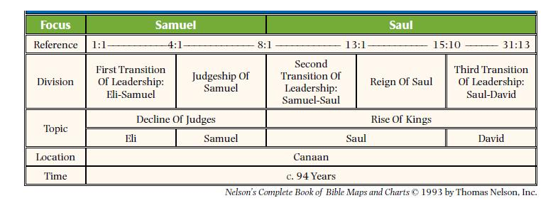
Keys for Christians
1. Samuel forms an interesting portrait of Christ in that he was a prophet, a priest, and though he was not a king, he was a judge who was used of God to inaugurate a new age.

2. Messiah is literally “the anointed one” and Samuel is the first biblical book to use the word anointed (2:10). Furthermore, the primary portrait and anticipation of Messiah is found in the life of David. He was born in Bethlehem, worked as a shepherd, was ruler over Israel, and became the forerunner of Messiah King through the Davidic dynasty. In the New Testament, Christ is described as a “descendant of David according to the flesh” (Rom. 1:3).

3. God’s Presence / The Ark of the Covenant is a picture of God’s presence, literally His throne or footstool. The ark of the covenant, a sacred portable chest, was the most sacred object in the tabernacle and the temple. It symbolized God’s presence and His covenant with Israel. Believing the ark would protect them in battle, the army of Israel carried the sacred chest into conflict with the Philistines. The Philistines captured the ark but were eager to return it when they were visited by a series of plagues. As a side note, the law within the Ark is a shadow and type of the Holy Spirit.

4. False Conversion / Superficial Religion: During Samuel’s leadership, the people of Israel, wanting to be like the nations, demanded a king. Under God’s direction, Samuel then anointed Saul to be the first king. But Saul was rejected by God because of his disobedience. To replace Saul, again under God’s directions, Samuel anointed David, a man after God’s own heart to become the king of Israel. The rest of the book describes the struggles bet4. ween jealous and demented Saul and godly David.

5. Waiting on God: The clamor for an earthly king in First Samuel was a natural outcome of this practical rejection (8:7). God had intended to give Israel a king (see Gen. 49:10; Deut. 17:14-20), but the people insisted on the king of their choice instead of waiting for God’s king. … Saul was rejected by the Lord because he failed to learn the truth that “to obey is better than sacrifice” (15:22). He became characterized by mental imbalance, raging jealousy, foolishness, and immorality. David illustrated the principle that, “the Lord does not see as man sees” (16:7). The Lord established the Davidic dynasty because of David’s obedience, wisdom, and dependence on God. We read in 1 Samuel 8:7, “And the Lord said to Samuel, “Listen to the voice of the people in regard to all that they say to you, for they have not rejected you, but they have rejected Me from being king over them”.

6. Persecution of the godly. Saul is a picture of those who persecute God’s church. They usually come from within, like the Jews who gave Jesus over to be crucified.

7. David is a type of Christ as God’s King. He is ultimately raised up, but he is not recognizable as a king. He is small, but he easily defeats God’s enemies (ch. 17 Goliath). Historically, one of the key purposes of 1 Samuel is to record the divine origin of the Davidic line. We see David confronting Goliath with the soldiers afraid on the side lines! We see how our salvation is in our strong King who can defeat all our enemies.

2 Samuel

(Expansion for the Kingdom)
1 Corinthians 15:25, For he must reign until he has put all his enemies under his feet.

Authors: Samuel, Nathan, and Gad (prophets, see 1 Samuel 10:25; 1 Chronicles 29:29)

Date: 930 B.C. and later.

Outline of 2 Samuel
I. The Triumphs of David (1-10)
A. The Coronation of the King (1:1-5:6)
B. The Consolidation of the Kingdom (5:7-6:23)
C. The Covenant Concerning the Kingdom (7:1-29)
D. The Conquests of the King (8:1-10:19)
II. The Transgressions of the King (11:1-27)
A. The Adultery by the King (11:1-13)
B. The Murder Caused by the King (11:14-27)
III. The Troubles of the King (12:1-24:25)
A. Troubles at Home (12:1-13:36)
B. Troubles in the Kingdom (13:37-24:25)

Keys for Christians

Gazing at Christ: With the exception of his sins, David remains a type of Christ as the king of Israel. It is in this chapter that God establishes the Davidic Covenant which ultimately has its fulfillment in the person of Christ.
- Longing for Christ: The greatest type of Christ in the OT ultimately shows that we cannot hope in shadows. David fails, Israel fails, all the types and shadows ultimately leave us longing for the True King.
- David Numbers God’s People. By the end of David’s life we find him numbering the people to demonstrate how great he is. God brings a great plague upon the people as a result. As a type of Christ, he is not the one who is strong. David’s job is to remain small in his own eyes and point to the true King, Jesus.
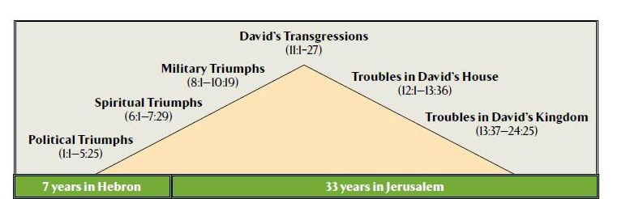

Key Verses:
2 Samuel7:12-16 – The Davidic Covenant, “your house and your kingdom shall be made sure forever before me. Your throne shall be established forever.’”
David’s family (at least 20 children by at least 9 wives)
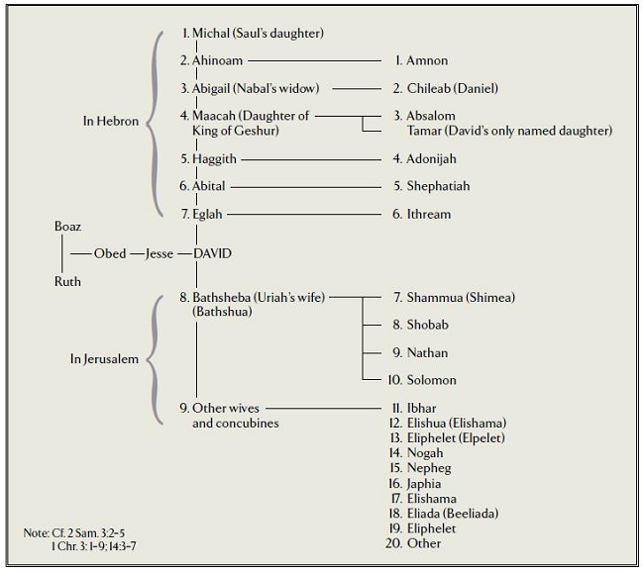

Key verse: we reap what we sow…

2 Samuel 12:10, “Now therefore the sword shall never depart from your house, because you have despised me and have taken the wife of Uriah the Hittite to be your wife.’ “

Though the continuation of David’s line was part of the promise of the Davidic Covenant (7:4–17), his large family was a constant source of heartache and trouble throughout the latter part of 2 Samuel. David’s family troubles included the death of Bathsheba’s infant son as judgment for David’s adultery (12:15–23), the incest of Amnon with Tamar, and Absalom’s subsequent murder of Amnon (13:1–36). Perhaps most striking was the rebellion of David’s son Absalom, who drove David from Jerusalem, took David’s wives, and nearly wrested the kingdom from David (15:7—18:33). The intrigue and hostility among the children of David’s many wives and concubines was partially, and perhaps largely, due to David’s polygamy. While common, polygamy was never successful because it violated the divine ordinance (Gen. 2:24).

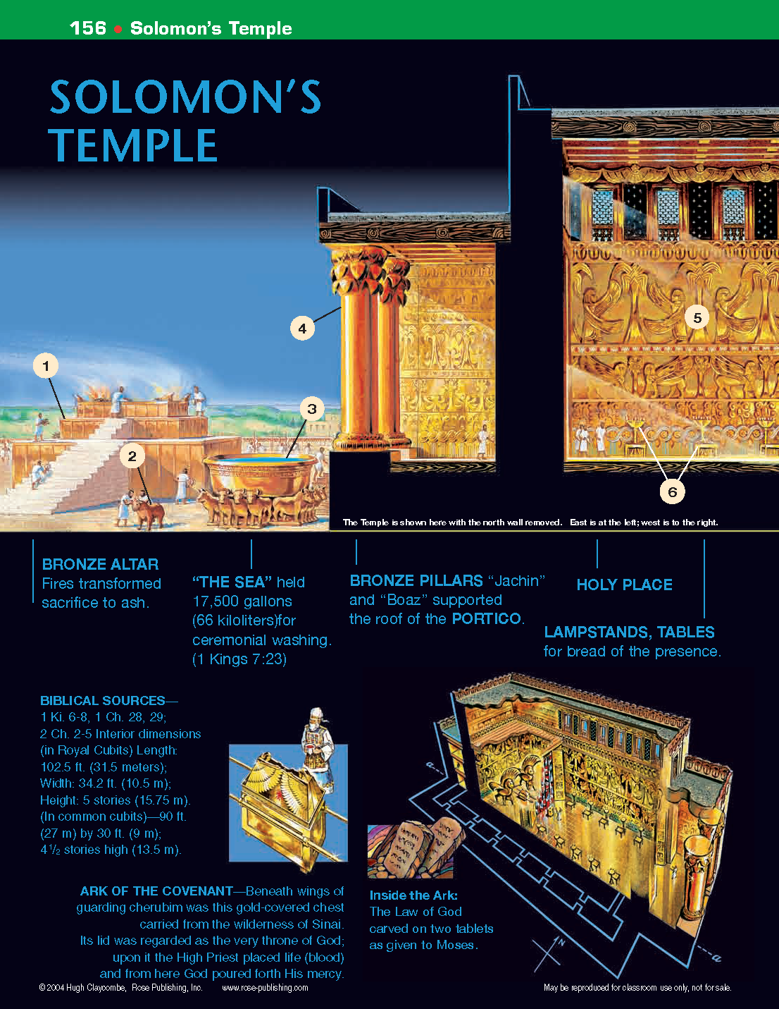
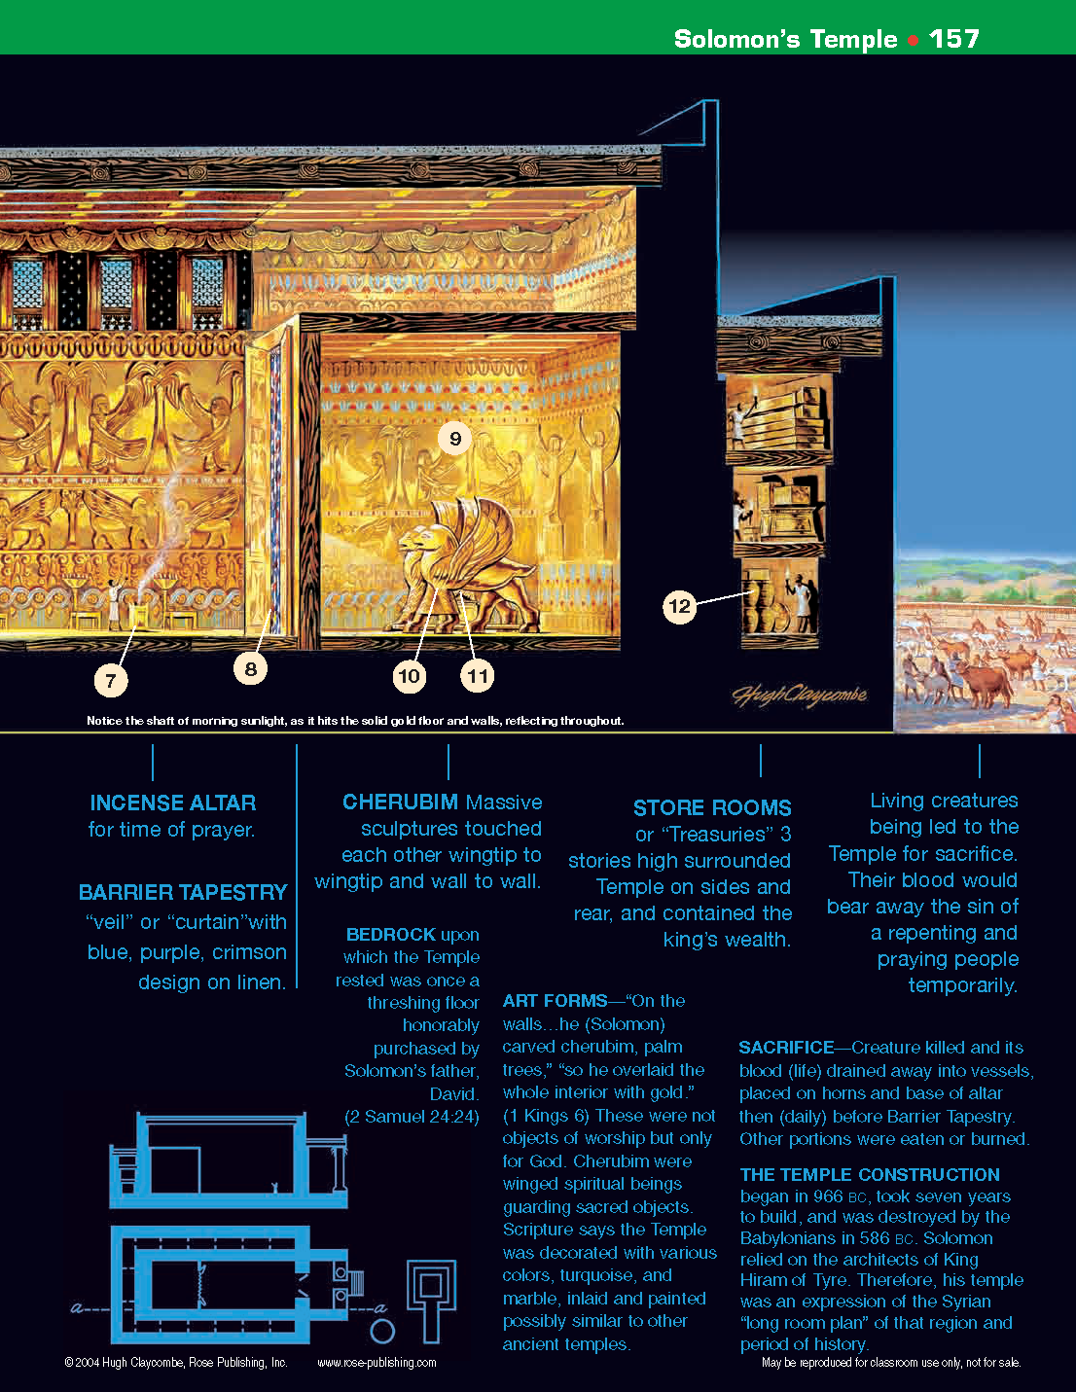
1 Kings

(Preparation for the Kingdom)
Matthew 12:42¸ “and, behold, a greater than Solomon is here.”

Author: Likely Jeremiah

Date: About 550 B.C

Keys for Christians
- Power of Christ: Solomon portrays Christ in he is a King of Peace. Solomon reigns as supreme king over the land!
- Glory of Christ: Like David, Solomon is one of the greatest types in the Old Testament of Christ, portraying Messiah in His future reign on earth. Solomon especially does this as his fame, glory, wealth, and honor all speak of Christ in His earthly kingdom.
- Solomon also portrays Christ in the great wisdom he demonstrated.
- Solomon’s Temple: After David’s death (chaps. 1-2), his son Solomon became king. Chapters 1-11 trace the life and reign of Solomon, including Israel’s rise to the peak of her glory, the spread of the nation’s kingdom, and the construction of the temple and palace in Jerusalem.
- Solomon strays. Sadly, in Solomon’s later years, he drifted from the Lord because of his pagan wives who wrongly influenced him and turned his heart away from the worship of God in the temple.
- Divided Kingdom: As a result, the king with the divided heart leaves behind a divided kingdom. For the next century, the book of First Kings traces the twin histories of two sets of kings and two nations of disobedient people who are growing indifferent to God’s prophets and precepts.
  - Jeroboam I, son of Nebat: The Northern Kingdom took as their king Jeroboam I, the most notorious king in Israel’s history – (Ahab takes a close second). From this point on, Satan counterfeits the true religion of Israel. This is always what the wicked one wants to do. See 1 Kings 12:28-31,
- Elijah’s Ministry: 1 Kings 17 through 19 recording the great ministry of Elijah. Elijah portrays the coming of John the Baptist who clears the way for the Lord’s ministry (Mal. 4:5-6). Elijah’s victory on Mt. Carmel ended with the slaying of 450 prophets of Baal (18:20–40) and pictures the 2nd coming of Christ in victory over all enemies.

Outline of the book of 1 Kings
I. The United Kingdom: The Forty Year Reign of Solomon (chs.1-11)
II. The Divided Kingdom: The First Eighty Years of the Two Kingdoms (12-22)
A. The Cause of Division (12:1-24)
B. The Reign of Jeroboam in Israel (12:25-14:20)
C. The Reign of Rehoboam in Judah (14:21-31)
D. The Reign of Abijam in Judah (15:1-8)
E. The Reign of Asa in Judah (15:9-24)
F. The Reign of Nadab in Israel (15:25-31)
G. The Reign of Baasha in Israel (15:32-16:7)
H. The Reign of Elah in Israel (16:8-14)
I. The Reign of Zimri in Israel (16:15-20)
J. The Reign of Omri in Israel (16:21-28)
K. The Reign of Ahab in Israel (16:29-22:40)
L. The Reign of Jehoshaphat in Judah (22:41-50)
M. The Reign of Ahaziah in Israel (22:51-53)

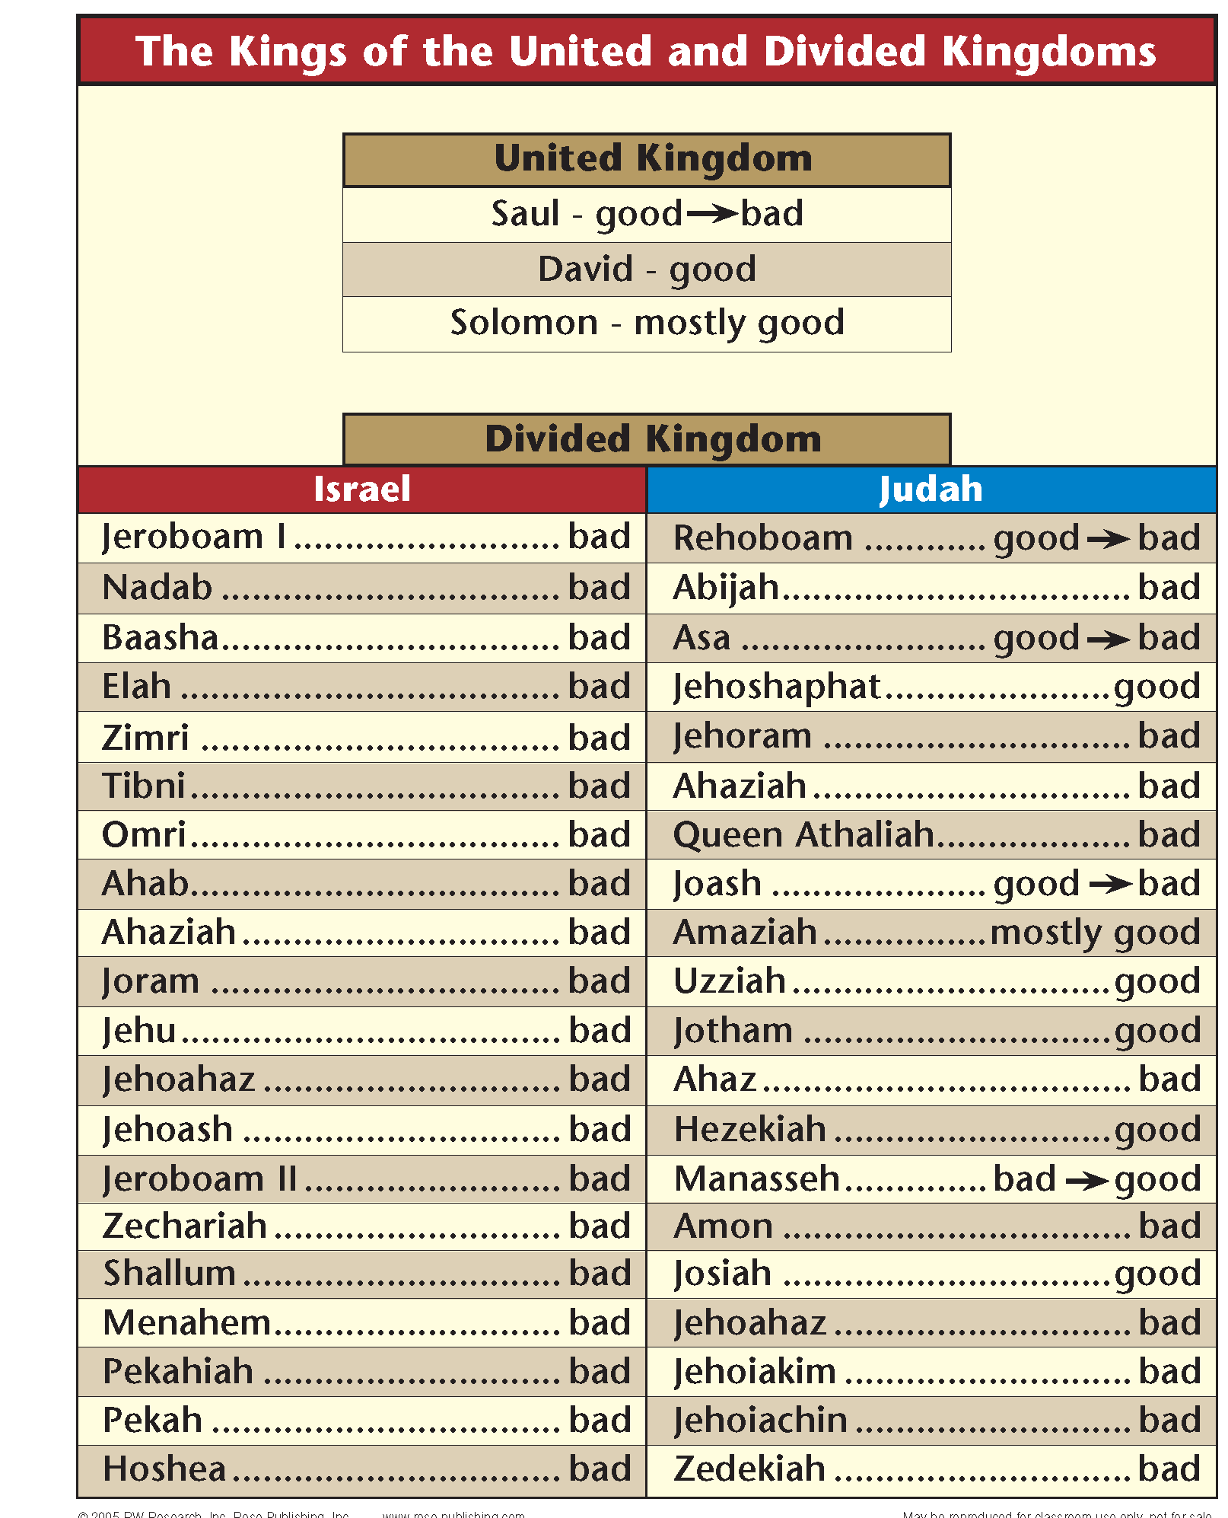
All the Northern Kings (Israel) were BAD
Some of the Southern Kings (Judah) were BAD, some were GOOD
NONE were perfect. That alone belongs to CHRIST!
All the Northern Kings (Israel) were BAD
Some of the Southern Kings (Judah) were BAD, some were GOOD
NONE were perfect. That alone belongs to CHRIST!
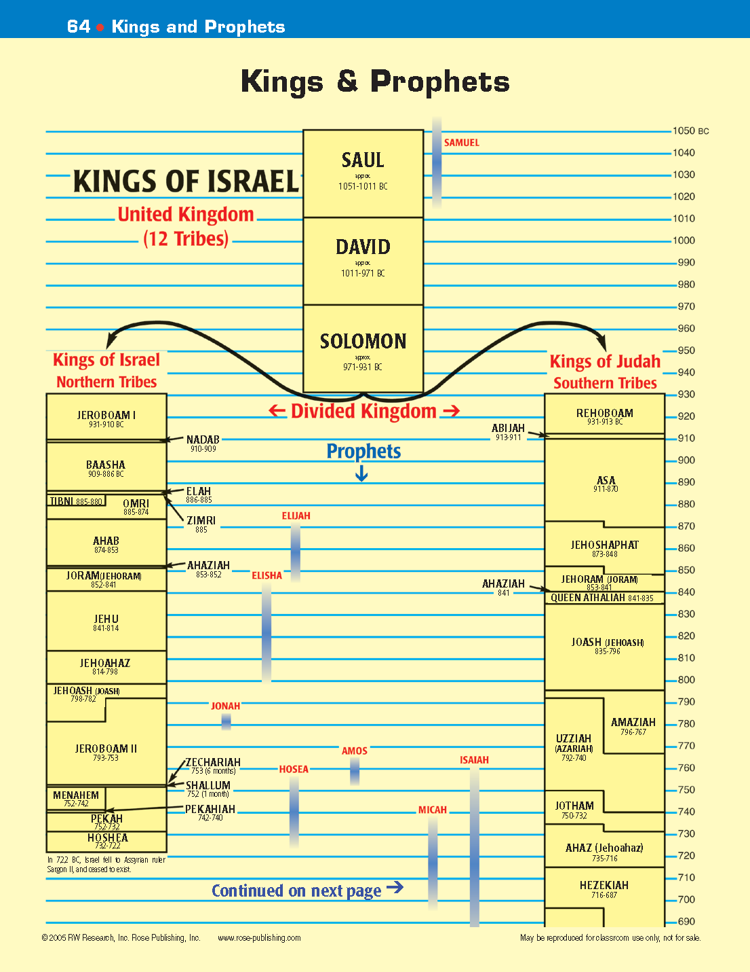
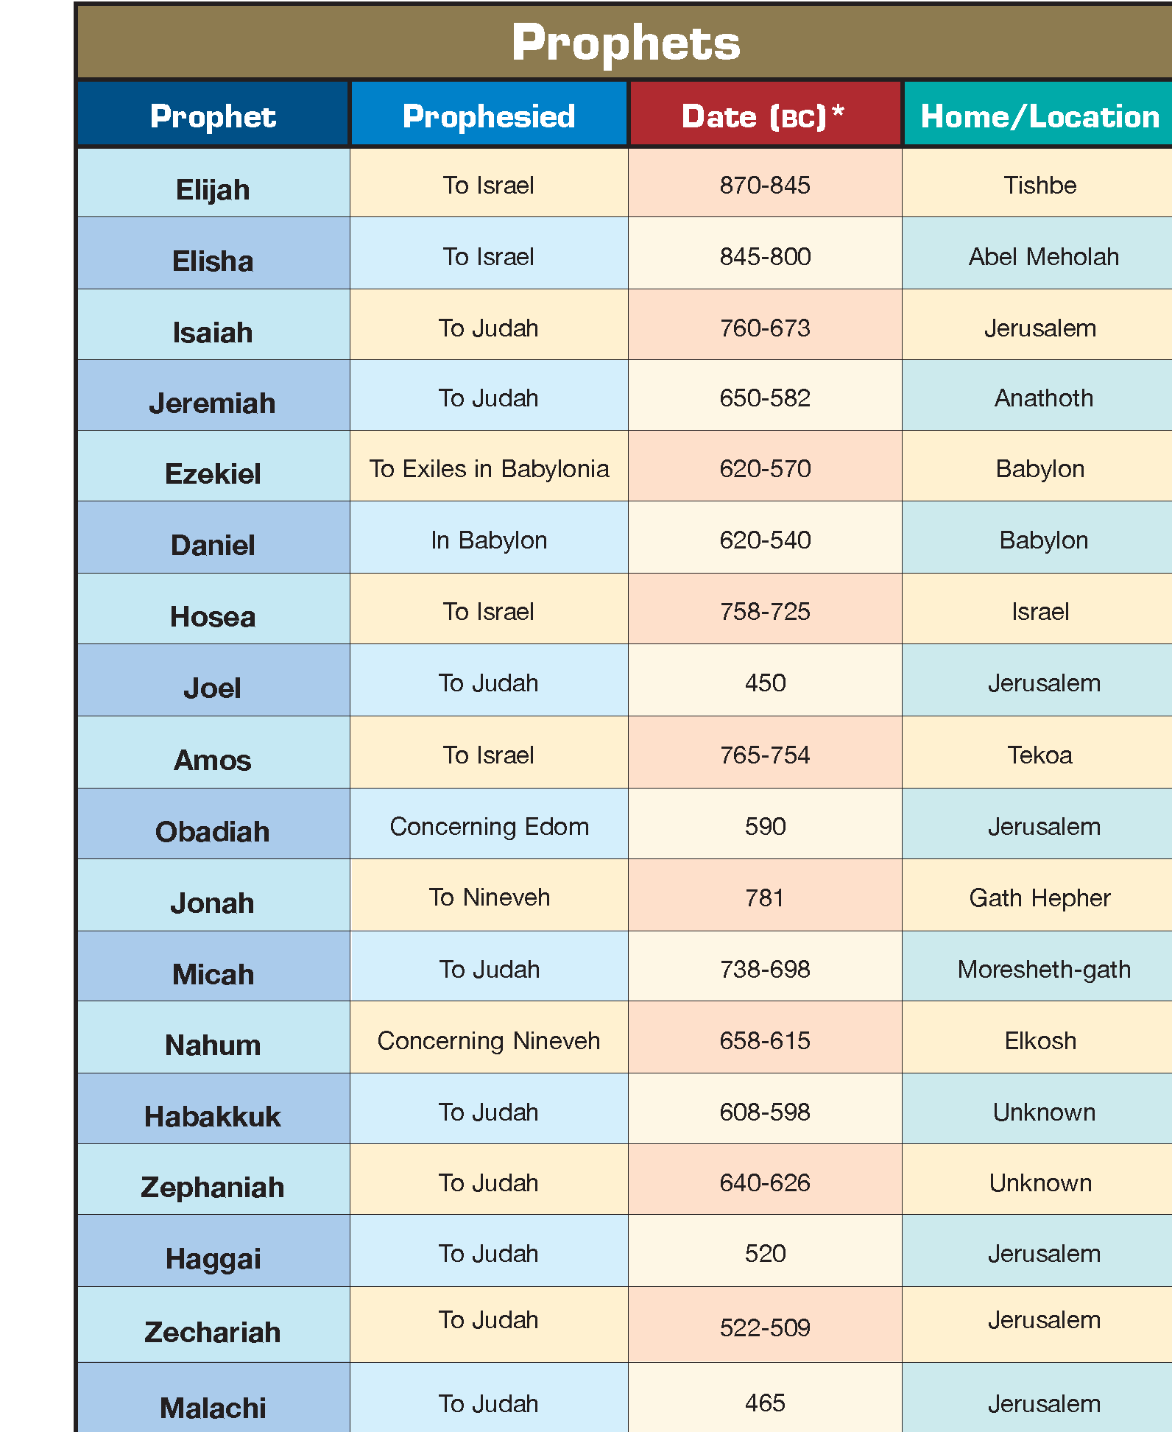
All but Elijah and Elisha above are considered “writing prophets” because God inscripturated their writings in the Scriptures. There were hundreds of other “oral prophets like Elijah and Elisha, i.e. Enoch, Noah, Nathan, Gad, and the many schools of the prophets.

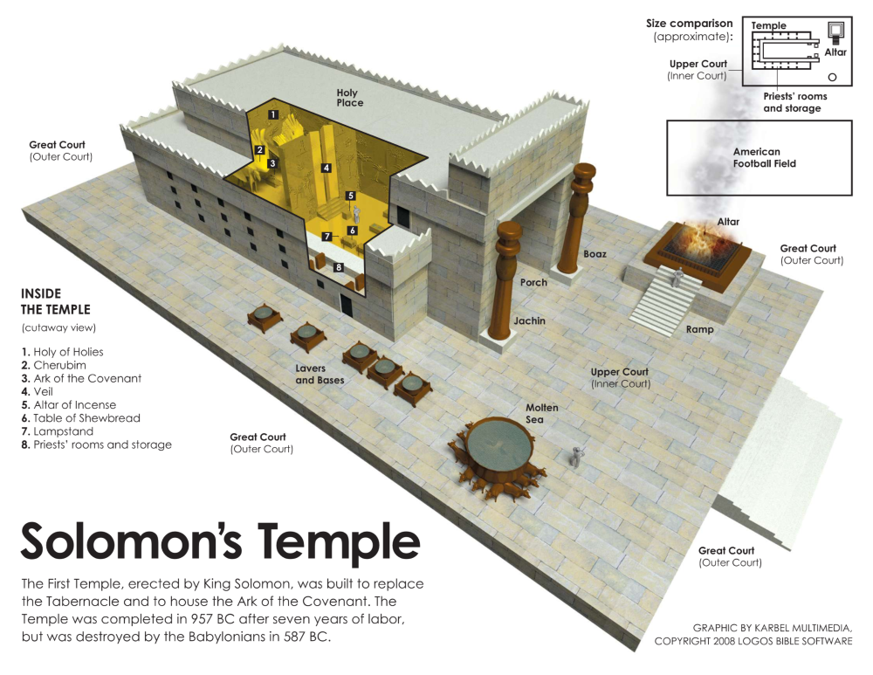

Temple Floor Plan
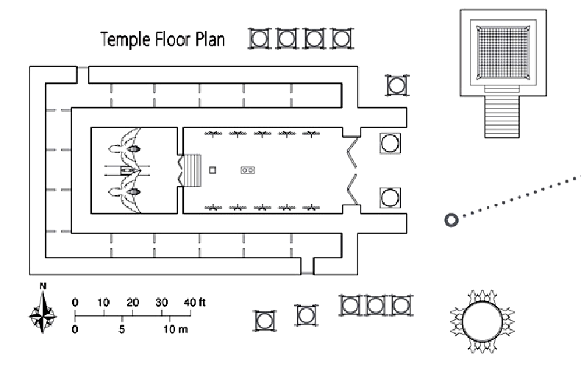

THE TEMPLE TOUR
The Temple in the Bible was built in 960 Bo by King Solomon. To understand the Temple's purpose, it is important to know that God made the world and established the rules. God told Adam that the result of sin was death, Adam disobeyed, and sin, death, and disease entered the world. In spite of this, God loved his people and had mercy.
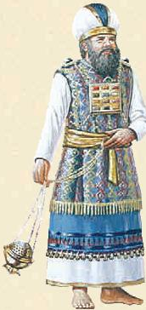
Before Jesus' death and resurrection, God provided a way to atone for sin so that people could be in His holy presence. God allowed the blood of a perfect animal to temporarily take the place of the sinner's life. This blood sacrifice took away sin and made the sinner right with God temporarily.
God loved the world so much that He sent His son Jesus to atone, or take away, a believer's sin once and for all. The blood of Jesus Christ was the final sacrifice needed. (Genesis 2:17; 4:3-7; Leviticus 1; 16:1, 2; Isaiah 59:2; Romans 3:23; Hebrews 10:26-31)
Here are pictures of peace with God during the lime of the temple (`Then', and today ("Now").

BRAZEN ALTAR (Bronze Altar)
THEN God required the people to regularly sacrifice a perfect animal (lambs, goats, doves, bulls) for their sins. The blood of the animal justified the people before God and restored their relationship with Him. N NOW Jesus is our perfect sacrifice. He led a sinless life and willingly died for our sins to make us right with God for all time. No more sacrifices are required. (Lev.1 7:11; Heb. 9:25; John 1:29; Rev. 13:8; Hebrews 10:10; Rom. 4:25)

SACRIFICE
THEN The person bringing the offering put his hand on the head of the animal while it was killed, symbolically putting his sins onto the animal. The animal died in his place.
NOW Jesus is the Lamb of God, just as bulls or lambs were sacrificed. We are told to present our bodies as a living sacrifice acceptable to God, holy, not conformed to the world, and with a renewed mind. (John 1:29; Romans 12:1, 2) We are to offer God another kind of sacrifice: praising His name, doing good, and sharing with others. (Hebrews 13:15, 16)

“THE SEA" (Bronze Basin)
THEN Priests washed themselves at the basin, purifying themselves before entering the Temple. It was about 15 ft. (4.6 m) across and held more than 10,000 gallons (38,000 liters) of water. It stood on 12 bronze oxen.
NOW Believers in Christ are saved and cleansed by the blood of Jesus. Even though we have accepted Jesus' sacrificial death on our behalf, we too need to be cleansed, spiritually. If we confess our sins, God will forgive and cleanse us. (Exodus 30:18; 38:8; 1 Kings 7:23-26; 1 John 1:7-10)

BRASS PILLARS (Bronze Pillars)
THEN The pillars, called "Jachin" on the right and "Boaz" on the left, supported the roof of the portico. They were 27 feet (9 m) high.
NOW Those who are faithful to Jesus through trials will be made "a pillar" in the Temple of God. (Revelation 3:12)

HOLY PLACE
THEN Only priests were allowed to enter the Holy Place. They did this daily.
NOW Believers in Jesus have been made holy through Jesus' sacrifice and can go directly to God. (Ex.29-30; Heb. 9-10)

GOLDEN LAMPSTANDS AND TABLES OF SHOWBREAD
THEN Ten gold larnpstands and ten tables for bread were made for the Temple. (1 Kings 7:49; 2 Chron. 4:7, 8, 19, 20)
NOW Christ is the light of the world and the bread of life. (John 9:5; 6:48-51)

GOLDEN INCENSE ALTAR
THEN Prayers were offered at the gold Altar of Incense where special sweet incense required by God was burned.
NOW The prayers of God's people are a sweet incense to God. (1 Kings 6:22; 2 Chronicles 4:19; Exodus 30:35-37; Rev. 5:8)

THE VEIL
THEN Curtain, and doors of olive wood) Then The veil separated the Holy Place from the Most Holy Place where the Ark of the Covenant rested, separafing a holy God from sinful people. Once ayear only the High Priest entered here.
NOW Believers in Jesus may enter God's presence through prayer because they are made acceptable to God by the blood of Jesus, the great High Priest. When Jesus died, the Temple veil tore in two from top to bottom. (2 Chronicles 3:14; 1 Kings 6:31-35; Exodus 25-26; Matt. 27:51; Heb. 10:19-22)

MOST HOLY PLACE
THEN The Most Holy Place was God's throne room where He would meet and give His commands, between the two cherubim, on the Mercy Seat over the Ark of the Covenant The high priest sprinkled blood on the Mercy Seat on the Day of Atonement to atone for the sins of the people for that year.
NOW Believers can come boldly before God's throne of grace. (Hebrews 14:16)

CHERUBIM
THEN Massive olive-wood sculpriares of cherubim, winged creatures, represented the guardians of God's divine presence. These cherubim were overlaid with gold and they touched each other, wingtip to wingtip and wall to wall. When God banished man from the Garden of Eden, he placed cherubim and a flaming sword to guard the way to the tree of life. (1 Kings 6:19-29; Genesis 3:24)
NOW Believers can have eternal life in God's presence through faith in Jesus Christ. (John 3:16; John 17)

ARK OF THE COVENANT
THEN The Ark was a carved wooden box overlaid with gold. Inside was the Law of God (the Ten Commandments) inscribed on two tablets of stone. Its lid, the Mercy Seat, represented the meeting place between God and man (Ex25:10-22).
NOW God wants to commune with us today. He made it possible to know Him through Jesus. (Jn. 14:6; Heb. 9:4; 10:22)

STOREROOMS (Treasuries)
THEN Three-story rooms contained the treasures of God's Temple and the dedicated gifts. These treasures were plundered several times.
NOW We are commanded by Jesus to not lay up treasures for ourselves on earth, but to lay up treasures in heaven (1 Chronicles 28:11, 12; Matthew 6:19-21). God has lavished on every believer “every spiritual blessing in Christ” (Eph. 1:3-9).

* The Temple took 7 years to build, began in 966BC and was destroyed by the Babylonians in 586BC.

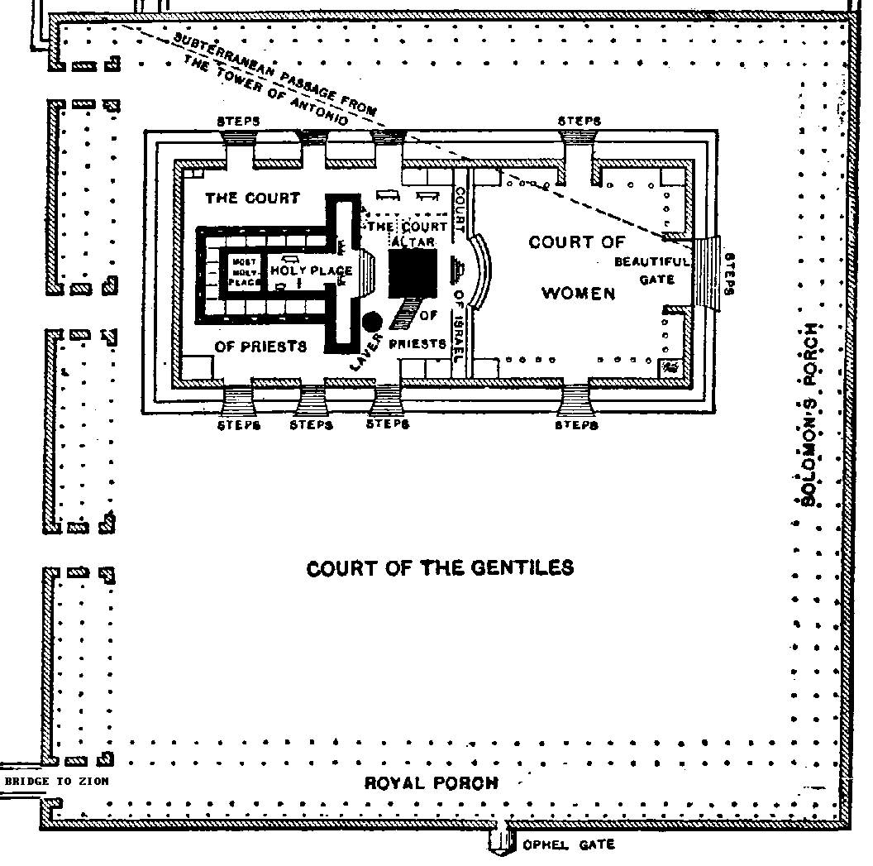
TEMPLE AREA PLAN
2 Kings

(Deterioration and Deportation of the Kingdom)

Hebrews 3:12 Take care, brothers, lest there be in any of you an evil, unbelieving

heart, leading you to fall away from the living God.

Author: Likely Jeremiah

Date: About 550 B.C

Keys for Christians
1. Two amazing ministries: Elijah naturally anticipates the forerunner of Christ in John the Baptist (Matt. 11:14; 17:10-12; Luke 1:17) and Elisha in many ways reminds us of Jesus Christ in His ministry. Jensen compares and summarizes their ministry:
2. The imagery of the Temple vs. the High Places is very important for the Christian. What we see with the good kings is a pattern of repentance, revival (tearing down the high places), and repair (of the Temple) as compared to the bad kings who demonstrate a stubborn heart, sin (rebuilding the high places), and sloth (neglecting the Temple).
3. The power of spiritual warfare: 2 Kings :16-17 tells the story of the king of Syria warring against Israel and surrounded the city of Dothan in Samaria. A servant of Elisha was quite afraid, but Elisha said, “Do not be afraid, for those who are with us are more than those who are with them.” 17 Then Elisha prayed and said, “O LORD, please open his eyes that he may see.” So the LORD opened the eyes of the young man, and he saw, and behold, the mountain was full of horses and chariots of fire all around Elisha.”
3. The fall of Israel to her enemies teaches the Christian a lesson about salvation. Our salvation is through Christ alone. We are helpless to save ourselves. Israel refused to believe this, and constantly compromised and made bargains with her enemies. The result was that Israel fell to Assyria in 722 B.C. and Judah fell to the Babylonians in 586 B.C. In both kingdoms the prophets continued to warn the people that God would punish them unless they repented.

Conclusion: Second Kings teaches that willful sin in a nation has a woeful end. In 1 and 2 Samuel, the nation is born, in 1 Kings it is divided, and in 2 Kings it is dispersed. After years of pleading with His people through the prophets, God’s patience finally turns to discipline just as He promised. The two kingdoms collapsed because of the failure of the kings to rule righteously and give heed to God’s truth.

Outline of the book of 2 Kings
I. The Divided Kingdom (1:1-17:41)
A. The Reign of Ahaziah in Israel (1:1-18 )
B. The Reign of Jehoram (Joram) in Israel (2:1-8:15)
1. The translation of Elijah (2:1-11)
2. The beginning of Elisha’s ministry (2:12-25)
3. Jehoram’s expedition against Moab (3:1-27)
4. Elisha’s ministry (4:1-8:15)
C. The Reign of Joram (Jehoram) in Judah (8:16-24)
D. The Reign of Ahaziah in Judah (8:25-29)
E. The Reign of Jehu in Israel (9:1-10:36)
F. The Reign of Athaliah in Judah (11:1-16)
G. The Reign of Jehoash (Joash) in Judah (11:17-12:21)
H. The Reign of Jehoahaz in Israel (13:1-9)
I. The Reign of Jehoash (Joash) in Israel (13:10-25)
J. The Reign of Amaziah in Judah (14:1-22)
K. The Reign of Jeroboam II in Israel (14:23-29)
L. The Reign of Azariah (Uzziah) in Judah (15:1-7)
M. The Reign of Zechariah in Israel (15:8-12)
N. The Reign of Shallum in Israel (15:13-15)
O. The Reign of Menahem in Israel (15:16-22)
P. The Reign of Pekahiah in Israel (15:23-26)
Q. The Reign of Pekah in Israel (15:27-31)
R. The Reign of Jotham in Judah (15:32-38)
S. The Reign of Ahaz in Judah (16:1-20)
T. The Reign of Hoshea in Israel (17:1-41)
1. Israel’s Defeat (17:1-6 )
2. Israel’s Sins (17:7-23)
3. Israel’s Dispersion (17:24-41)
II. The Surviving Kingdom of Judah (18:1-25:30)
A. The Reign of Hezekiah (18:1-20:21)
B. The Reign of Manasseh (21:1-18)
C. The Reign of Amon (21:19-26)
D. The Reign of Josiah (22:1-23:30)
E. The Reign of Jehoahaz (2 Chron. 36:1-4) (23:31-33)
F. The Reign of Jehoiakim (23:34-24:7)
G. The Reign of Jehoiachin (24:8-16)
H. The Reign of Zedekiah (24:17-25:21)
1. Rebellion against Babylon and destruction of the Temple (24:17-25:10)
2. Third deportation to Babylon (25:11-21)
I. The Governorship of Gedaliah, a Puppet Governor (25:22-26)
J. The Release of Jehoiachin in Babylon (25:27-30)

1 & 2 Kings in Contrast
1 Kings |  | 2 Kings
Begins with King David |  | Ends with the king of Babylon
Opens with Solomon’s glory |  | Closes with Jehoiachim’s shame
Begins with the construction of Temple |  | Begins with the destruction of Temple
Begins with the blessings of obedience |  | Closes with the burning of the Temple
Traces the progress of apostasy |  | Describes the consequences of apostasy
Shows how kings failed to rule God’s people |  | Depicts consequences of that failure
Introduces the prophet Elijah |  | Introduces the prophet Elisha
Emphasizes the patience of the Lord |  | Confirms the Lord’s sure punishment of sin

A Comparison of Elijah and Elisha
SIMILARITIES
Both were lead prophets to the Northern Kingdom of Israel in 9th century BC.
Both were empowered by God in extraordinary ways.
Both trained the “sons of the prophets” as a key priority.
Both had unusual departures from this life.

CONTRASTS
Elijah |  | Elisha
Type of John the Baptist, thundering the message of repentance for sin (Malachi 4) |  | Type of Christ – Elisha multiplied twenty loaves of bread to feed over 100 men (compare Jesus' multiplication of loaves and fishes).
Elijah means “Yahweh is my God” |  | Elijah means “My God saves”
Poor & rustic |  | Wealthy background
Elijah’s ministry emphasized God’s law, judgment, and severity to ungodly leaders |  | Elisha supplemented this by demonstrating God’s grace, love and tenderness to believers
Shorter ministry (14 yrs) |  | Longer ministry (50 yrs)
Approximately 8 miracles recorded |  | Approximately 16 miracles recorded
Mentioned 29 times in the New Testament |  | Mentioned only once in the New Testament (Lk 4:27).
Fits the image of a prophet; with long flowing hair and a girdle of skin around his loins. |  | Dressed normally like everyone else
Elijah is translated without death 2Ki 2:1-11 |  | Elisha's bones (death) bring life 2 Ki 13:20-21
Elijah's 8 miracles:
1. Shut up the heavens causing a drought and opening to cause rain | 1 Kings 17:14, 41-46
2. multiplies flour and oil | 1 Kings 17:7-16
3. raises the widow's son from the dead | 1 Kings 17:17-24
4. defeats the prophets of Baal | 1 Kings 18:16-40
5. fed by ravens | 1 Kings 17:2-8
6. destroys Ahaziah's soldiers with lightening | 2 Kings 1:9-13
7. parts the Jordan River | 2 Kings 2:8
8. taken to heaven in God's chariot | 2 Kings 2:9-18

Elisha's 16 miracles (double portion):
1. parted the Jordan River | 2 Kings 2:14-15
2. purified water | 2 Kings 2: 19-22
3. curses attackers who are then savaged by bears | 2 Kings 2: 23-25
4. caused a flood to foil the Moabites | 2 Kings 3: 14-25
5. miraculous flow of oil for the poor widow | 2 Kings 4: 2-7
6. fertility to the woman of Shunem | 2 Kings 4: 8-17
7. raised a child from the dead | 2 Kings 4:32-37
8. purified poisoned soup | 2 Kings 4:38-41
9. multiplication of loaves to feed a large crowd | 2 Kings 4:42-44
10. healing Naaman of leprosy | 2 Kings 5: 1-19
11. Gehazi cursed with leprosy | 2 Kings 5:20-27
12. made an iron axehead float | 2 Kings 6:1-7
13. struck the Aramaeans with sun blindness – then cured them | 2 Kings 6: 15-23
14. predicted the end of a famine | 2 Kings 7:1-20
15. prophesied the death of Ben-Hadad and the rise of Hazael | 2 Kings 8:7-15
16. predicts Israel will defeat Aram 3 times | 2 Kings 13:14-19
1 Chronicles

(Preparation of the Temple)

Revelation 21:22 And I saw no temple in the city, for its temple is the Lord God the Almighty and the Lamb.

Author: Ezra

Date: 450-425 B.C.

Keys for Christians
1. Repetition: Chronicles may seem like a repeat of 1 and 2 Kings, but repetition is actually necessary for our learning. Written for those returning from captivity, First and Second Chronicles are really one book written by Ezra for those coming back from captivity. So it is not a mere repetition, but more of a spiritual editorial of the history of the people of Israel. The Kings are said to give man’s viewpoint while the Chronicles give God’s perspective.

2. God Doesn’t Break Promises: God knows our frame and knows we need to hear that His promises are true, so Ezra gives us a history of God’s faithfulness. Chronicles has been called a little “Old Testament” because it begins with Adam and continues through to the captivity. In a sense it is a “miniature Old Testament,” tracing in capsule form the flow of Old Testament history. The Chronicles have also been called the “book of John” for the Old Testament. Like the Gospels repeated some of the same events, but with a different perspective, so Ezra tells the events of Israel with a perspective on Judah and her kings. There are about 8 verses more per king of Judah than in Kings.

2. God knows our name! Genealogies are important.
- God’s Person: The genealogies speak of the mercy and kindness of God to remember His people. These are heirs of God, his very children, and so it is in the New Testament (Rom. 8:17). God knows our name. God says through Isaiah: “Behold, I have engraved you on the palms of my hands (Isaiah 49:16). God knows all the names of His children!

- God’s Purpose: The genealogies were also a demonstration of the divine purpose being worked out until Christ's coming. They helped complete the Bible story of our Savior, who was the son of David, the son of Judah, the son of Abraham, and the son of Adam. He took their humanity, ''yet without sin.'' “All Scripture is God-breathed and profitable” including these lists of names!

- God’s Promises: Genealogies also teach us that God will keep his promise to Adam, who is the first named (1:1). God will bring the Promised Savior-King. The key verse is 1 Chronicles 17:14: Speaking of David and the Davidic Covenant, “But I will settle him in My house and in My kingdom forever, and his throne shall be established forever.” Chapter 17 is parallel with 1 Samuel 7, but it is given after the captivity. It is a reiteration of God’s covenant with David that Jesus Christ would come.

Ezra and the people were looking forward to their true King. “Concerning this salvation, the prophets who prophesied about the grace that was to be yours searched and inquired carefully, inquiring what person or time the Spirit of Christ in them was indicating when he predicted the sufferings of Christ and the subsequent glories” (1 Peter 1:10–11).

4. We are God’s Holy Temple: Prominent in David’s victories, and in the people’s joy and prosperity is the Ark of the Covenant. Just as the Ark of the Covenant in the Holy of holies was the dwelling place of God among Israel, so the church is the dwelling place of God with His people in this age. Ephesians 2:19–22 says we are God’s “holy temple”: “So then you are no longer strangers and aliens, but you are fellow citizens with the saints and members of the household of God, 20 built on the foundation of the apostles and prophets, Christ Jesus himself being the cornerstone, 21 in whom the whole structure, being joined together, grows into a holy temple in the Lord. 22 In him you also are being built together into a dwelling place for God by the Spirit.”

Key Verses:
God reiterates His promise that Christ will come through David
1 Chronicles 11:1–3, “Then all Israel gathered together to David at Hebron and said, “Behold, we are your bone and flesh. 2 In times past, even when Saul was king, it was you who led out and brought in Israel. And the LORD your God said to you, ‘You shall be shepherd of my people Israel, and you shall be prince over my people Israel.’ ” 3 So all the elders of Israel came to the king at Hebron, and David made a covenant with them at Hebron before the LORD. And they anointed David king over Israel, according to the word of the LORD by Samuel.”

God is Able to Accomplish it: it’s HIS KINGDOM
1 Chronicles 29:11–12 Yours, O LORD, is the greatness and the power and the glory and the victory and the majesty, for all that is in the heavens and in the earth is yours. Yours is the kingdom, O LORD, and you are exalted as head above all. 12 Both riches and honor come from you, and you rule over all. In your hand are power and might, and in your hand it is to make great and to give strength to all.

Outline
I. Genealogies from Adam to David (1:1-9:44)
II. The Rise and Anointing of David (10:1-12:40)
A. The Death of Saul (10:1-14)
B. The Accession of David (11:1-3)
C. The Capture of Jerusalem (11:4-9)
D. The Heroes of David (11:10-12:40)
III. David’s Reign (13:1-29:21)
A. David and the Ark (13:1-17:27)
1. David brings the Ark to Chidon: Uzza’s death (13:1-14)
2. David’s fame and victory over the Philistines (14:1-17)
3. David brings the ark to Jerusalem (15:1-29)
4. David’s celebration and arrangements for the ark (16:1-43)
5. David’s desire to build a Temple: the Davidic covenant (17:1-27)
B. David’s Wars (18:1-20:8)
C. David’s Sinful Census (21:1-30)
D. David’s Preparations for the Temple (22:1-23:1)
E. David’s Organization of the Levites (23:2-26:32)
1. Numbering of and duties of the Levites (23:2-32)
2. Dividing the Levites into twenty-four groups (24:1-31)
3. Assigning the musicians (25:1-31)
4. Appointing gatekeepers (26:1-19)
5. Assigning the treasures (26:20-28)
6. Delegating magistrates (26:29-32)
F. David’s Civil Leaders (27:1-34)
G. David’s Last Instructions to the People and to Solomon (28:1-21)
H. David’s Offerings and Worship (29:1-21)
IV. The Accession of Solomon and Death of David (29:22-30)

2 Chronicles

(Destruction of the Temple)

Revelation 21:22 And I saw no temple in the city, for its temple

is the Lord God the Almighty and the Lamb.

Author: Ezra

Date: 450-425 B.C.

Keys for Christians

1.Promise: The throne of David has been destroyed, but the line of David remains. Murders, treachery, battles, and captivity all threaten the messianic line; but it remains clear and unbroken from Adam to Zerubbabel. The fulfillment in Christ can be seen in the genealogies of Matthew 1 and Luke 3.

2. Worship: The temple which is so prominent in 2 Chronicles is a beautiful portrait of Christ (see Matt. 12:6; John 2:19; and Revelation 21:22), so 2 Chronicles gives the returned exiles hope for the Second Temple.

3. Correlation w/ Worship: As sin increases, so true worship decreases. As the Temple is in disrepair, the people are in idolatry and despair. Like Israel, the foundation of an effective, powerful, growing church is to acknowledge the presence of God's Spirit and to obey His leading in every aspect of church life and ministry. God's work must be done God's way

4. God’s Mercy: Manasseh teaches us a valuable lesson about God’s mercy. 2 Chronicles 33:9-17, “Manasseh led Judah and the inhabitants of Jerusalem astray, to do more evil than the nations whom the LORD destroyed before the people of Israel.10 The LORD spoke to Manasseh and to his people, but they paid no attention. 11 Therefore the LORD brought upon them the commanders of the army of the king of Assyria, who captured Manasseh with hooks and bound him with chains of bronze and brought him to Babylon. 12 And when he was in distress, he entreated the favor of the LORD his God and humbled himself greatly before the God of his fathers. 13 He prayed to him, and God was moved by his entreaty and heard his plea and brought him again to Jerusalem into his kingdom. Then Manasseh knew that the LORD was God. 14 Afterward he built an outer wall for the city of David west of Gihon, in the valley, and for the entrance into the Fish Gate, and carried it around Ophel, and raised it to a very great height. He also put commanders of the army in all the fortified cities in Judah. 15 And he took away the foreign gods and the idol from the house of the LORD, and all the altars that he had built on the mountain of the house of the LORD and in Jerusalem, and he threw them outside of the city. 16 He also restored the altar of the LORD and offered on it sacrifices of peace offerings and of thanksgiving, and he commanded Judah to serve the LORD, the God of Israel. 17 Nevertheless, the people still sacrificed at the high places, but only to the LORD their God.”

5. God’s Justice: The Temple is destroyed in 586BC by the Babylonians and over 7000 of the best and the brightest are taken to Babylon.

6. God’s Faithfulness: The book ends where Ezra begins, the famous decree of Cyrus. 2 Chronicles 36:22-23, “Now in the first year of Cyrus king of Persia, that the word of the LORD by the mouth of Jeremiah might be fulfilled, the LORD stirred up the spirit of Cyrus king of Persia, so that he made a proclamation throughout all his kingdom and also put it in writing: 23 “Thus says Cyrus king of Persia, ‘The LORD, the God of heaven, has given me all the kingdoms of the earth, and he has charged me to build him a house at Jerusalem, which is in Judah. Whoever is among you of all his people, may the LORD his God be with him. Let him go up.”

Two Centuries Before Cyrus’ Birth
Long before Cyrus was born, two centuries to be exact, God prophesied through Isaiah, that Cyrus would be the one who would let His people go from captivity.
“Thus says the LORD to his anointed, to Cyrus, whose right hand I have grasped, to subdue nations before him and to loose the belts of kings, to open doors before him that gates may not be closed: 2 “I will go before you and level the exalted places, I will break in pieces the doors of bronze and cut through the bars of iron, 3 I will give you the treasures of darkness and the hoards in secret places, that you may know that it is I, the LORD, the God of Israel, who call you by your name. 4 For the sake of my servant Jacob, and Israel my chosen, I call you by your name, I name you, though you do not know me. 5 I am the LORD, and there is no other, besides me there is no God; I equip you, though you do not know me, 6 that people may know, from the rising of the sun and from the west, that there is none besides me; I am the LORD, and there is no other.”
Isaiah 45:1-6
Cyrus’ Decree Discovered
In 1879, an explorer by the name of Hormuzd Rassam discovered the famous “Cyrus Cylinder” (now in the British Museum) at the site of ancient Babylon. The small (9 inch long), barrel-shaped, clay chronicle describes the benevolent policy of Cyrus in restoring captives to their homelands, along with their religious treasures. In part, the inscription has the ruler saying:
“I returned to these sacred cities on the other side of the Tigris, the sanctuaries of which have been ruins for a long time, the images which [used] to live therein and established for them permanent sanctuaries. I [also] gathered all their [former] inhabitants and returned [to them] their habitations”

George Rawlinson, Camden Professor of ancient history at Oxford University, wrote concerning Cyrus:
“Of all the Persian monarchs, he was the one most distinguished for mildness and clemency; the one to whom the sufferings of a captive nation, torn violently from its home and subjected to seventy years of grievous oppression, would most forcibly have appealed”.

Outline
I. The Reign of Solomon (1:1-9:31)
II. The Kings of Judah (10:1-36:21)
A. Rehoboam (10:1-12:16)
B. Abijah (13:1-22)
C. Asa (14:1-16:14)
D. Jehoshaphat (17:1-20:37)
E. Jehoram (21:1-20)
F. Ahaziah (22:1-9)
G. Queen Athaliah (22:10-23:15)
H. Joash (23:16-24:27)
I. Amaziah (25:1-28)
J. Uzziah (26:1-23)
K. Jotham (27:1-9)
L. Ahaz (28:1-27)
M. Hezekiah (29:1-32:33)
N. Manasseh (33:1-20)
O. Amon (33:21-25)
P. Josiah (34:1-35:27)
Q. Joahaz (36:1-4)
R. Jehoiakim (36:5-8)
S. Jehoiachin (36:9-10)
T. Zedekiah (36:11-21)
III. The Decree of Cyrus (36:22-23)

Ezra

(Reconstruction of the Temple and Restoration of the People)

Revelation 21:3 And I heard a loud voice from the throne saying, “Behold, the dwelling place of God is with man. He will dwell with them, and they will be his people, and God himself will be with them as their God.

Author: Ezra

Date: between 457 B.C. and 444 B.C.

Interesting Fact: In the ancient Hebrew Bible, Ezra and Nehemiah were treated as one book and called “The Book of Ezra.” Modern Hebrew Bibles designate the two-fold arrangement of Ezra and Nehemiah as in our English versions. Further, Josephus (Against Apion 1. 8) and Jerome (Preface to the Commentary on Galatians) also considered the books of Ezra and Nehemiah as one.

Timing of Ezra
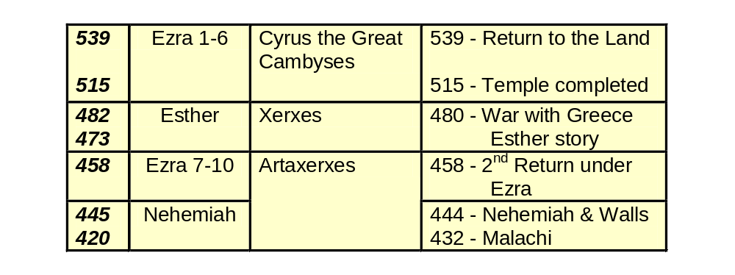
Keys for Christians
1. The Sovereignty of God: The book opens with the amazing fulfillment of prophecy (Isaiah 45:1-6). God said he would bring a king to free His people without war. Xenophon, a Greek writer who was contemporary with Cyrus and fought in his army, described the Persian ruler as psuchen philanthropotaton, i.e., as a humane, benevolent, loving soul.

2. The Call of Faith: The people are called by faith to go back to the land of their fathers and worship God there! Ezra 1:3 Whoever there is among you of all His people, may his God be with him! Let him go up to Jerusalem which is in Judah, and rebuild the house of the Lord, the God of Israel; He is the God who is in Jerusalem.

3. God’s Calling to Ministers: Ezra is a Levitical priest, also called Ezra the Scribe (Hebrew: עזרא הסופר, Ezra ha-Sofer), a direct descendant of Aaron, through Eleazar (Ezra 7:1-5). According to the Scripture he returned from the Babylonian exile and reintroduced the Torah in Jerusalem (Ezra 7-10 and Neh 8). According to tradition, he may also have been a high priest. Though the book of Ezra does not name its author, Jewish tradition (the Talmud) ascribes it to Ezra along with Chronicles and Nehemiah. Ezra probably finished the book between 456 (when the events of 10:17-44 took place) and 444, when Nehemiah arrived in Jerusalem.

3. God’s Promises: From an historical standpoint, Ezra continues the narrative where 2 Chronicles ends and traces the history of the return of the Jews from exile in Babylon and the rebuilding of the temple. From a spiritual and doctrinal standpoint, Ezra demonstrates how God fulfilled His promise to return His people to the land of promise after seventy years of exile as announced by the prophets.

4. The Centrality of Worship: As in Chronicles, Ezra, as a priest, shows the centrality of the temple and its worship to the life of the nation as God’s people. It begins with the decree of Cyrus, king of Persia, which allowed a remnant of the people to return. The people enthusiastically began rebuilding the temple, but were delayed for 18 years by enemies from the north. Finally a decree from Darius let them finish (see Ezra 1-6).

5. Opposition: We are told in Ezra 4:6 that Ahasuerus put a stop to the building of the Temple. Who was this Ahasuerus? We are used to seeing “Ahasuerus” in the book of Esther where it refers to Xerxes, but it is not a name, it is merely a title and can refer to any of the Persian kings. And so it was Cambyses, not Xerxes that put a stop to the building of the second Temple.

King | Date of Reign | Actions Taken
Cyrus | 539-530 | Granted permission for the Jews to return and rebuild Jerusalem and the Temple
Cambyses | 530-522 | Put a stop to the reconstruction
Smerdis | 522 | He was a pretender to the throne and quickly overturned
Darius | 522-486 | Granted permission for the reconstruction of the Temple to continue
Xerxes | 486-464 | He was the King who elevated Esther
Artaxerxes | 464-423 | Granted permission for Nehemiah to return and rebuild the walls of Jerusalem.
6. Revival takes place when God’s people repent. We see this in the spiritual, moral, and social restoration of the Remnant who returned under the leadership of Zerubbabel and Ezra.

- 2:1 Now these are the people of the province who came up out of the captivity of the exiles whom Nebuchadnezzar the king of Babylon had carried away to Babylon, and returned to Jerusalem and Judah, each to his city.
- 6:21-22 And the sons of Israel who returned from exile and all those who had separated themselves from the impurity of the nations of the land to join them, to seek the Lord God of Israel, ate the Passover. 22 And they observed the Feast of Unleavened Bread seven days with joy, for the Lord had caused them to rejoice, and had turned the heart of the king of Assyria toward them to encourage them in the work of the house of God, the God of Israel.

8. Surrender to God’s Kingship through His Word: Ezra 7:10, “For Ezra had set his heart to study the law of the LORD, and to practice it, and to teach His statutes and ordinances in Israel.”

9. Worship is the main theme of Ezra: Key chapters would include
- Chapter 1: the decree of Cyrus allowing the remnant to return to rebuild the Temple – God’s place of worship
- Chapter 3: the foundation of the temple completed.
- Chapter 6: the completion and dedication of the temple and the keeping of the Passover.
- Chapters 7-9: the 3rd return under Ezra and his prayer.

Outline
I. The Restoration; The First Return to Jerusalem under Zerubbabel (1-6)
A. The Decree of Cyrus (1:1-11)
B. The Census of the People (2:1-70)
C. The Construction of the Temple Begun (3:1-13)
D. The Opposition (4:1-24)
E. The Construction Renewed (5:1-6:12)
F. The Temple Completed (6:13-22)
II. The Reformation of the People; the Return Under Ezra (7:1-10:44)
A. The Return to Jerusalem (7:1-8:36)
B. The Revival of Jerusalem (9:1-10:44)

Nehemiah

(Reconstruction of the City)

Revelation 21:3 And I heard a loud voice from the throne saying, “Behold, the dwelling place of God is with man. He will dwell with them, and they will be his people, and God himself will be with them as their God.

Author: Nehemiah

Date: about 445 B.C. to 425 B.C.

Walk Through Nehemiah
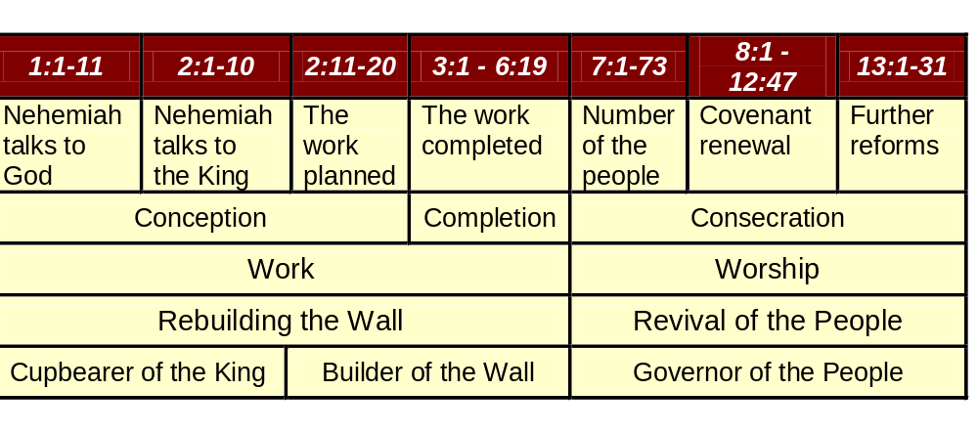
Timeline of Nehemiah

Keys for Christians

1. The Surety of Redemption: Nehemiah surely portrays Christ in his willingness to leave his high position in order to bring about His work of restoration. Further, the decree of Artaxerxes marks the beginning point of Daniel’s prophecy of seventy weeks of years which begins the countdown for the Messiah giving his life for His people (Dan. 9:25-27).

2. The Power of Prayer: Nehemiah 1:4, “As soon as I heard these words I sat down and wept and mourned for days, and I continued fasting and praying before the God of heaven.”
3. The Power of the Word: Nehemiah 8:5–15, “And Ezra opened the book in the sight of all the people, for he was above all the people, and as he opened it all the people stood. 6 And Ezra blessed the LORD, the great God, and all the people answered, “Amen, Amen,” lifting up their hands. And they bowed their heads and worshiped the LORD with their faces to the ground. 7 Also Jeshua, Bani, Sherebiah, Jamin, Akkub, Shabbethai, Hodiah, Maaseiah, Kelita, Azariah, Jozabad, Hanan, Pelaiah, the Levites, helped the people to understand the Law, while the people remained in their places. 8 They read from the book, from the Law of God, clearly, and they gave the sense, so that the people understood the reading.”

4. God Uses Common People: Nehemiah’s name means “Yahweh consoles or comforts.” Nehemiah is not a paid religious professional. He is a man with a secular job, the king’s cupbearer. He tests food. Nehemiah has no formal religious training. He’s not a pastor; he’s not a priest in Israel. He’s a man working a job in Persia. Nehemiah was a layman, a cupbearer to the great Artaxerxes who ruled Persia from 464 to 423 BC. He goes from cupbearer to wall builder to governor of Jerusalem.

5. God Calls Teams: Ezra and Nehemiah were contemporaries (see Neh. 8:2, 9). Both were men of God but served Yahweh in different capacities. While Ezra was a priest and involved more with the religious restoration of returning Remnant, Nehemiah was a layman and served in a political capacity as governor in the rebuilding of the walls of Jerusalem.

6. God’s Timing is Perfect: Under the leadership of Nehemiah, they accomplished in fifty-two days what had not been done in the ninety-four years since the first return under Zerubbabel (6:15-16). By obedient faith they were able to overcome what appeared to be insurmountable opposition.

7. A Picture of the Church: We see the people working together to build the walls and protect God’s Temple.
- Nehemiah 4:6 So we built the wall and the whole wall was joined together to half its height, for the people had a mind to work.

8. Spiritual Warfare: Through God’s help our enemies flee.
- Nehemiah 6:15-16 So the wall was completed on the twenty-fifth of the month Elul, in fifty-two days. 16 And it came about when all our enemies heard of it, and all the nations surrounding us saw it, they lost their confidence; for they recognized that this work had been accomplished with the help of our God.
8:8 And they read from the book, from the law of God, translating to give the sense so that they understood the reading.

Outline
I. The Rebuilding of the Walls (1-7)
A. Preparation for Rebuilding (1:1-2:20)
B. Rebuilding(3:1-7:73)
II. The Revival of the People (8:1-13:31)
A. The Renewal of the Covenant (8:1-10:39)
B. The Obedience of the People to the Covenant (11:1-13:31)

Esther

(Protection of God’s People)

1Peter 2:9, But you are a chosen race, a royal priesthood, a holy nation, a people for his own possession, that you may proclaim the excellencies of him who called you out of darkness into his marvelous light.
Romans 8:28–29, And we know that for those who love God all things work together for good, for those who are called according to his purpose. 29 For those whom he foreknew he also predestined to be conformed to the image of his Son, in order that he might be the firstborn among many brothers.

Author: Unknown,perhaps Ezra or Nehemiah

Date: likely about 480BC, during Xerxes war with Greece

Keys for Christians
1. God chooses the weak: The book takes its name from the chief character, whose Hebrew name Hadassah (Myrtle) was changed to the Persian name Ester, which probably means “star.” She was truly a “nobody” who God used as an instrument (1 Corinthians 1).

2. Redemption: Esther tells the story of a beautiful Jewish girl whom King Xerxes of Persia chose to be his queen. When Haman plotted to murder all the Jews, Queen Esther’s cousin Mordecai persuaded Esther to try to save her people. Risking her own life, she appealed to the king and rescued the Jews. Although the name of God does not appear in this book, the theme and purpose of the book is to show God’s providential care of His people in their trials and persecutions.
Esther 4:16 “Go, gather all the Jews to be found in Susa, and hold a fast on my behalf, and do not eat or drink for three days, night or day. I and my young women will also fast as you do. Then I will go to the king, though it is against the law, and if I perish, I perish.”

3. God’s Power to Save:
- Mordecai says to Esther: 4:14 For if you remain silent at this time, relief and deliverance will arise for the Jews from another place and you and your father’s house will perish. And who knows whether you have not attained royalty for such a time as this?
- Esther provides a fitting picture of Christ in that she was willing to put herself in the place of death for her people’s salvation and also in that she acted as an advocate for them. In addition, we also see how God continued to providentially protect the Jews through whom He would give the Messiah.
- A Picture of the “joy unspeakable” we have in Christ: 8:17 “And in each and every province, and in each and every city, wherever the king’s commandment and his decree arrived, there was gladness and joy for the Jews, a feast and a holiday. And many among the peoples of the land became Jews, for the dread of the Jews had fallen on them.” This is the inauguration of the feast of Purim, chapter 9.

Outline
I. The Danger to the Jews (1:1-3:15)
A. The Choice of Esther as Queen in Place of Vashti (1:1-2:23)
B. The Conspiracy of Haman Against the Jews (3:1-15)
II. The Decision of God’s Servant (Esther) for the Jews (4:1-5:14)
III. The Deliverance of God’s People (6:1-10:3).
A. The Defeat of Haman (6:1-7:10)
B. The Decree of King Ahasuerus (Xerxes) and Mordecai (8:1-17)
C. The Defeat Over the Enemies of the Jews (9:1-19)
D. The Days of the Feast of Purim (9:20-32)
E. The Declaration of Mordecai’s Fame and Exaltation at Court (10:1-3)

Finding Jesus in the Old Testament
Poetry Books

Wisdom Literature
We come to Old Testament wisdom literature. Hebrew wisdom literature, as distinguished from the wisdom writings of other cultures, was centered on God: “The fear of the LORD is the beginning of knowledge: but fools despise wisdom and instruction” (Prov. 1:7).

Themes of Christ in Wisdom Literature
True wisdom centers on living in the very presence of God, or to put it better in our New Testament times, living in the presence of Christ. The five books that traditionally comprise Old Testament wisdom literature are as follows:

- Job—sanctification by Christ
- Psalms—communion with Christ
- Proverbs—wise living in Christ
- Ecclesiastes—satisfaction through Christ
- Song of Solomon—union with Christ

The Timing of the Wisdom Literature
While Hebrew poetry occurred throughout Old Testament history, there were three primary periods of poetic literature.
- The Patriarchal period—Job (c. 2000 B.C.)
- The Davidic period—Psalms (c. 1000 B.C.)
- The Solomonic period
  - Song of Solomon—a young man’s love
  - Proverbs—a middle-aged man’s wisdom
  - Ecclesiastes—an old man’s sorrow (c. 950 B.C.)
Job

(Sanctification through Suffering)
James 5:11 You have heard of the steadfastness of Job, and you have seen the purpose of the Lord, how the Lord is compassionate and merciful.

Author: Possibly Job himself, Elihu, Moses, or Solomon

Date: Likely before 1500 BC

Time of Writing

Job is likely the oldest book in our Bible. While the events of Genesis precede Job, it is likely the book was written long before Moses, sometime in the patrarchal period, during or before the time of Abraham

Who was Job?
- Job was first and foremost an historical human being. Ezekiel speaks of Job as an historical figure in 14:14, “even if these three men, Noah, Daniel, and Job, were in it, they would deliver but their own lives by their righteousness, declares the Lord GOD.” Indeed, Ezekiel and Daniel were contemporaries.
- Job was also very wealthy. “this man was the greatest of all the people of the east” (Job 1:3).
- Job most importantly was a man that knew and feared the Lord. Job 1:1 “There was a man in the land of Uz whose name was Job, and that man was blameless and upright, one who feared God and turned away from evil.”

Keys for Christians
1. Prophecies of Christ:
Job 19:25–27 (ESV), “For I know that my Redeemer lives, and at the last he will stand upon the earth. 26 And after my skin has been thus destroyed, yet in my flesh I shall see God, 27 whom I shall see for myself, and my eyes shall behold, and not another.”

2. Glimpses of Christ
- Christ our Ultimate Mediator
Christ is seen in several ways in Job. Job acknowledges a Redeemer (19:25-27) and prays for a Mediator (9:33; 25:4; 33:23). He knows he needs someone who can explain the mystery of “suffering” which is answered only in Christ Who identifies with our suffering and ultimately both answers Satan’s accusations, which are ultimately against God, and defeats him (Heb. 2:14-18; 4:15; Rom. 8:32-34). Job teaches us that Christ is the believer’s Life, Redeemer, Mediator, and Advocate.
  - Job 9:33 – Job asks for a “mediator” between God and man.
  - Job 25:4 – Job has no righteousness of his own, though he is blameless. He asks, “How then can man be in the right before God? How can he who is born of woman be pure?”
  - Job 33:23, Job asks for “a mediator…to declare to man what is right for him”

- Job, a Type of Christ
Job in many ways is being conformed into the image of Jesus, and portrays Christ in many ways. He is a picture of what we should all be: Christlikeness.

Job |  | Jesus
Job 1:2, “and that man was blameless and upright, one who feared God and turned away from evil”. |  | Without sin
Tempted by Satan |  | Tempted by Satan 40 days
God Himself defends and ministers to Job |  | Angels minister to our Lord
Told by wife: Curse God and die |  | Mocked by the people
Job’s children died |  | Jesus’ disciples scattered
Relatives and friends reject him |  | “He came unto his own, and his own received him not”
So marred no one recognized him |  | So marred no one recognized him
Felt forsaken by God (but wasn’t) |  | “My God, why have you forsaken me?”
His later life is better than the first |  | Resurrected to New Life! He is risen!

3. Questions Foreshadowing Christ (Job 14)
As Job was pondering the cause of his misery, three questions came to his mind, all of which are answered only in our Lord Jesus Christ. These questions occur in chapter 14.

- The Need for a Savior
Job 14:4 (ESV), “Who can bring a clean thing out of an unclean? There is not one.” The answer to Job’s anguished question is found in Jesus Christ. Christ has paid the penalty for our sin and has exchanged it for His righteousness, thereby making us acceptable in God’s sight (Hebrews 10:14; Colossians 1:21-23; 2 Corinthians 5:17).

- Eternal Life
Job 14:14 (ESV), “If a man dies, shall he live again?” This is another question about eternal life that is answered only in Christ. With Christ, the answer to “shall he live again?” is yes! We do indeed live again if we are in Him. “When the perishable has been clothed with the imperishable, and the mortal with immortality, then the saying that is written will come true: ‘Death has been swallowed up in victory.’ ‘Where, O death, is your victory? Where, O death, is your sting?’” (1 Corinthians 15:54-55).

4. Key Themes in Job
- Blamelessness. Job 1:1, "In the land of Uz there lived a man whose name was Job. This man was blameless and upright; he feared God and shunned evil."

- Contentment. Job 1:21, "Naked I came from my mother's womb, and naked I will depart. The LORD gave and the LORD has taken away; may the name of the LORD be praised."

- Faith. Job 42:5-6, "My ears had heard of you but now my eyes have seen you. Therefore I despise myself and repent in dust and ashes.”

- Accountability to God
We see very early on in the book that the most evil beings on earth are accountable to Almighty God. The book ends with Job, the blameless believer, giving an account before God.

- Examples of Bad Theology
Throughout Job, we begin to understand the attributes of God. God is great and God is good. We see attacks on the person of God through the bad theology of Satan and Job’s three friends.
- Job’s friends were the first preachers of the “prosperity gospel”.
  - “If you are in a right relationship with God, you’re going to be healthy and wealthy. Since you are suffering, you must be in sin. You must lack faith. Repent!”
- Satan’s bad theology is actually in harmony with Job’s friends:
  - “God has to bribe His people with blessings to follow Him. Take the blessings away, and Job will curse you.”
- Of course, Job lived a life of good theology – truly understanding the goodness and greatness of God.
  - When suffering came, Job worshiped
  - When all was lost, Job said, “Naked I came from my mother’s womb, and naked shall I return. The LORD gave, and the LORD has taken away; blessed be the name of the LORD” (Job 1:21).

- God’s Goodness & Human Suffering
The age old question of why the righteous suffer if God is so good and powerful is answered at the end of Job. Ultimately, Job needed a Redeemer (19:25) – so though he was blameless, Job was not sinless. Lesson: The reasons for suffering in a person’s life are not necessarily related to personal sin, but are within the scope of God’s good and powerful providence resulting in the defeat of evil in a way that vindicates evil and bring the most glory to Himself. Obviously, the entire book of Job points to the greatest act of sin in human history: the Cross of Jesus Christ, and how the suffering of the only perfectly righteous person could bring glory to God and relief to unworthy to humanity.
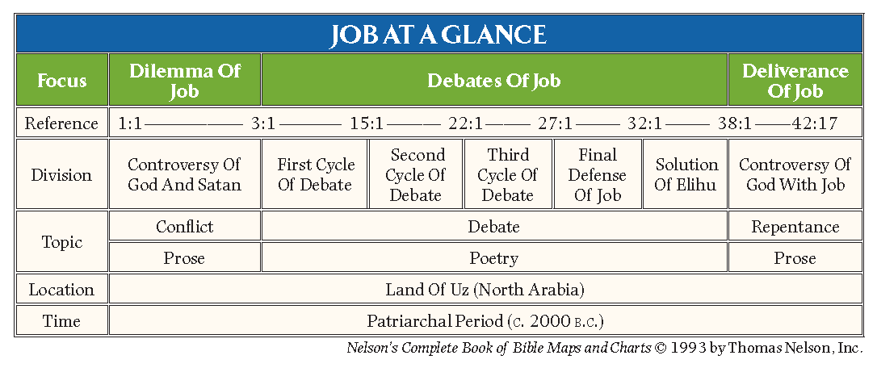

Outline of Job
Visual Outline:
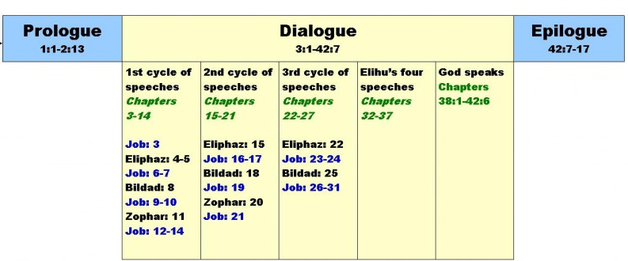

Expanded outline:
- The Prologue: the Disasters (Afflictions) of Job (1-2)
  - His Circumstances and Character (1:1-5)
  - His Calamities and their Source—Satan (1:6-2:10)
  - His Comforters (2:11-13)
- The Dialogues or False Comfort of the Three Friends (3:1-31:40)
  - First cycle of debate (3:1-14:22)
    - Job’s lament (3:1-26)
    - Eliphaz’ reply (4:1-5:27; and Job’s rejoinder, 6:1-7:21)
    - Bildad’s reply (8:1-22; and Job’s rejoinder, 9:1-10:22)
    - Zophar’s reply (11:1-20; and Job’s rejoinder, 12:1-14:22)
  - Second cycle of debate (15:1-21:34)
    - Eliphaz’ reply (15:1-35; and Job’s rejoinder, 16:1-17:16)
    - Bildad’s reply (18:1-21; and Job’s rejoinder, 19:1-29)
    - Zophar’s reply (20:1-29; and Job’s rejoinder, 21:1-34)
  - Third cycle of debate (22:1-31:40)
    - Eliphaz’ reply (22:1-30; and Job’s rejoinder, 23:1-24:25)
    - Bildad’s reply (25:1-6)
  - Final Defense of Job (26:1-31:40)

- The Words of Elihu (32:1-37:24)
  - First speech: God’s instruction to man through affliction (32:1-33:33)
  - Second speech: God’s justice and prudence vindicated (34:1-37)
  - Third speech: the advantages of pure and consistent piety (35:1-16)
  - Fourth speech: God’s greatness and Job’s guilt in accusing God of unfairness (36:1-37:24)
- God’s Revelation from the Whirlwind (38:1-42:6)
  - The First Revelation: God’s omnipotence proclaimed in creation; Job’s self-condemning confession (38:1-40:5)
  - The Second Revelation: God’s power and man’s frailty; Job’s humble response (40:6-42:6)
- The Epilogue: God’s rebuke of the false comforters; Job’s restoration and reward of a long and blessed life (42:7-17)
Psalms

(Communion with Christ)
Luke 24:44 All things must be fulfilled, which were written in the law of Moses, and in the prophets, and in the psalms, concerning me.

Author: Moses, David, Solomon, Asaph family, Korah family, others

Date: Likely 1405 to 500 BC

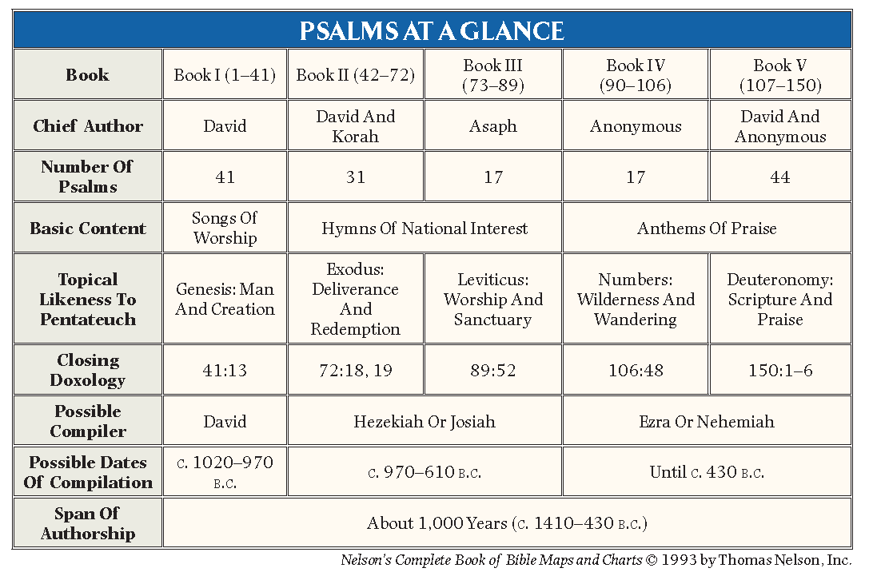 Another way of looking at the book divisions:
Book | Psalms | Author | General Content
Book I | Psalms 1-41 | David | Songs of worship
Book II | Psalms 42-72 | David & Korah | Hymns of petition
Book III | Psalms 73-89 | Mainly Asaph | Hymns of petition
Book IV | Psalms 90-106 | Mainly Anonymous | Anthems of praise
Book V | Psalms 107-150 | David and Anonymous | Anthems of praise

Outline of the Psalms
The Psalms are really five books in one. Each of the following book division concludes with a doxology while Psalm 150 occupies the place of the doxology and forms an appropriate conclusion to the entire collection.
Epiphanius said, “The Hebrews divided the Psalter into five books so that it would be another Pentateuch.” The Midrash of Psa. 1:1 states, “Moses gave the Israelites the five books of the Law, and to correspond to these David gave to them the Book of the Psalms in five books.”
This correspondence to the Pentateuch may be seen in the following outline:
- Psalms about man and creation (1-41)—corresponds to Genesis.
- Psalms about Israel and redemption (42-72)—corresponds to Exodus.
- Psalms about worship and the Temple (73-89)—corresponds to Leviticus.
- Psalms about our sojourn on the earth (90-106)—corresponds to Numbers.
- Psalms about praise and the Word of God (107-150)—corresponds to Deuteronomy.

Author:
The Book of Psalms is not only the largest book of the Bible, but it perhaps the most widely used book in Scripture because of the way it speaks to the human heart in all of our experiences in life. Again and again sighing is turned into singing through prayer and praise. For the most part, though the texts of the psalms do not designate their authors, the titles do often indicate the author of the various psalms. The following chart designates the authors of these psalms as they are found in the titles:

- David: 73 psalms are attributed to David in the superscriptions, and an additional two, Psalms 2 and 95, are ascribed to David in the New Testament. – 75 total.
- Korah family: Ps. 42-49; 84; 86; 87; 88 – 12 total.
- Asaph family: Ps. 50, 73-83 – 12 total.
- Solomon: 2 of the psalms (72) and (127) are attributed to Solomon, David's son and successor. – 2 total.
- Moses: Psalm 90 is a prayer assigned to Moses. – 1 total.
- Others: Other psalms are ascribed to Heman the Ezrahite, and Ethan the Ezrahite.
- Ezra (?): Fifty of the psalms are anonymous, although some of these are traditionally ascribed to Ezra.

Christ in Psalms
Specific Prophetic fulfillments applied to Christ:
Prophecy | Psalm | New Testament Passage
1. Birth | 104:4 | Heb. 1:7
2. Humiliation | 8:4 | Heb. 2:6
3. Deity | 45:6 | Heb. 1:8
4. Ministry | 69:9 | John 2:17
5. Rejection | 118:22-23;  41:9 | Mt. 21:42; Mk. 12:10-11; Lk. 20:17; Acts 4:11; Eph. 2:20; 1 Pet. 2:7  John 13:18
6. Betrayal | 41:9 | John 13:18
7. Crucifixion events | 22 | Matt. 27:39, 43, 46; Luke 23:35; Mt. 27:35; Lk. 23:34; Jn. 19:24; Jn 20:25
8. Resurrection | 2  16:8-10 | Heb. 1:5  Acts 2:27; Acts 13:35-37
9. Ascension | 68:18 | Eph. 4:8
10. Reign | 102:26; 110:1-2 | Heb. 1:11; Mt. 22:43-44; Mk. 12:36; Lk. 20:42-43; Acts 2:34-35; 1 Cor. 15:25; Heb. 1:13; 10:12-13)

Psalm Genres
*These Psalms may appear in more than one genre. They are difficult to classify because they fit into more than one genre.

Messianic Psalms – Help us see Christ – Goal is to receive the GRACE of God
Quoted in NT | 2, 8, 16, 18, 22, 40, 41, 45, 68, 69, 91, 97, 102, 109, 110, 118
Lament Psalms – Help us with Repentance, Danger, Fear – Goal is to TRUST God
Community | 12, 44, 58, 60, 74, 79, 80, 83, 85, 89*, 90, 94, 123, 126, 129
Individual | 3, 4, 5, 7, 9-10, 13, 14, 17, 22, 25, 26, 27*, 28, 31, 36*, 39, 40:12-17, 41, 42-43, 52*, 53, 54, 55, 56, 57, 59, 61, 64, 70, 71, 77, 86, 89*, 120, 139, 141, 142
Penitential | 6, 32*, 38, 51, 102, 130, 143
Imprecatory | 35,69, 83, 88, 109, 137, 140
Thanksgiving Psalms – Help us to UNDERSTAND God – Goal is to PRAISE God
Community | 65*, 67*, 75, 107, 124, 136*
Individual | 18, 21, 30, 32*, 34, 40:1-11, 66:13-20, 92, 108*, 116, 118, 138
Songs of Trust | 11, 16, 23, 27*, 62, 63, 91, 121, 125, 131
Hymn and Doxology | 8*, 19:1-6, 33, 66:1-12, 67*, 95, 100, 103, 104, 111, 113, 114, 117, 145, 146, 147, 148, 149, 150
Temple Psalms (Public Worship) – Helps us to REMEMBER God’s Mighty Acts – Goal is to be COMFORTED by God
Salvation History | 8*, 105-106, 135, 136
Covenant Songs | 50, 78, 81, 89*, 132
Royal / Enthronement | 2, 18, 20, 21, 29, 45, 47, 72, 93, 95*, 96, 97, 98, 99, 101, 110, 144
Songs of Zion | 46, 48, 76, 84, 87, 122
Temple Liturgies | 15, 24, 68*, 82, 95*, 115, 134
Wisdom Psalms – Helps us with our SOURCE of Strength – Goal is to LIVE for God
Wisdom for Life | 1*, 36*, 37, 49, 73, 112, 127, 128, 133
Wisdom & the Word | 1*, 19:7-14, 119

List of Quotations from the Messianic Psalms in the New Testament
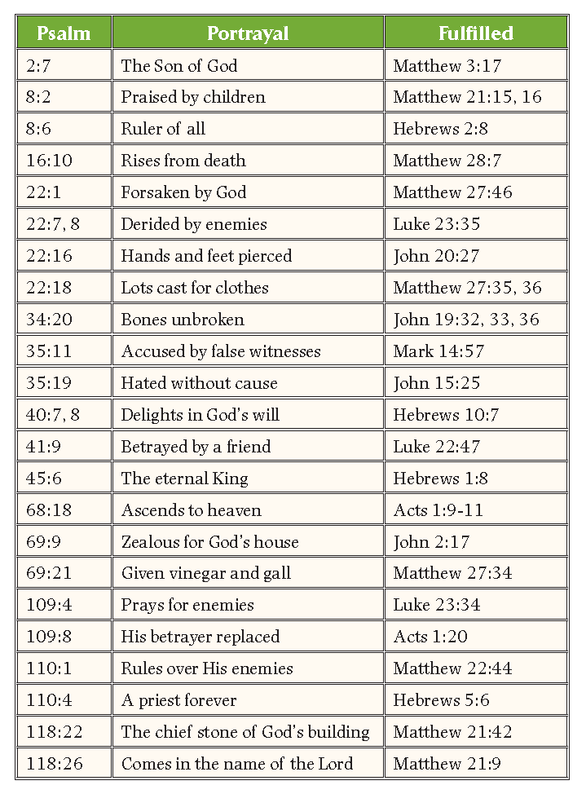

Proverbs

(Living Wisely in Christ)
1Cor. 1:24 but to those who are called, both Jews and Greeks, Christ the power of God and the wisdom of God.
1 Kings 4:32 [Solomon] also spoke 3,000 proverbs, and his songs were 1,005.

Author: King Solomon, Agur, King Lemuel

Date: From 700 to 931 BC

Purpose of Proverbs
The book of Proverbs provides wise sayings and observations designed to develop proper attitudes and godly behavior. We are told in 2 Peter 1 to “add to your faith…knowledge”. Here we find how to apply the Bible to the practical issues of life. To knowledge we are to add “self-control… and perseverance”. We are to choose that which pleases God. Proverbs tells us in very specific terms how to do this.

Authors of Proverbs
According to 1 Kings 4:32, Solomon spoke 3,000 proverbs and 1,005 songs. And while he wrote most of proverbs in this book, later chapters indicate that he was not the only author of the book. Three sections of the proverbs are ascribed to Solomon; chapters 1:1-9:18; 10:1-22:16, and 25:1-29:27. However, the proverbs in the latter section (25:1-29:27) were selected from Solomon’s collection by King Hezekiah’s committee (25:1). Chapter 30 is specifically attributed to Agur, son of Jakeh. Agur may refer to Solomon himself as Agur means “the gatherer”. Solomon might have been calling himself the collector of the Proverbs. Proverbs 31:1-9 is attributed to King Lemuel. Lemuel’s sayings contain several Aramaic spellings that point to a non-Israelite background. * Lemuel was likely king of Massa in Arabia, a son of Ishmael.

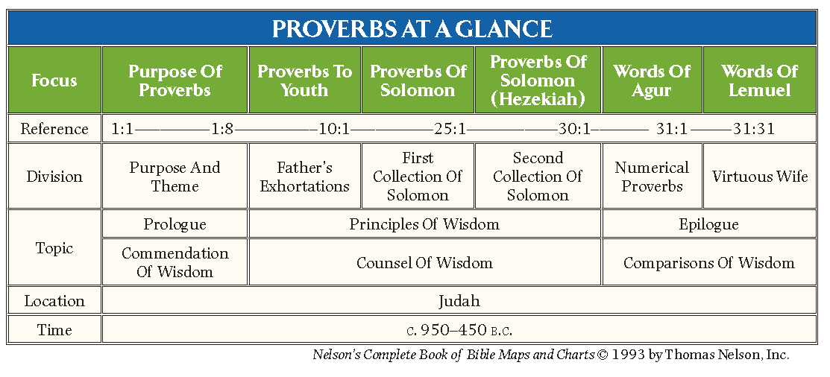

Outline of Proverbs
- Introduction: the Purpose of Proverbs (1:1-7)

- The Precepts of Wisdom: Proverbs to Youth (1:8-9:18)
  - Obey Parents (1:8-9)
  - Avoid Bad Company (1:10-19)
  - Heed Wisdom’s Call and Advice (1:20-33)
  - Avoid the Adulteress (2:1-22)
  - Trust and Honor God (3:1-12)
  - The Blessings of Wisdom (3:13-20)
  - Be Kind and Generous to Others (3:21-35)
  - Get Wisdom (4:1-9)
  - Avoid Bad Company (4:10-19)
  - Above All, Keep Your Heart (4:20-27)
  - Do Not Commit Adultery (5:1-14)
  - Be Faithful to Your Own Spouse (5:15-23)
  - Avoid Surety (6:1-5)
  - Shun Laziness (6:6-19)
  - Avoid Adultery (6:20-35)
  - Avoid the Adulteress (7:1-27)
  - Wisdom and Folly Contrasted (8:1-9:18)

- The Proverbs of Solomon (10:1-24:34)
  - Proverbs Contrasting the Godly and the Wicked (10:1-15:33)
  - Proverbs Encouraging Godly Lives (16:1-22:6)
  - Proverbs Concerning Various Practices (22:17-23:35)
  - Proverbs Concerning Various People (24:1-34)

- The Proverbs of Solomon Copied by Hezekiah’s Men (25:1-29:27)
  - Proverbs Concerning Relationships with Others (25:1-26:28)
    - With kings (25:1-7)
    - With neighbors (25:8-20)
    - With enemies (25:21-24)
    - With yourself (25:25-26:2)
    - With fools (26:3-12)
    - With sluggards (26:13-16)
    - With gossips (26:17-28)
  - Proverbs Concerning Actions (27:1-29:27)
    - In relation to life (27:1-27)
    - In relation to law (28:1-10)
    - In relation to wealth (28:11-28)
    - In relation to stubbornness (29:1-27)

- The Words of Agur (30:1-33)
  - Personal Words (30:1-14)
  - Numerical Proverbs (30:15-33)

- The Words of Lemuel (31:1-9)
- The Capable Wife (31:10-31)

Christ as seen in Proverbs:
Christ our Wisdom
In chapter 8, wisdom is personified and seen in its perfection. It is divine (8:22-31), it is the source of biological and spiritual life (3:18; 8:35-36), it is righteous and moral (8:8-9), and it is available to all who will receive it (8:1-6, 32-35). This wisdom became incarnate in Christ “in whom are hidden all the treasures of wisdom and knowledge” (Col. 2:3). “But of Him you are in Christ Jesus, who became for us wisdom from God—and righteousness and sanctification and redemption” (1 Cor. 1:30; cf. 1 Cor. 1:22-24).

Christ our Righteousness
If to be “wise” is to be skillful in honouring God, skillful in righteousness, and always on the side of the LORD, then we see Christ as the perfect example of wisdom. He is the One who fulfilled all righteousness (Matthew 3:15; John 8:29). No one has ever honoured the Father as Jesus has, for there has never been a submission as great as His (Hebrews 5:8), nor has anyone so completely yielded His will to the will of the Father (Luke 22:42).

Proverbs, a Schoolmaster to bring us to Christ
“Wherefore the law was our schoolmaster to bring us unto Christ, that we might be justified by faith” (Gal. 3:24). The law taught us our sinfulness, our total failure to satisfy the righteousness of God, and that we needed a Saviour who would satisfy all of God’s requirements, that we might be saved by faith. The more we read Proverbs, the more we are convinced that Proverbs is a schoolmaster, as well.

Proverbs: Two Ways
Proverbs is full of choices between the good and wise way, and the foolish and wicked way. The foolish way may appear to be wise to us, but it is the way of evil, rather than the way of the fear of the Lord. The Lord gives wisdom so that we may walk in the right way.
“There is a way which seemeth right unto a man,
but the end thereof are the ways of death.”
Proverbs 14:12
Jesus also spoke of two ways: the broad road that leads to destruction, and the narrow road that leads to life. One, which might look good, is the broad way that many take but which leads to destruction, while the other way is the way to life (Matthew 7:13-14).

Growing and Changing in Christ through Proverbs
The fear of the Lord is the over all theme of Proverbs. To walk in the very presence of God is the fear of the Lord. This fear leads us through sanctification. His presence helps us to walk very carefully through life. As Peter said, we can add to our faith: virtue, knowledge, self-control, perseverance, godliness, brotherly kindness, and love.

Ecclesiastes

(Satisfaction in Christ)

Matthew 5:6 Blessed are those who hunger and thirst for righteousness, for they shall be satisfied.

Author: Solomon

Date: Around 931 BC (in Solomon’s declining years)

Author: According to Jewish tradition, Solomon wrote the Song in his early years, expressing a young man’s love. He wrote the Proverbs in his mature years, manifesting a middle-aged man’s wisdom. He reportedly wrote Ecclesiastes in his declining years, revealing an old man’s sorrow (cf. 12:1). Perhaps Ecclesiastes is the record of Solomon’s regret for and repentance from his grave moral lapses recorded in 1 Kings 11. The Book of Ecclesiastes, then, would have been written just before Solomon’s death and subsequent division of his kingdom that occurred in 931 B.C.

Title of the Book
The name Ecclesiastes stems from the title given in the Greek translation, the Septuagint. Greek term, ecclesiastes, means “assembly” and is derived from the word ekkle„sia, “assembly, church.” “The Hebrew title is Qoheleth, which means “one who convenes and speaks at an assembly,” or “an ecclesiastic” or “preacher.”

Christ as seen in Ecclesiastes:
Satisfaction in Christ
Since Christ alone is man’s means to God where man finds wholeness and satisfaction, or life and life more abundantly (John 10:10; 7:37-38), the futility and perplexity experienced in life can only be removed through a personal relationship with the Lord Jesus. Man’s aspiration for significance and satisfaction are found only in the Savior.

Faith that Works
“Fear God” is a way of saying “Live in the presence of God”, which is the life of faith. The whole purpose of man is to have a faith that is alive, considering one day we are going to meet the Lord face to face. As Solomon concluded in Ecc 12:13-14, “The end of the matter; all has been heard. Fear God and keep his commandments, for this is the whole duty [purpose] of man. 14 For God will bring every deed into judgment, with every secret thing, whether good or evil.”

Solomon Falls into the Same Trap as Adam and Eve
Long ago, in the garden, Adam and Eve worked the land under the sun, and their lives were filled with significance. They were made to last, and work was fulfilling, not futile. But then they sinned. And everything changed. What was intended to bring pleasure—tending and filling the earth, meaningful work, and child bearing—was forever after reduced to exasperating toil and filled with pain.

The End of the Matter: Everything Matters
The final message of Ecclesiastes is not that nothing really matters but that everything matters. If there is a God who will one day judge the world, then everything matters. God will bring every deed into judgment, including every secret thing. Nothing will be excluded. What we did, how we did it, and why we did it will all have eternal significance. And that is good news, isn’t it? Doesn’t it take away the sense of meaningless that we sometimes feel?

Outline of Ecclesiastes
By Matthew Black
I. The Meaningless Life (ch. 1-6)
- Life without Christ is Meaningless 1:1-8
- Knowledge without Christ is Meaningless 1:9-18
- Pleasure without Christ is Meaningless 2:1-10
- Work without Christ is Meaningless 2:11-26
- Events without Christ is Meaningless 3:1-15
- Injustice without Christ is Meaningless 3:16-26
- Relationships without Christ are Meaningless ch. 4
- Worship without Christ is Meaningless 5:1-7
- Wealth without Christ is Meaningless 5:8-20
- The Meaningless Promises of Money ch 6
- Legacy without Christ is Meaningless 7:1-6

II. The Meaningful Life (ch. 7-12)
- Foundations of a Meaningful Life ch. 7
- A Meaningful Life is Submitted to Authority 8:1-8
- A Meaningful Life Finds Contentment in Christ 8:9-17
- How to Live a Meaningful Life 9:1-10
- Admonition to Meaningful Living 9:11-18
- Avoiding a Meaningless Life 10:1-11
- The Waste of the Meaningless Life 10:12-20
- Meaningful Living for Young and Old 11:1-12:8
- The Key to a Meaningful Life: Fearing God 12:9-14

Song of Solomon

(Union with Christ)
Eph 5:32 This mystery is profound, and I am saying that it refers to Christ and the church.

Author: Solomon
Date: About 965 B.C.

Outline of Song of Solomon
By Matthew Black
- What Should Attract You to a Potential Mate 1:1-4
- When are You Ready to Marry 1:5-7
- The Courtship Begins 1:7-2:7
- Passion, Purity, and Engagement 2:8-3:5
- A Wedding Designed by God 3:5-11
- God’s Plan for Intimacy 4:1-5:1
- The Sanctifying Power of Conflict in Marriage 5:2-6:13
- Practices that Help us Grow 7:1-13
- The Picture of Christ and the Church 8:1-14

Christ in Solomon’s Bride
We see Christ in the Song of Solomon through the marriage that Solomon had with the Shulamite farm girl. She is poor and dark and is totally out of Solomon’s league. So like Christ, Solomon humbles himself and loves her.

Christ in Solomon’s Marriage
Paul said in Eph 5:32 This mystery is profound, and I am saying that it refers to Christ and the church.We see Christ in the various stages of marriage that are found in the Song of Solomon.

- Anticipation: We anticipate His coming!
- Purity: We are pure and faithful to Christ.
- Passion: We love Him, we sacrifice for Him. He sacrificed for us!
- Provision: We can expect Christ to nourish and provide for us!
- Protection: We can live under the protection of Christ.
- Completion: Christ completes us!
- Procreation: In Christ we bear fruit.

Christ as seen in the Song of Solomon:
This book illustrates Christ’s love for the church which is seen as the bride of Christ in the New Testament (cf. 2 Cor. 11:2; Eph. 5:23-25; Rev. 19:7-9; 21:9). Song 7:10 “I am my beloved’s, And his desire is for me.”

Pre-Exile Prophets
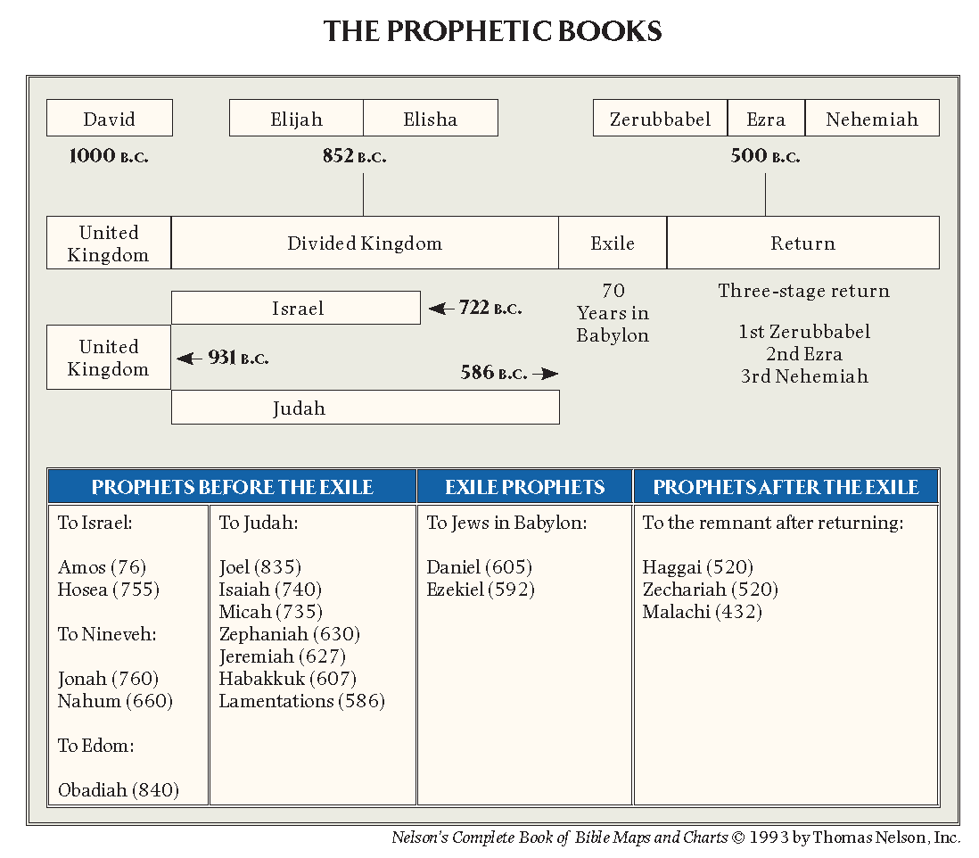

A Comparison of the Four Major Prophets

The major prophets are only called “Major” because of the length of their books. The so-called “writing prophets” have left us seventeen books. Four of these prophets—Isaiah, Jeremiah, Ezekiel, and Daniel—are called the major prophets. Twelve others are represented by much shorter books and are called “minor prophets”—a reference to the length of their writings, not to their quality or importance. The minor prophets were normally compiled in one scroll and called the “Twelve Prophet Book”. The Major Prophets bring us major hope!
- Isaiah – Hope of Messiah’s Rescue of Those Deserving Judgment
- Jeremiah – Hope of Justice
  - Lamentations (continuation of this hope of justice)
- Ezekiel – Hope of Paradise
- Daniel – Hope of Survival

Comparison of the Four Major Prophets
 | Isaiah | Jeremiah | Ezekiel | Daniel
Message | Hope of Messiah | Hope of Justice | Hope of Paradise | Hope of Survival
Prophesied To: | Jews in Judea | Jews in Judea and captivity | Jews captive in Babylon | Jews captive in Babylon and Gentile kings
Concerning: | Judah and Nations  (Isa. 1:1; 2:1) | Judah and Nations (Jer. 1:5, 9-10; 2:1-2) | The whole house of Israel (Ezek. 2:3-6; 3:4-10, 17) | Israel and Gentile Nations  (Dan. 2:36ff; 9)
During the reigns of: | Uzziah, Jotham, Ahaz, Hezekiah, Manasseh (kings of Judah) | Josiah, Jehoahaz, Jehoiakim, Jehoiachin, Zedekiah  (kings of Judah) | Zedekiah  (king of Judah);  Nebuchadnezzar  (king of Babylon) | Jehoiakim, Jehoiachin, Zedekiah  (kings of Judah).  Nebuchadnezzar  (king of Babylon),  Darius (Mede)  Cyrus (Persian)
Dates: | 740-680 B.C. | 627-585 B.C. | 592-570 B.C. | 605-536 B.C.
Historical  Setting: | 2 Kings 15-21;  2 Chronicles 26-30 | 2 Kings 22-25 | Daniel 1-6 | Daniel 1-6

It may be easier to divide them into the times and peoples they prophesied to. In this sense we understand that various prophets were contemporaries of one another and several knew each other. We may divide them as such:
- Pre-exile prophets
- Exile prophets
- Post-exile prophets

The Former Prophets (Historical Books)
The first division of the Old Testament was known as the Law with the second being called the Former Prophets, but these included four books which have already been outlined—Joshua, Judges, Samuel, and Kings. Though these books deal with the history of Israel, they were composed from a prophetic viewpoint and possibly even the authors themselves may have been prophets by profession.

The Latter Prophets
The seventeen books of the Major and Minor Prophets considered in this section were classified in the Hebrew Bible as the Latter Prophets. The term ‘latter’ speaks primarily of their place in the canon rather than of their chronological position. These prophets are sometimes called the writing prophets because their authors wrote or recorded their utterances. There were other oral prophets like Nathan, Ahijah, Iddo, Jehu, Elijah, Elisha, Oded, Shemaiah, Azariah, Hanani, Jahaziel, and Huldah who left no records of their utterances. Mostly because of their size, the Latter Prophets are subdivided into the Major Prophets (Isaiah, Jeremiah, and Ezekiel), and the twelve Minor Prophets, whose writings could all be included in one large scroll which came to be known in Greek as “the Twelve-Prophet Book”. Daniel, usually viewed as one of the Major Prophets in the English Bible, actually appears in the third division of the Hebrew Canon called “the Writings.”
Lamentations will also be dealt with here because of its place in the English Bible, though in the Hebrew Bible it is among the five rolls or megilloth, the shorter books, which were brief enough to be read publicly on anniversaries.

The Time Span of the Prophets
Pre-exile prophets |  | Exile Prophets  ---70 year Exile--- | Prophets after  Return to Israel
To Israel  Amos (776)  Hosea (755)  To Edom  Obadiah (840)  To Ninevah  Jonah (760)  Nahum (660) | *Date of Assyrian Captivity: 722 BC  To Judah  Joel (835)  ISAIAH (740)  Micah (735)  Zephaniah (630)  JEREMIAH (627)  Habakkuk (607)  Lamentations (586) | *Date of Babylonian Captivity: 605 BC  To Jews in Babylon  DANIEL (605)  EZEKIEL (592) | *Decree of Cyrus: 537 BC  *Date of Return from Captivity: 536 BC  To the Remnant after Returning  Haggai (520)  Zechariah (520)  Malachi (452)

Subject Matter of the Prophets
The subject matter of all the Prophets, according to Gerhardus Vos, can be easily divided into the following parts:
- The Self-Revelation and Attributes of God (YHWH)
- The Love of YHWH for His people
- The Sin of God’s people
- The Judgment and Restoration of His people

Threefold Function of Prophets
As God’s spokesman, their message can be seen in a three-fold function they had among the people of God in the Old Testament:
PREACHING – First, they functioned as preachers who expounded and interpreted the Mosaic law to the nation. It was their duty to encourage, admonish, reprove, denounce sin, threaten with the terrors of judgment, call to repentance, and bring consolation and pardon. Their activity of rebuking sin and calling for repentance consumed far more of the prophets’ time than any other feature of their work. The rebuke was driven home with predictions about the punishment that God intended to send on those failing to heed the prophet’s warning (cf. Jonah 3:4).
PROPHECY – Second, they functioned as predictors who announced coming judgment, deliverance, and the amazing promise of the coming Messiah and His kingdom. Predicting the future was never intended merely to satisfy man’s curiosity, but was designed to demonstrate that God knows and controls the future, and to give purposeful revelation. The prediction given by a true prophet would be visibly fulfilled. The failure of the prediction to be fulfilled would indicate that the prophet had not spoken the word of Yahweh (cf. Deut. 18:20-22). In 1 Samuel 3:19 it is said of Samuel that the Lord was with him and let none of his prophetic words fail (lit., “fall to the ground”).
PROSECUTING ATTORNEY – Finally, they functioned as watchmen over the people of Israel (Ezek. 3:17). Ezekiel stood as a watchman on the walls of Zion ready to trumpet a warning against religious apostasy. He warned the people against political and military alliances with foreign powers, the temptation to become involved in idolatry and Canaanite cultic worship, and the danger of placing excessive confidence in religious formalism and sacrificial ritual.
While the prophets functioned in various ways as they communicated God’s message, they occupied one major role in Israel’s religious system. The prophets in Israel occupied the role of a royal diplomat or prosecuting attorney, indicting the nation for violations of the Mosaic covenant.

Isaiah

(Hope of Messiah’s Rescue of Those Deserving Judgment)
Speaking of Christ in Isaiah 6: “Isaiah said these things because he saw his glory and spoke of him” (John 12:41).

Author: the Prophet Isaiah

Date: Ministry from 740–680 B.C.

Isaiah’s Personal History: Isaiah was truly a man of his times.
- From Distinguished Family: As the book clearly declares, the author is Isaiah, the son of Amoz, an apparently influential and distinguished Jewish family.
- A Diplomat: Isaiah appears to have been on familiar terms with the royal court even in the reign of Ahaz.
- Well-Educated: He was evidently a well-educated student of international affairs, who spent most of his time in the city of Jerusalem, where he rubbed shoulders with royalty and gave advice on foreign affairs because he was so in touch with the crosscurrents of world affairs.

Opposed Any Foreign Entanglements
Though often scoffed at, being directed by God, he vigorously opposed any entangling alliances with foreign powers (whether with Assyria as against Samaria and Damascus, or with Egypt as against Assyria). As warned by the Lord in chapter 6, his cause was doomed to failure, for both government and people chose to put their trust in the political alliances of man rather than in the sure person and promises of God.

Jonah & Hosea Immediately Precede Isaiah
Isaiah is a prophet during the pinnacle of the great Assyrian Empire. He was likely born during the reigns of Uzziah (Judah) and Jeroboam II (Israel). It is significant that Isaiah is preceded by Hosea, who preaches God’s love to the rebellious people of Northern Israel.
He is also preceded by Jonah who preaches mercy to the fiercest Gentile nation of the time – Assyria. Jonah is a reluctant prophet. Isaiah is not. Isaiah proclaims judgment upon Judah and all the surrounding nations (chapters 1-39) and then he proclaims hope in the Messiah (40-66).

Kings During the Time of Isaiah
Isaiah outdated Hezekiah by a few years because chapter 37, verse 38, records the death of Sennacherib in 681 B.C. Hezekiah was succeeded by his wicked son Manasseh who overthrew the worship of Yahweh and no doubt opposed the work of Isaiah.

Kings During Isaiah’s Time
Kings of Judah | Kings of Assyria | Kings of Israel
Uzziah (790-739 B.C.) | Tiglath-pileser III (745-727 B.C.)  2 Chron. 28:20 | Jeroboam II (782-753)  Zechariah (753-752 = 6mo.)  Shallum (752 - 1 mo.)  Menahem (752-742)  Pekahiah (742-740)  Pekah (740-732)  Hoshea (732-712)
Jotham (739-731 B.C.) | Sennacherib (705-681 B.C.)  Isaiah 37:38
Ahaz (731-715 B.C.) | Sennacherib (705-681 B.C.)  Isaiah 37:38
Hezekiah (715-686 B.C.) | Esarhaddon (681-669)  Isaiah 37:38
Manasseh (687-642 B.C.) | Esarhaddon (681-669)  Isaiah 37:38

Keys for Christians
- The Gospel of Isaiah: Isaiah’s name provides the theme of the book, “salvation is of Yahweh.” This is most evident by the fact the term “salvation” occurs some twenty-six times in Isaiah but only seven time in all the other prophets combined. Because of this, Isaiah has been called “the evangelical prophet” because he says so much about the salvation and redemptive work of Messiah. Isaiah really gives us the Gospel of the Old Testament.

- A Little Bible: Like the Bible’s 66 books, Isaiah has 66 chapters. The first 39 chapters correspond to the Old Testament and speak primarily of judgment and largely anticipate the coming of Messiah. The final 27 chapters neatly parallel the twenty-seven chapters of the New Testament because they speak a great deal about the mercy of Messiah and His Kingdom as the Servant of the Lord. Chapters 1-39 speak of man’s great need of salvation while chapters 40-66 reveal God’s provision of Salvation in Messiah and His kingdom.

- Christ the Sovereign Lord: In Isaiah 6 we see the Sovereign YHWH, and the Apostle John identifies this great God as Jesus Christ of Nazareth. Speaking of Christ in Isaiah 6: “Isaiah said these things because he saw his glory and spoke of him” (John 12:41).

- Christ, Born of a Virgin: War ensued and Ahaz (king of Judah) had his back against the wall with Syria and northern Israel breathing down his neck. God warned him to walk by faith in Isaiah 7:9 “If you are not firm in faith, you will not be firm at all.” The LORD then encouraged King Ahaz to ask for a sign of victory, but Ahaz with a self-righteous denial refused. Then the Lord gave Isaiah the famous prophecy: “Hear then, O house of David! Is it too little for you to weary men, that you weary my God also? 14 Therefore the Lord himself will give you a sign. Behold, the virgin shall conceive and bear a son, and shall call his name Immanuel” (7:13-14). In other words, there is coming one who is greater than the Syria, Israel, or the king of Assyria! He is Immanuel, God with us.

- Judgment Day, i.e. the Day of the Lord: Consider Isaiah 13:6-13 which points to the cataclysmic final day of the world: “Wail, for the day of the LORD is near; as destruction from the Almighty it will come! 7 Therefore all hands will be feeble, and every human heart will melt. 8 They will be dismayed: pangs and agony will seize them; they will be in anguish like a woman in labor. They will look aghast at one another; their faces will be aflame.
9 Behold, the day of the LORD comes, cruel, with wrath and fierce anger, to make the land a desolation and to destroy its sinners from it. 10 For the stars of the heavens and their constellations will not give their light; the sun will be dark at its rising, and the moon will not shed its light.
11 I will punish the world for its evil, and the wicked for their iniquity; I will put an end to the pomp of the arrogant, and lay low the pompous pride of the ruthless. 12 I will make people more rare than fine gold, and mankind than the gold of Ophir. 13 Therefore I will make the heavens tremble, and the earth will be shaken out of its place, at the wrath of the LORD of hosts in the day of his fierce anger.”
These kinds of passages are common in the first 39 chapters of Isaiah (i.e. ch. 13-24, esp. 24:1-3). Compare how Jesus spoke of this day in Matthew 24:29-32, “Immediately after the tribulation of those days the sun will be darkened, and the moon will not give its light, and the stars will fall from heaven, and the powers of the heavens will be shaken. 30 Then will appear in heaven the sign of the Son of Man, and then all the tribes of the earth will mourn, and they will see the Son of Man coming on the clouds of heaven with power and great glory. 31 And he will send out his angels with a loud trumpet call, and they will gather his elect from the four winds, from one end of heaven to the other.”

MORE MESSIANIC PROPHECIES IN ISAIAH
THE PROPHECY | THE FULFILLMENT
The Messiah: | Jesus of Nazareth:
Will be born of a virgin (Isaiah 7:14) | Was born of a virgin named Mary (Luke 1:26-31)
Will have a Galilean ministry (Isaiah 9:1,2) | Ministry began in Galilee of the Gentiles  (Matthew 4:13-16)
Will be an heir to the throne of David  (Isaiah 9:7; 11:1, 10) | Was given the throne of His father David  (Luke 1:32, 33)
Will have His way prepared (Isaiah 40:3-5) | Was announced by John the Baptist (John 1:19-28)
Will be spat on and struck (Isaiah 50:6) | Was spat on and beaten (Matthew 26:67)
Will be exalted (Isaiah 52:13) | Was highly exalted by God and the People (Philippians 2:9, 10)
Will be disfigured by suffering  (Isaiah 52:14; 53:2) | Was scourged by Roman soldiers who gave Him a crown of thorns (Mark 15L15-19)
Will make a blood atonement (Isaiah 53:5 | Shed His blood to atone for our sins (1Peter 1:2)
Will be widely rejected (Isaiah 53:1,3) | Was not accepted by many (John 12:37, 38)
Will bear our sins and sorrows (Isaiah 53:4, 5) | Died because of our sins (Romans 4L25; 1Peter 2:24, 25)
Will be our substitute (Isaiah 53:6,8) | Died in our place  (Romans 5:6, 8; 2 Corinthians 5:21)
Will voluntarily accept our guilt and punishment for sin (Isaiah 53:7,8) | Jesus took on our sins  (John 1:29; Romans 6:10; 2 Corinthians 5:21)
Gentiles will seek Him (Isaiah 11:10) | Gentiles came to speak to Jesus (John 12:20,21)
Will be silent before His accusers (Isaiah 53:7) | Was silent before Herod and his court (Luke 23:9)
Will save us who believe in Him  (Isaiah 53:12) | Provided salvation for all who believe  (John 3:16; Acts 16:31)
Will die with transgressors (Isaiah 53:12) | Was numbered with the transgressors  (Mark 15:27, 28; Luke 22:37)
Will heal the brokenhearted (Isaiah 61:1,2) | Healed the brokenhearted (Luke 4:18, 19)
God's Spirit will rest on Him (Isaiah 11:2) | The Spirit of God descended on Jesus  (Matthew 3:16; Mark 1:10; Luke 3:22; 4:1)
Will be buried in a rich man's tomb  (Isaiah 53:9) | Was buried in the tomb of Joseph, a rich man from Arimathea (Matthew 27:57-60; John 19:38-42)
He will judge the earth with righteousness (Isaiah 11:4,5) | Jesus was given authority to judge  (John 5:27; Luke 19:22; 2 Timothy 4:1,8)

- Promises of the Coming King: We read in Isaiah 32:1, “Behold, a king will reign in righteousness, and princes will rule in justice.” This coming King would be far more than just a good and righteous king. Isaiah 9:6-7, “For to us a child is born, to us a son is given; and the government shall be upon his shoulder, and his name shall be called Wonderful Counselor, Mighty God, Everlasting Father, Prince of Peace. 7 Of the increase of his government and of peace there will be no end, on the throne of David and over his kingdom, to establish it and to uphold it with justice and with righteousness from this time forth and forevermore. The zeal of the LORD of hosts will do this.”

- Promises of Christ’s Life: No book of the Old Testament presents a portrait of Christ that is as complete and comprehensive as does Isaiah. Isaiah portrays Messiah in His sovereignty above (6:1f), birth and humanity (7:14; 9:6; 11: 1), in His ministry by the Spirit (11:2f), His divine nature (7:14; 9:6); His Davidic descent (11:1); His work of redemption as our substitute (53), His ministry as the Servant Savior (49ff), and much more.

- Promises of Christ’s Death: With a book so full of rich truth and Messianic anticipation, deciding of a key chapter is not easy, but surely Isaiah 53 which points to Messiah as a suffering Savior who must die for our sin, is the most remarkable and key chapters of the Old Testament.

- The Christ Who Binds the Brokenhearted: Luke 4 records that Jesus read the following text and said, “Today this Scripture is fulfilled in your hearing”. Isaiah 61:1-2, “The Spirit of the Lord GOD is upon me, because the LORD has anointed me to bring good news to the poor; he has sent me to bind up the brokenhearted, to proclaim liberty to the captives, and the opening of the prison to those who are bound; 2 to proclaim the year of the LORD’s favor, and the day of vengeance of our God; to comfort all who mourn.”

Summary: In the first 39 chapters, we find Israel trusting in the wrong things! They trusted in:Israel trusted other kings – turning especially to the king of Egypt. Isaiah 31:1, God warns, “Woe to those who go down to Egypt for help and rely on horses, who trust in chariots because they are many and in horsemen because they are very strong, but do not look to the Holy One of Israel or consult the LORD!”

- Israel trusted themselves: Isaiah 22:10–11 (ESV), “and you counted the houses of Jerusalem, and you broke down the houses to fortify the wall. 11 You made a reservoir between the two walls for the water of the old pool. But you did not look to him who did it, or see him who planned it long ago.”
- Israel trusted other gods: the land was filled with altar stones and asherah poles and incense altars (27:9). They were necromancers, they consulted the dead. God asks them in Isaiah 8:19, “should not a people inquire of their God? Should they inquire of the dead on behalf of the living?” Even in the second part of Isaiahhapters 41, 44, 57, and 65 all have long sections about idolatry.
- Israel needed to trust in the LORD. There is a historical interlude in Isaiah 36-39 that points to the power of the One who is coming. The government was upon Hezekiah’s shoulders, and through faith he saw the great king Senacharib defeated and 185,000 of his army slaughtered by the Angel of the Lord in one night.
- The Solution: Hoping in Christ, Messiah-King. His Kingdom is coming.
  - Born of a virgin (7:14)
  - The God Man (9:6-7)
  - Son of David (11:1-12)
  - Glorious God (6:1-3)
  - Gracious Ministry to the Broken-Hearted (61:1-2)
  - His Comfort Announced by John the Baptist (40:1-5)
  - Light Dawns in Galilee of the Nations (9:1-2)
  - His Preaching Hardens the Proud (6:9-10)
  - He is the Servant that Brings Righteousness and Redemption to the Gentiles (four servant songs in chapters 42, 49, 50, 52-53)
  - The Day of the Lord not Just Judgment but Deliverance
  - Messiah will have a universal reign (2:2-4, 60:3-4, 7, 14)
  - Messiah will inagurate the New Heavens and Earth: Isaiah 66 ends with words that echo Jesus in Matthew 24, that YHWH will come in all His glory, and He will rejoice over the humble ones who tremble at His words, but those rebelious, He will destroy with fire. And He will inaugurate the new heavens and new earth.
  - The book ends with a warning to unbelievers Isaiah 66:24, “And they shall go out and look on the dead bodies of the men who have rebelled against me. For their worm shall not die, their fire shall not be quenched, and they shall be an abhorrence to all flesh.”

Conclusion: Trust Christ, the Messiah-King and you will have mercy and grace. There is no hope outside of Him!

Outline of Isaiah
Due to the size of Isaiah, we will restrict the outline to major sections.

I. Prophecies of Denunciation & Judgment (1:1-39:8)
A. Prophecies Against Judah (1:1-12:6)
B. Prophecies Against Gentile Nations (13:1-23:18)
1. Against Babylon (13:1-14:23)
2. Against Assyria (14:24-27)
3. Against Philistia (14:28-32)
4. Against Moab (15:1-16-14)
5. Against Damascus and Her Ally, Israel (17:1-14)
6. Against Ethiopia (18:1-7)
7. Against Egypt (19:1-20:6)
8. Against Babylon (21:1-10)
9. Against Edom (21:11-12)
10. Against Arabia (21:13-17)
11. Against Jerusalem (22:1-25)
12. Against Tyre (23:1-18)
C. Prophecies of the Day of the Lord (24:1-27:13)
1. Judgments of the Day of the Lord(24:1-23)
2. The Triumphs and Blessings of the Kingdom (25:1-27:13)
D. Prophecies Against Israel and Judah (Woes and Blessings) (28:1-35:10)
1. Woe on Samaria (28:1-29)
2. Woe on Judah (29:1-31:9)
3. Behold Messiah and His Kingdom (32:1-20)
4. Woe to Assyria, the Spoiler of Jerusalem (33:1-24)
5. Woe to the Nations (34:1-17)
6. Behold the Coming Kingdom (35:1-10)
E. Prophecies Against Sennacherib (36:1-39:8)
1. The Taunt from Assyria (36:1-22)
2. The Truth from God (37:1-7)
3. The Threat from Assyria (37:8-35)
4. The Triumph over Assyria (37:36-38)
5. The Sickness of Hezekiah (38:1-22)
6. The Stupidity of Hezekiah (39:1-8)

II. Prophecies of Comfort or Consolation (40:1-66:24)
A. Prophecies of Israel’s Deliverance and the Greatness of God (40:1-48:22)
B. Prophecy of Israel’s Deliverer; the Salvation of the Suffering Servant (49:1-57:21)
C. Prophecies of the Glorious Future Kingdom of Messiah (58:1-66).

Grouping According to the Exile and the Kingdoms of Israel and Judah
Group | Book | Approximate Dates
Pre-Exilic  Prophets of Israel | Jonah (preached to Nineveh)  Amos  Hosea | 780-850  765-750  755-715
Prophets of Judah | Obadiah (preached to Edom)  Joel  Isaiah  Micah  Nahum (preached to Nineveh)  Habakkuk  Zephaniah | 840  835-796  740-680  740-690  630-612  606-604  625
Exile Prophets | Jeremiah / Lam. (to Jews in Judea)  Daniel  Ezekiel | 627-585  606-537  593-571
Post-Exilic Prophets  Prophets of the Returned Remnant | Haggai  Zechariah  Malachi | 520 (during Ezra)  515 (during Ezra)  430 (Just after Nehemiah)

Jonah & Nahum: Prophets to Ninevah

(Hope for the Nations)

Prophets to the Nations
Christ’s great commission is to “make disciples of all nations” (Matt. 28:18-20), but we realize this was God’s heart in the Old Testament as well.
Unlike God’s call to prophesy to His covenant people, some of the prophets before the exile were commissioned to carry a message of judgment to the surrounding nations. Three prophets had this responsibility – Jonah and Nahum to Ninevah and Obadiah to Edom.

The God of the Nations
Ninevah (founded by Nimrod, Gen. 10:8-12) was the capital city of the great world empire of the time: Assyria. This was the very nation that was enticing Israel to sin by worshipping the false gods like Baal, Ashteroth, Chemosh, and Molech. Why would God have mercy on such a nation? Because God wanted to declare Himself to be “the God of the nations” (Psalm 22:28).

The Goodness and Severity of God
Jonah’s theme is the goodness of God, and Nahum, written about a hundred years later tells us of the severity of God. As Paul says, “behold the goodness and severity of God” (Romans 11:22). This same God will reveal Himself in the New Testament through Christ, to “reconcile the world to God”.
The message of these two prophets reminds us that the God of Israel is the Creator and God of the whole world. Though all do not yet acknowledge Him, yet all people are nonetheless accountable to Him. Our God in other words, is a GLOBAL GOD! Every other god is a sheer fabrication of the carnal imagination (cf. 1 Cor. 8:6).
Both Jonah and Nahum prophesied to the ancient city of Ninevah, capital of Assyria – Jonah in 750BC and Nahum in 650BC. Both books have one message: the coming judgment on Ninevah.
Jonah

(The Goodness of God)

Author: the Prophet Jonah

Date: Ministry from 780-850 B.C.
Matthew 12:40, “For just as Jonah was three days and three nights in the belly of the great fish, so will the Son of Man be three days and three nights in the heart of the earth”.

The book of Jonah is far more than a warning of judgment to the pagan capital of the ancient world empire Assyria. It is truly Messianic in nature – it points to Jesus! It points us to the death and resurrection of God’s Son, Jesus, “the Christ, the Savior of the world” (John 4:42).

Jonah, A Galilean?
The supposed tomb of Jonah is located near ancient Nazareth, so it was likely Jonah was Galilean. This could mean that the Pharisees were either mistaken or blatantly lied when they said to Nicodemus, “Search and look, for no prophet has arisen out of Galilee” (John 7:52).
Those who reject the inspiration of the Bible look at the book of Jonah as a myth, a legend, or an allegory that has no basis in actual human history. Yet the Scriptures teach us that Jonah was an actual historical figure and the events of his life actually happened (2 Kings 14:25, Matt. 12:38-42).

Keys for Christians
A Reluctant Prophet (1:1-3)
In the first chapter, we read that Jonah wanted to “flee from the presence of the Lord”. He was called to preach to the notorious city of Ninevah that had a population between 600,000 and one million people. They were infamous worshippers of the idols that had ensnared Israel.
Jonah was supposed to go 550 miles NorthWEST to Ninevah, but instead he went 2500 miles in the opposite direction with Tarshish likely being located in modern day Southern Spain.
Why did Jonah disobey? It was not likely that he was a coward, but that his motive was patriotic. He may have even known as Hosea 9:3 says that Assyria would later be the instrument God uses to destroy Israel.

Peter & Barnabas also Reluctant
We find an interesting account in Galatians 2 about Peter and Barnabas at the church in Antioch. Gal. 2:11-13 , “But when Cephas came to Antioch, I opposed him to his face, because he stood condemned. 12 For before certain men came from James, he was eating with the Gentiles; but when they came he drew back and separated himself, fearing the circumcision party. 13 And the rest of the Jews acted hypocritically along with him, so that even Barnabas was led astray by their hypocrisy.”
It’s interesting that it is Peter of all people to get caught up in this kind of racism, because he was shown a vision of God being the God of ALL NATIONS in Acts 10:13-16 , “Rise, Peter; kill and eat.” 14 But Peter said, “By no means, Lord; for I have never eaten anything that is common or unclean.” 15 And the voice came to him again a second time, “What God has made clean, do not call common.” 16 This happened three times, and the thing was taken up at once to heaven.”
We read later in Acts 10:34-36, 42 “Peter opened his mouth and said: “Truly I understand that God shows no partiality, 35 but in every nation anyone who fears him and does what is right is acceptable to him. 36 As for the word that he sent to Israel, preaching good news of peace through Jesus Christ (he is Lord of all), …42 And he commanded us to preach to the people and to testify that he is the one appointed by God to be judge of the living and the dead. 43 To him all the prophets bear witness that everyone who believes in him receives forgiveness of sins through his name.” So we see God’s heart for all nations in the book of Jonah.

God’s “Hesed” Love for the World
Jonah admits to the very heart of his great struggle: Jonah 4:2, “I know that you are a gracious and merciful God, slow to anger and abundant in loving-kindness [HESED], one who relents from doing harm”. To the Jew, it was amazing almost beyond belief that God loved people in the Gentile nations. But God’s covenant love was not just toward Israel. It was to anyone of any nation that would turn to Him in faith! (Think of the Old Testament example given by the Lord in Luke 4:25-27, “I tell you, there were many widows in Israel in the days of Elijah, when the heavens were shut up three years and six months, and a great famine came over all the land, 26 and Elijah was sent to none of them but only to Zarephath, in the land of Sidon, to a woman who was a widow. 27 And there were many lepers in Israel in the time of the prophet Elisha, and none of them was cleansed, but only Naaman the Syrian.” So we see in Jonah and throughout the Old Testament, God has a heart – indeed a covenant love – for the nations.

Jonah, a Type of Christ
Jesus said in Matthew12:38-42, “Then some of the scribes and Pharisees answered him, saying, “Teacher, we wish to see a sign from you.” 39 But he answered them, “An evil and adulterous generation seeks for a sign, but no sign will be given to it except the sign of the prophet Jonah. 40 For just as Jonah was three days and three nights in the belly of the great fish, so will the Son of Man be three days and three nights in the heart of the earth. 41 The men of Nineveh will rise up at the judgment with this generation and condemn it, for they repented at the preaching of Jonah, and behold, something greater than Jonah is here.” Jonah is a type of Christ for several reasons:

1. Jonah is thrown into the sea and into the belly of the fish, a type of the grave (1:4-17).
We read in Matthew 12:40, “For just as Jonah was three days and three nights in the belly of the great fish, so will the Son of Man be three days and three nights in the heart of the earth.”
Jonah was asleep during a great storm which put the lives of the ship’s crew in danger of destruction. He had to be awakened, and was rebuked for not caring about the potential danger to everyone’s lives. Jonah was appointed by God as being the cause of the storm (through the use of lots), and Jonah owned up to his guilt. Jonah then asked to be thrown overboard since this would stop the storm. The sailors tried to make it on their own, but ultimately came to trust in Jonah’s offer as a last result. They threw him overboard and were gloriously saved from their terrible predicament. Destruction was averted.
Jesus was ultimately sacrificed, just like Jonah, to save the lives of all from complete destruction. And while Jonah was legitimately guilty, Jesus took on himself our guilt. Jesus took our destruction that we might be spared. As Matthew Henry says:
Jonah is herein a type of Christ, that he gives his life a ransom for many; but with this material difference, that the storm Jonah gave himself up to still was of his own raising, but that storm which Christ gave himself up to still was of our raising. Yet, as Jonah delivered himself up to be cast into a raging sea that it might be calm, so did our Lord Jesus, when he died that we might live.” (Comments on Jonah 1:12).

2. As the big fish could not keep Jonah, neither could the grave keep the Savior.
In Luke 11:29–30, Jesus said, “This generation is an evil generation. It seeks for a sign, but no sign will be given to it except the sign of Jonah. 30 For as Jonah became a sign to the people of Nineveh, so will the Son of Man be to this generation.” Jonah appears to the Ninevites as one who has been brought back from the dead! In a similar way, though far superior, Jesus will be a sign to His generation. Indeed the death and resurrection of Christ will be the fulfillment of the type of Jonah. But Jesus will be swallowed and disgorged, not by a fish, but by death itself (Acts 2:23-24).

3. Jonah preached salvation to broken people.
Christ arose to proclaim the saving message to lost people. God “is patient toward you, not wishing that any should perish, but that all should reach repentance” (2 Peter 3:9).The people of Ninevah needed to believe the message of Jonah and repent. Jonah went to Ninevah and proclaimed the “good news” for forty days. And the people repented!
So as Jonah brought a message of hope and salvation to a despised people, so Christ brought a message of hope to the whole Gentile world, which the Jews despised. Even in our day, we need to see our tendency to preach the gospel only to people who are like we are. We need to truly reach out at a multi-generational, multi-cultural congregation.
Christ wants to save the lowest of the low, that is, all of us! That includes those who have practiced homosexuality, drunkenness, fornication of the vilest sort, and other sins so base that some of us do not even know what they are.
If God changes the publicans and sinners by the gospel message, we must be ready to receive them as part of our family. We need to thrill again with the statement of Paul in 1 Corinthians 6:11, “And such were some of you. But you were washed, you were sanctified, you were justified in the name of the Lord Jesus Christ and by the Spirit of our God.”

Conclusion
The book of Jonah teaches us of our continuing responsibility to preach the goodness of God, the good news of Christ to all. The church is comprised of a multitude of nations, not just people who look and have traditions like us. As in all generations, “faith comes by hearing, and hearing by the Word of Christ” (Rom. 10:17). If we do not repent at the preaching of the Word of Christ, we will hear the words of Christ in Matthew 12:42, “The men of Nineveh will rise up at the judgment with this generation and condemn it, for they repented at the preaching of Jonah, and behold, something greater than Jonah is here.”
Praise God for the goodness of God that Jonah preached to an unworthy nation!
  - The Fleeing of Jonah (1:1-17)
  - The Praying of Jonah (2:1-10)
  - The Preaching of Jonah (3:1-10)
  - The Learning of Jonah (4:1-11)
    - Jonah’s Complaint to God (4:1-3)
    - God’s Curriculum for Jonah (4:4-11)

Nahum

(The Severity of God)

Author: the Prophet Nahum

Date: Ministry from 627-585 B.C.
Nahum 1:3, “The LORD is slow to anger and great in power, and the LORD will by no means clear the guilty.”

The mercy, love, grace, and goodness of God cannot be proclaimed too fully, believed too firmly, or extolled to highly. I rejoice to declare to men and women everywhere that “The LORD is good.” ― “The goodness of God endures continually” (Ps. 52:1). But the book of Nahum is a wakeup call and a message that we cannot treat the grace of God casually. The theme of Nahum is the severity of God toward those who take His grace lightly. Nahum 1:3, “The LORD is slow to anger and great in power, and the LORD will by no means clear the guilty.”
Nahum single-mindedly proclaims the doom of the Assyrian capital of Nineveh. Among the reasons for the condemnation of the city are the inhumanities of the Assyrian army (2:12), and the vices of the city (3:4). The nature of God, specifically His wrath, His holiness, His justice, and His power, makes it inevitable that His enemies will perish (1:2–10). The brief book of Nahum can be divided into three parts:
- Nineveh Judged (ch. 1)
- Nineveh Sentenced (ch. 2)
- Nineveh Executed (ch. 3)

Keys for Christians
God of Love / God of Wrath
Nahum teaches us that the God whose goodness and longsuffering are so evident in Jonah is also the God who is uncompromising and relentless in His wrath toward those who reject His grace.

God’s Fierce Wrath
The first verse of Nahum's short prophecy sets the tone by telling us that Yahweh is a jealous and avenging God. He is full of vengeance and will disgorge His wrath against Nineveh. Many prophets ease into their subject matter, but not Nahum. These opening verses hit like a sledge hammer. They send a chill up your spine and cause the hair on your neck to stand straight up. This is not a God you would want to meet on a bad day. Before Him the mountains shake, the earth trembles and the rocks shatter. He is a God, says Nahum, of "fierce anger" who will pour out His wrath like fire (1:6). "I am against you," declares the Lord Almighty to Nineveh (2:13).

Comfort to God’s People
The conversion of the Ninevites in response to the preaching of Jonah was evidently short lived because they soon became ruthless, returning to their former wicked ways. Sargon II of Assyria destroyed Samaria and took the Northern Kingdom of Israel into captivity, scattering the ten tribes in 722. Later, Sennacherib of the Assyrians almost captured Jerusalem during the reign of Hezekiah in 701 B.C. But regardless of its power and prominence, Nineveh is clearly judged as doomed by a Holy God through the prophet Nahum. Assyria’s cruelty, power, and pride would come to an end by the power of God. Though the book focuses on Assyria’s fall and judgment, it is written to bring comfort to Judah.
We find a similar encouragement in 2 Thess. 1:5-10, “This is evidence of the righteous judgment of God, that you may be considered worthy of the kingdom of God, for which you are also suffering— 6 since indeed God considers it just to repay with affliction those who afflict you, 7 and to grant relief to you who are afflicted as well as to us, when the Lord Jesus is revealed from heaven with his mighty angels 8 in flaming fire, inflicting vengeance on those who do not know God and on those who do not obey the gospel of our Lord Jesus. 9 They will suffer the punishment of eternal destruction, away from the presence of the Lord and from the glory of his might, 10 when he comes on that day to be glorified in his saints, and to be marveled at among all who have believed, because our testimony to you was believed.”

The Mysteries of Calvary
We learn in Nahum 1:3 that God “will not at all acquit the wicked.” The mysteries of Calvary are bound up in that little phrase. Someone has written, ''It put Jehovah to no test when He rolled shining stars from the palm of His creating hand and scooped out the channels for the tempestuous seas. But when it came to saving rebellious man, God faced that which tested the infinite.'' A holy God ordained just laws for the government of His world. Man broke the law. All men break it, and God indeed must judge them.

Fulfilled Prophecy – First Hezekiah and Later the Medes
Nahum’s prophecy of God’s judgment on Assyria was partially fulfilled when the angel of the Lord slew 185,000 Assyrian soldiers in one night (2 Kings 19:35-37).
Indeed, a century after Nahum's prophecy, God turned loose His elements, and Nineveh fell to the armies of the Medes. The remains of that city were just a matter of conjecture until 1841, when the spade of the archeologist uncovered it, and the Bible story was confirmed.

Every Knee Shall Bow
While there are no direct Messianic prophecies in Nahum, in keeping with the basic christological spirit of all prophecy, Nahum sees Christ as the jealous God and avenger of His adversaries (1:2f). Christ is YHWH before whom “every knee shall bow and tongue confess that He is Lord” (Phil. 2). He is also the merciful God who took the full wrath for His people. As we read in 2 Corinthians 5:21, “For our sake he made him to be sin who knew no sin, so that in him we might become the righteousness of God.”

God’s Covenant Love
How true it is that God will give nations “in exchange” for His beloved people (Isaiah 43:3). The fate of Ninevah is a testimony of God’s covenant love for His people. It is this love that we see in Zechariah 2:8, “he who touches you touches the apple of his eye”. Though Assyria was the “rod of His anger” to discipline His people (Isa. 10:5), the Assyrians themselves would suffer YHWH’s wrath for their proud impenitence (Isaiah 10:12, “When the Lord has finished all his work on Mount Zion and on Jerusalem, he will punish the speech of the arrogant heart of the king of Assyria and the boastful look in his eyes”).
May God give each of us eyes to see that if we reject the grace of God in Christ, all that is stored up for us is His immeasurable wrath!

Amos

(Wake Up from Your Prosperity!

Author: the Prophet Amos

Date: about 760 B.C.
Amos 8:11, “Behold, the days are coming,” declares the Lord GOD, “when I will send a famine on the land— not a famine of bread, nor a thirst for water, but of hearing the words of the LORD.”

Amos the Farmer
Unlike Isaiah (who was not a man of the court) and Jeremiah (who was a priest) this book was written by Amos, a herdsman and a tender of sycamore fruit (1:1; 7:14). He was from Tekoa, which was located near Bethlehem about ten miles south of Jerusalem. That Amos is the author is supported not only from the claim of the book (1:1; 7:14), but from the pastoral language (7:10f), and the contents which demonstrated his knowledge of an out-of-doors way of life (see 3:4-5, 12; 5:8, 9; 9:9). Though he was a farmer and rancher he was very familiar with the Word of God.

Time Period: Just Before Isaiah, Micah and Hosea
According to 1:1, Amos prophesied during the reigns of Uzziah, king of Judah (767–739 B.C.), and Jeroboam, king of Israel (782–753 B.C.), thus leaving a possible time-frame from 767 to 753 B.C. The prophecy of 7:9–11 seems to indicate a time late in the reign of Jeroboam and a probable date of writing is 760–753 B.C. Amos ministered after the time of Joel and Jonah, and just before Isaiah, Micah, and Hosea. At this time Uzziah reigned over a prosperous and militarily successful Judah.

Keys for Christians
Laodicea of the Ancient World
The book of Amos addresses the excessive pursuit of luxury, self-indulgence, and oppression of the poor which characterized the period of prosperity and success in the Northern Kingdom of Israel under Jeroboam II.

To Whom Much is Given, Much Required
Amos reminded the Jews of their unique privileges, that they only, of all the families of the earth, have been known by God. But privilege always entails responsibility.
Amos 3:1-2. “Hear this word which the LORD has spoken against you, sons of Israel, against the entire family which He brought up from the land of Egypt, “You only have I chosen among all the families of the earth; Therefore, I will punish you for all your iniquities.”

God Obligated to Judge Insincere Worship
The next message is directed toward their sins, especially the insincerity of their formal religious ceremonies.
Amos 4:11-12. “I overthrew you as God overthrew Sodom and Gomorrah, And you were like a firebrand snatched from a blaze; Yet you have not returned to Me,” declares the LORD. “Therefore, thus I will do to you, O Israel; Because I shall do this to you, Prepare to meet your God, O Israel.”
Amos 5:21-23, “I hate, I despise your feasts, and I take no delight in your solemn assemblies. 22 Even though you offer me your burnt offerings and grain offerings, I will not accept them; and the peace offerings of your fattened animals, I will not look upon them. 23 Take away from me the noise of your songs; to the melody of your harps I will not listen.”

A Famine of the Word
Amos 8:11-12, “Behold, days are coming,” declares the Lord GOD, “When I will send a famine on the land, Not a famine for bread or a thirst for water, But rather for hearing the words of the LORD. “And people will stagger from sea to sea, And from the north even to the east; They will go to and fro to seek the word of the LORD, But they will not find it.”
People can be religious without truly being saturated with the Word and Christ.

Message to Laodicea
Amos brings our own minds to the New Testament warning to the Laodiceans. Revelation 3:15-19, “‘I know your works: you are neither cold nor hot. Would that you were either cold or hot! 16 So, because you are lukewarm, and neither hot nor cold, I will spit you out of my mouth. 17 For you say, I am rich, I have prospered, and I need nothing, not realizing that you are wretched, pitiable, poor, blind, and naked. 18 I counsel you to buy from me gold refined by fire, so that you may be rich, and white garments so that you may clothe yourself and the shame of your nakedness may not be seen, and salve to anoint your eyes, so that you may see. 19 Those whom I love, I reprove and discipline, so be zealous and repent.”

Judgment Seemed So Far Away
Judah. In the north, Israel was ruled by the capable king Jeroboam II. Economic and military circumstances were almost ideal, but prosperity only increased the materialism, immorality, and injustice of the people. During these years, Assyria, Babylon, Syria, and Egypt were relatively weak. Thus, the people of Israel found it hard to imagine the coming disaster predicted by Amos—a disaster that occurred barely three decades later.

Rebuilding the Fallen Tabernacle of David (the Church)
Yet the great hope of all the prophets is Christ. Amos looks beyond the crushing of Israel by the Assyrian army. Looking beyond the captivity of Israel and their restoration to the land, Amos described that glorious era when Christ would come to call the Gentiles through Israel
Amos 9:13-15, “Behold, the days are coming,” declares the LORD, “when the plowman shall overtake the reaper and the treader of grapes him who sows the seed; the mountains shall drip sweet wine, and all the hills shall flow with it. 14 I will restore the fortunes of my people Israel, and they shall rebuild the ruined cities and inhabit them; they shall plant vineyards and drink their wine, and they shall make gardens and eat their fruit. 15 I will plant them on their land, and they shall never again be uprooted out of the land that I have given them,” says the LORD your God.”
The Apostle James quotes this very passage in Acts 15 in reference to God setting up the Church and reaching the Gentiles. Acts 15:13-18, “After they finished speaking, James replied, “Brothers, listen to me. 14 Simeon has related how God first visited the Gentiles, to take from them a people for his name. 15 And with this the words of the prophets agree, just as it is written, 16 “ ‘After this I will return, and I will rebuild the tent of David that has fallen; I will rebuild its ruins, and I will restore it, 17 that the remnant of mankind may seek the Lord, and all the Gentiles who are called by my name, says the Lord, who makes these things 18 known from of old.’

Conclusion: The pre-Exile prophets remind us not to take God’s warnings for granted. God warned both Judah and Israel that judgment was coming. He showed great patience and mercy. Yet if we do not repent and trust in YHWH, there is no promised Savior for us.
The book of Hebrews gives us the same warnings.
- Hebrews 3:15, “Today, if you hear his voice, do not harden your heart.”
- Hebrews 10:28-31, “Anyone who has set aside the law of Moses dies without mercy on the evidence of two or three witnesses. 29 How much worse punishment, do you think, will be deserved by the one who has spurned the Son of God, and has profaned the blood of the covenant by which he was sanctified, and has outraged the Spirit of grace? 30 For we know him who said, “Vengeance is mine; I will repay.” And again, “The Lord will judge his people.” 31 It is a fearful thing to fall into the hands of the living God.”

Prosperity can be dangerous. We must not confuse it with God’s blessing. The true blessing is to partake in the Word of God and in all the blessings we have in Christ (Eph. 1:3-4).

Micah

(The Perfect Ruler is Coming)

Author: the Prophet Micah

Date: Ministry from 735-710 B.C.
Micah 5:2, “But you, O Bethlehem Ephrathah, who are too little to be among the clans of Judah, from you shall come forth for me one who is to be ruler in Israel, whose origin is from of old, from ancient days.”.

Who is Like YHWH?
The name Micah is a shortened form of Micaiah, which means “Who is like Yahweh?” Micah suggests this truth in 7:18 when he said, “Who is a God like You?”
Micah tells us he prophesied during the days of Jotham (750-732), Ahaz (736-716) and Hezekiah (716-687) (1:1). Micah speaks primarily to Judah, but since he also speaks to the Northern Kingdom of Israel and predicts the fall of Samaria (1:6), and the coming of Christ (5:2). Micah was a contemporary of the prophet Isaiah.

Keys for Christians
God on the Witness Stand
“Hear, you peoples, all of you; pay attention, O earth, and all that is in it, and let the Lord God be a witness against you, the Lord from his holy temple. For behold, the Lord is coming out of his place, and will come down and tread upon the high places of the earth. And the mountains will melt under him, and the valleys will split open, like wax before the fire, like waters poured down a steep place.” Micah 1:2-4 (ESV)
The language is that of the courtroom, with God as judge, plaintiff, and witness against the people. All this must be viewed against the backdrop of God’s covenant. God entered into covenant with the people of Israel when they came out of Egypt, and he gave them the blessings and the curses (Lev. 26; Deut. 27-30) – blessings if they kept the covenant and curses if they broke the covenant. This courtroom language is even stronger in chapter 6. There the prophet uses the term “indictment,” so we see the clear them of God’s judgment against His people. Micah begins with “law to the proud”, but he will ultimately climax with “grace to the humble”.
Judah has failed miserably. They have sold themselves and their nation to the wicked one. They have trampled on the grace of God. What they deserve is wrath. What they will get is grace in the form of the Messiah!

Micah Points to Christ
Micah is not rightly read or understood until it leads to Christ. Though God will bring Judah into captivity for 70 years, coming out of captivity will bring not only a restoration of the nation, but the very coming of the promised Messiah, the Seed of Abraham, the Son of David. Christ is the climax of Micah’s restoration. The labor pains of judgment for sin give birth to Christ in Bethlehem. (Matt 2:1-6; Micah 5:2).

A Temple Greater than Ezra’s Temple
Micah predicts a greater restoration of the Temple than Ezra records. (Ezra 3:12; Micah 4:1) Jesus points to Himself as that Temple, greater than the Temple built in the restoration. (Matthew 12:6). Consider Mic. 4:1, “It shall come to pass in the latter days that the mountain of the house of the LORD shall be established as the highest of the mountains, and it shall be lifted up above the hills; and peoples shall flow to it, 2 and many nations shall come, and say: “Come, let us go up to the mountain of the LORD, to the house of the God of Jacob, that he may teach us his ways and that we may walk in his paths.”

The True Mountain of the Lord
Here is the true Temple, the Church and Body of Christ. Hebrews 12:22-25, “But you have come to Mount Zion and to the city of the living God, the heavenly Jerusalem, and to innumerable angels in festal gathering, 23 and to the assembly of the firstborn who are enrolled in heaven, and to God, the judge of all, and to the spirits of the righteous made perfect, 24 and to Jesus, the mediator of a new covenant, and to the sprinkled blood that speaks a better word than the blood of Abel. 25 See that you do not refuse him who is speaking. For if they did not escape when they refused him who warned them on earth, much less will we escape if we reject him who warns from heaven.”

A Ruler Greater than King David
Micah’s greater ruler, who’s ways were from ancient days, is the eternal second Person of the Trinity. (Micah 5:2, “But you, O Bethlehem Ephrathah, who are too little to be among the clans of Judah, from you shall come forth for me one who is to be ruler in Israel, whose origin is from of old, from ancient days.”)
1 Timothy 6:15, “he [Christ]…is the blessed and only Sovereign, the King of kings and Lord of lords,”

The Good and Great Shepherd
Micah’s great shepherd is the Good Shepherd. As Micah 5:4 says, “And he shall stand and shepherd his flock in the strength of the LORD, in the majesty of the name of the LORD his God. And they shall dwell secure, for now he shall be great to the ends of the earth.”
Compare that with John 10:11, “I am the good shepherd. The good shepherd lays down his life for the sheep.”

A Firstborn Greater than All the Sacrifices
Christ is the firstborn, sacrificed where Israel’s would not do.
Micah 6:6-7, “With what shall I come before the LORD, and bow myself before God on high? Shall I come before him with burnt offerings, with calves a year old? 7 Will the LORD be pleased with thousands of rams, with ten thousands of rivers of oil? Shall I give my firstborn for my transgression, the fruit of my body for the sin of my soul?”

Micah 6:8, “He has told you, O man, what is good; and what does the LORD require of you but to do justice, and to love kindness, and to walk humbly with your God?”

The Fruit of Knowing YHWH
God has told them what he expects:
1. To do justice – walk in godliness applying God’s just Word to our lives (active faith).
2. To love kindness [HESED] – walk in God’s grace & mercy (gracious faith).
3. To walk humbly with your God – walk in humble faith (humble faith).
Albert Barnes has commented: The three moral duties here are summed up by our Lord (Mt 23:23), “judgment, mercy, and faith”.

Conclusion
Some of the promises of Micah await fulfillment in full, such as the bringing of peace to all the earth (Micah 4:3). Whether these promises have been realized, begun to be realized or await another day, nothing could be more sure than that they all find their fulfillment and realization in Jesus the Messiah. (John 5:39; Luke 24:44-45) The ultimate resolution to the argument of Micah, then, is Christ.
Hosea

(The Love of God)

Author: the Prophet Hosea, the son of Beeri, the husband of Gomer (1:3)

Date: Ministry from 790-739 b.c.
1 Peter 2:10, "Once you were not a people, but now you are God’s people; once you had not received mercy, but now you have received mercy.”

Hosea is a tiny little book. You can read it in its entirety in just a few minutes. There are fourteen short chapters, autobiographically written by a prophet called Hosea. He was living in the late 700s before Christ. He was the only prophet from northern Israel preaching to northern Israel. According to Hosea 1:1, Hosea ministered during the days of Uzziah (767-739), Jotham (739-731), Ahaz (731-715), and Hezekiah (715-686), kings of Judah and during the days of Jeroboam II (782-752), king of Israel. Hosea’s ministry spanned over 50 years!

A Message of Judgment and Compassion
His message is one of judgment and compassion. He is a prophet that is told by God to marry a prostitute. Hosea and his wife Gomer had three children, but tragedy struck that home even before the children came. For some unexplainable reason deep within the confines of Gomer’s fallen heart, Gomer decided to thwart that love, and seduced by the allurements of the night life she walked out of her home and started to sell herself in harlotry.

The Prophet and the Prostitute
Many an evening this prophet who would be seen by people in the day preaching God’s Word, would be seen in the streets at night in his beloved city looking for Gomer. At times we can imagine he’d be standing outside the brothel, just waiting for a moment to talk with her, to express his love to her, and to win her back. In the prophet Hosea’s home, God display’s His love for us in such extraordinary terms. And if you will give me your attention I want to take you through three profoundly moving truths. I promise you if we understand these truths it will be the most revolutionary thing in your life because from these truths, everything we know about love is defined.

Keys for Christians
Hosea’s Children – “Not my Children”
The blazing center of Hosea’s message and of Christ’s Gospel is that God transforms us by His mercy. Hosea chapters 1 through 3 depict the moral condition of Israel. The nation had been YHWH’s beloved wife. He had committed to her the honor of His name, but she had become an adulteress (1:2-3). God wanted to awake Israel to their dire situation, so he essentially tells Gomer to name her children:
    - Jezreel (1:4-5): Scattered, or Armageddon
    - Lo-ruhamah (1:6): No mercy (or not loved)
    - Lo-ammi (1:8-9): Not my people or not my child.
Can you imagine? “Not my child” get over here. “Not loved” get over here. Hey you “Armageddon” – yes, I will judge and destroy you – come here! Yet there is a breathtaking Gospel promise that God brings through these children.

The New People of God Promised
Hosea makes clear that the promise to Abraham (Gen. 12:1-3) to have a seed that would number the stars of heaven and the sand of the sea, was not to Israel alone, but to every nation under heaven. And these who were not God’s people, would be called “children of the Living God”. Hosea 1:10, “Yet the number of the children of Israel shall be like the sand of the sea, which cannot be measured or numbered. And in the place where it was said to them, “You are not my people,” it shall be said to them, “Children of the living God.”
The apostle Peter and the apostle Paul both claimed Hosea 1:10 as God’s fulfillment of restoring His kingdom – now with both Jews and Gentiles.
- 1 Peter 2:10, "Once you were not a people, but now you are God’s people; once you had not received mercy, but now you have received mercy.”
- Romans 9:25-26, “…he says in Hosea, “Those who were not my people I will call ‘my people,’ and her who was not beloved I will call ‘beloved.’” 26 “And in the very place where it was said to them, ‘You are not my people,’ there they will be called ‘sons of the living God.’”

Hosea’s Main Message
Hosea 3:1–3, “And the LORD said to me, “Go again, love a woman who is loved by another man and is an adulteress, even as the LORD loves the children of Israel, though they turn to other gods and love cakes of raisins.” 2 So I bought her for fifteen shekels of silver and a homer and a lethech of barley. 3 And I said to her, “You must dwell as mine for many days. You shall not play the whore, or belong to another man; so will I also be to you.”
The nature and attribute of God is to demonstrate mercy and compassion to unworthy people. This is the illustration of the harlot loved by the prophet, and it points to the love that God has for us. That He would buy us out of the brothel of sin and bring us into His faithful matrimony.
Israel of course spurned God’s love and went back to the brothel, yet this sets the scene of redemptive history for Christ to come.

Christ’s Rejection and Restoration as the True King David
Hosea 3:4–5, “For the children of Israel shall dwell many days without king or prince, without sacrifice or pillar, without ephod or household gods. 5 Afterward the children of Israel shall return and seek the LORD their God, and David their king, and they shall come in fear to the LORD and to his goodness in the latter days.”
Though our YHWH was spurned by Israel, He will call the new Israel (both Jews and Gentiles) to Himself and they will seek YHWH by yielding to the Lordship of the true King David.

Raised on the Third Day, According to the Scriptures, Union with Christ
Hosea gives the prophecy that the true Israel (Christ) will be struck down and die, and after three days will rise again.
Hosea 6:1-2, “Come, let us return to the LORD; for he has torn us, that he may heal us; he has struck us down, and he will bind us up. 2 After two days he will revive us; on the third day he will raise us up, that we may live before him.”
In a very real sense, not only is our resurrection made possible because of His, but the resurrection of the nation of Israel also depends upon the crucified, buried, and risen Christ.

The Tender Mercies of God
Hosea 11 gives us a glimpse of God’s tender patience, mercies, and compassion.
Hosea 11:7-9, “My people are bent on turning away from me, and though they call out to the Most High, he shall not raise them up at all. 8 How can I give you up, O Ephraim? How can I hand you over, O Israel? How can I make you like Admah? How can I treat you like Zeboiim? My heart recoils within me; my compassion grows warm and tender. 9 I will not execute my burning anger; I will not again destroy Ephraim; for I am God and not a man, the Holy One in your midst, and I will not come in wrath.”
John 3:16 tells us that God loves this world of rebellious, adulterous sinners so much that he gave more than the 15 pieces of silver that bought Gomer. He “gave His only Son”. He is “the Holy One in [who came in our] midst” who would not come in wrath. In fact, by Christ’s propitiation, He would satisfy the just demands of His wrath and bring forgiveness to those who were “Not His People”.

Christ is the True Israel (cf. 11:1 with Matt. 2:15)
Jesus is the ultimate promised seed that would come “out of Egypt”.
- Hosea 11:1, “When Israel was a child, I loved him, and out of Egypt I called my son.”
- Matthew 2:15, “[Jesus] remained there [in Egypt] until the death of Herod. This was to fulfill what the Lord had spoken by the prophet, “Out of Egypt I called my son.”

And of course, God did indeed call the nation of Israel out of Egypt, but as he goes on to say in the rest of Hosea 11, Israel failed miserably as God’s chosen son. He deserted the LORD and worshipped false gods. He refused to repent. Matthew quotes Hosea 11:1 to describe the young Jesus’ return from Egypt after the death of Herod. The disobedient, adopted son Israel (the nation) sinned. But the obedient, eternal Son, Jesus, made the atonement through His perfect life and sinless death on the Cross. Jesus is the True Israel, God’s Son who would never rebel.

No Savior Besides YHWH
Hosea 13:4, “I have been the LORD [YHWH] your God ever since the land of Egypt; you know no God but Me, and no Savior exists besides Me.” Of course, the Jehovah of the Old Testament is the Lord Jesus Christ of the New. ''Neither is there salvation in any other; for there is no other name under heaven given among men, whereby we must be saved'' (Acts 4:12).
Hosea’s name means “salvation”. As Hosea says, there is only ONE Savior, and it is YHWH. The New Testament reveals that Jesus is YHWH, the only Savior. This is apparent even in Jesus’ birth narrative. An angel of the Lord appeared unto Joseph and assured him that he did not need to fear taking Mary to be his wife, “for that which is conceived in her is of the Holy Spirit'” (Mat 1:20). The angel also said, “You shall call His name Jesus; for He shall save His people from their sins” (Mat 1:21).
Truly every knee will bow and every tongue will confess that “Jesus Christ is YHWH to the glory of God the Father” (cf. Phil 2:6-11).

Death Where is Your Sting?
Consider God’s remarkable promise in Hosea 13:14, “Shall I ransom them [Israel] from the power of Sheol? Shall I redeem them from Death? O Death, where are your plagues? O Sheol, where is your sting? Compassion is hidden from my eyes.” Did God simply mean he would reconstitute the physical nation of Israel? Thankfully we have an apostolic interpretation in 1 Cor. 15:55 –Through the Savior, true born again Christians – who are the new Israel – the new people of God – have become victorious over sin and death! That is the good news of Hosea!
Obadiah

(The Kingdom of the LORD)

Author: the Prophet Obadiah

Date: Likely around 840 B.C.
Revelation 11:15, “The kingdom of the world has become the kingdom of our Lord and of his Christ,
and he shall reign forever and ever.”

Obadiah is the shortest book of the Bible, containing only 21 verses. Obadiah is one of three prophets who preach to pagan nations. Jonah and Nahum preach to Assyria (capital city, Nineveh), and Obadiah preaches to Edom, who are the descendents of Jacob’s twin brother Esau, from which King Herod, the Idumean (Edomite) would come and try to destroy Jesus at the slaughter of the innocents (Matt. 2).
The author is an unknown prophet of Judah by the name of Obadiah (1:1). More than a dozen Old Testament men were named Obadiah. These include an officer in David’s army (1 Chron. 12:9), Ahab’s servant who hid God’s prophets (1 Kings 18:3), a Levite in the days of Josiah (2 Chron. 34:12), and a leader who returned from the Exile with Ezra (Ezra 8:9). So, the name Obadiah appears to be about as common a name as Smith or Jones in our day.
Nothing is known of Obadiah’s home town or family. The fact that his father is not named sug-gests that he was not out of a kingly or priestly line.
The land of Edom was a narrow strip of territory south of the Dead Sea. The region is rugged, mountainous, and naturally isolated from surrounding areas. A short message is given to this land to let them know that no matter how smug and proud they are, they must submit to the Savior that will be among God’s people (Mount Zion).

Keys for Christians
Judgment is Coming – Many “Asleep on the Railroad Tracks”
What is it that brings judgment to Edom, and to all nations (1:16)? Pride! Obadiah 3-8 outlines the pride of Edom. They felt very safe. They took great pride in their military strategy, being located in a region of high hills, lofty mountains, steep crags, intense heat, where water was scarce (a problem for invaders), and where there were innumerable caves (places for hiding and ambush). Edom’s attitude reflect the attitude of many who are without Christ. They live in carnal ignorance of God’s coming wrath. What a frightening place to be! It is like being asleep on the railroad tracks!
The Edomites boasted of their wealth, and they relied on their skillful alliances. Their arrogance was manifested by their wise and discerning leaders. For these reasons, they felt that their army was unstoppable, and their security was certain.
The Lord God knew that they thought with arrogance, verses 3-4: “Who will bring me down to the ground?” 4 Though you soar aloft like the eagle, though your nest is set among the stars, from there I will bring you down, declares the LORD.” The message delivered by Obadiah was the Lord’s response, “I will bring you down.” God destroyed them because of their arrogance, violence, and apathy, especially with respect to the destruction of Israel. They sought to take advantage of Israel’s distress, simply because it was in their power to do so (vs. 9-14).
We must always remember that “God resists the proud, but gives grace to the humble” (1 Peter 5:5).

The Day of Christ as Judge
Obadiah 1:15-16, “For the day of the LORD is near upon all the nations. As you have done, it shall be done to you; your deeds shall return on your own head. 16 For as you have drunk on my holy mountain, so all the nations shall drink continually; they shall drink and swallow, and shall be as though they had never been.”
2 Peter 3:9-11 looks backward to this prophecy and enlightens us further, “The Lord is not slow to fulfill his promise as some count slowness, but is patient toward you, not wishing that any should perish, but that all should reach repentance. 10 But the day of the Lord will come like a thief, and then the heavens will pass away with a roar, and the heavenly bodies will be burned up and dissolved, and the earth and the works that are done on it will be exposed. 11 Since all these things are thus to be dissolved, what sort of people ought you to be in lives of holiness and godliness, 12 waiting for and hastening the coming of the day of God, because of which the heavens will be set on fire and dissolved, and the heavenly bodies will melt as they burn!”

The Way of Escape
God provides a place of escape for those who would turn to Him – Mount Zion. The brevity of Obadiah’s 21 verses is offset by its severity. There is no stronger message of condemnation of the enemies of God anywhere else in the Scriptures. There is no compromise, no hope of recovery, and no deliverance; only judgment – final and forever.
Christ is lifted up as the only deliverer. Only through Him is their a way of escape. Obadiah 1:17, “But in Mount Zion there shall be those who escape, and it shall be holy, and the house of Jacob shall possess their own possessions.”

Christ the Possessor of the Kingdom
Obadiah 1:21, “Saviors shall go up to Mount Zion to rule Mount Esau, and the kingdom shall be the LORD’s.”
Albert Barnes notes who these “saviors” are:
“the word “saviors” includes those who, before and afterward, were the instruments of God in saving His Church and people, yet, all saviors shadowed forth or back the one Savior, who alone has the office of Judge, in whose kingdom, and associated by Him with Him, {1 Cor. 6:2} “the saints shall judge the world,” as He said to His Apostles, {Mt 19:28} “you which have followed Me, in the regeneration when the Son of man shall sit in the throne of His glory, you also shall sit upon twelve thrones, judging the twelve tribes of Israel.”

These “saviors” (as Barnes and many others note) are the apostles of Christ, the teachers of the Word, and especially the preachers and teachers of the Gospel in these latter days. They are called “saviors” not because they obtain our salvation, but because they preach salvation through the Gospel of Christ and show us the way to obtain that salvation.
They, and the Word preached by them, are the means by which the good news of salvation is delivered to all men. While Christ is the only Savior who alone came to purchase salvation, and is the author of it, saviors and deliverers of the Gospel will be more and more in evidence as the end of the age draws near. And Christ Himself will possess the Kingdom, as John says in Revelation 11:15, “The kingdom of the world has become the kingdom of our Lord and of his Christ, and he shall reign forever and ever.”

Joel
Author: the Prophet Joel

Date: Ministry likely from 835-796 B.C.
Acts 2:16-21, “But this is what was uttered through the prophet Joel: 17 “‘And in the last days it shall be, God declares, that I will pour out my Spirit on all flesh, and your sons and your daughters shall prophesy, and your young men shall see visions, and your old men shall dream dreams; 18 even on my male servants and female servants in those days I will pour out my Spirit, and they shall prophesy. 19 And I will show wonders in the heavens above and signs on the earth below, blood, and fire, and vapor of smoke; 20 the sun shall be turned to darkness and the moon to blood, before the day of the Lord comes, the great and magnificent day. 21 And it shall come to pass that everyone who calls upon the name of the Lord shall be saved.”

Background
Disaster struck the Southern Kingdom of Judah in the form of a cloud of locusts. In a matter of hours, the fields were stripped bare, and the prophet Joel seized this opportunity to proclaim God’s message. The plague of locusts is seen as a foreshadowing of the coming day of the Lord. In light of this, the book warns of approaching judgment, calls the people to repentance, and gives God’s people hope of the coming day of salvation that will follow judgment.
The Hebrew name of the prophet Joel (Yo’el) means “Yahweh is God,” a name appropriate to a book which emphasizes God’s sovereign work of salvation in history.

Time Period
It has traditionally been dated c. 835 B.C., when Joash was placed upon the throne at the age of seven and Jehoiada the priest functioned as the real ruler (2 Kin. 11; 12). This period seems to fit the text of Joel since the influence of the priesthood appears to be strong and there is no mention of a king.
The book of Joel can be divided into two sections:
- the day of the Lord in retrospect (ch. 1)
- and the final day of the Lord in the future (chs. 2; 3)

Keys for Christians
The Day of the Lord: The Locusts and the Assyrians
Joel uses a recent drought and locust plague that strikes Judah without warning as an object lesson to warn of a future invasion of Israel in the Day of Yahweh. In just a very short time, a matter of hours, every piece of vegetation is stripped bare. If the nation will repent and return to the Lord, God will restore His relationship with her and bless her. This was true in the historical situation in which Joel was writing and will be true any time in the future.
The essence of the present judgment was a locust plague would first come (1:1-4) and then another nation (Assyria) would come that would be in number like the locusts to judge northern Israel (1:5-7). As the locusts had attacked and destroyed the land, so the nation of Assyria would attack and destroy.

Taking God Seriously
God often sends those He is calling to Himself lesser times of judgment represented by “the day of the Lord”. God sent Israel these locusts in mercy before the greater swarm of the Assyrians would come. In Joel 1:14-17 we see that Joel encouraged the priest to call for a fast all across the land. It was time for the entire nation to repent. This solemn assembly was to take place in the Temple and was to be a time of scriptural repentance, worship, and prayer to God. They were to cry to the Lord because of how sinful the nation had become. The "Day of the Lord" was at hand. Unless they repented, Israel would perish!

Pentecost
The promises in Joel 2:28-32 are vitally encouraging for the Christian.
- Joel 2:28-32, “And it shall come to pass afterward, that I will pour out my Spirit on all flesh; your sons and your daughters shall prophesy, your old men shall dream dreams, and your young men shall see visions. 29 Even on the male and female servants in those days I will pour out my Spirit. 30 “And I will show wonders in the heavens and on the earth, blood and fire and columns of smoke. 31 The sun shall be turned to darkness, and the moon to blood, before the great and awesome day of the LORD comes. 32 And it shall come to pass that everyone who calls on the name of the LORD shall be saved. For in Mount Zion and in Jerusalem there shall be those who escape, as the LORD has said, and among the survivors shall be those whom the LORD calls.”

It is this passage which Peter quoted and proclaimed was inaugurated during the event at Pentecost (Ac. 2:16 -21). Those who survive Judgment Day are those who believe on the Christ that Peter is preaching!
Paul also referred to this prophecy in Romans 10:13, where he used Joel 2:32 to substantiate his argument that “there is no difference between Jew and Gentile” (Ro. 10:12). Salvation is for all; as the prophet Joel stated: “Everyone who calls on the name of the Lord will be saved” (2:32).

Restoring the Years the Locusts Have Eaten
Joel 2:25-26, “I will restore to you the years that the swarming locust has eaten, the hopper, the destroyer, and the cutter, my great army, which I sent among you. 26 “You shall eat in plenty and be satisfied, and praise the name of the LORD your God, who has dealt wondrously with you. And my people shall never again be put to shame.” The LORD will “take pity on His people” (2:18).
The context as to how God restores and reconciles His people is through the converting and transforming ministry of the Holy Spirit that begins at Pentecost and carries on until the “last days” are done - at the return of Jesus Christ.

God’s Holiness, Judgment, New Heavens and Earth
Joel’s vivid depiction of the dreadful aspects of the day of the Lord has served as a reminder of God’s holiness and judgment and as a continuing call to wholehearted repentance and holiness of life. Ultimately, the great day of the Lord is the day of Christ’s return, the day when he will judge the whole world, casting his enemies into hell and blessing believers with an eternal inheritance in the new heavens and new earth which Joel looks forward to in Joel 3:18ff.
Joel 3:18-21, “And in that day the mountains shall drip sweet wine, and the hills shall flow with milk, and all the streambeds of Judah shall flow with water; and a fountain shall come forth from the house of the LORD and water the Valley of Shittim. 19 “Egypt shall become a desolation and Edom a desolate wilderness, for the violence done to the people of Judah, because they have shed innocent blood in their land. 20 But Judah shall be inhabited forever, and Jerusalem to all generations. 21 I will avenge their blood, blood I have not avenged, for the LORD dwells in Zion.”

Who Will Save Us?
The message of Joel can be summarized in Joel 2:32, “it shall come to pass that everyone who calls on the name of the LORD shall be saved.” Paul quoted this verse referring to faith in Jesus Christ in Romans 10:9-12, “if you confess with your mouth that Jesus is Lord and believe in your heart that God raised him from the dead, you will be saved. 10 For with the heart one believes and is justified, and with the mouth one confesses and is saved. 11 For the Scripture says, “Everyone who believes in him will not be put to shame.” 12 For there is no distinction between Jew and Greek; for the same Lord is Lord of all, bestowing his riches on all who call on him. 13 For “everyone who calls on the name of the Lord will be saved.”
The true fulfillment of God’s end times blessing on Israel is found in Christ through the ministry of His Spirit, and His work of conversion in the heart that causes people to call out to Christ for salvation.

Habakkuk

(Trust/Faith in God)

Author: the Prophet Habakkuk

Date: Ministry from 790-739 b.c.
Romans 1:17, For in it the righteousness of God is revealed from faith for faith, as it is written,
“The righteous shall live by faith.”
Date
Because the book anticipates the coming Babylonian invasion and shows an awareness of the fame of the Babylonians, Habakkuk probably ministered during the reign of Jehoiakim of Judah. It appears that Babylon had not invaded Judah, though it was imminent (see 1:6 and 2:1), which suggests Habakkuk prophesied shortly before Babylon’s invasion in 605 B.C. around 606.

Theme
The theme of this prophecy flows out of Habakkuk’s perplexity over the coming invasion of the wicked Babylonians. It concerns the problems of his faith in the face of two apparent difficulties: (1) Why did God permit the increasing evil in Judah to go unpunished (1:2-4)? And how could a Holy God (1:13) use sinful nations like Babylon as His source of judgment (1:12-2:1)? Habakkuk grapples with these difficulties which are solved in the light of God’s continuing revelation, and the prophet closes in a psalm of joyous trust. The book is thus a theodicy, a defense of God’s goodness and power in view of the problem of evil.

The book of Habakkuk may be conveniently divided into two portions: the problems or perplexity of Habakkuk (chs. 1 and 2), and the praise of Habakkuk (ch. 3). Realizing Israel’s iniquity and need for punishment, Habakkuk is perplexed with the moral dilemma of how a holy God could employ the even more wicked Babylonians to chastise His children. God’s response is twofold: He reaffirms His basic moral nature which implies that everyone must eventually face judgment for their offenses (2:2–20). God also gives Habakkuk a vision of His infinite glory, a vision somewhat reminiscent of the one given in Job 38–41. These two responses are enough to reestablish Habakkuk’s faith in God.

Keys for Christians
How Long?
Habakkuk 1:2, “O LORD, how long shall I cry for help, and you will not hear?” There is one thing we all hate to do – wait!

The Just Shall Live By Faith
Habakkuk 2:4, “Behold, his soul is puffed up; it is not upright within him, but the righteous shall live by his faith.” Justification comes by faith alone. The Protestant Reformation under Martin Luther was influenced by the Book of Habakkuk. Luther's discovery of the biblical doctrine that the just shall live by faith came from his study of the apostle Paul's beliefs in the Books of Romans and Galatians. But Paul's famous declaration, "The just shall live by faith" (Rom. 1:17), is a direct quotation from Habakkuk 2:4. Thus, in this brief prophetic book, we find the seeds of the glorious gospel of our LORD and Savior Jesus Christ.
The Apostle Paul, in Romans 1:17, took the declaration of Habakkuk 2:4 and declared it to be the heart of the gospel. God’s righteousness can only be achieved through faith in Christ, so the just manner of living is by faith. Habakkuk calls believers of all times to trust in GOD, to be faithful and thus live as GOD wants us to live.
Paul quotes Habakkuk again in Galatians 3:11, “Now it is evident that no one is justified before God by the law, for “The righteous shall live by faith“. Paul is rebuking the Galatian believers for being tempted to find justification before God by the works of the law. It is now and has always been “by faith”. This is Paul’s point.
Galatians 3:28-29 give the crescendo that all who live by faith today are living the same way that the saved in the Old Testament lived- by faith in the Anointed one: “There is neither Jew nor Greek, there is neither slave nor free, there is no male and female, for you are all one in Christ Jesus. 29 And if you are Christ’s, then you are Abraham’s offspring, heirs according to promise.”

Habakkuk Looked to Christ
Habakkuk knew his prophecy was pointing to the Lord Jesus, as did all the prophets. Peter is clear about this in 1 Peter 1:10-12, “Concerning this salvation, the prophets who prophesied about the grace that was to be yours searched and inquired carefully, 11 inquiring what person or time the Spirit of Christ in them was indicating when he predicted the sufferings of Christ and the subsequent glories. 12 It was revealed to them that they were serving not themselves but you, in the things that have now been announced to you through those who preached the good news to you by the Holy Spirit sent from heaven, things into which angels long to look.”

The Knowledge of the Glory of the LORD
Habakkuk 2:14, “For the earth will be filled with the knowledge of the glory of the LORD as the waters cover the sea.” It was the plan of God to the ruin of the Babylonian monarchy (which all the world could not but take notice of), but this would pave the way for something greater!

Christ Revealed
Habakkuk 3:13, “You went out for the salvation of your people, for the salvation of your anointed. You crushed the head of the house of the wicked, laying him bare from thigh to neck. Selah”
The terminology used by Habakkuk in 3:13 ties the idea of salvation with that of the anointing of the LORD. It refers first to their deliverance from Egypt, and then the future deliverance in Christ. As Matthew Henry says:
“God sent plagues on Egypt, for the humbling of proud Pharaoh, and the obliging of him to let the people go…He would hereby give a type and figure of the redemption of the world by Jesus Christ… What God did for his Israel of old was done with an eye to his Anointed, for the sake of the Mediator, Jesus Christ who was both the Founder and Foundation of the covenant made with them.
It was salvation with Him, for in all the salvations wrought for them, God looked upon the face of His Anointed and had mercy on His people.”

The roots of these Hebrew words reflect the two names of our Lord: The word “salvation,” which appears three time in 3:13 and 18, is the root word from which the name “Jesus” is derived (see Matt. 1:21). “Your Anointed” of course is a direct reference to Christ, which means “anointed”.

Pre-exilic Prophet
Zephaniah

(Blessing in the midst of Judgment)

Author: Zephaniah, great-great-grandson of King Hezekiah (1:1)

Date: 630 B.C.
Colossians 3:2-3, “Set your minds on things that are above, not on things that are on earth. 3 For you have died, and your life is hidden with Christ in God.”

The Message of Zephaniah
The book of Zephaniah repeatedly hammers home the message that the day of the Lord, judgment day, is coming when sin will be dealt with. Israel and her Gentile neighbors will experience the crushing hand of God’s wrath. But after the chastening process is complete, blessing will come in the person of the Messiah.

Descendant of Hezekiah
Zephaniah is the only prophet in the Bible that is of royal descent. Normally the genealogy of a prophet is traced no further than his father. Zephaniah, however, traces his ancestry back four generations in order to demonstrate his royal lineage as the great-great-grandson of King Hezekiah (1:1). Thus, he was a distant relative of King Josiah and those to whom he addresses his prophecy.

The Reign of Josiah
Zephaniah is written early in the reign of King Josiah, before he discovers the book of the Law and the great revival sweeps the land.

Message of Zephaniah
Zephaniah presents a dress rehearsal of the ultimate Day of Judgment. He predicts the “Day of the Lord” when the Babylonians destroy Judah. Desolation, darkness, and ruin will strike Judah and the nations because of the wrath of God upon sin. Zephaniah moves three times from the general to the specific:
- from universal judgment to judgment upon Judah (1:1—2:3);
- from judgment upon surrounding nations to judgment upon Jerusalem (2:4—3:7); and
- from judgment and cleansing of all nations to the restoration of Israel (3:8–20).

The two broad divisions of the book are the judgment in the day of the Lord (1:1—3:8), and the salvation in the day of the Lord (3:9–20).

Keys for Christians
Judgment is Coming on All People and Nations
“For Gaza will be abandoned... Ashkelon... Ashdod... Ekron... Surely Moab will be like Sodom, and the sons of Ammon like Gomorrah... You also, O Ethiopians... and destroy Assyria... And He will make Ninevah a desolation...” (Zeph. 2:4,8-9; 12-13). Ashkelon, Ashdod and Ekron were principle Philistine cities to the east along the coast of the Mediterranean. Moab and Ammon were to the west, Assyria to the north and Ethiopia to the south. In every direction the Lord promises to bring judgment upon the idolatrous and wicked nations. Jehovah is not just the God of Israel, nor is His power limited only to Israel and Judah proper. He is the Creator and sustainer of all. In these prophecies, especially the one concerning Assyria, the prophet predicts what no man could have guessed. At this time, thriving Assyria was powerful and seemed invincible. But Zephaniah contends that shortly Assyria was to fall and Ninevah be destroyed. This was accomplished when Babylon, under Nebuchadnezzar, conquered Assyria within a generation.
We must remember that though the nations around Israel were great, so sudden destruction comes. This points forward to the true day of the Lord described by Paul in
1 Thess. 5:2-4, “For you yourselves are fully aware that the day of the Lord will come like a thief in the night. 3 While people are saying, “There is peace and security,” then sudden destruction will come upon them as labor pains come upon a pregnant woman, and they will not escape. 4 But you are not in darkness, brothers, for that day to surprise you like a thief.”

From Condemnation to No Condemnation!
In Zephaniah, God’s judgment is meant to be redemptive and not merely retributive. There is a warning of condemnation, so that the people will repent and turn to YHWH. There is the announcement of impending doom, but Zephaniah beseeches us to seek the Lord “before” (3 times) this awful day of the Lord comes. Divine judgment is not inevitable, it is not some immutable law of fate. Though condemnation is imminent, there is no condemnation for those who trust in YHWH.

God will Take Away Your Punishment!
Zephaniah envisions a day when God takes away our sins: “The LORD has removed your punishment” (3:15, HCSB), a time when “you shall not be put to shame because of the deeds by which you have rebelled against me” (3:11). It is a day when Yahweh is "mighty to save," a time when He "takes great delight" in us, a time when “he will quiet you by his love; he will exult over you with loud singing” (3:16-17).

Hidden with Christ
The significance of the name Zephaniah ("the Chosen of YHWH") has a relationship with the ministry of Jesus Christ. The truth of the Passover in Egypt, when those who were hid behind the doors marked with blood, were protected from the angel of death, is repeated in the promise of Zephaniah 2:3, “Seek the LORD, all you humble of the land, who do his just commands; seek righteousness; seek humility; perhaps you may be hidden on the day of the anger of the LORD.”
Colossians 3:2-3 refers to this aspect of Christ's ministry: “Set your minds on things that are above, not on things that are on earth. 3 For you have died, and your life is hidden with Christ in God.”

Every Knee Shall Bow
Zephaniah finally says that the day of the Lord is a day when “to him shall bow down, each in its place, all the lands of the nations” (Zeph. 2:11; cf. Isaiah 2:2, Micah 4:1-2, and Zechariah 8:22-23). Yahweh's judgment, then, is a “severe mercy” or a “tough love,” for it anticipates the time when His mercy triumphs over wrath (Habakkuk 3:2) and His grace overshadows our sin (Romans 5:20). Where sin abounds, grace much more abounds…

Something to Sing About!
When Christ becomes King over the regathered Israel, there is something to sing about. There is nothing to fear because Zephaniah gives us a picture of Christ calming us as the great warrior-general who has defeated all our foes – death, hell, sin, the grave are all defeated. He will quiet us and sing over us. Listen to the words of Zephaniah. Zephaniah 3:14-20, “Sing aloud, O daughter of Zion; shout, O Israel! Rejoice and exult with all your heart, O daughter of Jerusalem! 15 The LORD has taken away the judgments against you; he has cleared away your enemies. The King of Israel, the LORD, is in your midst; you shall never again fear evil. 16 On that day it shall be said to Jerusalem: “Fear not, O Zion; let not your hands grow weak. 17 The LORD your God is in your midst, a mighty one who will save; he will rejoice over you with gladness; he will quiet you by his love; he will exult over you with loud singing. 18 I will gather those of you who mourn for the festival, so that you will no longer suffer reproach. 19 Behold, at that time I will deal with all your oppressors. And I will save the lame and gather the outcast, and I will change their shame into praise and renown in all the earth.”

Heirs with Christ’s Fortunes
In that day when Christ is King, He will restore the fortunes of Israel that are soon to be lost to the Babylonians. As a gathered people in Christ, we are “heirs with God and joint heirs with Christ”. Listen to Zephaniah speak of our inheritance in shadow form. Zephaniah 3:20, “At that time I will bring you in, at the time when I gather you together; for I will make you renowned and praised among all the peoples of the earth, when I restore your fortunes before your eyes,” says the LORD.”

God’s Love and Judgment
The default mode of God’s nature is love, patience, grace, and mercy. We see this because just after Zephaniah gives his message, a great revival comes through Josiah’s discovery of the Law. The high places are torn down. The temple is restored. Yet as soon as Josiah in battle with the King of Egypt, his 30 year reign is cut short. Josiah dies before he is even 40 years old. The people turn back to a deviant worship of the hosts of heaven, and soon judgment comes down upon them. The Babylonians will destroy Jerusalem as Zephaniah said. But after 70 years God will restore Jerusalem and soon after send His Son to rescue the world. God will send His greatest, most fierce judgment not upon us, but upon His Son!

Exile Prophet in Judah and Egypt
Jeremiah

(Repentance and Restoration)

Author: the prophet Jeremiah

Date: Ministry from 627-585 BC
Matthew 27:9, “Then was fulfilled what had been spoken by the prophet Jeremiah, saying, “And they took the thirty pieces of silver, the price of him on whom a price had been set by some of the sons of Israel.”

The Prophet Jeremiah and His Message
A Prophet/Priest: Jeremiah is often known as the “weeping prophet” because of his fierce call to repentance and his companion prophetic writing, the book of Lamentations. Yet Jeremiah was not simply a prophet. He was a Levite, from a priestly family.
The book of Jeremiah is the prophecy of a man divinely called in his youth from Anathoth, a village in the tribe of Benjamin, within a few miles of Jerusalem, which had been appointed for the use of the Old Testament priests, the Levites, from the descendants of Aaron (Josh. 21:18).
Not Allowed to Marry: Jeremiah was the son of Hilkiah the priest and lived about two miles north of Jerusalem in the town of Anathoth. Jeremiah was prohibited from marrying or having children as a sign that judgment was near and that the next generation would be swept away. His closest co-laborer and friend was the scribe Baruch.
Imprisoned in Judah, Died in Egypt: Because of his unwelcome message of divine judgment to be brought about through Babylonian invasion, he was threatened and imprisoned. The prophet survived the Babylonian assault on the city and was later taken to Egypt where he died.
Outline of Book: The book may be divided into four main sections:
- the call of the prophet Jeremiah (ch. 1),
- prophecies to Judah (2:1—45:5),
- prophecies to the Gentiles (46:1—51:64),
- and the fall of Jerusalem (ch. 52).
As we mentioned earlier, Jeremiah is known as the “weeping prophet,” Jeremiah faithfully proclaimed the divine condemnation of rebellious Judah for forty years. His sympathy and concern for his nation caused him to grieve deeply over the rebelliousness and imminent doom of his people.

Faith and Fruit
Jeremiah is a heartbroken prophet with a heartbreaking message. Jeremiah’s great isolation was due to Jeremiah's message of condemnation, contrary to the hopes of the people, and because, among other things, he urged surrender to the Babylonians. In spite of this message, his devastating condemnation of the Judean leaders and his aversion for idolatry, the misfortune of his people deeply grieved him and broke his heart. Jeremiah in many ways brings us the vital message that true faith always bears godly fruit. He grieved because the people had great words but corrupt fruit.
Jeremiah labors for more than forty years proclaiming a message of doom to the stiff-necked people of Judah. Despised and persecuted by his countrymen, Jeremiah bathes his harsh prophecies in tears of compassion. His broken heart causes him to write a broken book, which is difficult to arrange chronologically or topically. But through his sermons and signs he faithfully declares that surrender to God’s will is the only way to avoid calamity.

Background
Jeremiah began his ministry during the reign of Josiah, a righteous king who was able to temporarily postpone the judgment announced by YHWH because of the sinful government of Manasseh. Josiah initiated reforms that included the destruction of the "high places" dedicated to pagan worship in all Judah and Samaria. The reforms, however, had little permanent effect upon the people.
In 609 B.C. Josiah was killed in Megiddo when he tried to keep Pharaoh Necho from coming to the assistance of the Assyrian remnant. Three sons of Josiah (Jehoahaz, Jehoiachin and Zedekiah) and a grandson (Jehoiakim) succeeded him on the throne. Jeremiah saw the political mistakes of these kings and spoke to them of God’s plan for Judah, but none of them listened to his warnings. Jehoiachin assumed an openly hostile attitude toward Jeremiah and destroyed one of the manuscripts that him sent him, ripping the text up and throwing the pieces into the fire. Zedekiah behaved like a weak and vacillating governor who sometimes asked for Jeremiah's counsels, but on other occasions allowed his enemies to mistreat him and send him to prison.

Keys for Christians
Jesus Often Quotes Jeremiah
In his teachings Jesus alludes to many passages of Jeremiah: "Is this house, which is called by my name, become a den of robbers in your eyes?" (7:11; Matt. 21:13); "which have eyes and see not, which have ears and hear not" (5:21; Mark 8:18); "you shall find rest for your soul" (Jeremiah 6:16; Matt. 11:29); "My people have been lost sheep" (50:6; Matt. 10:6).

God Calls the Weak, Childlike
The book begins with the call of Jeremiah. He was young, inexperienced, and fearful, but God calls the weak to confound the mighty.
Jeremiah 1:4-10, “Now the word of the LORD came to me, saying, 5 “Before I formed you in the womb I knew you, and before you were born I consecrated you; I appointed you a prophet to the nations.” 6 Then I said, “Ah, Lord GOD! Behold, I do not know how to speak, for I am only a youth.” 7 But the LORD said to me, “Do not say, ‘I am only a youth’; for to all to whom I send you, you shall go, and whatever I command you, you shall speak. 8 Do not be afraid of them, for I am with you to deliver you, declares the LORD.” 9 Then the LORD put out his hand and touched my mouth. And the LORD said to me, “Behold, I have put my words in your mouth. 10 See, I have set you this day over nations and over kingdoms, to pluck up and to break down, to destroy and to overthrow, to build and to plant.”

The True Ark of the Covenant
Jeremiah 3:14-18, “Return, O faithless children, declares the LORD; for I am your master; I will take you, one from a city and two from a family, and I will bring you to Zion. 15 “ ‘And I will give you shepherds after my own heart, who will feed you with knowledge and understanding. 16 And when you have multiplied and increased in the land, in those days, declares the LORD, they shall no more say, “The ark of the covenant of the LORD.” It shall not come to mind or be remembered or missed; it shall not be made again. 17 At that time Jerusalem shall be called the throne of the LORD, and all nations shall gather to it, to the presence of the LORD in Jerusalem, and they shall no more stubbornly follow their own evil heart. 18 In those days the house of Judah shall join the house of Israel, and together they shall come from the land of the north to the land that I gave your fathers for a heritage.”
What a beautiful picture of the Body of Christ, the true Ark of the Covenant, the place where God dwells. A day is foretold in Jeremiah 3 when there will be no need, or even thought for the ark of the covenant. The mercy seat which formed the lid of the ark is the symbol of the Throne of God. When the people of God are urged to “come boldly to the throne of grace that we may obtain mercy and find grace to help in time of need” (Heb. 4:16), it is evident that Christ is our true Mercy Seat, literally, our propitiation which satisfies God’s justice.

The Potter and the Clay: Jeremiah 18:1–10, “The word that came to Jeremiah from the LORD: 2 “Arise, and go down to the potter’s house, and there I will let you hear my words.” 3 So I went down to the potter’s house, and there he was working at his wheel. 4 And the vessel he was making of clay was spoiled in the potter’s hand, and he reworked it into another vessel, as it seemed good to the potter to do. 5 Then the word of the LORD came to me: 6 “O house of Israel, can I not do with you as this potter has done? declares the LORD. Behold, like the clay in the potter’s hand, so are you in my hand, O house of Israel. 7 If at any time I declare concerning a nation or a kingdom, that I will pluck up and break down and destroy it, 8 and if that nation, concerning which I have spoken, turns from its evil, I will relent of the disaster that I intended to do to it. 9 And if at any time I declare concerning a nation or a kingdom that I will build and plant it, 10 and if it does evil in my sight, not listening to my voice, then I will relent of the good that I had intended to do to it.”

Fire in My Bones
Often Jeremiah desired to resign the prophetic office because of the harshness of his message and the unfriendly response that it elicited. It was Jeremiah’s difficult task to confront a people who seemed to become more insanely confident as the peril grew. They believed that God would not let Jerusalem fall because they possessed the temple and the one true religion. Jeremiah was required to tell them that the terms of God’s covenant mandated punishment for disobedience.
We see this in Jeremiah 20:9, “If I say, “I will not mention him, or speak any more in his name,” there is in my heart as it were a burning fire shut up in my bones, and I am weary with holding it in, and I cannot.”

God’s Word, a Fire, a Hammer
Jeremiah 23:29-32, “Is not my word like fire, declares the LORD, and like a hammer that breaks the rock in pieces? 30 Therefore, behold, I am against the prophets, declares the LORD, who steal my words from one another. 31 Behold, I am against the prophets, declares the LORD, who use their tongues and declare, ‘declares the LORD.’ 32 Behold, I am against those who prophesy lying dreams, declares the LORD, and who tell them and lead my people astray by their lies and their recklessness, when I did not send them or charge them. So they do not profit this people at all, declares the LORD.”

An Expected End
Though Jeremiah preaches much judgment to the proud people of Judah, the prophet lets us in on God’s tender compassion for His children. It’s amazing that, moment by moment, He thinks of us; that there is a constant stream of divine thought towards His children in Christ; and that never, for one moment, are we out of those thoughts. Jeremiah 29:11, “For I know the plans I have for you, declares the LORD, plans for welfare and not for evil, to give you a future and a hope.”
The words in Jeremiah 29:11 were part of the letter that God sent by Jeremiah to the captives of Judah who were in Babylon. In the letter Jeremiah tells them to build houses and form families and abide peaceably in Babylon, until the time that the Lord would lead them out after seventy years. Yet there were certain false prophets among them who prophesied lies. They held out the false hope of escape. And they stirred up the Jewish captives to revolt against the Babylonians.
They needed to follow God’s plan because the “expected end”, the “future and hope” of God for His people was and is Jesus Christ.

The New Covenant
The well-known section on the new covenant (chs. 30–33) reflects Jeremiah’s special interest in the covenant. All the prophets based their accusations and appeals on Israel’s covenant relationship with God, but Jeremiah does so much more explicitly. He does not fault the content of the old covenant, but recognizes that it must be internalized if it is to be lived out. Thus he prophesies the coming of a new covenant— one that will be written on the hearts of God’s people.
Jeremiah 31:31–34, “Behold, the days are coming, declares the LORD, when I will make a new covenant with the house of Israel and the house of Judah, 32 not like the covenant that I made with their fathers on the day when I took them by the hand to bring them out of the land of Egypt, my covenant that they broke, though I was their husband, declares the LORD. 33 But this is the covenant that I will make with the house of Israel after those days, declares the LORD: I will put my law within them, and I will write it on their hearts. And I will be their God, and they shall be my people. 34 And no longer shall each one teach his neighbor and each his brother, saying, ‘Know the LORD,’ for they shall all know me, from the least of them to the greatest, declares the LORD. For I will forgive their iniquity, and I will remember their sin no more.”

Promises of Coming Righteous King, Jesus Christ
Jeremiah gives us various promises that speak directly of Christ. He promises that though the family of David will indeed enter captivity, God will not forget His promises to David and his line. He says: “I will raise up to David a righteous Branch” 6 Judah will be saved, and Israel will dwell securely. And this is the name by which he will be called: ‘The LORD is our righteousness” (Jer. 23:5-6).
Again, he says: “I will make a righteous Branch sprout from David’s line” (Jer. 33:15)
Here we have the prophecy of Christ’s imputed righteousness. Our Lord completed the work of obedience in his life, and said to his Father, "I have finished the work which you gave me to do." As 1 Corinthians 5:30 says, “He is the source of your life in Christ Jesus, whom God made our wisdom and our righteousness and sanctification and redemption.”

Jeremiah’s Death
Jeremiah was a contemporary of Zephaniah, Habakkuk, Daniel, and Ezekiel. His prophetic ministry began in 626 B.C. and ended sometime after 586. His ministry was immediately preceded by that of Zephaniah. Since Ezekiel began his ministry in Babylon in 593 he too was a late contemporary of this great prophet in Jerusalem. How and when Jeremiah died is unknown though Jewish tradition asserts that Jeremiah was put to death while living in Egypt.
Hebrews 11:37 which likely speaks of Isaiah and then Jeremiah: “They were stoned, they were sawn in two, they were killed with the sword. They went about in skins of sheep and goats, destitute, afflicted, mistreated.”

Exile Prophet in Babylon
Daniel

(God is Sovereign to Bring Redemption)

Author: the prophet Daniel (12:4)

Date: Ministry from 606-537 BC
Matthew 24:15-16, “So when you see the abomination of desolation spoken of by the prophet Daniel, standing in the holy place (let the reader understand), 16 then let those who are in Judea flee to the mountains.”

Background
Three of the most famous stories in the Bible are recorded in the book of Daniel: Shadrach, Meshach, and Abed-Nego in the fiery furnace, the handwriting on the wall at Belshazzar’s feast, and Daniel in the den of lions. The central message of God’s power and ultimate triumph is clear and is as relevant today as it was in the time of Daniel.
The name “Daniel” means “God is my Judge,” and the book is named after the author and main personality in the book. Christ attributed a quote from Daniel 9:27 to “Daniel the prophet” (Matt. 24:15).
Daniel was an adolescent when he was deported in 605 B.C. to Babylonia, where he lived more than seventy years. It seems that he belonged to a high-class family from Jerusalem. The deportation of the descendants of the nobility to Babylon had been prophesied by Isaiah to Hezekiah (Is. 39:7).
Along with the thousands of captives from Judah that were led to Babylon between 605BC and 582BC, the treasures of the palace and temple of Solomon were transferred. The Babylonians had subjugated all the provinces controlled by Assyria and consolidated its empire within an area that covered a great part of the Middle East.
Governing such a diverse empire in a territory so vast required the assistance of an efficient administrative bureaucracy. So Babylon took the best and the brightest of Israel and made them essentially educated slaves. Those who possessed required abilities became the right hand of the government. Because of the gifting, knowledge and good appearance, four young Hebrews were selected for the training program (1:4). The notable character of Daniel, Hananiah, Mishael and Azariah assured them positions in the king's palace; and it was Daniel who stood out above all the wise men of that vast empire (6:1-3).
Daniel is one of the few well-known biblical characters about whom nothing negative is written. His life was characterized by faith, prayer, courage, consistency, and lack of compromise. This “greatly beloved” man (9:23; 10:11, 19) was mentioned three times by his sixth-century-B.C. contemporary Ezekiel as an example of righteousness.

The Languages of Daniel
Daniel is written in both Hebrew and Aramaic. After an introductory chapter in Hebrew, Daniel switches to the Aramaic language in chapters 2–7 to describe the future course of the Gentile world powers. Then in chapters 8–12, Daniel reverts to Hebrew to survey the future of the Jewish nation under Gentile domination.

Theme: His Kingdom Cannot Fail!
The theme of God’s sovereign control in the affairs of world history clearly emerges and provides comfort to the future new covenant church, as well as to the Jews whose nation was destroyed by the Babylonians. The Babylonians, Persians, Greeks, and Romans will come and go, but God will establish the kingdom of Jesus Christ through His redeemed people forever.

Parallels between the visions of Revelation and Daniel

THE VISION | DANIEL | REVELATION
1. Three and a half time period (a time, 2 times and ½ a time) | Chapter 12:7 | Chapter 11:9, 11
2. The 10 horns | Chapter 7:8 | Chapters 12:3, 13:1; 17:3, 8
3. The Leopard, the Bear, and the Lion | Chapter 7:4-6 | Chapter 13:2
4. The Beast mouthing boasting and blasphemies | Chapter 7:8,11 | Chapter 13:5
5. The war against the Saints | Chapter 7:21 | Chapter 13:7
6. The worship of the Beast's statue | Chapter 3:5-7, 15 | Chapter 13:15
7. The Son of Man coming on the Glory-Cloud | Chapter 7:13 | Chapter 1:7 & 14:14

Outline of Daniel
Daniel has three principal section: The presentation of Daniel (Ch.1); the episode that prove Daniel's character and the development of his gifts of prophetic interpretation (chaps. 2-7); and his series of visions about future events and kingdoms (chaps. 8-12).

Keys for Christians
Separation to God
Another theme of this book is the emphasis on separation to God, with Daniel as the ultimate example. From his decision not to eat the king’s food (1:8–16), to his refusal to pray to the king (6:4–24), Daniel displayed such an uncompromising spirit that spectacular opportunities were opened for God to display His power on Daniel’s behalf.

Fear of God and Fear of Man
The first chapter sets the stage for the rest of the book by introducing Daniel and his three friends, Mananiah, Mishael, and Azariah. These four young Hebrew men were taken captive in one of the Babylonian raids against Judah in 605 B.C. Intelligent and promising, they were placed in special training as servants in the court of King Nebuchadnezzar; then their names and diets were changed to reflect Babylonian culture in an attempt to take away their Jewish identity. It is quite clear they fear God and not man. While they honor the king, two episodes demonstrate that they ultimately are servant of YHWH, not Nebuchadnezzar.
Tested by Food: Daniel and his friends rose to the challenge, proving their Jewish food was superior to the diet of the Babylonians (chapter 1). The young men increased in wisdom and knowledge, gaining favor in the king's court.
Tested by Fire: In the second major section of the book (chaps. 2-7), Daniel and his friends met several additional tests to prove that although they were being held captive by a pagan people, the GOD whom they worshiped was still in control. Daniel's three friends (renamed Shadrach, Meshach, and Abed-Nego) refused to worship the pagan Babylonian gods. Cast into the fiery furnace, they emerged unharmed because of the Lord’s miraculous protection.
Tested by Foes, Friends, and Feasting Lions: Daniel, refusing to follow the law of Darius, the king of Persia, would not stop praying to the LORD. As a result he was also thrown into a den of lions. But he was also saved by God’s direct intervention. These tests proved that YHWH whom they served was superior to the pagan gods of their captors.

Daniel’s Prayer Life
Daniel was faithful to the Lord even when the powerful government of the Medes and Persians turned against him. Daniel 6:7 tells us that all of Daniel’s fellow princes and governors got together to outlaw Daniel’s prayer life. We find his response in Daniel 6:10 , “When Daniel learned that the document had been signed, he went into his house. The windows in its upper room opened toward Jerusalem, and three times a day he got down on his knees, prayed, and gave thanks to his God, just as he had done before.”
Of course he is thrown into the lions’ den. When the lions' den event occurred, Daniel was in his 80s. Through a life of hard work and obedience to God, he had risen through the political ranks as an administrator of this pagan kingdom. In fact, Daniel was so honest and hardworking that the other government officials--who were jealous of him--could find nothing to remove him from office.
So they tried to use Daniel's faith in God against him. They tricked King Darius into passing a decree that during a 30-day period, anyone who prayed to another god or man besides the king would be thrown into the lions' den.
Daniel learned of the decree but did not change his habit. Just as he had done all his life, he went home, knelt down, faced Jerusalem, and prayed to God. The wicked administrators caught him and told the king. King Darius, who loved Daniel, tried to save him, but the decree could not be revoked.
At sundown, they threw Daniel into the den of lions. The king could not eat or sleep all night. At dawn he ran to the lions' den and asked Daniel if his God had protected him. Daniel replied,
“My God sent his angel and shut the lions’ mouths, and they have not harmed me, because I was found blameless before him; and also before you, O king, I have done no harm.” 23 Then the king was exceedingly glad, and commanded that Daniel be taken up out of the den. So Daniel was taken up out of the den, and no kind of harm was found on him, because he had trusted in his God” (Daniel 6:22–23).
King Darius had the men arrested who falsely accused Daniel, and along with their wives and children, they were all thrown into the lions' den, where they were immediately killed by the beasts.
Then the king issued another decree, ordering the people to fear and reverence the God of Daniel. Daniel prospered under the reign of Darius and King Cyrus the Persian after him.

Christ in the Book of Daniel
We cannot consider the prophetic Scriptures without coming eventually to the One who is the Spirit of prophecy, the Lord Jesus Christ.
Christ’s Kingdom is the Stone that Smashes All Kingdoms: Daniel 2:34, 44–45, “As you looked, a stone was cut out by no human hand, and it struck the image on its feet of iron and clay, and broke them in pieces. 44 And in the days of those kings the God of heaven will set up a kingdom that shall never be destroyed, nor shall the kingdom be left to another people. It shall break in pieces all these kingdoms and bring them to an end, and it shall stand forever, 45 just as you saw that a stone was cut from a mountain by no human hand, and that it broke in pieces the iron, the bronze, the clay, the silver, and the gold. A great God has made known to the king what shall be after this. The dream is certain, and its interpretation sure.”.
The image that is given in the vision represents all the great empires of world history, and it is said that Christ will be the smiting stone that crushes them all. God's Son is the One who shall come to destroy Gentile dominion. It is He whose kingdom “shall never be destroyed” (vs. 44).
Christ is the Fourth Man in the Fire: Nebuchadnezzar looked into the fiery furnace and said, “Look!" he answered, "I see four men loose, walking in the midst of the fire; and they are not hurt, and the form of the fourth is like the Son of God” (Daniel 3:25, NKJV). The king did not know of whom he spoke, but this no doubt was a theophany, a pre-incarnate appearance of the Lord Jesus.
Daniel, a Type of Christ: Daniel's trial resembles that of Jesus before Pontius Pilate, and his escape from certain death is like Jesus' resurrection.
Christ Given the Kingdom: What a majestic scene in chapter 7! The Ancient of days, God the Father, is seated upon His throne. The time setting is immediately before the return of Christ to establish His kingdom. We read, “I saw in the night visions, and behold, with the clouds of heaven there came one like a son of man, and he came to the Ancient of Days and was presented before him. 14 And to him was given dominion and glory and a kingdom, that all peoples, nations, and languages should serve him; his dominion is an everlasting dominion, which shall not pass away, and his kingdom one that shall not be destroyed. '' (Dan 7:13-14). The verses that follow are paralleled by the description of Christ in Revelation 11:15, “The kingdom of the world has become the kingdom of our Lord and of his Christ, and he shall reign forever and ever.” Consider Jesus’ own words in
Matthew 24:25-27, “And there will be signs in sun and moon and stars, and on the earth distress of nations in perplexity because of the roaring of the sea and the waves, 26 people fainting with fear and with foreboding of what is coming on the world. For the powers of the heavens will be shaken. 27 And then they will see the Son of Man coming in a cloud with power and great glory”

The Messiah and His Mission
The prophecy of Daniel 9:24-27 sets forth the primary mission of our Lord Jesus. Daniel 9:24-27, “Seventy weeks are decreed about your people and your holy city-- to bring the rebellion to an end, to put a stop to sin, to wipe away (propitiate) injustice, to bring in everlasting righteousness, to seal up vision and prophecy, and to anoint the most holy place. 25 Know and understand this: From the issuing of the decree to restore and rebuild Jerusalem until Messiah the Prince will be seven weeks and 62 weeks. It will be rebuilt with a plaza and a moat, but in difficult times. 26 After those 62 weeks the Messiah will be cut off and will have nothing. The people of the coming prince will destroy the city and the sanctuary. The end will come with a flood, and until the end there will be war; desolations are decreed. 27 He will make a firm covenant with many for one week, but in the middle of the week he will put a stop to sacrifice and offering. And the abomination of desolation will be on a wing of the temple until the decreed destruction is poured out on the desolator.”
This passage gives several particulars in addition to a very precise timing of the event.
1) He would come and deal with the problem of sin. (9:24). Note three different phrases used in the prophecy; “the rebellion to an end”; “to put a stop to sin”; “to wipe away injustice.” Jesus introduced a system by His own blood through which one can be washed from his sins and held accountable for them no longer as well as continue to be forgiven as one walks by faith and seeks forgiveness by repentance.
2) He would bring in “everlasting righteousness”. (9:24). Jesus enacted heaven's plan to make sinners righteous by grace through faith (Romans 1:16,17; 3:21-26).
3) He would “to seal up vision and prophecy” (9:24). This means to bring to completion; to close or finish. Matthew Henry says, “all the prophetical visions of the Old Testament, which had reference to the Messiah. He sealed them up, that is, he accomplished them,”
With the coming of Jesus and His new covenant, Divine revelation was fulfilled. Jesus Christ is the final Word from God. Hebrews 1:1-2a, “Long ago God spoke to the fathers by the prophets at different times and in different ways. 2 In these last days, He has spoken to us by /His/ Son,”
4) He would “anoint the most holy place” (9:24). Jesus is the Messiah (Hebrew), or Christ (Greek). Both of these words mean “anointed one.” The most holy place now is the Church or Body of Christ, which is the Temple of God. The blood on the Day of Atonement would “anoint the most holy place” to make a way of acceptance for God’s people. Matthew Henry says Christ came “to anoint the gospel-church, his spiritual temple, or holy place, to sanctify and cleanse it, and appropriate it to himself (#Eph 5:26), or to consecrate for us a new and living way into the holiest, by his own blood (#Heb 10:20), as the sanctuary was anointed,
5) Christ, “the Messiah will be cut off” (vs. 26). Christ will give His life up for His people.
6) He will “make a firm covenant” with many. (9:27). His covenant is the New Testament, ratified by His death, and His covenant is better, because it is the real thing, not just the shadow (Hebrews 8:6).
7) He will bring OT sacrifices to an end, “he will put a stop to sacrifice and offering” (9:27). He did this by offering Himself as our only perfect sin offering, thus fulfilling the Law and taking that system out of the way. (Hebrews 7:18,19; 24,25).

Jesus Quotes from Daniel to Establish His Office as Messiah
The Lord Jesus Himself quoted from this book of Daniel (Mat 24:14,15,30; Luke 21:24-27; Mat 26:63,64). He used the prophecy of Daniel, about the coming of the Son of man in clouds of heaven, as proof that He was both God and Christ.
We hear Jesus quoting from Daniel 7:13 in Mark 14:60-62, “Then the high priest stood up before them all and questioned Jesus, “Don’t You have an answer to what these men are testifying against You?” 61 But He kept silent and did not answer anything. Again the high priest questioned Him, “Are You the Messiah, the Son of the Blessed One?” 62 “I am,” said Jesus, “and all of you will see the Son of Man seated at the right hand of the Power and coming with the clouds of heaven.”

The Resurrection of the Just and the Unjust
Daniel's spectacular book closes with a vision of the final judgment, when the righteous will receive everlasting life and the wicked will receive the Lord’s condemnation. Daniel 12:2-3, “And many of those who sleep in the dust of the earth shall awake, some to everlasting life, and some to shame and everlasting contempt. 3 And those who are wise shall shine like the brightness of the sky above; and those who turn many to righteousness, like the stars forever and ever.”
The name “Daniel” means “God is Judge” and we find that God judges His only Son in order to wipe away the sins of those who trust in Him, but all others are crushed without mercy under His righteous judgment. Exile Prophet in Babylon
Ezekiel

(God is Sovereign to Bring Redemption)

Author: the prophet Ezekiel

Date: Ministry from 592-570 B.C.
Revelation 21:22-26, “And I saw no temple in the city, for its temple is the Lord God the Almighty and the Lamb. 23 And the city has no need of sun or moon to shine on it, for the glory of God gives it light, and its lamp is the Lamb. 24 By its light will the nations walk, and the kings of the earth will bring their glory into it, 25 and its gates will never be shut by day—and there will be no night there. 26 They will bring into it the glory and the honor of the nations.”

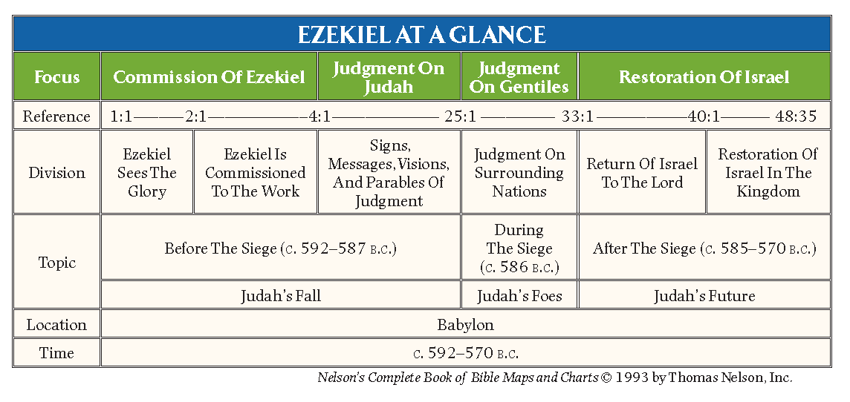
Background
Ezekiel is writing from a bad situation to more than 10,000 fellow Jews in the same situation. They’re all exiled a thousand-mile walk from home living in the heart of the Babylonian Empire, in what is now Iraq. At age 25, in 597 BC, the priest Ezekiel is taken captive to Babylon. Five years later, he begins 22 years of ministry as a prophet, from 592 to 570.
Babylon had already invaded the Jewish nation twice. First in 625 BC. That was to introduce themselves as the new world superpower replacing Assyria, which they had just crushed. They also took the occasion to demand that the Jews send them tax money each year. The Babylonisans came again eight years later in 597BC. They did this to collect their taxes after the Jewish king decided to stop sending money.
It was during the second invasion that Babylon took thousands of Jews with them, Ezekiel included. Political prisoners, of sorts, many were free to live as they pleased in Babylon – as long as they didn’t try to go home.
Ezekiel is a priest, which means he now has nothing to do. The work of a priest takes place in the Jerusalem temple, which for Ezekiel is a long and forbidden commute. But God gives him a new job. Ezekiel becomes a prophet to the Jewish exiles in Babylon. Nebuchadnezzar would destroy Solomon’s Temple in 587 BC during what is known as the “Jerusalem Siege”.

Ezekiel’s Message
Ezekiel’s message has two basic points:
- Judgment: God is going to allow the Babylonians to destroy what remains of the Jewish nation and to exile most Jews who survive the onslaught.
- Glory: God will eventually send the Jews back home to rebuild their nation to levels of glory never seen before.
Ezekiel uses prophecies, parables, signs, and symbols to dramatize God’s message to His exiled people. Though they are like dry bones in the sun, God will reassemble them and breathe life into the nation once again. Present judgment will be followed by future glory. The Hebrew name transliterated “Ezekiel” means “God Strengthens” or “Strengthened by God.” The name occurs twice in this book and nowhere else in the Old Testament.

Visions, Dreams, and Dark Sayings
Ezekiel begins his autobiographical account by declaring “The heavens were opened and I saw visions of God” (1:1). A vision in the Bible days was a miraculous experience of a man of God on a special occasion whereby God revealed truth to him in some pictoral and audible form. Visions and dreams given to prophets are often “dark sayings” and not easy to interpret. Consider the words of God in Numbers 12:6–8, “And he said, “Hear my words: If there is a prophet among you, I the LORD make myself known to him in a vision; I speak with him in a dream. 7 Not so with my servant Moses. He is faithful in all my house. 8 With him I speak mouth to mouth, clearly, and not in riddles [dark sayings], and he beholds the form of the LORD...”

Comparison of the Four Major Prophets
 | Isaiah | Jeremiah | Ezekiel | Daniel
Prophesied To: | Jews in Judea | Jews in Judea and captivity | Jews captive in Babylon | Jews captive in Babylon and Gentile kings
Concerning: | Judah and Jerusalem  (Isa. 1:1; 2:1) | Judah and Nations (Jer. 1:5, 9-10; 2:1-2) | The whole house of Israel  (Ezek. 2:3-6; 3:4-10, 17) | Israel and Gentile Nations  (Dan. 2:36ff; 9)
During the reigns of: | Uzziah, Jotham, Ahaz, Hezekiah (kings of Judah) | Josiah, Jehoahaz, Jehoiakim, Jehoiachin, Zedekiah  (kings of Judah) | Zedekiah  (king of Judah);  Nebuchadnezzar  (king of Babylon) | Jehoiakim, Jehoiachin, Zedekiah  (kings of Judah).  Nebuchadnezzar  (king of Babylon
Dates: | 740-680 B.C. | 627-585 B.C. | 592-570 B.C. | 606-537 B.C.
Historical  Setting: | 2 Kings 15-21;  2 Chronicles 26-30 | 2 Kings 22-25 | Daniel 1-6 | Daniel 1-6
.
Keys for Christians
The Work of the Spirit
The English pastor of the 19th century, John Gill noted that the vision of Ezekiel’s first chapter of the “wheel in a wheel” was a vision of the operation of the Spirit of God. He writes:
There is an unity, harmony, and consistence, in the ministration of the gospel; the wheels have one likeness; and though the doctrines of the gospel are mysterious, abstruse, and hidden to many, are like a riddle, or an enigma, or as a wheel within a wheel yet they are plain to enlightened minds, to them that find spiritual and experimental knowledge: and as wheels when set in motion roll on with force and rapidity; so the doctrines of the gospel, when the Spirit of God is in those wheels, or when they are attended with his energy, they come with demonstration and power, and are the power of God unto salvation.

The Throne of God and the Glory Cloud
What we have in the first chapter of Ezekiel is a vision of God. The wheels are the operation of God’s Spirit. We see the angelic “living creatures” doing the bidding of the Spirit of God: “Wherever the Spirit wanted to go, they went, and the wheels rose along with them, for the spirit of the living creatures was in the wheels” (1:20).
Upon the wheels is the throne of God: “And above the expanse over their heads there was the likeness of a throne, in appearance like sapphire; and seated above the likeness of a throne was a likeness with a human appearance” (1:26) and “Such was the appearance of the likeness of the glory of the LORD. ” (1:28b).

Ezekiel Falls on His Face
The key elements that point us to this amazing vision of God are the oft mentioned “fire” and “cloud” that remind us of the glory cloud that led the children of Israel in their wanderings. In chapter 1, Ezekiel sees God Himself, glowing and surrounded by a halo of light. “Such was the appearance of the likeness of the glory of the LORD. And when I saw it, I fell on my face, and I heard the voice of one speaking” (1:28b).

Hope in Judgment
Ezekiel’s message, though hard to hear, at least offers hope. It assures the Jews that even though they’re in breach of contract for breaking their ancient covenant to serve God, they are still God’s chosen people. God will punish them for their centuries of sin. But punishment isn’t God’s final word. Ezekiel and the other Bible prophets don’t end their messages with doom and gloom. Their messages end with God’s punishment achieving its effect: repentance, forgiveness, and restoration back into the land.

A Bitter Message, Sweeter than Honey
This judgment and rebuild temple will prepare the way for Messiah to come. For the Jews in exile, Ezekiel says they can count on going back home to a better Jerusalem than they left. We see this in Ezekiel 2 and 3.
2:9-10, “when I looked, behold, a hand was stretched out to me, and behold, a scroll of a book was in it. 10 And he spread it before me. And it had writing on the front and on the back, and there were written on it words of lamentation and mourning and woe.”
3:3, “Son of man, feed your belly with this scroll that I give you and fill your stomach with it.” Then I ate it, and it was in my mouth as sweet as honey.”
It was a scroll of bitter judgment that would end up in great glory – a message that is sweeter than honey!

Ezekiel’s Tel Aviv
Israel’s most cosmopolitan city took its name in 1909 from the first Jewish community to hear Ezekiel’s message. The prophet went to “Tel-abib” (Eze. 3:15). The name means "mound of the deluge" because it was flooded by the Euphrates River in the land of Babylon. When the Jews returned to Israel, they named their coastal city “Tel Aviv” to symbolize the rebirth of Israel, which Ezekiel predicted.

Ezekiel’s Wife
His wife died as a sign to the exiled Jews that Jerusalem would not be spared (24:16–24). His prophetic ministry shows a priestly emphasis in his concern with the temple, priesthood, sacrifices, and the Shekinah (the glory of God manifested in the temple). As Ezekiel was not allowed to mourn for that which was precious to him, so the Jews were not to mourn the Temple of God.
Ezekiel 24:16–24, “Son of man, behold, I am about to take the delight of your eyes away from you at a stroke; yet you shall not mourn or weep, nor shall your tears run down. 17 Sigh, but not aloud; make no mourning for the dead. Bind on your turban, and put your shoes on your feet; do not cover your lips, nor eat the bread of men.” 18 So I spoke to the people in the morning, and at evening my wife died. And on the next morning I did as I was commanded.
19 And the people said to me, “Will you not tell us what these things mean for us, that you are acting thus?” 20 Then I said to them, “The word of the LORD came to me: 21 ‘Say to the house of Israel, Thus says the Lord GOD: Behold, I will profane my sanctuary, the pride of your power, the delight of your eyes, and the yearning of your soul, and your sons and your daughters whom you left behind shall fall by the sword. 22 And you shall do as I have done; you shall not cover your lips, nor eat the bread of men. 23 Your turbans shall be on your heads and your shoes on your feet; you shall not mourn or weep, but you shall rot away in your iniquities and groan to one another. 24 Thus shall Ezekiel be to you a sign; according to all that he has done you shall do. When this comes, then you will know that I am the Lord GOD.’”

The Good Shepherd, Great Shepherd, Chief Shepherd
A condemnation of the current leaders of Israel leads to a prophecy of the true Shepherd that would come and gather His sheep to Himself.
Ezekiel 34:11–14, “For thus says the Lord GOD: Behold, I, I myself will search for my sheep and will seek them out. 12 As a shepherd seeks out his flock when he is among his sheep that have been scattered, so will I seek out my sheep, and I will rescue them from all places where they have been scattered on a day of clouds and thick darkness. 13 And I will bring them out from the peoples and gather them from the countries, and will bring them into their own land. And I will feed them on the mountains of Israel, by the ravines, and in all the inhabited places of the country. 14 I will feed them with good pasture, and on the mountain heights of Israel shall be their grazing land. There they shall lie down in good grazing land, and on rich pasture they shall feed on the mountains of Israel.”
This passage has a clear allusion to the Shepherd’s Psalm 23, another prophecy given of the coming of David’s Son who is both King and Shepherd.
Ezekiel 34:23–24, “And I will set up over them one shepherd, my servant David, and he shall feed them: he shall feed them and be their shepherd. 24 And I, the LORD, will be their God, and my servant David shall be prince among them. I am the LORD; I have spoken.” This is an obvious prophecy of Christ who is the “Good Shepherd” (Jn. 10:11-16).
Christ claims personally to be “the good shepherd” mentioned in Ezekiel. They will be one and have one Shepherd over them (cf. Jn. 17, Jesus’ high priestly prayer). He is the Chief Shepherd (1 Peter 5:4) and the Great Shepherd of the sheep (Heb. 13:20). The Son of God comes to gather into one flock the “lost sheep of the house of Israel” (Matt. 15:24) and the lost sheep from among every nation (Matt. 28:18-20).
Christ summarizes His fulfillment of this prophecy from Ezekiel in John 10:16, “And I have other sheep that are not of this fold. I must bring them also, and they will listen to my voice. So there will be one flock, one shepherd.”
The River of Life
Pouring from the Temple is a stream. Ezekiel 47:1, “Then he brought me back to the door of the temple, and behold, water was issuing from below the threshold of the temple toward the east…” Everywhere this water flows it brings life where previously there had been nothing but death. Ezekiel 47:9, “And wherever the river goes, every living creature that swarms will live, and there will be very many fish. For this water goes there, that the waters of the sea may become fresh; so everything will live where the river goes.”
The picture of the healing waters flowing from the altar in the temple holds a remarkable Christological message. The Temple symbolizes Christ; the altar symbolizes Christ crucified; the healing water indicates the spiritual life that flows from the crucified Savior (cf. John 19:34, “But one of the soldiers pierced his side with a spear, and at once there came out blood and water”).
To the Samaritan woman, the Lord offered “living water” (John 4:10). The ‘water’ that He gives becomes a “fountain of water springing up into everlasting life (John 4:14). A little later at the Feast of Tabernacles, we read our Lord’s commentary of how He is this River of Life: “On the last day of the feast, the great day, Jesus stood up and cried out, “If anyone thirsts, let him come to me and drink. 38 Whoever believes in me, as the Scripture has said, ‘Out of his heart will flow rivers of living water.’ ” 39 Now this he said about the Spirit, whom those who believed in him were to receive, for as yet the Spirit had not been given, because Jesus was not yet glorified” (John 7:37–39).
The River of Life is flowing from the Temple (47:1; Joel 3:18; Zech.14:8-9). This is the “river whose streams make glad the city of God, the holy habitation of the Most High” (Psalm 46:4). Along its banks are trees that provide food and medicine, “for the healing of the nations” (47:12; Rev. 22:1-2). Ezekiel’s Temple’s greatest fulfillment is in the people of God. We are formed into a Temple as we are builded into Christ, who is the chief Cornerstone!

The New Heart and Covenant
Ezekiel 36:25–27, “I will sprinkle clean water on you, and you shall be clean from all your uncleannesses, and from all your idols I will cleanse you. 26 And I will give you a new heart, and a new spirit I will put within you. And I will remove the heart of stone from your flesh and give you a heart of flesh. 27 And I will put my Spirit within you, and cause you to walk in my statutes and be careful to obey my rules.”
Ezekiel 37:26–28, “I will make a covenant of peace with them. It shall be an everlasting covenant with them. And I will set them in their land and multiply them, and will set my sanctuary in their midst forevermore. 27 My dwelling place shall be with them, and I will be their God, and they shall be my people. 28 Then the nations will know that I am the LORD who sanctifies Israel, when my sanctuary is in their midst forevermore.”
The context shows that there will be a wonderful spiritual awakening that will begin with Israel. This awakening as we will see in a moment had a powerful beginning at Pentecost in Acts 2. This was the ratification of the New Covenant – the pouring out of the Spirit of God (cf. Jer. 31:33-34).
The signification addition promised by God and prophesied by Ezekiel is the indwelling of the Holy Spirit in believers. This is one of the glories of the New Covenant. The indwelling of the Holy Spirit was dependent upon the completed work of the Messiah, the Lord Jesus Christ. He must be glorified (John 7:37-39), dying and suffering in the place of His people, rising from the dead, and ascending to the glory of the Father to the right hand of the “Majesty on high” (Heb. 1:3).
The Promises of the New Covenant are:
- The complete removal of sin through the cleansing blood of the New covenant (36:25; Heb. 13:20).
- The law of God written on the heart – an obedient and sensitive heart of flesh with the removal of the heart of stone (36:26; Jer. 31:33; 2 Cor. 3:3; 5:17 – “old things are passed away, the new has come”).
- The Holy Spirit of God indwelling all believers (36:27; Rom. 8:9; 1 Cor. 3:16; 6:19).

The Valley of Dry Bones – Born Again!
Twenty-five times Ezekiel referes to the ministry of the Spirit of God (e.g. chapter 1, 2:2; 3:12, 14, 24). The unique work of the Holy Spirit is brought to attention in the vision of the Valley of Dry Bones in Ezekiel 37:1–14, “The hand of the LORD was upon me, and he brought me out in the Spirit of the LORD and set me down in the middle of the valley; it was full of bones. 2 And he led me around among them, and behold, there were very many on the surface of the valley, and behold, they were very dry. 3 And he said to me, “Son of man, can these bones live?” And I answered, “O Lord GOD, you know.” 4 Then he said to me, “Prophesy over these bones, and say to them, O dry bones, hear the word of the LORD. 5 Thus says the Lord GOD to these bones: Behold, I will cause breath to enter you, and you shall live. 6 And I will lay sinews upon you, and will cause flesh to come upon you, and cover you with skin, and put breath in you, and you shall live, and you shall know that I am the LORD.”
7 So I prophesied as I was commanded. And as I prophesied, there was a sound, and behold, a rattling, and the bones came together, bone to its bone. 8 And I looked, and behold, there were sinews on them, and flesh had come upon them, and skin had covered them. But there was no breath in them. 9 Then he said to me, “Prophesy to the breath; prophesy, son of man, and say to the breath, Thus says the Lord GOD: Come from the four winds, O breath, and breathe on these slain, that they may live.” 10 So I prophesied as he commanded me, and the breath came into them, and they lived and stood on their feet, an exceedingly great army.
11 Then he said to me, “Son of man, these bones are the whole house of Israel. Behold, they say, ‘Our bones are dried up, and our hope is lost; we are indeed cut off.’ 12 Therefore prophesy, and say to them, Thus says the Lord GOD: Behold, I will open your graves and raise you from your graves, O my people. And I will bring you into the land of Israel. 13 And you shall know that I am the LORD, when I open your graves, and raise you from your graves, O my people. 14 And I will put my Spirit within you, and you shall live, and I will place you in your own land. Then you shall know that I am the LORD; I have spoken, and I will do it, declares the LORD.”
Here the spiritual destitution, regeneration and restoration of God’s people are envisioned. The vision denotes the collective misery of Israel in exile and of mankind in general as “dead in trespasses and sins” (Eph. 2:1-3). Ezekiel is not concerned with the political stature of the nation, but simply being alive as soldiers in the army of the Living God.
The Power of the Word – The power of the new life is in the Word that Ezekiel prophesies. Ezekiel is directed to preach and pray, and the result is the life of those who were spiritually dead. They are resurrected! This is the “first resurrection” spoken of by John in Revelation 21:4-6. He who has the first resurrection will not partake in the second death.
From this and other Old Testament Scriptures, Nicodemus should have understood as a teacher of Israel, the words of the Lord Jesus in John 3:5–8 “Truly, truly, I say to you, unless one is born of water and the Spirit, he cannot enter the kingdom of God. 6 That which is born of the flesh is flesh, and that which is born of the Spirit is spirit. 7 Do not marvel that I said to you, ‘You must be born again.’ 8 The wind blows where it wishes, and you hear its sound, but you do not know where it comes from or where it goes. So it is with everyone who is born of the Spirit.”
This vision is linked with the Day of Pentecost and the coming of the Holy Spirit. Acts 2:2–4, “And suddenly there came from heaven a sound like a mighty rushing wind, and it filled the entire house where they were sitting. 3 And divided tongues as of fire appeared to them and rested on each one of them. 4 And they were all filled with the Holy Spirit and began to speak in other tongues as the Spirit gave them utterance.”

The True Temple
Ezekiel 37:27, “My dwelling place shall be with them, and I will be their God, and they shall be my people.” The destruction of Jerusalem and the temple by the invading forces of the Babylonians in 586-7 BC brought dismay to the Jews in Babylon. Thirteen years after the fall of the city, Ezekiel is given the vision of a new temple in Jerusalem (40:1).
When the exiles return following the decree of Cyrus (539 BC) Zerubbabel, encouraged by the prophets Haggai and Zechariah, reguilds the temple in Jerusalem (Ezra 5:2; 6:14-16). But it as not as spectacular as prophesied by Ezekiel. Some elements of the vision seem to go beyond a reasonable literal understanding (47:1-12).
The second Temple as expanded under King Herod did much to try to come close to Ezekiel’s vision – it was a mammoth Temple! But it was still just a fourth of the size of the Temple in Ezekiel’s vision.
Several solutions to this prophecy have been noted.
- Some say that Ezekiel’s Temple will be built in the Millennial Kingdom. This view held by Premillennialists only. It is a possibility, but problematic as it would entail continued animal sacrifice after the Second coming of Christ.
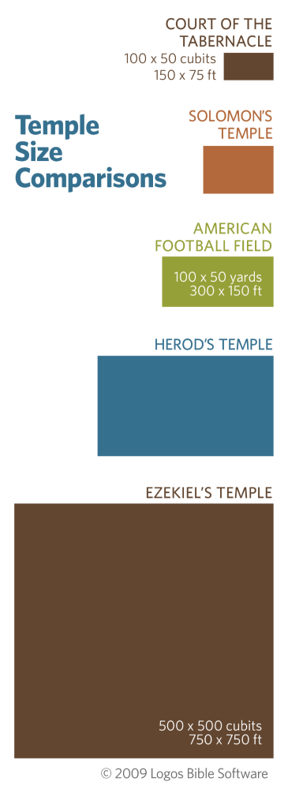
- Others hold that this was the Temple that God intended for Zerubbabel to build, and had the Jews continued to obey God, they would have built it, but they came short.
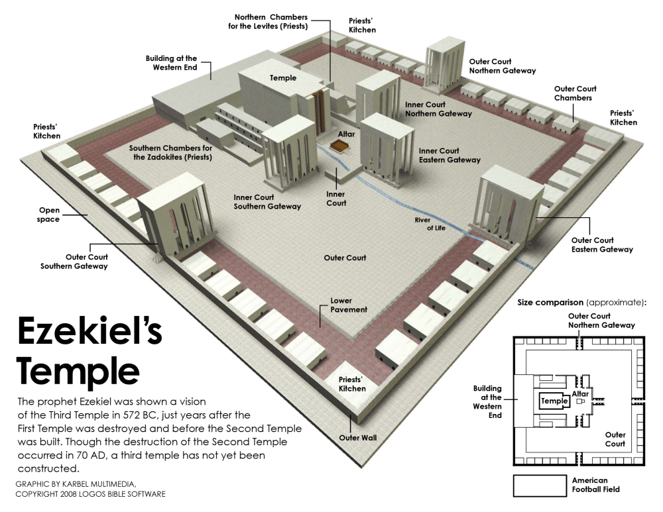
- Others still hold that Ezekiel’s Temple is ultimately a shadow of the true temple, Christ and His church where He will be our God and we will be His people.

I find a combination of the second and third views satisfactory. The Jews did not obey the Lord as they should and yet, we can all be encouraged at the spiritual insights that Ezekiel’s Temple gives us.
The Temple is ultimately a picture of Christ and His people even as the Apostle John speaks of in the book of Revelation 21:1-3, 22-26, “Then I saw a new heaven and a new earth, for the first heaven and the first earth had passed away, and the sea was no more. 2 And I saw the holy city, new Jerusalem, coming down out of heaven from God, prepared as a bride adorned for her husband. 3 And I heard a loud voice from the throne saying, “Behold, the dwelling place of God is with man. He will dwell with them, and they will be his people, and God himself will be with them as their God.
22 And I saw no temple in the city, for its temple is the Lord God the Almighty and the Lamb. 23 And the city has no need of sun or moon to shine on it, for the glory of God gives it light, and its lamp is the Lamb. 24 By its light will the nations walk, and the kings of the earth will bring their glory into it, 25 and its gates will never be shut by day—and there will be no night there. 26 They will bring into it the glory and the honor of the nations.”
Ezekiel’s Temple points to the true Temple, the people of God. Consider:
  - It’s large – God wants many people of all nations to come!
  - There are numerous hundreds of dining areas, little restaurants – an invitation to dine with God as our Friend
Acts 7 is a very helpful commentary in understanding the ultimate meaning of the shadow of the Temples in Scripture. Acts 7 is actually quoting Isaiah 66:1-2.
Acts 7:48–50, “Yet the Most High does not dwell in houses made by hands, as the prophet says, 49 “ ‘Heaven is my throne, and the earth is my footstool. What kind of house will you build for me, says the Lord, or what is the place of my rest? 50 Did not my hand make all these things?’

Symbolic of Christ – Ezekiel’s temple is ultimately a symbolic shadow and picture of Christ. He is the true and living Temple. He pointed to Himself as the true Temple when he said if they tore down “this Temple” He would rebuild it in three days (John 2:19-22). He draws His people together as “living stones” in this true Temple, His Body. 1 Peter 2:5, “you yourselves like living stones are being built up as a spiritual house, to be a holy priesthood, to offer spiritual sacrifices acceptable to God through Jesus Christ.” Ephesians 2:21, “in whom the whole structure, being joined together, grows into a holy temple in the Lord” (cf. 1 Cor. 3:16; 6:19).
E.J. Young (Westminster theologian and popular commentator) concludes, “This elaborate representation [of Ezekiel’s Temple] is a picture of the Messianic age. The Lord dwells in the midst of His people…Ezekiel… was speaking of Christ… He was in a manner peculiar to himself, preaching Jesus Christ.”

Parallels between Ezekiel and Revelation

THE VISION | EZEKIEL | REVELATION
1. The throne vision | Chapter 1 | Chapter 4
2. The book being opened | Chapters 2-3 | Chapter 5
3. The four plagues | Chapter 5 | Chapter 6:1-8
4. Those slain under the altar | Chapter.6 | Chapter 6:9-11
5. The wrath of God | Chapter 7 | Chapter 6:12-17
6. The seal on the Saint's foreheads | Chapter 9 | Chapter 7
7. The coals from the altar | Chapter.10 | Chapter 8
8. The 1/3 destruction | Chapter 5:1-4 &12 | Chapter 8:6-12
9. No more delay | Chapter 12 | Chapter 10:1-7
10. The eating of the book | Chapter 2 | Chapter 10:8-11
11. Prophecy against the Nations | Chapters 25-32 | Chapter 10:11
12. The measuring of the Temple | Chapters 40-43 | Chapter 11:1-2
13. Comparing Jerusalem to Sodom | Chapter 16 | Chapter 11:8
14. The cup of wrath | Chapter 23 | Chapter 14
15. The vine of the land | Chapter 15 | Chapter 14:18-20
16. The great harlot | Chapters 16, 23 | Chapters 17-18
17. The lament sung over the city | Chapter 27 | Chapter 18
18. The scavenger's feast | Chapter 39 | Chapter 19
19. The first resurrection | Chapter 37 | Chapter 20:4-6
20. The Battle of Gog and Magog | Chapter 38-39 | Chapter 20:7-9
21. The New Jerusalem | Chapters 40-48 | Chapter 21
22. The River of Life | Chapter 47 | Chapter 22

Post-Exile Prophets

Post-exile Prophet
Haggai

(Turning Apathy to Enthusiasm)

Author: the prophet Haggai

Date: August 29 to December 18, 520 BC
Hebrews 12:26, “At that time his voice shook the earth, but now he has promised, “Yet once more I will shake not only the earth but also the heavens” (quoting Haggai 2:6).

Second Shortest Book
Haggai is second only to Obadiah in brevity among the Old Testament books, but this strong and frank series of four brief sermons accomplishes its intended effect. It was written over a period of just under 4 month’s time. We know this because of the clear dates recorded in Haggai.
In 538 B.C., Cyrus of Persia issued a decree allowing the Jews to return to their land and rebuild their temple, and in 536 B.C. work on the temple commenced. The returning exiles met with strong opposition from the Samaritans in the land, and work on the temple stopped in 534 B.C. It was in this context that God called His prophets Haggai and Zechariah to the same task of urging the people to complete the temple. All four sermons of Haggai are precisely dated in the year 520 B.C., the second year of the reign of Darius I (521–486 B.C.), king of Persia. The first was delivered on the first day of the Hebrew month of Elul (August-September), the second on the first day of Tishri (September-October), and the last two on the twenty-fourth day of Kislev (November-December). Later, the messages were compiled into what is now known as the book of Haggai.

Houses More Important than Temple
The work on the temple had ceased and the people had become more concerned with the beautification of their own houses than with the building of the central sanctuary of God. Because of their misplaced priorities, their future labors cannot be blessed by God. Only when the people put the Lord first by completing the task He set before them will His hand of blessing once again be upon them.

Zechariah and Haggai
The prophet Haggai is known only from this book and from two references to him in Ezra 5:1 and 6:14. There he is seen working alongside the younger prophet Zechariah in the ministry of encouraging the rebuilding of the temple. Haggai returned from Babylon with Zerubbabel and evidently lived in Jerusalem. After Haggai started preaching, Zechariah began preaching as well.

Haggai, an Older Prophet from First Temple Era?
Haggai 2:3 is an interesting verse: “Who is left among you who saw this house in its former glory? How does it look to you now? Doesn’t it seem like nothing to you?” (HSCB). Some interpret 2:3 to mean that he was born in Judah before the 586 B.C. destruction of the first temple and was one of the small company who could remember the splendor of the former temple. This would mean that Haggai was about seventy-five years old when he prophesied in 520 B.C. It is equally likely, however, that he could have been born in Babylon during the captivity.

A Message from God
One outstanding feature of Haggai’s message is his strong awareness that his messages had their origin in God. Some 25 times he affirmed the divine authority of his messages. He consistently introduced his messages with, “This is what the Lord Almighty says,” and concluded them with a similar focus (“declares the Lord Almighty”).

Apathy of the People
Haggai, along with Zechariah and Malachi, faced a different situation than had the pre-exilic prophets. Those earlier prophets confronted a people who tended to depend upon physical ceremonies and buildings rather than upon a true relationship with God marked by obedience. In contrast, the postexilic prophets ministered to a discouraged and apathetic people who were tempted to believe that nothing they did made any difference from a religious standpoint. The destruction of Jerusalem had humbled a once-proud people and they were influenced by the Persian view of all religions as equal in value.
As a result, the returning Jews saw little reason to pay careful attention to their distinctive laws and practices, and they felt no need to be overly concerned about rebuilding the temple. Of course, the dangers of this situation were profound. In short order, the Jews would be assimilated into the pagan culture around them; the revelatory heritage would be lost, and the messianic line of promise extinguished. The postexilic prophets were faced with the task of encouraging the people to distinguish themselves from the other peoples by the character of their obedience, and this obedience had to begin with the rebuilding of the temple and the reestablishment of the Mosaic laws.

Structure and Themes
Haggai’s basic theme is clear: the remnant must reorder its priorities and complete the temple before it can expect the blessings of God. The four messages recorded here may be entitled: the completion of the latter temple (1:1–15), the glory of the latter temple (2:1–9), the present blessings of obedience (2:10–19), and the future blessings of promise (2:20–23).
The promise of Haggai 2:9 points ahead to the crucial role the second temple was to have in God’s redemptive plan. Herod the Great later spent years enlarging and enriching this temple, and it was filled with the glory of God incarnate every time Christ came to Jerusalem.

Keys for Christians
The Temple Filled with Glory
Haggai 2:6–7, 9, “For thus says the LORD of hosts: Yet once more, in a little while, I will shake the heavens and the earth and the sea and the dry land. 7 And I will shake all nations, so that the Desire of All Nations shall come in, and I will fill this house with glory, says the LORD of hosts… 9 The latter glory of this house shall be greater than the former, says the LORD of hosts. And in this place I will give peace, declares the LORD of hosts.’ ”
This is a Messianic promise that will be fulfilled when 500 years after Haggai, the incarnate Son of God will enter the temple and bring a greater glory to it than the first temple. Christ is, as Hebrews 1:3 says, “the radiance of the glory of God and the exact imprint of his nature, and he upholds the universe by the word of his power”.
Even so, the true temple, His very body, would be destroyed and raised on the third day. So all who believe in him and come to him are “living stones…built up as a spiritual house, a holy priesthood” offering up “spiritual sacrifices acceptable to God through Jesus Christ” (1 Peter 2:5). Solomon’s Temple and the rebuilt temple of Zerubbabel are shadows of the true Temple, the Body of Christ (1 Cor. 3:16-17; 6:19-20).

The Messianic Line
The Messiah is also portrayed in the person of Zerubbabel (2:23), who becomes the center of the messianic line, sealing both branches together. Zerubbabel was of the tribe of Judah, of the house of David. He never had a kindom, nor ever wore a crown, nevertheless, the Lord chose him and made him as a “signet”.
Haggai 2:23, “I will take you, O Zerubbabel my servant, the son of Shealtiel, declares the LORD, and make you like a signet ring, for I have chosen you, declares the LORD of hosts.” So Zerubbabel becomes the center of the Messianic line and is like a signet sealing both branches together. Two lines descend from Zerubabbel, that of Mary the mother of Jesus and his step father, Joseph, who gave legal right to Jesus to reign (Matt. 1:12-13; Luke 3:27).

Post-exile Prophet
Zechariah

(God Encourages His People)

Author: the prophet Zechariah

Date: 515 BC
Matthew 23:34-37, “some you will flog in your synagogues and persecute from town to town, 35 so that on you may come all the righteous blood shed on earth, from the blood of innocent Abel to the blood of Zechariah the son of Barachiah, whom you murdered between the sanctuary and the altar. 36 Truly, I say to you, all these things will come upon this generation. 37 “O Jerusalem, Jerusalem, the city that kills the prophets and stones those who are sent to it! How often would I have gathered your children together as a hen gathers her brood under her wings, and you would not!”

Background
For a dozen years or more, the task of rebuilding the temple had been half completed. The prophet Zechariah was commissioned by God to encourage the people to complete this important task. Rather than exhorting them with strong words of rebuke (as Haggai did), Zechariah offered a very positive goal: the temple must be built, for someday the glory of the Messiah would inhabit it.
Zechariah, whose name means “Yahweh Remembers,” was one of the postexilic prophets and a contemporary of Haggai. The name “Zechariah” was a popular one in the Old Testament, being shared by no fewer than twenty-nine Old Testament characters. As the son of Berechiah and grandson of Iddo, he came from one of the priestly families of the tribe of Levi. He was born in Babylon and was brought by his grandfather to Palestine when the Jewish exiles returned under Zerubbabel.

Time Period of Zechariah
Zechariah was a younger contemporary of Haggai the prophet, Zerubbabel the governor, and Joshua the high priest. The historical setting for chapters 1–8 is the same as that of Haggai (520–518 B.C.). Work was resumed on the temple in 520 B.C. and the project was completed in 516 B.C. Chapters 9–14 are undated, but stylistic differences and references to Greece (9:13) indicate a date of between 480 and 470 B.C. This would mean that Darius I (521–486 B.C.) had passed from the scene and had been succeeded by Xerxes (486– 464 B.C.), the king who made Esther queen of Persia.

Outline of Zechariah
Encouragement through God’s Rule – via eight visions (1:7–6:15)
Encouragement through God’s Word – via two messages (ch. 7-8)
Encouragement through God’s Son – via two prophecies (ch. 9-14)

Eight Night Visions (1:7–6:15)

These eight visions that Zechariah receives reveal God’s glorious future for His people under the rule and direction of the Lord Jesus Christ, the Messiah.

Zechariah’s Eight Night Visions
Vision | Reference | Meaning
The Red-horse Rider among the Myrtle Trees | 1:7-17 | Christ, our Warrior General, though hidden in trial, will be victorious – He shows there is a false peace among the nations.
The Four Horns and the Four Craftsmen | 1:18-21 | The nations that persecute God’s people (the four horns, perhaps Egypt, Assyria, Babylon, and the Medo-Persians) would be torn down by four craftsman (unnamed, but the point is God is bigger than nations and able to bring in His kingdom.)
The Surveyor with a Measuring  Line | Chapter 2 | Christ is the Master Builder of His Church
The Cleansing and Crowning of  Joshua the High Priest | Chapter 3 | Justification and the Great Exchange – our filth for Christ’s Righteousness
The Golden Lampstand and the  Two Olive Trees | Chapter 4 | The Ministry of the Holy Spirit (olive tree) and Christ (the olive Branch)
The Flying Scroll | 5:1-4 | The Ministry of the Scriptures (in comfort, conviction, & condemnation)
The Women of Wickedness in the Basket | 5:5-11 | Wickedness (idolatry) Removed from Israel at Shinar (Babylon), represented by two women (possibly Babylon and Assyria)
The Four Chariots | 6:1-15 | The Report of true rest that comes from the Messiah’s Kingdom

Two Messages
- Judgment Message Against Faking Worship (Hypocrisy)
Zechariah 7:5-6, 11-13 “Say to all the people of the land and the priests, When you fasted and mourned in the fifth month and in the seventh, for these seventy years, was it for me that you fasted? 6 And when you eat and when you drink, do you not eat for yourselves and drink for yourselves?... 11 But they refused to pay attention and turned a stubborn shoulder and stopped their ears that they might not hear. 12 They made their hearts diamond-hard lest they should hear the law and the words that the LORD of hosts had sent by his Spirit through the former prophets. Therefore great anger came from the LORD of hosts. 13 “As I called, and they would not hear, so they called, and I would not hear.”
- Salvation Message About God’s Faithfulness
Zechariah 8:2-8, 12, “Thus says the LORD of hosts: I am jealous for Zion with great jealousy, and I am jealous for her with great wrath. 3 Thus says the LORD: I have returned to Zion and will dwell in the midst of Jerusalem, and Jerusalem shall be called the faithful city, and the mountain of the LORD of hosts, the holy mountain. 4 Thus says the LORD of hosts: Old men and old women shall again sit in the streets of Jerusalem, each with staff in hand because of great age. 5 And the streets of the city shall be full of boys and girls playing in its streets. 6 Thus says the LORD of hosts: If it is marvelous in the sight of the remnant of this people in those days, should it also be marvelous in my sight, declares the LORD of hosts? 7 Thus says the LORD of hosts: behold, I will save my people from the east country and from the west country, 8 and I will bring them to dwell in the midst of Jerusalem. And they shall be my people, and I will be their God, in faithfulness and in righteousness. 12 For there shall be a sowing of peace. The vine shall give its fruit, and the ground shall give its produce, and the heavens shall give their dew. And I will cause the remnant of this people to possess all these things.”

Two Prophecies (ch. 9-14)
Prophecy of the First Advent (the Rejected Savior) ch. 9-11 – This prophecy describes the time of Zechariah through the rejection of Christ. We have the humility of Christ on a humble donkey (9.9-10), and the rejection of Christ by the leaders of Israel (11:8).
Prophecy of the Second Advent (the Rejected Savior Enthroned) ch. 12-14 – The second burden begins with the nation in warfare and mourning over their sin toward the ‘one whom they pierced,’ and ends with God faithfully cleansing His people, going to battle on their behalf, and finally establishing His Kingdom physically on all the earth.

Keys for Christians
Christ, the True Temple Builder & Priest-King
Zechariah 6:12–13, “Behold, the man whose name is the Branch: for he shall branch out from his place, and he shall build the temple of the LORD. 13 It is he who shall build the temple of the LORD and shall bear royal honor, and shall sit and rule on his throne. And there shall be a priest on his throne, and the counsel of peace shall be between them both.”
Since the promise is given to Zerubbabel that he himself will finish the rebuilding of the temple in Jerusalem (4:9), another temple must be intended here. God promises that the man spoken of as the Branch – that is the Messiah (cf. Isa. 4:2; Jer. 23:5-6) – will build, not a temple to the Lord, but rather the temple of the Lord. Joshua the high priest who is given the crown is pointing toward the true Priest-King, our Lord Jesus Christ.
Moreover, Christ will be the glory of the new temple, and He will rule as both king and priest. Such a double function was impossible in the Old Covenant since priests were descended from the tribe of Levi, not Judah.
The only other Priest King in the Old Testament is Melchizedek (Gen.14; Psa. 110), and our Lord is a priest in his priestly order (Heb. 7:1-10).

The Humble Messiah King
Zechariah 9:9-10, “Rejoice greatly, O daughter of Zion! Shout aloud, O daughter of Jerusalem! behold, your king is coming to you; righteous and having salvation is he, humble and mounted on a donkey, on a colt, the foal of a donkey. 10 I will cut off the chariot from Ephraim and the war horse from Jerusalem; and the battle bow shall be cut off, and he shall speak peace to the nations; his rule shall be from sea to sea, and from the River to the ends of the earth.”
The Jewish rabbis always understood this passage to refer to the coming of Messiah but tried to change their views after Christians applied it to Jesus of Nazareth.
Half a millennium had passed before the Lord Jesus said to His disciples one day, ''Go into the village opposite you, in which, at your entering, you shall find a colt tied, on which never man sat; loose him, and bring him here'' (Luke 19:30). Christ entered Jerusalem amid the plaudits of the crowd, riding upon a colt in exact fulfillment of prophecy. The accuracy of the minute details in the Word are breath-taking! What other book would dare risk such predictions? [cf. Mat 21:1-11].
Christ is prophesied to be just, possessing salvation, humble, outwardly poor (riding in a donkey), and as one whose kingdom is characterized by universal peace, since He has conquered all kings and nations.

Messiah, Betrayed with 30 Pieces of Silver
Zechariah 11:12–13, “I said to them, “If it seems good to you, give me my wages; but if not, keep them.” And they weighed out as my wages thirty pieces of silver. 13 Then the LORD said to me, “Throw it to the potter”—the lordly price at which I was priced by them. So I took the thirty pieces of silver and threw them into the house of the LORD, to the potter.”
The chief priests and the elders of Jesus’ day had no realization that they were fulfilling prophesy when they paid the sum of 30 pieces of silver to Judas Iscariot. After he committed suicide, they “threw it… to the potter” that is they bought the “potter’s field” with the blood money (Matt. 27:1-10; 11:12-13).

Messiah, the Pierced One
Zechariah 12:10 “And I will pour out on the house of David and the inhabitants of Jerusalem a spirit of grace and pleas for mercy, so that, when they look on me, on him whom they have pierced, they shall mourn for him, as one mourns for an only child, and weep bitterly over him, as one weeps over a firstborn”.
Shortly after our Lord died on the cross, soldiers arrived with orders to break the legs of the three crucified men. The legs of the men on either side of Christ were broken, but our Lord looked to be already dead, so a solider thrust a sword into His side and pierced Him. He would be pierced but like the Passover Lamb of Exodus 12:46, “you shall not break any of his bones.”
Also predicted in this passage is the great spiritual awakening of Pentecost where the crowd was confronted with crucifying the Lord.
- Acts 2:23, “this Jesus, delivered up according to the definite plan and foreknowledge of God, you crucified and killed by the hands of lawless men”.
- Acts 2:36, “Let all the house of Israel therefore know for certain that God has made him both Lord and Christ, this Jesus whom you crucified.”

This brought a great spiritual awakening among Israel, so that they “mourned over him whom they pierced”. As Acts 2:37, “Now when they heard this they were cut to the heart, and said to Peter and the rest of the apostles, “Brothers, what shall we do?”

Messiah, the Stricken Shepherd
Zechariah 13:7-9 “Awake, O sword, against my shepherd, against the man who stands next to me,” declares the LORD of hosts. “Strike the shepherd, and the sheep will be scattered; I will turn my hand against the little ones. 8 In the whole land, declares the LORD, two thirds shall be cut off and perish, and one third shall be left alive. 9 And I will put this third into the fire, and refine them as one refines silver, and test them as gold is tested. They will call upon my name, and I will answer them. I will say, ‘They are my people’; and they will say, ‘The LORD is my God.”
At the first verse of Zech. 13, the Lord promises that a fountain will be flowing that will wash all the guilt of moral pollution away from His people. What this fountain is becomes clear when read of the piercing of YHWH (12:10) and the striking of the Shepherd. This fountain is the death and suffering of our Lord Jesus Christ on the Cross of Calvary.
In Matthew 26:31-32, Jesus quoted this passage and told his disciples that when he was crucified all his disciples would be scattered. But he said “after I have been raised, I will go before you into Galilee” (Mt. 26:32).

Messiah and His Robe of Righteousness
Zechariah 3:1–5, “Then he showed me Joshua the high priest standing before the angel of the LORD, and Satan standing at his right hand to accuse him. 2 And the LORD said to Satan, “The LORD rebuke you, O Satan! The LORD who has chosen Jerusalem rebuke you! Is not this a brand plucked from the fire?” 3 Now Joshua was standing before the angel, clothed with filthy garments. 4 And the angel said to those who were standing before him, “Remove the filthy garments from him.” And to him he said, “Behold, I have taken your iniquity away from you, and I will clothe you with pure vestments.” 5 And I said, “Let them put a clean turban on his head.” So they put a clean turban on his head and clothed him with garments. And the angel of the LORD was standing by.”
From Matthew Henry on this passage:
“The angel showed Joshua, the high priest, to Zechariah, in a vision. Guilt and corruption are great discouragements when we stand before God. By the guilt of the sins committed by us, we are liable to the justice of God; by the power of sin that dwells in us, we are hateful to the holiness of God. Even God's Israel are in danger on these accounts; but they have relief from Jesus Christ, who is made of God to us both righteousness and sanctification. Joshua, the high priest, is accused as a criminal, but is justified. When we stand before God, to minister to him, or stand up for God, we must expect to meet all the resistance Satan's subtlety and malice can give. Satan is checked by one that has conquered him, and many times silenced him. Those who belong to Christ, will find him ready to appear for them, when Satan appears most strongly against them. A converted soul is a brand plucked out of the fire by a miracle of free grace, therefore shall not be left a prey to Satan. Joshua appears as one polluted, but is purified; he represents the Israel of God, who are all as an unclean thing, till they are washed and sanctified in the name of the Lord Jesus, and by the Spirit of our God. Israel now were free from idolatry, but there were many things amiss in them. There were spiritual enemies warring against them, more dangerous than any neighbouring nations. Christ loathed the filthiness of Joshua's garments, yet did not put him away. Thus God by his grace does with those whom he chooses to be priests to himself. The guilt of sin is taken away by pardoning mercy, and the power of it is broken by renewing grace.”

Faking Worship (7)
God’s Faithfulness (8)

Much of the material of this chapter is adapted from Vern Polythress. The Shadow of Christ in the Law of Moses (Walgumuth and Hyatt Publishers: Nashville: 1991).
Charles L. Feinberg, Class Notes, Dallas Theological Seminary, p. 3, 1960’s. Feinberg pointed out this quote was very ancient. The Midrash is a Rabinical Commentary.
Geisler, pp. 195-196.
Bruce Wilkinson and Kenneth Boa, Talk Thru the Old Testament, Vol. I, Thomas Nelson Publishers, 1983, p. 39.
Some of the ideas for this chart were drawn from A Popular Survey of the Old Testament, by Norman L. Geisler, Baker Book House, Grand Rapids, 1977, p. 83 and Talk Thru The Bible, by Bruce Wilkinson and Kenneth Boa, Thomas Nelson Publishers, Nashville, 1983, p. 47-49.
Nelson, Thomas (2010-01-19). Nelson's Complete Book of Bible Maps and Charts, 3rd Edition (Kindle Locations 1425-1428). Thomas Nelson. Kindle Edition.
Nelson, Thomas (2010-01-19). Nelson's Complete Book of Bible Maps and Charts, 3rd Edition (Kindle Locations 1512-1514). Thomas Nelson. Kindle Edition.
Wilkinson and Boa, p. 72.
Nelson, Thomas (2010-01-19). Nelson's Complete Book of Bible Maps and Charts, 3rd Edition (Kindle Locations 1628-1635). Thomas Nelson. Kindle Edition.
Charles Caldwell Ryrie, Ryrie Study Bible, Expanded Edition, Moody, electronic media.
Wilkinson and Boa, p. 84.
Raised from the dead: Related by Jesus: Matthew 9:18-19, 23-26; Mark 5:22-24, 35-43; Luke 7:11-17; 8:40-42, 49-56; 11:1-44
Multiplication of loaves: Related by Jesus: Matthew 14:13-21; 18:32-38; Mark 6:31-44; Luke 9:10-17; John 6:1-13
Curing of Skin Disease: Related by Jesus: Matthew 8:1-4; Mark 1:40-45; Luke 5:12-16; 17:11-19
Ryrie.
Wilkinson and Boa, p. 110.
Pritchard, James B. (1973), The Ancient Near East â€“ An Anthology of Texts and Pictures (Princeton, NJ: Princeton University Press), Vol. I., 208.
Rawlinson, George (1873), Historical Illustrations of the Old Testament (Boston: Henry A. Young & Co.), 194.
Xenophon (1893 Ed.), Cyropaedia, J.S. Watson and Henry Dale, Translators (London: George Bell & Sons), (8.7.3; cf. 1.2.1).
Ryrie, electronic media.
Warren W. Wiersbe. Be Determined.(Wheaton, IL: Victor Books, 1992), introduction.
Wilkinson and Boa, p. 125.
Norman L. Geisler, A Popular survey of the Old Testament, Baker, Grand Rapids, 1977, p. 180.
Charles L. Feinberg, Class Notes, Dallas Theological Seminary, p. 3, 1960’s. Feinberg pointed out this quote was very ancient. The Midrash is a Rabinical Commentary.
Geisler, pp. 195-196.
Ryrie, p. 831.
Wilkinson and Boa, p. 164.
Geisler, p. 214.
Archer, Electronic Media.
Carl Laney, Bibliotheca Sacra, Oct.-Dec. 1981, p. 315-316.
Wilkinson and Boa, p. 191.
Barnes commentary on Obadiah 1:21, Barnes Notes.
John Gill’s Sermon on Ezekiel one, accessed at http://www.reformedreader.org/rbs/gill/wheels.htm on 8 May 2013.

