When God Sends Revival
2 Chronicles 22-24
___________________________________________
The King is Coming (2 Chronicles)

Prepared by: Matthew S. Black

Sunday, January 22, 2017, 10:30am at Living Hope Church of Roselle, Illinois

livinghopechurch.net

“Revival, above everything else, is a glorification of the Lord Jesus Christ, the Son of God. It is the restoration of Him to the center of the life of the Church.”
~ D. Martyn Lloyd Jones

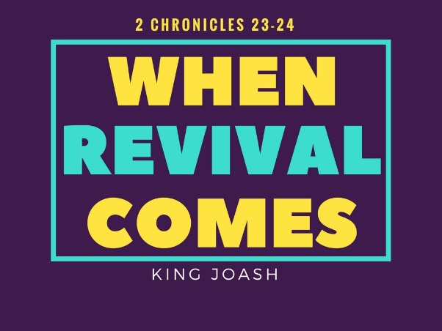
O
pen your Bible to 2 Chronicles. We are in a 15-message series in the book of 2 Chronicles entitled “The King is Coming.” This morning we are looking at a message number nine entitled: “Joash: When God Sends Revival.”

Proposition: God is ready to give revival and a baptism of power to all of His children. Will you receive it?

When Revival Comes

We need our church to be woken up. We need only but to ask for it. God is ready to give revival and a baptism of power to all of His children. Will you receive it?

Story of Evan Roberts

Just after eleven o’clock on a Wednesday evening a hundred years ago, a solo voice rang out with the beautiful Welsh hymn “Here Is Love Vast As The Ocean.”

Maybe a thousand people were in the Moriah Chapel in Wales at the time, packing every pew and squeezing into every spare corner. They’d been here for more than four hours, in a service of intense emotion. Revival had come! How did it happen?

For thirteen years Evan Roberts prayed for a new filling of the Holy Spirit in revival. He said, “For thirteen years I had prayed for the Spirit, and this is the way I was led to pray. William Davies, the deacon, said one night in the society: “Remember to be faithful. What if the Spirit descended and you absent? Remember Thomas! What a loss he had!”

How it Happened

Then one Friday night, while young Evan Roberts was praying, he tells the story, “I was taken up to a great expanse – outside of time and space. I was in deep communion with God. Before this God had seemed afar off and distant. That night God was so close, I was frightened, but I’ve never been frightened since. So great was my shivering that I rocked the bed, and my brother, being awakened, took hold of me, thinking I was ill.

“After that experience I was awakened every night a little after 1 o’clock in the morning. This was most strange, for through the years I slept like a rock, and no disturbance in my room would awaken me. From that hour I was taken up into the Divine Fellowship for about four hours. What it was I cannot tell you; except that it was Divine. About five o’clock I was again allowed to sleep on till about nine.

At this time I was again taken up into the same experience as in the earlier hours of the morning until about twelve or one o’clock in the afternoon. This continued for three months.

My family began to question me. Why didn’t I get up earlier, but it was too divine to say anything about it.”

After three months of praying he went to a prayer meeting with Evangelist Seth Roberts. On the way to the meeting he felt himself almost bursting.

Near the end of the prayer meeting Evan Roberts’ prayed a simple prayer. It was a fearful thing for him. He almost burst and began to cry out: “Oh Lord, bend me, Oh Lord, O Lord, bend me!” At that moment, the Spirit began to work mightily in the people and a great revival came to Whales.

That prayer blossomed into the theme of the revival: “Bend the Church and save the world.” Evan Roberts’ desire was that the church would know to have revival, one must simply ask God.

Evan Roberts Quote

While corporate or national revival is given by the sovereign outpouring of the Spirit, personal revival is the life of Jesus for the child of God. And so the child of God needs but to ask for a greater reality of the life of Jesus in us.

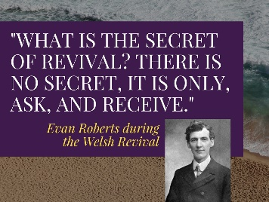

The Evangelist, Evan Roberts said:

“What is the secret of revival? There is no secret, it is only, ask, and receive.”

Revival belongs to the child of God. We have been risen with Christ unto newness of life. It is ours to live in that newness of life in the full outpouring of the Spirit.

Four Beginning Marks

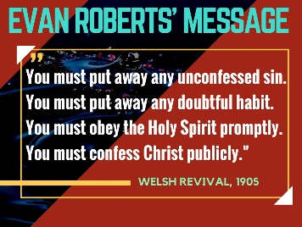

That sweet personal revival, where God may grant a sweeping revival of our entire congregation and community begins, Evan Roberts of the 1905 Welsh Revival said, with four marks:

“You must put away any unconfessed sin.

You must put away any doubtful habit.

You must obey the Holy Spirit promptly.

You must confess Christ publicly.”

Do you want to know God more than you want anything else? That’s revival. That’s what Israel experienced when Queen Athaliah was dethroned and a little six year old king was elevated to David’s throne.

Review of Key Persons
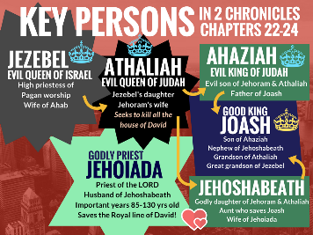
Let me give you a review of what’s going on in these chapters. Let me review the key players in these very dark scenes.
- Wicked Queen Jezebel. She’s married to Ahab (king of Northern Israel). We all know that Jezebel is a Gentile Queen from Tyre and Sidon. She brings Israel to a new level of depravity. In fact she is probably known as the wickedest woman that has ever lived. Yet there is one wicked than her. Jezebel’s daughter is named Athaliah.
- Evil Queen Athaliah is even more wicked than her mother because she does everything she can to destroy the royal family of David. Her goal is that David has no more descendants. And we know that includes the Lord Jesus Christ.
- Athaliah has two children: one evil and one good.
  - Evil King Ahaziah is duped by his mother Queen Athaliah into trusting the house of Ahab, and was lured to his own death and the death of his descendants, so that as far as anyone knew, the royal line of David was extinct. That means no Christmas, no cross, no resurrection. Queen Athaliah is so evil she is willing to murder her own children and grandchildren.
  - Godly Jehoshabeath marries the central good figure in Judah during this time: Jehoiada.
  - Godly Priest Jehoiada is a man known as "the Priest" even though he is 85 years old when he gets involved in saving the Kingdom. He does his best work beginning at 85 and he serves the Lord for 45 years and dies at the ripe old age of 130.

Review
And so Queen Athaliah, the daughter of Jezebel had been Queen for six years in Israel. She had dethroned and murdered and massacred the royal family.

First we find that…

- In Revival, Christ is exalted, (23:1-15).
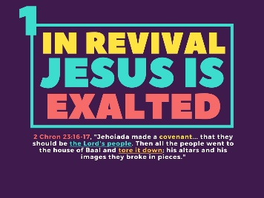
We turn to 2 Chronicles 23, and we have a very exciting chapter in the Bible.

Let David’s Son Reign
2 Chron 23:1-3, “But in the seventh year Jehoiada took courage and entered into a covenant with the commanders of hundreds… 2 And they went about through Judah and gathered the Levites from all the cities of Judah, and the heads of fathers' houses of Israel, and they came to Jerusalem. 3 And all the assembly made a covenant with the king in the house of God. And Jehoiada said to them, “Behold, the king's son! Let him reign, as the Lord spoke concerning the sons of David.”
Here is this man who is about 91 years old, and he begins a revival. Jehoiada is an old man, but he’s not given up.
Maybe you are older today, and you used to care for God’s church. You used to lead God’s church, but you’ve lost your passion and your edge.
Whatever your age, old or young, get in the game. This priest was 91 when revival broke out! And it lasted for the next 30 years until Jehoiada the priest died at age 130.

LET HIM REIGN

Revival Begins: A Declaration from Jehoiada: LET HIM REIGN
The Revival in Judah began with a declaration from Jehoiada: Let him reign! (Vs. 3). We need to let the Son of David reign today! That’s what revival is!
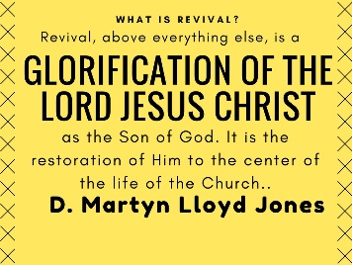
“Revival, above everything else, is a glorification of the Lord Jesus Christ, the Son of God. It is the restoration of Him to the center of the life of the Church.” - D. Martyn Lloyd Jones

Andrew Murray Quote
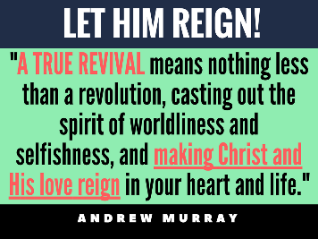
Andrew Murray said it this way, “A TRUE REVIVAL means nothing less than a revolution, casting out the spirit of worldliness and selfishness, and making Christ and His love reign in your heart and life.”

God Has Highly Exalted Jesus
St. Paul in Philippians 2:9-10 says that “God has highly exalted him and bestowed on him the name that is above every name, 10 so that at the name of Jesus every knee should bow, in heaven and on earth and under the earth, 11 and every tongue confess that Jesus Christ is Lord, to the glory of God the Father.”

Humbled before the throne of Christ
Let me ask you, have you humbled yourself before the throne of Jesus Christ? Your life will remain completely insignificant in light of eternity until you humble yourself before Christ. Let Him be high and lifted up in your life.
Give Him control of your heart and mind!
Some of you are ruled by condemnation. Let the love of Jesus rule in you, and there is “no condemnation” for those who know the love of Christ.
Some of you are ruled by the self-life. May the omnipotent power of Christ flood your soul with the grace that will break the bondage of any and every sin in your life.
Jesus is King! King of kings! Jesus is Lord! Lord of lords! Let us exalt Him! He is worthy!

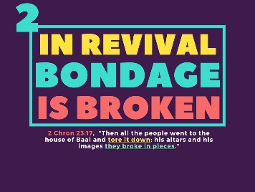
- In Revival, bondage is broken, (23:16-17).

We look at 2 Chronicles 23, and we have a very exciting chapter in the Bible.

Great Changes Are Made in Revival
Let the Son of David reign! That’s when we see a renewal where the bondage to sin is broken. Let’s read about all the good things that took place.
2 Chron 23:16 – They made a covenant. “And Jehoiada made a covenant between himself and all the people and the king that they should be the Lord's people.”
2 Chron 23:17 – They tore down their idols. “Then all the people went to the house of Baal and tore it down; his altars and his images they broke in pieces, and they killed Mattan the priest of Baal before the altars.”

DL Moody Quote
D L Moody decried the bondage of idolatry in his day, “You don’t have to go to heathen lands today to find false gods. America is full of them. Whatever you love more than God is your idol.”

Baal Shrine is Destroyed!
Shockingly, there was a Baal shrine (v. 17), constructed in the courts of the Temple of the Lord in Jerusalem under the auspices of Ahab’s house (cf. 21:11, 13)! But the people renewed their walk with YHWH in this covenant, and the Baal shrine was demolished.
When revival comes, bondage is broken. What are you in bondage to?

Blaise Pascal Quote
To find out what you are in bondage to, you must ask, what do I honor? What do I treasure? What do I hold above all things in my life, even above Christ? What has displaced the honor of Christ?
Blaise Pascal said it this way: “There is nothing so abominable in the eyes of God as idolatry, whereby men render to the creature that honor which is due only to the Creator.”

The Life of Bondage
High places were not harmless shrines—God’s people were seduced to flagrant sin at these altars. Isaiah rebuked them: “Are you not children of rebellion … who inflame yourselves among the oaks, under every luxuriant tree, who slaughter the children in the ravines?” (Isaiah 57:4-5).
The Kings of Judah succumbed to the worship of Canaanite dieties and built a high place for Baal and Asherah on the hills around Jerusalem. Queen Athaliah even had a Baal and Asherah shrine built in the courtyard of the Temple.

Today’s High Places
Today we don’t construct idolatrous clay figurines of Baal or attend worship services for Asherah, but our temptations are just as seductive and perhaps even more subtle.
Believers today might avoid obvious “high places” such as theft, ugly words or explosive anger. But we tend to be casual about sins that we have grown to accept in our lives. We need to ask the Spirit of God to convict us of sin today.
O God, tear down these idols in my life! Tear down: envy, worry, spiritual pride, sexual sins, gossip, sinful anger and explosiveness. These habits are nothing but sinful deeds of the flesh, and the true child of God refuses to live in bondage to them (Galatians 5:19-21).

Come, Let Us Return
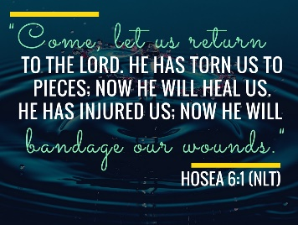
God invites us to return! Hosea 6:1, “Come, let us return to the Lord. He has torn us to pieces; now he will heal us. He has injured us; now he will bandage our wounds.”
He says in Hosea 6:3, “Let us know; let us press on to know the Lord; his going out is sure as the dawn; he will come to us as the showers, as the spring rains that water the earth.”

“Come Back to Me!
God is saying, “Come back to me!” I will bind up the wounds of your soul. Let’s tear down the idols and

How Do we Escape the Bondage of Idolatry?
We must go to our own funerals. Paul said, “I have been crucified with Christ. It is no longer I who live, but Christ who lives in me. And the life I now live in the flesh I live by faith in the Son of God, who loved me and gave himself for me” (Galatians 2:20). If we die to this world, we will have the fountain of life in Christ overflowing to abundance in our lives!

The Abundant Life
Let’s receive the abundant life today in covenant with the Living God! Matthew 1:23 tells us, by definition, that Jesus was Immanuel, which means, “God with us.” Jesus stated His purpose for being on earth in John 10:10: “I came that they may have life and have it abundantly.” That’s what revival is all about! “It’s the renewal of the abundant life in the Spirit of God.” As Christians, we are to “to know the love of Christ that surpasses knowledge, that you may be filled with all the fullness of God” (Ephesians 3:19).
In order to have that fullness, you must clear out the clutter of idols. There must be a reformation! In revival, bondage is broken.
You must tear down the idols in your life!

When Revival Comes, Everything Changes
When revival comes:
- Doubt can become faith.
- Discouragement can become joy.
- Despair can become purpose and fulfillment.
- Defeat can become victory.
How can that happen? Hosea said, “Return to the Lord.” Be like those in King Joash’s day: tear down the idols and return to the Lord. Here is a six year old child, but he’s commanding everyone to tear down the idols. Whether you are 6 or 96, don’t tolerate idols in your heart, in your family, in your church. Tear them down!

There Must be Genuine Repentance
When revival comes, the bondage to idols is broken. If you are born again, you have “turned from idols to serve the living God” (1 Thess. 1:9).

Leonard Ravenhill said, “There are two kinds of people in the world—only two kinds. Not black or white, rich or poor, but those either dead in sin or dead to sin.”
When revival comes, things change. Baals are torn down. The Spirit lifts up Christ. Hunger for the Word increases. People come to Christ!
Lasting change comes from a true awakening by the Lord first.

Effects of Revival (Cowper)
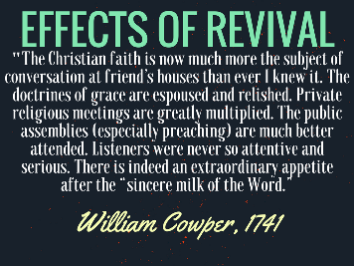
William Cowper (friend of John Newton who wrote Amazing Grace) was a young man when the First Great Awakening broke out and revival came with power to America. Cowper wrote what it was like to experience revival and its effects.
In 1741 Cowper wrote, “The Christian faith is now much more the subject of conversation at friend’s houses than ever I knew it. The doctrines of grace are espoused and relished. Private religious meetings are greatly multiplied. The public assemblies (especially preaching) are much better attended. Listeners were never so attentive and serious. There is indeed an extraordinary appetite after the “sincere milk of the Word.”

Breaking the Bondage
Breaking the bondage of idols means you put off the old life by putting on the new life. You tear down the idols and begin to enjoy the presence of the living God. And that brings us to our next point.

- In Revival, blessing is flowing, (23:16-17).
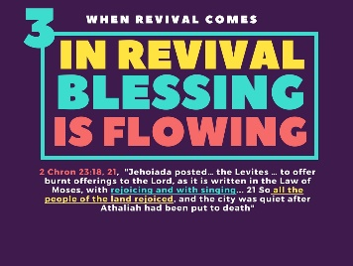
We turn to 2 Chronicles 23, and we have a very exciting chapter in the Bible.

2 Chron 23:18 – They offered Levitical sacrifices again and got the choir going. “And Jehoiada posted watchmen for the house of the Lord under the direction of the Levitical priests and the Levites whom David had organized to be in charge of the house of the Lord, to offer burnt offerings to the Lord, as it is written in the Law of Moses, with rejoicing and with singing, according to the order of David.”
2 Chron 23:21 – There was great joy! “So all the people of the land rejoiced, and the city was quiet after Athaliah had been put to death with the sword.”

Their whole way of pagan life was interrupted. Gone was Athaliah the wicked queen of Baal and daughter of Jezebel.
A whole new way of living had begun! This is what we should be seeking!

St. Augustine Quote
The world can never provide lasting and meaningful joy. In revival, God becomes “sweeter than all pleasure.”
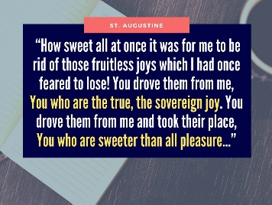
Listen to St. Augustine, “How sweet all at once it was for me to be rid of those fruitless joys which I had once feared to lose! You drove them from me, You who are the true, the sovereign joy. You drove them from me and took their place, You who are sweeter than all pleasure.”

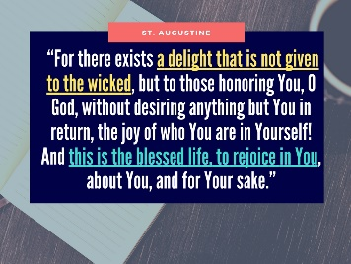
“For there exists a delight that is not given to the wicked, but to those honoring You, O God, without desiring anything but You in return, the joy of who You are in Yourself! And this is the blessed life, to rejoice in You, about You, and for Your sake.” – St. Augustine

In Your Presence
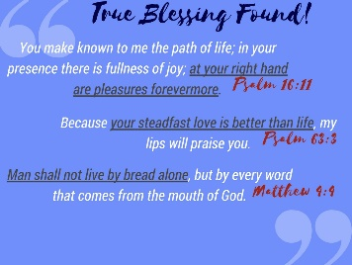
Psalm 16:11, “You make known to me the path of life; in your presence there is fullness of joy; at your right hand are pleasures forevermore.”
Where do we find fullness of joy? In God’s presence! In revival, we realize it is vain to seek lasting pleasure anywhere else than God!

Living Water
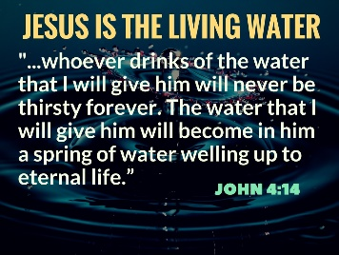
Jesus promises “living water.” He says, “whoever drinks of the water that I will give him will never be thirsty forever. The water that I will give him will become in him a spring of water welling up to eternal life” (Jn 4:14).

Your Steadfast Love is Better than Life
Psalm 63:1-4, “O God, you are my God; earnestly I seek you; my soul thirsts for you; my flesh faints for you, as in a dry and weary land where there is no water. 2 So I have looked upon you in the sanctuary, beholding your power and glory. 3 Because your steadfast love is better than life, my lips will praise you. 4 So I will bless you as long as I live; in your name I will lift up my hands.”
Jesus, quoting Deuteronomy 8:3 said it this way, “Man shall not live by bread alone, but by every word that comes from the mouth of God” (Matthew 4:4).
True lasting joy comes from God’s presence!
Brainerd Quote
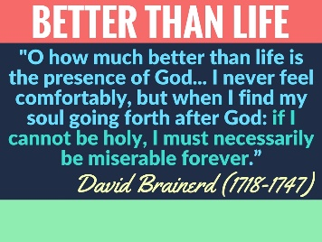
David Brainerd (1718-1747) died before the age of thirty, yet his influence goes on today. He said, “O how much better than life is the presence of God.” He went on to say, “I never feel comfortably, but when I find my soul going forth after God: if I cannot be holy, I must necessarily be miserable forever.”

What About You?
What about you today? Are you miserable without the presence of God? All the little things we look to in life are but trinkets compared to the immeasurable love of God.
Ask God for a revival in your life where all your true joy comes from Him! Give Him the sacrifice of praise and thanksgiving! He is worthy!

Worthy is the Lord!
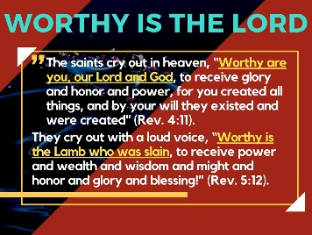
The saints cry out in heaven (Rev. 4:11), “Worthy are you, our Lord and God, to receive glory and honor and power, for you created all things, and by your will they existed and were created.”
They cry out with a loud voice, “Worthy is the Lamb who was slain, to receive power and wealth and wisdom and might and honor and glory and blessing!” (Rev. 5:12).

- In Revival, believers are working, (24:11-13).
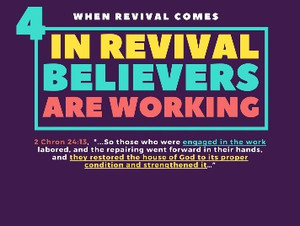
And now we see that after this great revival, they take up a great collection and restore the house of the Lord (vs. 1-14).

They Restored the House of the Lord
They put a chest outside the Temple and took a collection. 2 Chron 24:11-13, “And whenever the chest was brought to the king's officers by the Levites, when they saw that there was much money in it, the king's secretary and the officer of the chief priest would come and empty the chest and take it and return it to its place. Thus they did day after day, and collected money in abundance. 12 And the king and Jehoiada gave it to those who had charge of the work of the house of the Lord, and they hired masons and carpenters to restore the house of the Lord, and also workers in iron and bronze to repair the house of the Lord. 13 So those who were engaged in the work labored, and the repairing went forward in their hands, and they restored the house of God to its proper condition and strengthened it…”

McCully Quote
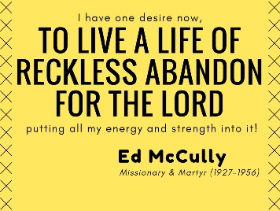
Ed McCully (1927-1956), missionary martyr to the Waorani tribe of Equador: “I have one desire now, to live a life of reckless abandon for the Lord, putting all my energy and strength into it."

You Need Only Ask for More of Communion
When revival comes, there is an outpouring of God’s grace. Now again, you need to commune with God and ask for this renewed life of God in the heart of man.
“You have not because you ask not,” James (4:1) said.
Our Lord asks in Luke 11:13, “So if you sinful people know how to give good gifts to your children, how much more will your heavenly Father give the Holy Spirit to those who ask him?”
Ask, and He will give you a greater level of communion in the Holy Spirit. Do you want it? Ask for it! Do you want the blessings of His presence to flow? Go to the throne of grace and ask.

Revival is Never Without Results
When revival comes it results in great sacrifice and work for the Lord!
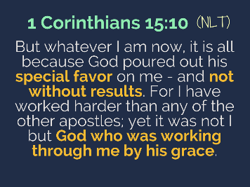
1 Corinthians 15:10 (NLT), “But whatever I am now, it is all because God poured out his special favor on me - and not without results. For I have worked harder than any of the other apostles; yet it was not I but God who was working through me by his grace.”
When God’s grace – His special favor and power – is upon you, it is never without results! It causes us to work hard.
Eze. 36:26 – God takes out the heart of stone and puts within us a heart of flesh – and the Bible says He puts His Spirit in us and “causes us to walk in His statutes and keep his judgements.”

God is Working in You
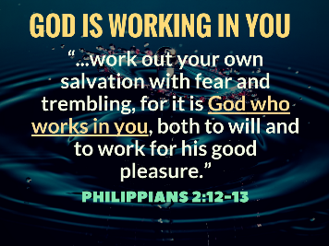
God is working in you! Remember what St. Paul says in Phil. 2:12-13. God is working in you! “...work out your own salvation with fear and trembling, for it is God who works in you, both to will and to work for his good pleasure.”

Andrew Bonar Quote
Revival has an effect on you and others. Andrew Bonar says, “Revivals begin with God's own people; the Holy Spirit touches their heart anew, and gives them new fervor and compassion, and zeal, new light and life. And after He has thus come to you, He next goes to the valley of dry bones...to bring people to life."
He goes on to say, “Oh, what responsibility this lays on the Church of God! If you grieve the Spirit of God away from yourselves, or hinder His visit, then the poor perishing world suffers sorely!”
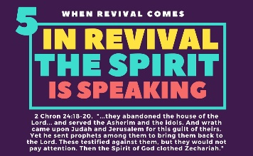
Don’t resist the Lordship of Jesus in your life. It will be bad for you and bad for others!!

- In Revival, the Spirit is speaking, (24:15-19a).

God Sends Prophets
2 Chron 24:15-16, “But Jehoiada grew old and full of days, and died. He was 130 years old at his death. 16 And they buried him in the city of David among the kings, because he had done good in Israel, and toward God and his house.”
They treated Jehoiada like a king, literally. They buried him among the kings. There is no higher honor.
2 Chron 24:17-19a, “Now after the death of Jehoiada the princes of Judah came and paid homage to the king. Then the king listened to them. 18 And they abandoned the house of the Lord, the God of their fathers, and served the Asherim and the idols. And wrath came upon Judah and Jerusalem for this guilt of theirs. 19a Yet he sent prophets among them to bring them back to the Lord…”

Jehoiadah’s Legacy
Just consider that this man Jehoiadah propped up Joash all those years. What a man!

But after Jehoiadah’s death, God sent prophets to care for the people’s souls since King Joash woud not.

God is Faithful even when We are Not
The revival lasted 39 years, but King Joash strayed. What do you do when people around you stray? It shakes you! But God is faithful! He will hold us fast! He will preserve us for His heavenly Kingdom!

Remember 2 Timothy 2:13, “If we are faithless, He remains faithful. He cannot deny Himself.”
Always Faithful: Take Your Troubles to God
God is ready to rescue you right now. If you are backsliding or you feel you’ve wandered, God will grant you a holy anguish for your own soul.
Weep for your soul! Take your troubles to the Lord. That’s what David did.
“I took my troubles to the LORD; I cried out to him, and he answered my prayer” (Psalm 120:1 (NLT).

In Faithfulness God Afflicts Me
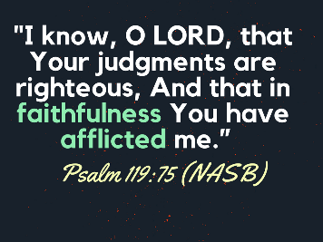
You may be afflicted by God this morning. Listen to the Spirit! You may be shaken and confused. Take it to Jesus. “I know, O LORD, that Your judgments are righteous, And that in faithfulness You have afflicted me.”
God afflicts you to bring you closer to Him. In other words, sometimes the best thing for you is to fee the chastening of the Lord so that you can eventually feel His comfort and favor.

Transition: Let me say, without the renewed life of the Spirit in our congregation, there is only a desert of dryness. Without revival, God will discipline His children and judge our country and our world. We need revival!

- Without Revival, God judges (vs. 19b-27).
Finally, because God is holy, we find that He cannot leave it alone or neglect it. God is meticulous in His judgement against sin.
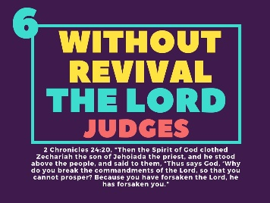

2 Chron 24:19b-22, “…19b These [prophets] testified against them, but they would not pay attention.
20 Then the Spirit of God clothed Zechariah the son of Jehoiada the priest, and he stood above the people, and said to them, “Thus says God, ‘Why do you break the commandments of the Lord, so that you cannot prosper? Because you have forsaken the Lord, he has forsaken you.’”
21 But they conspired against him, and by command of the king they stoned him with stones in the court of the house of the Lord. 22 Thus Joash the king did not remember the kindness that Jehoiada, Zechariah's father, had shown him, but killed his son. And when he was dying, he said, “May the Lord see and avenge!”

Joash Dies
And how did the Lord avenge? He brought King Joash’s life to an end. God brings a small Syrian army to show that He is in total control.
2 Chron 24:23-25, “At the end of the year the army of the Syrians came up against Joash. They came to Judah and Jerusalem and destroyed all the princes of the people from among the people and sent all their spoil to the king of Damascus. 24 Though the army of the Syrians had come with few men, the Lord delivered into their hand a very great army, because Judah had forsaken the Lord, the God of their fathers. Thus they executed judgment on Joash.
25 When they had departed from him, leaving him severely wounded, his servants conspired against him because of the blood of the son of Jehoiada the priest, and [the Syrian soldiers] killed him on his bed. So he died, and they buried him in the city of David, but they did not bury him in the tombs of the kings.”

God’s Loving Discipline: For Christians No Condemnation
True believers like Joash are not condemned at the day of Christ. But he dies in the way of God’s discipline.
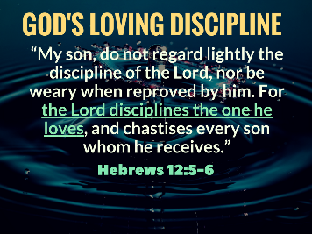
Take God’s discipline seriously. Hebrews 12:5-6, “My son, do not regard lightly the discipline of the Lord, nor be weary when reproved by him. For the Lord disciplines the one he loves, and chastises every son whom he receives.”
Takes God’s discipline seriously. Joash did not. God raised up prophets and even tried to touch his heart through the Zechariah, the son of Joash’s father-figure, Jehoiada the Priest.
But Joash did not listen, and the Lord took him.

God Judges Sin at the Cross
The ultimate judgement for sin is either at the Cross or in Hell forever. You have to pay for it or you have to have someone who is perfect pay for it on your behalf.
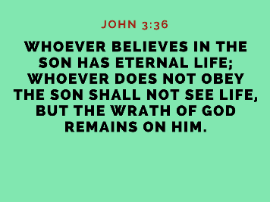
John 3:36, “Whoever believes in the Son has eternal life; whoever does not obey the Son shall not see life, but the wrath of God remains on him.”

Spurgeon Quote
I pray today that there will be a holy unrest when it comes to sin in our lives. Spurgeon was right when he said,
“I believe the holier a man becomes, the more he mourns over the unholiness which remains in him.” – Charles Haddon Spurgeon

St. Augustine Quote
I pray that we might call on God like St. Augustin did. He said:
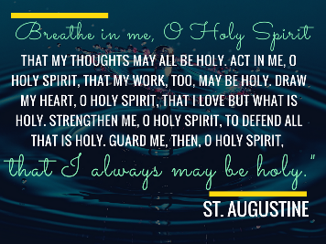
“Breathe in me, O Holy Spirit, that my thoughts may all be holy. Act in me, O Holy Spirit, that my work, too, may be holy. Draw my heart, O Holy Spirit, that I love but what is holy. Strengthen me, O Holy Spirit, to defend all that is holy. Guard me, then, O Holy Spirit, that I always may be holy. Amen.” – St. Augustine

Conclusion
I want God’s reviving presence anew in my life. And He’s here. We need only ask. We need only exalt Jesus and put down all other idols in our lives.

I Want to See Where You Work
When I was a child, I had heard much of where my father worked, at the First National Bank of Chicago.
But one day I got the courage to ask my father, “Daddy, I want to see where you work.” He gladly brought me downtown.
We went up, up, up, almost to the top, to the 59th floor. What an amazing experience. I got to see the expanse of the city. I got to meet the chairman of the board. I got to hold my Daddy’s hand.
God wants to do more for you than a good earthly father. He wants to bring you to where he is. If you are in Christ, you are seated in the heavenly places.
We need but ask, and “Oh Father in Heaven, I want to see you work in me!” Take me up to the highest heaven! Let me see the expanse of your love.
Grant it O God, In Jesus Name! Amen!

Selman, M. J. (1994). 2 Chronicles: an introduction and commentary (Vol. 11, p. 469). Downers Grove, IL: InterVarsity Press.
Jonathan Edwards. Memoirs of the Rev. David Brainerd (Oxford University Press: Oxford, UK, 1818), 207.
Edwards. Memoirs of Brainerd, 77.
Elisabeth Elliot. Through Gates of Splendor (Wheaton, IL: Tyndale House Publishers, 1986), 50-51.

