MATT BLACK, Sun, August 9, 2020
livinghopechurch.net

5 | JOSHUA 4
Memorial Stones
Your greatest crisis can be your greatest blessing
Outline
1. The Monument’s Purpose (4:1-10a)
A Reminder of Salvation (4:1-6a)
A Teacher of Future Generations (4:6b-8; 21-24)
A Warning of Judgment Averted (4:9-10)
A Promise of God’s Presence
2. The Monument’s People (4:10b-14)
The People
The Priests
The Platoon
The Premier General
3. The Monument’s Picture (4:15-24)
A Picture of Faith
A Picture of God’s Presence
A Picture of God’s Faithfulness
Celebrate Christ

Call to Worship
2 Corinthians 1:20-22, For all the promises of God find their Yes in Christ. That is why it is through him that we utter our Amen to God for his glory. ²¹ And it is God who establishes us with you in Christ, and has anointed us, ²² and who has also put his seal on us and given us his Spirit in our hearts as a guarantee.
Songs
Behold Our God
His Final Word
He Will Hold Me Fast
In Christ Alone
It is Well with My Soul

ANNOUNCEMENTS
WELCOME: Welcome visitors
GIVING: You can still give over Zelle through your bank with no fees. We also have a collection box on the Welcome Center.
PRAYER: Continue in prayer for Areta Reid’s family with the passing of her brother.
MEMORIAL: Service for David Beakey August 22, Saturday 10am.

Introduction
Open your Bible to the book of Joshua. We continue in a series in the book of Joshua called “Footsteps of Faith.” We’ve entitled the message: “The 12 Stones.” The children of Israel had come right to the threshold of their Canaan. They were about to cross over the river Jordan. They were about to enter the land and possess the inheritance God had promised to them. They were facing the greatest crisis of their existence. The opportunity to enter the promised land was right in front of them, but the Jordan River was at flood stage with raging rapids, a mile wide at her widest point. Over two million people were waiting to enter.
Have you ever looked straight into the blazing center of a crisis? My hope today is that we will realize that our greatest crisis is what God wants to turn into our opportunity place of growth. God uses all things for good to conform us to Christ (Rom 8:28-30).
This is a promise for all of God’s people but is perhaps more clearly seen in the life of Job. It was Job who said,
Though he slay me, yet will I trust in him (Job 13:15).
God will take a crisis and grow you. This principle is illustrated by the story of Joshua 3 and 4 when God’s people crossed the Jordan River. It was at flood season, and the Jordan was a mile wide during this time at its widest point. God promised once the priests’ feet touched the waters of the river Jordan, he would part the waters, turning their crisis into a place of growth. So the priests obeyed. As they entered the Jordan and their feet touch the water, the great river stopped flowing, and it started stacking up like it was held up by a plexiglass shield. The ark of the covenant stopped right there in the middle of the riverbed of the Jordan. God’s people went right on through and came up on the other side. For twenty miles across from Adam, near Shiloh in the north, to the south at Gilgal, the Jordan River went dry during this unexpected miracle during flood season. While the water of the Jordan was held back, God commanded his people to set up a monument of twelve stones from the bottom of the river. “This monument was to be a symbol for the people to look on in time of doubt and confusion in order to remember God’s awesome power, love, and faithfulness to them and future generations (Josh 4:1–9).” Garrett Higbee summarizes the principle of this story well: “﻿The hard cases are perhaps the greatest opportunities to see the power of God and his Word at work in changing lives.” Each of us ought to face a crisis with a deep assurance of God’s promises to use this crisis to transform the heart of us (Phil 1:6; 1 Thess 5:23-24).

Here in Joshua 3 and 4, we find one of the climactic events in all of biblical history. The Israelites had waited forty years, but now the time had come. It is a poignant moment as they stride across the riverbed of the Jordan, opened for them by the miraculous power of God. Behind them, they leave the wearying decades of meandering around in a barren wilderness and the tragic memories of countless funerals for an entire generation of people who would not trust God's promises. Slavery in Egypt and the bare survival of nomadic life are bygone experiences now.
Their joy had been magnified by recent events. But when they arrived at the Jordan, they found it is flood stage, menacing in its speed and dangerous in what it could do to the families of Israel. The rapid current left Israel flatfooted. The river was impassible, its crossing impossible.
Have you ever had a crisis that seemed to put an impasse in front of what you thought was God’s will? It’s at those moments we learn the most about our God, as he builds our faith in his power to grow us.

You know the story. God intervened, performing a miracle that paralleled the miracle of the Exodus from Egypt. God rolled back the waters of the Jordan River, just as he had done with the Red Sea. God meant what he had said through Moses years before. Here was his signature again, in the same way, to assure his people that he was good to his word.
While crossing the Jordan, they are told to erect a monument of 12 stones. Later they are told to carry another set of stones out of the Jordan to Gilgal where they were placed, and then Joshua assembled them there (4:21). These stones had great significance to the people of Israel then and to us today.
Remember as soon as the priests’ feet touched the water, the flow of the water cut off upstream (a total of 20 miles of the Jordan turned to dry land, 3:16), and the river stood up like a wall. Then the ark was brought to the middle of the opening, and all the people were invited to cross on either side of the ark, each side a half a mile away from the ark itself (3:4). This is their conversion and confirmation into the faith of Yahweh. In this passage we see four markers of this new step of faith: the 12 stones, the society, the Shekinah glory, and the city of Gilgal.

The Monument’s Purpose (4:1-10a)
Joshua 4:1-6a │ When all the nation had finished passing over the Jordan, the Lord said to Joshua, ² “Take twelve men from the people, from each tribe a man, ³ and command them, saying, ‘Take twelve stones from here out of the midst of the Jordan, from the very place where the priests' feet stood firmly, and bring them over with you and lay them down in the place where you lodge tonight.’” ⁴ Then Joshua called the twelve men from the people of Israel, whom he had appointed, a man from each tribe. ⁵ And Joshua said to them, “Pass on before the ark of the Lord your God into the midst of the Jordan, and take up each of you a stone upon his shoulder, according to the number of the tribes of the people of Israel, ⁶ that this may be a sign among you…

A Reminder of Salvation (4:1-6a)
The stones were a personal reminder of the mighty hand of the Lord opening up the Jordan and bringing his promises to pass by bringing them into the promised land.
By returning to Gilgal on a regular basis, as they did, since Gilgal was their base of operations, they would see the stones and be reminded of the power and faithfulness of the great God who was with them, leading them in their conquest.
Twelve men hoisted heavy stones to their shoulders from Jordan's floor and then had Joshua arranged them in the promised land, by God's command. They were assembled there as a sign, an unmistakable marker at the very place where God had demonstrated his power to overcome any obstacle to his will.

A Reminder to Worship!
Before Shiloh or Jerusalem, the Tabernacle was erected here at Gilgal as a place of worship. It was really the first holy city or more like an encampment. It was also a place of training and instruction for the people. Like Shiloh and Jerusalem, the geography of this place has hills surrounding a smaller hill upon which the place of worship is. Gilgal today is a plain surrounded by hills between the Jordan River and Jericho, and the ruins of their “city” are still there today in the shape of a footprint. You can see at the entrance to the footprint are the twelve stones placed in a way so all could see.

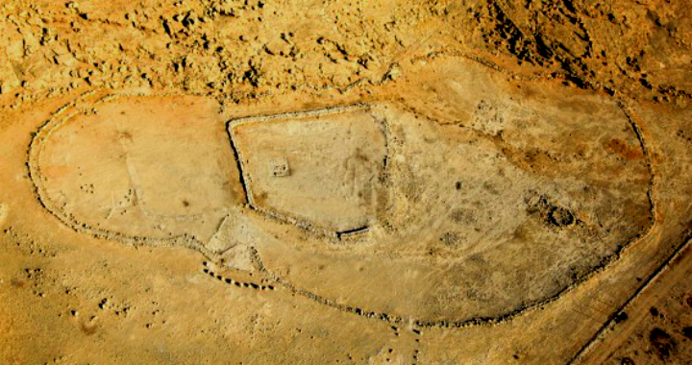
The ruins of Gilgal outside of Jericho (2018)

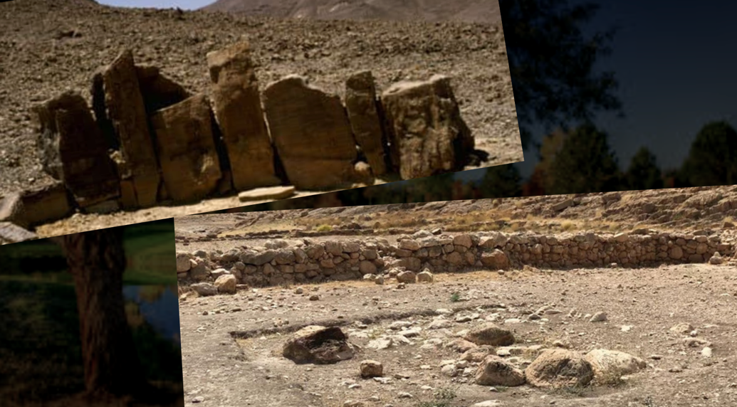
12 Standing Stones (example) and the actual remains of the 12 stone monument

Here in this picture, we have an example of a Standing Stone monument, and then the actual remains of the 12 stones. This is similar to the Standing Stone monument with 12 stones at Mount Ebal that Joshua erected with the alter in chapter 8 of Joshua. The remains are still there today at Mount Ebal.

What are some memorial stones that you have to look back upon in your life? Several things come to mind that remind me of my conversion: my personal testimony of salvation, God’s work of the Spirit to sanctify me, his gifts that I stir up through service, just to name a few. I love seeing my life change. I love seeing your lives change.
My baptism is a memorial stone. The Lord’s supper is a memorial stone for us. Most of all the fruit of the Spirit marks God’s presence and power in our lives!
Indeed, we are all living memorial stones in God’s temple. Each of us is alive with the Spirit of God in us.

A Teacher of Future Generations (4:6b-8; 21-24)
The children of this church need to hear about the great victories you have experienced in your life. The stones also were a reminder to the future generations of God’s personal interaction and salvation for his people.
Joshua 4:6b-8 │ When your children ask in time to come, ‘What do those stones mean to you?’ ⁷ then you shall tell them that the waters of the Jordan were cut off before the ark of the covenant of the Lord. When it passed over the Jordan, the waters of the Jordan were cut off. So these stones shall be to the people of Israel a memorial forever.” ⁸ And the people of Israel did just as Joshua commanded and took up twelve stones out of the midst of the Jordan, according to the number of the tribes of the people of Israel, just as the Lord told Joshua. And they carried them over with them to the place where they lodged and laid them down there

Joshua 4:21-24 │ And he said to the people of Israel, “When your children ask their fathers in times to come, ‘What do these stones mean?’ ²² then you shall let your children know, ‘Israel passed over this Jordan on dry ground.’ ²³ For the Lord your God dried up the waters of the Jordan for you until you passed over, as the Lord your God did to the Red Sea, which he dried up for us until we passed over, ²⁴ so that all the peoples of the earth may know that the hand of the Lord is mighty, that you may fear the Lord your God forever.”
Our children need to know that God is alive and well! What kind of memorial stones do we have today to teach our children?
We can mention the church’s sacraments of the Lord’s supper and baptism. Sacraments are an outward sign and seal of an inward reality. They are a dramatization of actual events. They picture the work of Jesus Christ in his death and resurrection. Each time these sacraments are experienced, there is a memorial, a reminder of the Lord’s death and resurrection. This is a wonderful time to teach our children. As the cup and bread are passed out and our children are not permitted to partake, and they ask why, we have the privilege to explain the Gospel to them. “Well, son, Jesus died on the cross for our sins. This cup and bread are reminders of his shed blood and broken body.” Our children may ask about baptism. “Well, daughter, the waters of baptism are like a tomb in which the person going into the water is ‘buried with Christ’ and then they rise up out of the water ‘to walk with him in newness of life.” What a wonderful way to teach our children through these “memorial stones.” Of course our remembrance of the good news of Christ’s death and resurrection are in no way limited to the sacraments.
How about the memorial stones of the Lord’s Day worship? Our kids don’t remember a time when they haven’t been in church.
We remember in so many informal ways like keeping journals of God’s work in your life and answers to prayer, prayer meetings and testimony times when we recount God’s love and faithfulness, Sunday worship where we extol the Triune God for his work in our salvation, among hundreds and thousands of other things.
But really, it is those times of crisis that we remember the most. That time when you felt like nothing good could come out of your marriage, but in faith you waited, and you found God was greater than any marriage crisis.

The Goal
The goal is to get your eyes off of your crisis and on to your great God!

A Warning of Judgment Averted (4:9-10)
Joshua 4:9-10a │ And Joshua set up twelve stones in the midst of the Jordan, in the place where the feet of the priests bearing the ark of the covenant had stood; and they are there to this day. ¹⁰ For the priests bearing the ark stood in the midst of the Jordan until everything was finished that the Lord commanded Joshua to tell the people, according to all that Moses had commanded Joshua…
There seems to be two sets of stones: one set is a memorial to God’s faithfulness. The other is a memorial to God’s judgment. The stones in the river would be forgotten and would in a way “perish.” The stones in the Jordan that anyone who doesn’t cross into God’s promised land will perish and be forgotten.
The name “Jor-dan” is significant. “Jor” (from yarad) means to flow down, and “Dan” means to “execute judgment.” Hosea confirms the idea with God’s proclamation: “…I will pour out my wrath on them like water” (Hos 5:10). Aren’t you glad you have been delivered from God’s downflowing wrath and judgment? Even our baptism is a sign and seal of God’s covenant today, and the picture goes back to the Red Sea and the Jordan River. We pass through the waters of judgment, being united in Christ’s death. Our judgment is put on Christ, and we are raised to walk out of that water “in newness of life” (Rom 6:4).
This row of 12 stones at the bottom off the Jordan was never to be seen by future generations. They would never inquire about it, once the Jordan waters flowed again. This 12 stone memorial would perish in the waters of the Jordan, just as the Egyptian army had perished in the waters of the Red Sea so many years before. These 12 stones were a memorial to God’s justice. The typological lessons in this account provide an eternal, but disheartening, perspective.
The 12 stones under the waters of the Jordan may be a typological picture of all people who reject the salvation that God offers. They have not been delivered. They have not “crossed over” and received the grace of God. They remain under the waters, and are not counted among those who have entered into their inheritance, their promised land.

A Promise of God’s Presence
On the other hand, the stones in the water may simply be another reminder of where they had crossed in the Jordan so that anytime the water went down, they might be able to see the stones in the water where the ark had been, and where the water had been held back by the hand of God. These stones then were a reminder of God’s presence.

The Monument’s People (4:10b-14)

The People
Joshua 4:10 │ The people passed over in haste.
So many were passing over. Aside from efficiency, why would they pass over “in haste”? We could surmise that they were ready and excited to enter into the promised land. They believed the promises of God. This is a wonderful picture of faith. Isn’t it true that when we come to Christ, we rush to him “in haste” because he is so beautiful? We come leaving all behind. I love the words of Jesus who said,
Come to me, all who labor and are heavy laden, and I will give you rest. ²⁹ Take my yoke upon you, and learn from me, for I am gentle and lowly in heart, and you will find rest for your souls. ³⁰ For my yoke is easy, and my burden is light (Mt 11:28-30).
The people in Joshua’s day were leaving the wilderness behind for the promised land. So every Christian leaves their old life behind to take up Christ’s cross. By losing the ambition, reputation, and possibilities of the old life, we actually gain life since we gain eternal life, and so much even in this short, temporal life we live on earth.

The Priests
Joshua 4:11 │ And when all the people had finished passing over, the ark of the Lord and the priests passed over before the people.
There is a twenty-mile expanse where the Jordan has dried up and the people may cross. In the middle of this great expanse is the ark with the pillar of glory above it. The people can see the ark for miles, but they have to keep that distance. God has already instructed them to keep a half mile distance on both sides of the ark, but they have nine and a half miles of dry expanse to cross on either side.
Notice it is the priests holding the ark that is leading the way. They hadn’t chosen this for themselves but were chosen by God through their families, who were from the tribe of Levi. So it is that in the new covenant, we are all priests, chosen by God and set apart for his service. We are all part of a holy priesthood. The duty of a priest is to bring himself and others nearer to God.
We are all called to be priests and to “make disciples of every nation” (Mt 28:19). What about you as a leader? Are you leading the way to God? Your body, the Bible says, is the ark, the habitation of God (1 Cor 6:19)! Are you pointing people to Christ? We all have this responsibility as God’s new covenant priests. We believe in the priesthood of every believer. Every member of Christ’s body is a minister (Eph 4:11-12).
But you are a chosen race, a royal priesthood, a holy nation, a people for his own possession, that you may proclaim the excellencies of him who called you out of darkness into his marvelous light (1 Pet 2:9).
Dear saints, you are all priests, with priestly responsibilities. Exercise those duties. Draw yourself and those around you nearer to God.

The Platoon
Joshua 4:12-13 │ The sons of Reuben and the sons of Gad and the half-tribe of Manasseh passed over armed before the people of Israel, as Moses had told them. ¹³ About 40,000 ready for war passed over before the Lord for battle, to the plains of Jericho.
Now you have the people from two and a half tribes that had determined to stay on the other side of Jordan but were committed to helping the conquer each tribe’s land. Out of all the tribes, there were 40,000 warriors armed and ready for war. The text brings up several questions. Where did they get the armaments and armor? Whatever they had was very limited, as far as human weaponry. They had seen war in the days of Moses. Perhaps they took some weapons from the people they conquered who were very sophisticated in their weaponry having chariots and armaments of iron.
In any case, they are trusting in God and ready to lead. Are you experienced in spiritual warfare? There are always those in the church who have had the experience of spiritual warfare and are more mature. We are commanded by the apostle to appoint mature, godly men as elders in the church. Also mature and godly men and women are to disciple those who are more new to the faith (Titus 2).

The Premier General
Joshua 4:14 │ On that day the Lord exalted Joshua in the sight of all Israel, and they stood in awe of him just as they had stood in awe of Moses, all the days of his life.
Joshua from the very beginning always pointed to the Lord as the main general of Israel, but Joshua is indeed the human general. Like Moses before him, he is meek, and yet they stand “in awe” of Joshua. Why? Because, “On that day the Lord exalted Joshua in the sight of all Israel” (4:14). Like Joseph, we might say “the hand of the Lord” was upon Joshua. “Potiphar noticed this and realized that the LORD was with Joseph, giving him success in everything he did” (Gen 39:3; cf 39:23, 40:3). There is a graciousness God grants to leaders who follow the Lord. God always raises up leaders who have his presence and grace upon them.
Humble yourselves in the sight of the Lord, and He will lift you up. (Jas 4:10)
If you want to be used of God you must face that crisis with humility and grace. The only way to do that is to get your strength from the Lord himself.
When you are weak you are strong, because you are empowered by Christ.

The Monument’s Picture (4:15-24)

A Picture of Faith
We must be reminded that the ark is the physical and tangible representation of God’s presence. Accompanying the ark of the covenant no doubt was the very Shekinah glory of God, his manifest presence in the pillar-like glory cloud. Remember the people had a twenty-mile area to cross the Jordan on dry ground. They could not come near the ark but had to pass a half a mile on each side. They could see the ark but could not touch it. They could see the glory cloud. They were to get a glimpse of that massive display of God’s glory and remember it.
Joshua 4:15-18 │ And the Lord said to Joshua, ¹⁶ “Command the priests bearing the ark of the testimony to come up out of the Jordan.” ¹⁷ So Joshua commanded the priests, “Come up out of the Jordan.” ¹⁸ And when the priests bearing the ark of the covenant of the Lord came up from the midst of the Jordan, and the soles of the priests' feet were lifted up on dry ground, the waters of the Jordan returned to their place and overflowed all its banks, as before.
We must be reminded that the ark is the physical and tangible representation of God’s presence. Accompanying the ark of the covenant no doubt was the very Shekinah glory of God, his manifest presence in the pillar-like glory cloud. Remember the people had a twenty-mile area to cross the Jordan on dry ground. They could not come near the ark but had to pass a half a mile on each side. They could see the ark but could not touch it. They could see the glory cloud. They were to get a glimpse of that massive display of God’s glory and remember it.

A Picture of God’s Presence
This monument was something only God could provide for. He opened the River so the rocks could be gathered and arranged. Those rocks are still there till this day.
Joshua 4:18 │ And when the priests bearing the ark of the covenant of the Lord came up from the midst of the Jordan, and the soles of the priests' feet were lifted up on dry ground, the waters of the Jordan returned to their place and overflowed all its banks, as before.
This monument was a picture and reminder of the presence of God with his people. Consider the power of God’s presence. When the ark moved out of the waters, the waters returned to their place from 20 miles away! So it is that all Christians are like the ark – we carry the presence of God with us.
Do you not know that your body is a temple of the Holy Spirit within you, whom you have from God? You are not your own, for you were bought with a price. So glorify God in your body (1 Cor 6:19-20).
Just as the ark could be seen from afar (up to 20 miles away), our testimony for Christ is seen by all those around us. Jesus said,
You are the light of the world. A city set on a hill cannot be hidden. Nor do people light a lamp and put it under a basket, but on a stand, and it gives light to all in the house. In the same way, let your light shine before others, so that they may see your good works and give glory to your Father who is in heaven (Mt 5:14-16).

A Picture of God’s Faithfulness
Joshua 4:19 │ The people came up out of the Jordan on the tenth day of the first month, and they encamped at Gilgal on the east border of Jericho.
Until now, the reader knows only that the crossing took place during the flood stage of the Jordan, that is in the spring. Now the text specifies the tenth day of the first month. The same date appears in Exodus 12:2–3, where it introduces the preparations for the Passover, which occurs on the fourteenth day [Good Friday].
It was on the same day forty years before that Israel had begun to prepare for going out of Egypt by setting apart the Passover lamb (Exo 12:2–3).
So it’s four days away till Passover celebration, which will take place in Joshua 5.

A Picture for our Children
Joshua 4:20-24 │ And those twelve stones, which they took out of the Jordan, Joshua set up at Gilgal. ²¹ And he said to the people of Israel, “When your children ask their fathers in times to come, ‘What do these stones mean?’ ²² then you shall let your children know, ‘Israel passed over this Jordan on dry ground.’ ²³ For the Lord your God dried up the waters of the Jordan for you until you passed over, as the Lord your God did to the Red Sea, which he dried up for us until we passed over, ²⁴ so that all the peoples of the earth may know that the hand of the Lord is mighty, that you may fear the Lord your God forever.”
Sometimes when we get overwhelmed, we forget how big God is! We need to be telling the stories of our great God to our children! That’s what the 12 stone monument was for: a testimony to our children and a legacy for generations to come.
Let me ask you: are you leaving an eternal legacy of living stones?
And you are living stones that God is building into his spiritual temple. What’s more, you are his holy priests. Through the mediation of Jesus Christ, you offer spiritual sacrifices that please God (1 Pet 3:5).
Conclusion
These 12 stones tell a story of deliverance and of remembrance. We need to remember that God wants to turn your greatest crisis into your greatest victory. First, that crisis is one of faith. Are you in Christ? Do you know him? Have you been delivered from your sin? Do you have a testimony of salvation that you can give? How did God bring you across the Jordan of death, hell and sin?

Celebrate Christ
I love the 12 memorial stones the tell of victory. I can think of another stone. A stone that was moved in front of the tomb of our crucified Savior. That stone was there for three days. I want us to remember that stone. It was rolled away!
Jesus’ baptism site is very near where these 12 standing stones were taken out of the water. John the Baptist presented Jesus at this very spot as “the Lamb of God who takes away the sins of the world” (Jn 1:29). Jesus is our Lamb. He takes upon himself the wrath of that River of Judgment. He takes us, like those stones, and makes us living memorials to the grace of God.

Dale Ralph Davis, Joshua: No Falling Words, Focus on the Bible Commentary (Scotland: Christian Focus Publications, 2000), 37–38.
Garrett Higbee, “Tony and Bipolar Disorder” in Stuart Scott. Counseling the Hard Cases. B&H Publishing. Kindle Edition.
Ibid.
James Montgomery Boice, Joshua (Grand Rapids, MI: Baker Books, 2005), 40.
James Strong, Enhanced Strong’s Lexicon (Woodside Bible Fellowship, 1995), Strong’s number 1777.
Richard S. Hess, Joshua: An Introduction and Commentary, vol. 6, Tyndale Old Testament Commentaries (Downers Grove, IL: InterVarsity Press, 1996), 126.
Keil, Joshua, 51.

