Warnings about Entering the Kingdom

Matthew 7:13-29
___________________________________________
King of Kings! (Gospel of Matthew Series)
Prepared by: Matthew S. Black
Sunday, September 29, 2013, 10:30am at Living Hope Church of Roselle, Illinois

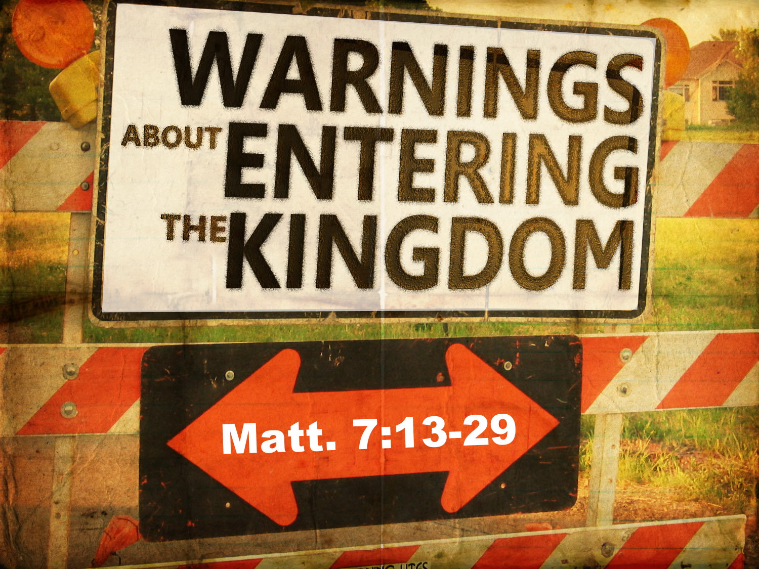
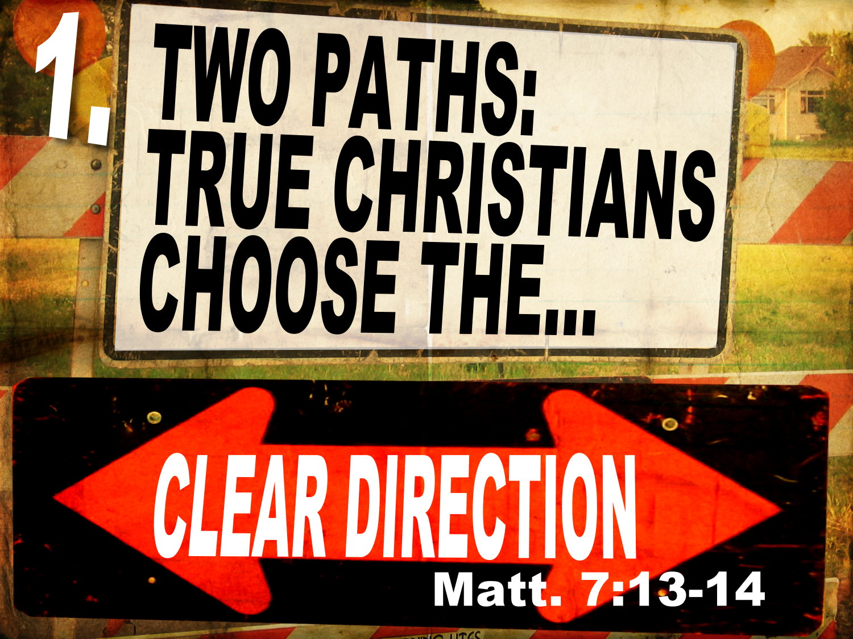
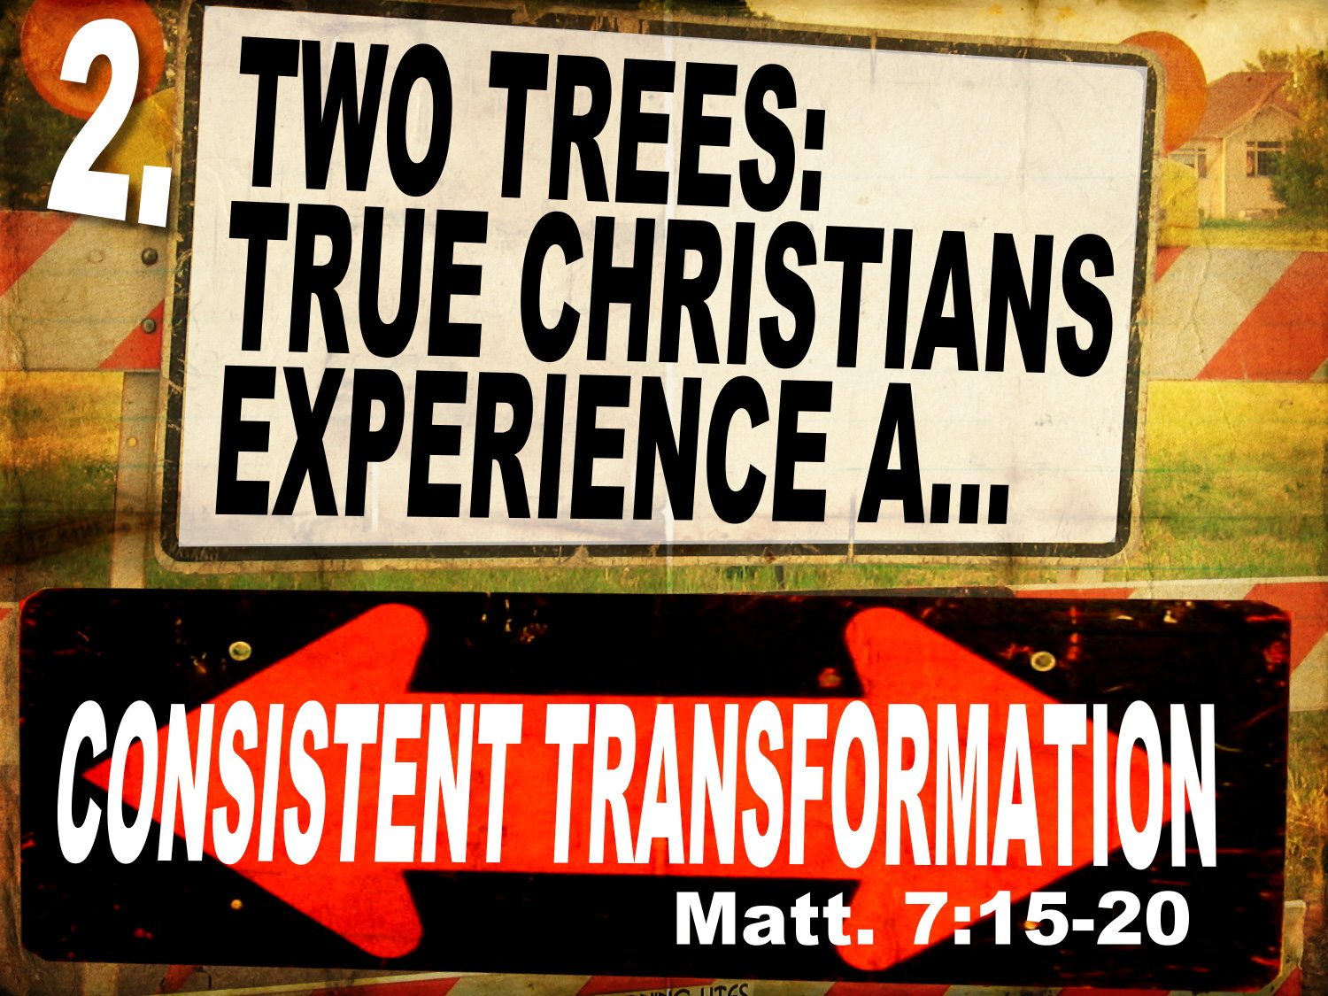
“The success of an illegitimate coiner depends largely upon how closely the counterfeit resembles the genuine article. Heresy is not so much the total denial of the truth as a perversion of it. That is why half a lie is always more dangerous than a complete repudiation. Hence when the Father of Lies enters the pulpit it is not his custom to flatly deny the fundamental truths of Christianity, rather does he tacitly acknowledge them, and then proceed to give an erroneous interpretation and a false application.” A.W. Pink
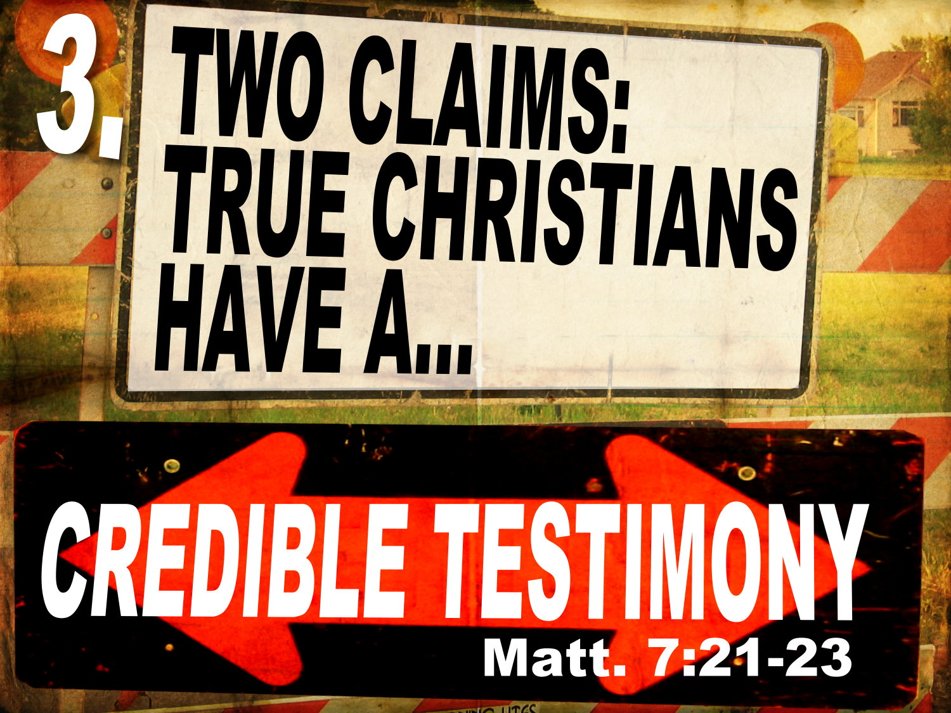
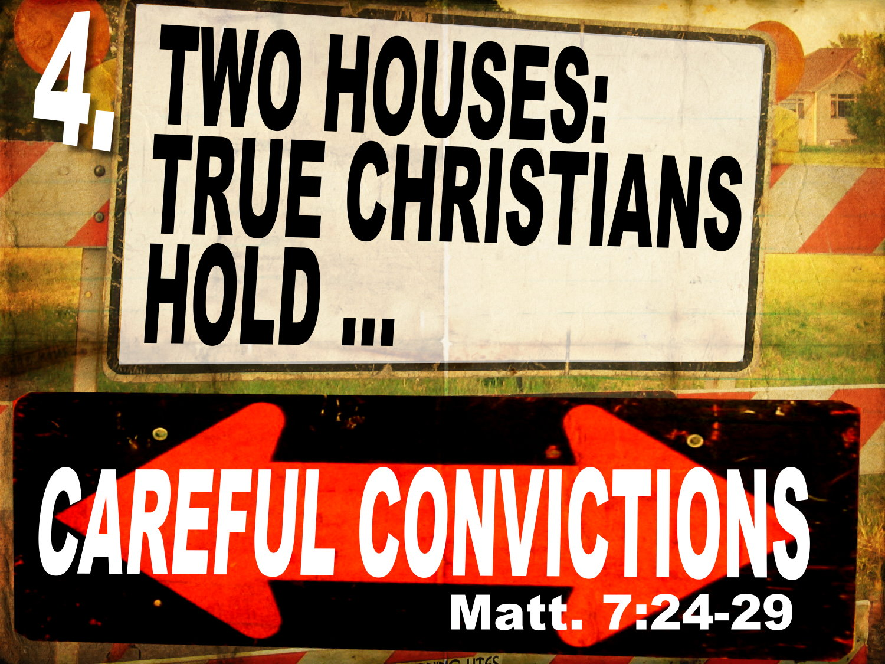

- Welcome Visitors
- Thanks to all who helped and participated in the Counseling Seminar. If you missed first Sat., not too late to sign up. Free videos.
- Ladies, sign up for the Ladies’ Retreat. Today is last day to sign up.
O
pen your Bible to Matthew 7:13-29. We are continuing in a series through the Sermon on the Mount entitled: “King of kings.” You’ll notice I’ve changed the title a bit from your bulletin. This morning we are looking a message entitled: “Warnings about Entering the Kingdom.”

Wet Floor
When there are signs as to how to enter a place you need to notice. Sometimes there is a “Wet Floor” sign. You need to pay attention. You might go to a wedding reception and there are signs that direct you where to go. Following signs are important.

Going to Spain the Long Way
I remember people would come to visit us in Spain, and for those who know me, when I’m talking with someone, I’m so focused on that person that I might get distracted. My wife and I would joke because every time people would come to visit us, we would take them the long way back from the airport. We lived on the border of France, and we always seemed to end up in France because I wouldn’t follow the signs. I’d just tell them we were taking the scenic route!
It might be ok to get lost on your way to Spain, but it is not ok to get lost on your way to eternity. You want to make sure how to enter the Kingdom.

Jesus Final Invitation
So here in the chapter 7 of Matthew we have Jesus’ final invitation for the Kingdom. The King has arrived. The promised Son of God spoken of by all the prophets was now on the scene.

Two Groups of People
Before Christ are two groups of people: the proud, self-sufficient, legalistic, very sharp, very knowledgeable Pharisees and Sadducees. The other group were the rag-tag sinners. These were people who were humble, poor, weak, and they had been broken.
Which ones are the Kingdom citizens? Jesus is going end how He started. He began by telling us that those who are the Blessed citizens of the kingdom were “bankrupt of spirit”. They were broken and wretched and poor in their own eyes. Jesus is going to give four illustrations that warn us to ENTER THE KINGDOM.

Warnings are Good
How many of you are glad for labels on hazardous items. You wouldn’t want poison to have the wrong label, like “MILK.” No you want poison to clearly be labeled: POISON. This is serious when we are talking about our bodies, but it is even more important when considering our never dying souls.

A Warning
Jesus closes His invitation to enter the kingdom with a warning to those who might lead you astray. There are only two kinds of people, only two. Those who enter the kingdom through radical surrender to the King, and those who do not. Today you are either protected by His lordship, or you will be crushed by it.

Outline
Jesus is going to give four illustrations that warn us to ENTER THE KINGDOM.
- Two paths: True Christians choose the clear direction (7:13-14).
- Two trees: True Christians have a consistent transformation (7:15-20).
- Two claims: True Christians have a credible testimony (7:21-23).
- Two houses: True Christians have careful convictions (7:24-29).

- Two paths: True Christians choose the clear direction (7:13-14).

Matthew 7:13-14, “Enter by the narrow gate. For the gate is wide and the way is easy that leads to destruction, and those who enter by it are many. 14 For the gate is narrow and the way is hard that leads to life, and those who find it are few.”

ENTER THE NARROW GATE
Enter with Urgency!
Enter is in the aorist imperative tense, and therefore demands a definite and specific action. It has the idea of making a bee-line to the gate. Don’t waste time! Do it now! It’s urgent! The command is not to admire or to ponder the gate but to enter it. Many people admire and respect Jesus Christ but never receive Him as Lord and Savior. Because they never receive the King and never enter the kingdom, they are as much separated from the King and as much outside His kingdom as is the rankest atheist or most unethical pagan.
Matthew 16:24–25, Jesus said, “If anyone would come after me, let him deny himself and take up his cross and follow me. 25 For whoever would save his life will lose it, but whoever loses his life for my sake will find it.”
We sang it this morning by Augustus Toplady in Rock of Ages:
Nothing in my hand I bring,
Simply to the cross I cling;
Naked, come to Thee for dress;
Helpless look to Thee for grace;
Foul, I to the fountain fly;
Wash me, Savior, or I die.

Violently in Love with Christ
Matthew 11:12, Jesus said, “the violent take it by force…” There is an awakening in those that enter the Kingdom, such that they do not delay. They enter with a holy violence! Charles Haddon Spurgeon explained it this way:
“The man who is pardoned, and who knows it, then becomes violently in love with Christ. He does not love Him just a little, but He loves Him with all His soul, and all His might. He feels as if he could wish to die for Christ and his heart pants to live alone with his Redeemer and serve Him without interruption.”

Are you wrecked by the love of God? Have you left the “City of Destruction” behind? Enter in! Don’t look back! In Luke 9:62, Jesus said, “No one who puts his hand to the plow and looks back is fit for the kingdom of God.”

Not just Admiration, but Action
Jesus knows that admiration without action is deadly, that conviction without commitment is deceptive. This is the Gospel of the Kingdom and Jesus is calling for repentance. The King has arrived on the scene. Superficial religion is not enough. You must have a “righteousness that exceeds the righteousness” of the Scribes and Pharisees. Jesus says His way is narrow. No one likes to be called narrow!

Not Narrow Like the Pharisees
Now Jesus is not telling us to be narrow like the Pharisees. He’s not telling us to be critical and judgmental and harsh. We certainly do not want to be narrow and self-righteous like the list-carrying Pharisees.

The Bishops’ Narrow Comments
Sometimes Christians can be inflexibly dogmatic about matters in which the Scriptures are not clear, like the bishop who when he was visiting a small denominational college in 1870 took strong exception when the president happened to remark that in fifty years it might be possible for men to soar in the air like birds. The bishop was scandalized and replied, “Flight is strictly reserved for the angels and I beg you not to repeat your suggestion lest you be guilty of blasphemy!” Thirty-three years later Bishop Wright’s sons, Orville and Wilbur, made the world’s first flight at Kitty Hawk! We must avoid uninformed, pious narrowness at all costs.

WIDE IS THE GATE THAT LEADS TO DESTRUCTION

Back in our passage, in Matthew 7:14, we read one of the most frightening verses in the Bible: “For the gate is wide and the way is easy that leads to destruction, and those who enter by it are many.” We must avoid the wide road. The problem with the wide path is that it looks like it’s leading to bliss and happiness. Both roads are labeled: “Eternal Life.”
We remember Proverbs 14:12, “There is a way that seems right to a man, but its end is the way to death.”

The Broad Road is Heavily Travelled
The thing about the wide road is that it is “wide” and “easy”. You don’t have to surrender anything. You don’t have to repent. You continue unchanged.
Today the wide road is the new norm. You can be a Christian and a homosexual today. You can be a Christian in America and deny the virgin birth of Christ or the resurrection. Society is promoting complete inclusion – anything and everything goes, and whole denominations are entering onto the wide path to destruction. John Knox, and JC Ryle and John Wesley and many others are turning over in their graves.
Many are on this road! It’s heavily travelled!

Where Does the Wide Gate Lead?
Both the broad and the narrow ways point to the good life, to salvation, heaven, God, the kingdom, and blessing-but only the narrow way actually leads to those. There is nothing here to indicate that the broad way is marked “Hell.” The point our Lord is making is that it is marked “Heaven” but does not lead there.

Not the Loss of Being, but the Loss of Well Being
Apōleia (destruction) does not refer to extinction or annihilation, but to total ruin and loss (cf. Matt. 3:12; 18:8; 25:41, 46; 2 Thess. 1:9; Jude 6–7). It is not the complete loss of being, but the complete loss of well-being. It is the destination of all religions except the way of Jesus Christ, and it is the destiny of all those who follow any way but His. It is the destination and destiny of perdition, hell, and everlasting torment. As David says in Psalm 1:6, “The way of the wicked will perish” (Ps. 1:6). It is a place of eternal, conscious torment away from the presence of God.

Hard to Find
Matthew 7:14, “ For the gate is narrow and the way is hard that leads to life, and those who find it are few.” The gate is narrow and hard to find. No one is looking for the gate to eternal life because “no one seeks after God” (Romans 3:11).

What/Who is this Narrow Gate?
What is this narrow gate? Really we should ask WHO is the gate? John 10:9, “I am the door. If anyone enters by me, he will be saved and will go in and out and find pasture.” Jesus said in John 14:6, “I am the Way, the Truth, and the Life, no man comes to the Father except by Me.”

Clear Direction
What Jesus is saying is that true Kingdom citizens have a clear direction. They enter into Christ. This is the theme of the New Testament. You are either in Christ or you are outside of Him. You must enter the narrow gate. It will cost you everything. We must forfeit this world and all it has to offer. We must not listen to its deceitful offers and charms.

Paul’s Testimony
Paul said in Galatians 2:20, “I have been crucified with Christ. It is no longer I who live, but Christ who lives in me. And the life I now live in the flesh I live by faith in the Son of God, who loved me and gave himself for me.”
He says in Philippians 3 Paul recounts all his human attainments, but compared to Christ, he says all human attainments are like rubbish and dung. Phil. 3:8-10, “Indeed, I count everything as loss because of the surpassing worth of knowing Christ Jesus my Lord. For his sake I have suffered the loss of all things and count them as rubbish, in order that I may gain Christ 9 and be found in him, not having a righteousness of my own that comes from the law, but that which comes through faith in Christ, the righteousness from God that depends on faith— 10 that I may know him and the power of his resurrection, and may share his sufferings, becoming like him in his death.”

Evidence That You Have Entered… Constantly Stripped of All
So you know those who have entered the narrow gate, because God keeps stripping them of everything. You get to a certain place in your Christian life, and God keeps crushing you. He keeps allowing you to suffer and be stripped of everything, so you cling more and more to Christ.
Christ is Better!
And you keep coming to the conclusion: Christ is better than all! All I need or want is Him and His narrow way. As good as family is, Christ is better than family. As good as your occupation is, Christ is better than the best job, better than the best food, better than the best human attainments!
So the clear direction of the Kingdom citizen could be summarized by the Psalmist in several places.
Psalm 73:25–26
25 Whom have I in heaven but you?
And there is nothing on earth that I desire besides you.
26 My flesh and my heart may fail,
but God is the strength of my heart and my portion forever.

Psalm 16:11
in your presence there is fullness of joy;
at your right hand are pleasures forevermore.

Psalm 63:3
your steadfast love is better than life,
my lips will praise you.

So this narrow path, where the poor in spirit “hunger and thirst” after Christ and His righteousness. This is the clear direction of the saints of God.

- Two trees: True Christians have a consistent transformation (7:15-20).
How far are false teachers willing to go for Christ? The answer? Not very far!

Matthew 7:15-20, “Beware of false prophets, who come to you in sheep’s clothing but inwardly are ravenous wolves. 16 You will recognize them by their fruits. Are grapes gathered from thornbushes, or figs from thistles? 17 So, every healthy tree bears good fruit, but the diseased tree bears bad fruit. 18 A healthy tree cannot bear bad fruit, nor can a diseased tree bear good fruit. 19 Every tree that does not bear good fruit is cut down and thrown into the fire. 20 Thus you will recognize them by their fruits.”

False Prophets
False prophets have no calling or commission from God, and they have no message from God. They twist God’s message for selfish purposes. They are “false prophets.” And Jesus says you need to be very careful to stay far away from them.

Categories of False Prophets
John MacArthur categorizes false prophets into three categories.
- Heretics – those who blatantly disregard correct doctrine. A heretic is literally one who is “schismatic” or divides the brethren. Romans 16:17–18, “I appeal to you, brothers, to watch out for those who cause divisions and create obstacles contrary to the doctrine that you have been taught; avoid them. 18 For such persons do not serve our Lord Christ, but their own appetites, and by smooth talk and flattery they deceive the hearts of the naïve.”

- Apostates – these are those who once followed the faith, but have fallen away from it. “Demas has forsaken me, having loved this present world” (2 Timothy 4:11), or 1 John 2:19, “They went out from us, but they were not of us; for if they had been of us, they would have continued with us. But they went out, that it might become plain that they all are not of us.”

- Deceivers – 2 John 7–John said, “Many deceivers are entered into the world, who confess not that Jesus Christ cometh in the flesh. This is a deceiver and an antichrist.” See also 2 Corinthians 11:14-15, “even Satan disguises himself as an angel of light. ¹⁵ So it is no surprise if his servants, also, disguise themselves as servants of righteousness. Their end will correspond to their deeds.”

It is the deceivers mainly that Jesus is talking about because they are like “ravenous wolves in sheep’s clothing” (7:15). These are pastors who care little whether you grow. They care little whether they apply God’s Word to your life. They want your money. They want to use you and fleece you.

AW Pink: An Illegitimate Coiner
AW Pink said this: “The success of an illegitimate coiner depends largely upon how closely the counterfeit resembles the genuine article. Heresy is not so much the total denial of the truth as a perversion of it. That is why half a lie is always more dangerous than a complete repudiation. Hence when the Father of Lies enters the pulpit it is not his custom to flatly deny the fundamental truths of Christianity, rather does he tacitly acknowledge them, and then proceed to give an erroneous interpretation and a false application.”

No Real Change=No Regeneration
There is a ravenous, selfish nature in a false teacher. One not touched by the Spirit of God cannot help but live for self alone. This is the bad fruit. It’s living for self. Like a cancer sucks the life out of the body, so a false teacher is a leach and a disease. His motive is always self.
2 Corinthians 5:17, “Therefore, if anyone is in Christ, he is a new creation. The old has passed away; behold, the new has come.”
Ezekiel 36:26, “And I will give you a new heart, and a new spirit I will put within you. And I will remove the heart of stone from your flesh and give you a heart of flesh.”

Partakers of the Divine Nature
Jesus says there is a great change in the true child of God that false teachers don’t have. In other words, a good tree (or nature) produces good fruit. A corrupt tree (or nature) produces foul fruit. 2 Peter 1:4 tells us that all Christians are “partakers of the divine nature, having escaped from the corruption that is in the world because of sinful desire.” Christians no longer in their hearts lust after the world like they once did because they have a new nature that opposes the old nature.
Jesus very plainly stated that if we are to see the king-dom of heaven we “must be born again” (John 3:3). The born again person, by definition, has a new, regenerated heart that delights in the Law of Christ and His rule in their life. A professing Christian may call himself a carnal Chris-tian to excuse his carnal living, but the contention of the Scriptures is that he is no Christian at all.

- Two claims: True Christians have a credible testimony (7:21-23).

Matthew 7:21-23, “Not everyone who says to me, ‘Lord, Lord,’ will enter the kingdom of heaven, but the one who does the will of my Father who is in heaven. 22 On that day many will say to me, ‘Lord, Lord, did we not prophesy in your name, and cast out demons in your name, and do many mighty works in your name?’ 23 And then will I declare to them, ‘I never knew you; depart from me, you workers of lawlessness.”

I Never Knew You
Not long ago I was thumbing through an old Bible, and I discovered a poem written many long years ago by my wife’s great grandmother, Caroline Isabel (Birky) Stutzman. The words she penned convey the urgency I think we need to have when handling this important subject. Grandma Caroline was born July 18, 1889, and yet these words are so strickingly relevant today. The poem is entitled “Is It True?”
You say you have accepted Christ
How wonderful, if it is really true.
But to be saved for long eternity
Christ too must have accepted you.
For the words of Christ are thus,
If you love Me My commandments you will keep,
Be sure Satan is not deceiving you
Truly many who thought they knew shall weep
For many souls are only deceived
And think to Christ they are true
But some day they shall hear His voice
“Depart from Me for I never knew you.”

Antinomians
False teachers claim to know Christ, but their lives reveal something different. Almost every detail of this description is shocking. The word “many” is breathtaking. As we take a closer look at this multitude of people, we see people we are familiar with. These are not the atheists and the prostitutes and the drug dealers here. These are all—every one of them—church peo-ple. These are people filled with religious activity. These are people who have "having the appearance of godliness, but denying its power” (2 Timothy 3:5). The outward looked great, but inwardly they had no new nature and no indwell-ing Spirit, yet they still have assurance. We will see shortly that this assurance was a false assurance.

They Know the Right Words
Those who are self-deceived are many times hard to detect because they know when and how to say all the right words. They say, “Lord, Lord”. Because we cannot see into most people’s personal lives, all we really know about a great majority of church members is what they tell us and what we see of them at church activities. Many have the right words without a changed heart. I’m amazed at how much of the Bible people can know, and how many sermons a person can hear, and yet it never deeply affects the way they live and how they spend their time. Jesus said to these people in Luke 6:46, “Why do you call me ‘Lord, Lord,’ and not do what I tell you?” Jesus Christ required holiness of all those who call Him Lord. All the theological knowledge in the world cannot make up for a lack of burning holiness in the heart.

They Perform Outwardly Righteous Deeds
The self-deceived will be people you least expect be-cause self-deceived people are many times just as active in “spiritual” activity as true believers. According to Matthew 7:21-23, they preach, cast out devils, and are fervent in religious works. The problem is, their life is divided, just as their tongue is divided. They truly have two masters. They are like Jeroboam who worshipped Baal and Asherah alongside Je-hovah. Outside they can put on a convincing spiritual mask, but in the private life there is no meaningful walk with God, and there is evidence of a strong self-orientation instead of a Christ-orientation.
They base their salvation on something other than the fruit of the new nature and the assuring presence of the Ho-ly Spirit. There are a multitude of people scattered through-out our churches who are at this moment deceived. What is giving them assurance of heaven even though they are without the Holy Spirit, enemies of God, and still dead in their sins?

The Lawless
Christ describes these self-deceived people as those that “work iniquity”, yet they did not see themselves this way. They saw themselves in a totally different way. They never examined themselves. The phrase “you [all] that work iniquity” is one word: anomian. It is the same word where we get our word antinomian. It means those who are without the law or rule of Christ in their life. Christ’s message to antinomians is (paraphrasing): “Get away from me you that do not have my Lordship ruling from within you.” There is something that could turn the light on for the self-deceived. If they would stop all the activity and examine their heart and life, they might come to a knowledge that they actually have never experienced the new birth.

A Failure to Examine Oneself
Self examination in the Bible is key to a proper biblical assurance. Paul encourages us to do this. Unlike some preachers today who almost discourage self examination, Paul recommended we do it:
Examine yourselves, to see whether you are in the faith. Test yourselves. Or do you not realize this about yourselves, that Jesus Christ is in you?—unless indeed you fail to meet the test! (2 Corinthians 13:5).
One of the purposes of the Lord’s Supper celebration is to give place for corporate and individual self examination. Paul says:
Let a person examine himself, then, and so eat of the bread and drink of the cup (1 Corinthians 11:28).
In self examination, we are looking for the rule of the Spirit of God in our hearts. “Does Jesus Christ dwell in me?” is the question we ought to be asking. Christ says only those who do “the will of my Father which is in heaven” will enter into heaven. Those who pass from death to life have only one desire: to do the will of the Father. The only way to do the will of the Father in heaven is to have the divine nature, the new nature in you, and to have the Spirit of God reveal-ing the Word and will of God to you.

- Two houses: True Christians have careful convictions (7:24-29).

Matthew 7:24-29, “Everyone then who hears these words of mine and does them will be like a wise man who built his house on the rock. 25 And the rain fell, and the floods came, and the winds blew and beat on that house, but it did not fall, because it had been founded on the rock. 26 And everyone who hears these words of mine and does not do them will be like a foolish man who built his house on the sand. 27 And the rain fell, and the floods came, and the winds blew and beat against that house, and it fell, and great was the fall of it.”
28 And when Jesus finished these sayings, the crowds were astonished at his teaching, 29 for he was teaching them as one who had authority, and not as their scribes.”

The Contrast between Hearing and Doing
Lots of knowledge is good if it is applied rightly, but woe to those who know God’s Word but do not apply it!

The true Christian carefully applies God’s Word. James 1:21–25, “Therefore put away all filthiness and rampant wickedness and receive with meekness the implanted word, which is able to save your souls. 22 But be doers of the word, and not hearers only, deceiving yourselves. 23 For if anyone is a hearer of the word and not a doer, he is like a man who looks intently at his natural face in a mirror. 24 For he looks at himself and goes away and at once forgets what he was like. 25 But the one who looks into the perfect law, the law of liberty, and perseveres, being no hearer who forgets but a doer who acts, he will be blessed in his doing.”
The Pharisees didn’t care about applying God’s word to their own hearts. Their convictions were not personal. They had the outward all together.

Conclusion: Those who enter the Kingdom, all they have is Christ! Enter through Christ. Know Him and make Him Known!

Dr. Popaderos – Broken Mirror Fragments
As we conclude, want to share with you a story about a very interesting well-educated Greek philosopher whose name is Dr. Alexander Popaderos. And Dr. Popaderos every summer on the island of Crete taught a class on ethics for two weeks. And this particular summer just as he was getting ready to close the class, the last few minutes of the class, he said, “Now are there any questions before we go?” And just as he was getting ready to say, “OK then you’re dismissed,” a little man in the back of the room, a rather timid looking man, sort of carefully raised his hand and said, “Dr. Popaderos,” “Yes” “I have a question” “Yes, what is it?” He said, “I’d like to know, what is the meaning of life?”
As you can imagine, people were ready to go home, and they were very irritated by this little fellow’s heavy question!
Dr. Popaderos very quickly quieted the group, he said to the class, “You know, if you don’t mind I’d like to answer that question.” He reached into his back pocket, and took out his wallet. He took out of the wallet a little mirror about the size of a fifty-cent piece, honed down on the edges, kind of sparkling. And then he told this tale, he said, “When I was a child, I began to realize that I could have so much fun with that mirror. I would simply catch the glint of the Sun, and shine that mirror into an otherwise darkened place. As I grew older I began to learn that this is no child’s toy. This is really a metaphor for my life. Now I am not the light—I am not the source of the light. I am simply a broken mirror fragment. But if I allow the sun to shine on my mirror fragment, it is amazing what light I can bring into darkness.” Then he said, “Ladies and Gentlemen, that is the meaning of life.”
Each of us is a mirror fragment. We are not the Light. We are not the source of the Light. We are simply a broken mirror fragment. But when we permit the SON to hit our mirror fragment, and then bounce off into the life of a darkened heart, there can be change, there can be illumination.

MacArthur, J. F., Jr. (1985). Matthew (p. 452). Chicago: Moody Press.
Hughes, R. K. (2001). The sermon on the mount: the message of the kingdom (p. 241). Wheaton, IL: Crossway Books.
Ibid., 242.
MacArthur, J. F., Jr. (1985). Matthew. MacArthur New Testament Commentary (457). Chicago: Moody Press.
Ibid.

