What God Does with Your Darkness
2 Chronicles 22-24
___________________________________________
The King is Coming (2 Chronicles)

Prepared by: Matthew S. Black

Sunday, January 15, 2017, 10:30am at Living Hope Church of Roselle, Illinois

livinghopechurch.net

“I believe the holier a man becomes, the more he mourns over the unholiness which remains in him.” ~ Charles Haddon Spurgeon

O
pen your Bible to 2 Chronicles. We are in a 15-message series in the book of 2 Chronicles entitled “The King is Coming.” This morning we are looking at a message number eight entitled: “Ahaziah, Athaliah, & Joash: What God Does with Your Darkness.”

Proposition: God demonstrates His love by doing good to us through Christ even in the midst of great evil.

The Mullet and the Money

I want to tell you a story I’ve entitled “The Mullet and the Money.” It was June of 1990. My sister had the scissors in her hand. She did it. She cut it. And that was the end of my mullet. If you don’t know what a mullet is, you are better off! I was to be enrolled in Christian school that fall, and they had standards.

It was also when we realized that we were being robbed of thousands of dollars each month. Six months earlier my mother had died, and my dad signed away our social security money (about $3000 total between my sister and I) to a lady in Louisiana who was to take care of us. That lasted about a month and we were left to stay with friends of the family while she collected tens of thousands of dollars our money (close to $40K). That was the greatest evil I saw as a child, but we all know there are much greater evils in this world, and some of you have endured them.

How Does God Relate with Evil? He is Holy

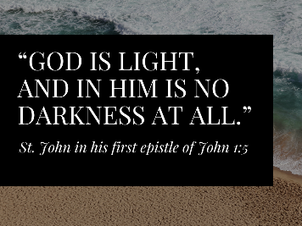

How does God relate with evil in your life? God is absolutely holy. We all know 1 John 1:5, “God is light, and in him is no darkness at all.”

Wayne Grudem Quote

Theologian Wayne Grudem said says it this way:

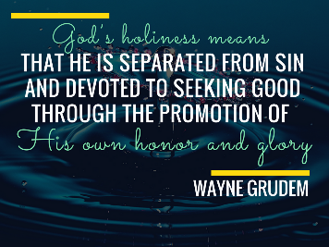

“God’s holiness means that he is separated from sin and devoted to seeking good through the promotion of His own honor and glory.”

God is separated from sin. In Him there is no darkness – no evil – whatsoever. He is dedicated to promoting the ultimate good of the beauty of His holiness. He is good and worthy to be praised!

The Big Question

And yet evil exists. How can evil exist if an all-powerful good God rules the universe? We are going to attempt to answer that question in 2 Chronicles 22-24 this morning.

What does God do with evil and darkness? Let’s read and 2 Chron 22:1-12 and begin to find out.

Reading of Holy Scripture
Let’s begin by reading 2 Chron 22:1-12, “And the inhabitants of Jerusalem made Ahaziah, his youngest son, king in his place, for the band of men that came with the Arabians to the camp had killed all the older sons. So Ahaziah the son of Jehoram king of Judah reigned. 2 Ahaziah was twenty-two years old when he began to reign, and he reigned one year in Jerusalem. His mother's name was Athaliah, the granddaughter of Omri. 3 He also walked in the ways of the house of Ahab, for his mother was his counselor in doing wickedly. 4 He did what was evil in the sight of the Lord, as the house of Ahab had done. For after the death of his father they were his counselors, to his undoing. 5 He even followed their counsel and went with Jehoram [Joram of Israel] the son of Ahab king of Israel to make war against Hazael king of Syria at Ramoth-gilead. And the Syrians wounded Joram [of Israel], 6 and he returned to be healed in Jezreel of the wounds that he had received at Ramah, when he fought against Hazael king of Syria. And Ahaziah the son of Jehoram king of Judah went down to see Joram [Jehoram I] the son of Ahab in Jezreel, because he was wounded.
7 But it was ordained by God that the downfall of Ahaziah should come about through his going to visit Joram [of Israel]. For when he came there, he went out with Jehoram to meet Jehu the son of Nimshi, whom the Lord had anointed to destroy the house of Ahab. 8 And when Jehu [the next king of Israel after Joram] was executing judgment on the house of Ahab, he met the princes of Judah and the sons of Ahaziah's brothers, who attended Ahaziah, and he killed them. 9 He searched for Ahaziah, and he was captured while hiding in Samaria, and he was brought to Jehu and put to death. They buried him, for they said, “He is the grandson of Jehoshaphat, who sought the Lord with all his heart.” And the house of Ahaziah had no one able to rule the kingdom.”

First we find that…

- God controls your darkness, (22:1-9).
Ahaziah’s Downfall Ordained by God
We see here the key verse is verse 7, “it was ordained by God that the downfall of Ahaziah should come about.”

An Ineffective Puppet King

We are dealing with Israel’s darkest days, in which the very royal line of David is almost extinct.

We see the rise of an ineffective puppet King Ahaziah who reigns only one year. Then we see a plot to kill all the offspring of the house of David so that the most wicked woman alive at that time, Queen Athaliah (Jezebel’s daughter), can reign with no competition. She is evil incarnate.

As things get dark in Israel, you are left to wonder, “Is God still on the throne?” Perhaps you are wondering the same thing in your life.

Our country grows more depraved each day. The darkness of sin is overwhelming. It’s hard to be a Christian in these evil and pagan days.

But God has a purpose for all the evil and calamity that is occurring in your life. God wants to do good to you. He proved it in Christ.

Key Persons
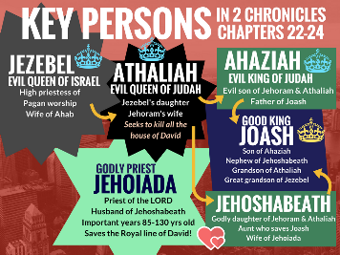
Let me give you a sneak preview of what’s going to happen in these chapters. Let me introduce you to the key players in these very dark scenes.
- Wicked Queen Jezebel. She’s married to Ahab (king of Northern Israel). We all know that Jezebel is a Gentile Queen from Tyre and Sidon. She brings Israel to a new level of depravity. In fact she is probably known as the wickedest woman that has ever lived. Yet there is one wicked than her. Jezebel’s daughter is named Athaliah.
- Evil Queen Athaliah is even more wicked than her mother because she does everything she can to destroy the royal family of David. Her goal is that David has no more descendants. And we know that includes the Lord Jesus Christ.
- Athaliah has two children: one evil and one good.
  - Evil King Ahaziah is duped by his mother Queen Athaliah into trusting the house of Ahab, and was lured to his own death and the death of his descendants, so that as far as anyone knew, the royal line of David was extinct. That means no Christmas, no cross, no resurrection. Queen Athaliah is so evil she is willing to murder her own children and grandchildren.
  - Godly Jehoshabeath marries the central good figure in Judah during this time: Jehoiada.
  - Godly Priest Jehoiada is a man known as "the Priest" even though he is 85 years old when he gets involved in saving the Kingdom. He does his best work beginning at 85 and he serves the Lord for 45 years and dies at the ripe old age of 130.

So the gist of this first scene is that a deep seeded evil is not at work in the heart of Queen Athaliah, and she convinces her son Ahaziah to destroy his own children. 2 Chron 22:3, “his mother was his counselor in doing wickedly.”

Compatibilism
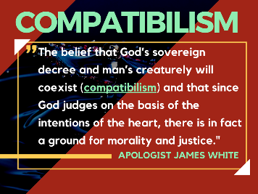
Compatibilism is “the belief that God’s sovereign decree and man’s creaturely will coexist (compatibilism) and that since God judges on the basis of the intentions of the heart, there is in fact a ground for morality and justice." – Apologist James White
In other words, God directs the consequences of evil, but He is not the Author of it. Man is the source of sin and is held accountable for it.

James 1:13
Though God controls the consequences of evil events, He is not touched by it, and does not tempt anyone.
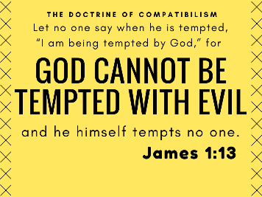
"Let no one say when he is tempted, “I am being tempted by God,” for God cannot be tempted with evil, and he himself tempts no one."

How Does God Control Evil?
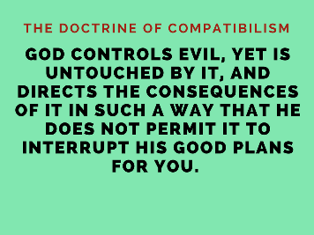
God controls evil, yet is untouched by it, and directs the consequences of it in such a way that he does not permit it to interrupt his good plans for you.
“The Hebrew grammar of 22:7a suggests that this sentence was intended as a parenthetical note. The Chronicler explained that God had a secret purpose for Ahaziah’s visit to Joram.”
In other words, this evil looks really bad, but God is going to direct the outcome for good.

No Weapon Shall Prosper
Evil will never stifle God's good plans in Christ for you.
Isaiah 54:17, “No weapon that is formed against you will prosper.”
Queen Athaliah couldn’t do it to the royal line of David. Her weapons had no power over David’s son. She tried to destroy the coming Christ. She was controlled and motivated very likely by Satan himself. But Satan is no match for David’s royal Son!
And because you are “in Christ,” God’s plan for you is unstoppable.

God’s Good Plan is Unstoppable!
Evil will never stifle God's good plans in Christ for you.
- Ephesians 1:11, “ God works all things after the counsel of His own will.”
- Daniel 2:20, “he removes kings and sets up kings.”
- Daniel 4:17, “The Most High rules the kingdom of men and gives it to whom he will.”
- Daniel 4:35, “He does according to his will among the host of heaven and among the inhabitants of the earth; and none can stay his hand or say to him, ‘What have you done?’”
- Jeremiah 29:11 (NIV), “For I know the plans I have for you," declares the LORD, "plans to prosper you and not to harm you, plans to give you hope and a future”
God raises up kings and kingdoms. He wants to prosper His people spiritual. Ephesians says we have every spiritual blessing in Christ.
God certainly has absolute control over Queen Athaliah, and her evil cannot stifle the good plans of God.

God’s Good in Job
Evil is allowed to afflict the child of God for one purpose: to conform that person to the image of Jesus. No one can stop that plan – no king or queen no matter how great. No evil can harm you without God’s permission. And even when He gives permission, the outcome is always good: conformity to Christ.
Suffering because of evil is a way that God disciplines His children (Heb. 12). Let’s be clear, it’s only by permission that Satan can afflict us. Consider Job 1:12, concerning Job, “the Lord said to Satan, “Behold, all that he has is in your hand. Only against him do not stretch out your hand. [i.e. Don’t kill him] So Satan went out from the presence of the Lord.”
What was the point of Job’s suffering? To bring glory and honor to God! God was demonstrating the power of a regenerated heart. Job had a new nature, and his suffering would bring the evidence of his heart to the test and bring it to the surface. He gloried in his redeemer and “worshipped God” in all his suffering.

Conformity to Christ
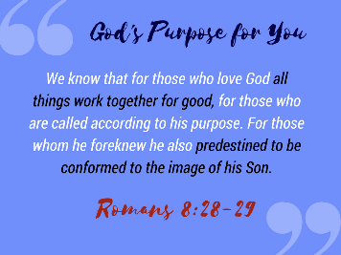
Like Job, God has a plan for the evil and the suffering in our lives. We see that plan in Romans 8:28-29, “we know that for those who love God all things work together for good, for those who are called according to his purpose. 29 For those whom he foreknew he also predestined to be conformed to the image of his Son…”

- God protects you in your darkness, (22:10-12).
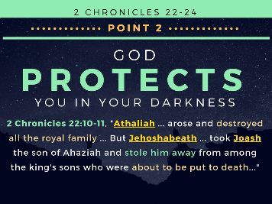

God Raises up Jehoshabeath
2 Chron 22:10, “Now when Athaliah the mother of Ahaziah saw that her son was dead, she arose and destroyed all the royal family of the house of Judah.”
What a dark time! It looks like evil has triumphed. It looks like Satan has one. Here we have the Maleficence of the Old Testament, and it seems she has won.
“She destroyed all the royal family of the house of Judah” (vs. 10). That’s the line of Jesus. No one left. No one. Or so she thought.

How Did This Happen? Jehoshaphat!
How did this happen? It was good king Jehoshaphat who introduced his son Jehoram to Jezebel’s daughter, Athaliah.
What? Jehoshaphat! How could he? He had a big heart. Remember his desire was to do good. But good motives do not erase reckless and careless actions.
Before we go judging good King Jehoshaphat, I think the point of this passage is that God indeed does work all things out for good – even this horribly careless sin of Jehoshaphat.
He should have had his son marry a believing Jewish girl, not a pagan Baal worshipper.
1 Corinthians 6:14-16, “Do not be unequally yoked with unbelievers. For what partnership has righteousness with lawlessness? Or what fellowship has light with darkness? 15 What accord has Christ with Belial? Or what portion does a believer share with an unbeliever? 16 What agreement has the temple of God with idols? For we are the temple of the living God.”
Whether business partnerships or worship or marriage, we are called to live separated unto God.

Alexander Pope (Poet) Quote
Jehoshaphat got too close to the evil and he unwittingly embraced it.
“Vice is a monster of so frightful mien
As to be hated needs but to be seen;
Yet seen too oft, familiar with her face,
We first endure, then pity, then embrace.”

Not Even a Hint!
Paul says in Ephesians 5:3 (NIV), “... among you there must not be even a hint of sexual immorality, or of any kind of impurity, or of greed, because these are improper for God's holy people.”

An Arranged Marriage with Athaliah
Jehoshaphat planted a hint of evil by arranging a marriage for his son Jehoram with Athaliah, daughter of Jezebel. That leads the assassination and extermination of the royal family of Judah. Remember, Jesus is the “Lion of the tribe of Judah.” His line is through Ahaziah. And now Ahaziah is dead and he has no sons, or so it seems.

Seed of the Woman Can No Longer Crush Serpent
Satan is rejoicing. The seed of the woman can no longer crush the head of the serpent! But wait!

A Son is Conceived and Hidden
We read in 2 Chron 24:1, “[Joash’s] mother's name was Zibiah of Beersheba.” Apparently, one of Ahaziah’s wives, Zibiah is pregnant with the son of her now dead husband, and no one knows about it.
Athaliah thinks she had wiped Messiah’s seed off the map.

Joash is Hidden and Safe with Jehoshabeath
2 Chronicles 22:11-12, “But Jehoshabeath, the daughter of the king, took Joash the son of Ahaziah and stole him away from among the king's sons who were about to be put to death, and she put him and his nurse in a bedroom. Thus Jehoshabeath, the daughter of King Jehoram and wife of Jehoiada the priest, because she was a sister of Ahaziah, hid him from Athaliah [her mother], so that she [Athaliah] did not put him [Joash] to death. 12 And he [Joash] remained with them six years, hidden in the house of God, while Athaliah reigned over the land.”
So Athaliah has a daughter (Jehoshabeath) who hides her dead brother’s heir to the throne, and no one knows about it. For six years Jehoshabeath hides Joash and his nurse, and likely the mother Zibiah was coming and going. For SIX YEARS this goes on!

Can I just remind us that God is committed to preserve and protect His saints. Satan can roar but he cannot ultimately harm your soul. You are protected in the midst of the darkness!

No One Can Snatch Us
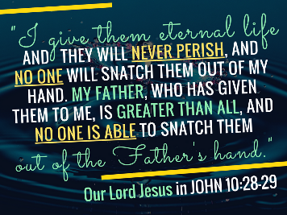
Our Lord Jesus said in John 10:28-29, “I give them eternal life, and they will never perish, and no one will snatch them out of my hand. My Father, who has given them to me, is greater than all, and no one is able to snatch them out of the Father’s hand.”

If God is For Us…
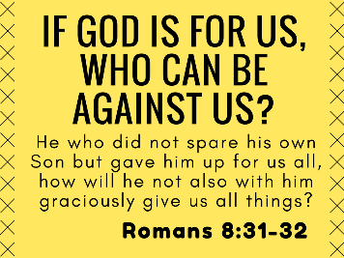
Can I ask you a question? Romans 8:31-39, “If God is for us, who can be against us? 32 He who did not spare his own Son but gave him up for us all, how will he not also with him graciously give us all things? 33 Who shall bring any charge against God's elect? It is God who justifies. 34 Who is to condemn? Christ Jesus is the one who died—more than that, who was raised—who is at the right hand of God, who indeed is interceding for us. 35 Who shall separate us from the love of Christ? Shall tribulation, or distress, or persecution, or famine, or nakedness, or danger, or sword?”
What does he say in verse 37? “No, in all these things we are more than conquerors through him who loved us. 38 For I am sure that neither death nor life, nor angels nor rulers, nor things present nor things to come, nor powers, 39 nor height nor depth, nor anything else in all creation, will be able to separate us from the love of God in Christ Jesus our Lord.”
Amen and hallelujah! You are in Christ! God’s love protects you. You are uncondemned by evil. Even your own evil cannot condemn you! (8:1, “There is no condemnation for those in Christ.”) You are ultimately protected from evil. It cannot harm you.

- God revives you out of your darkness, (23:1-21).
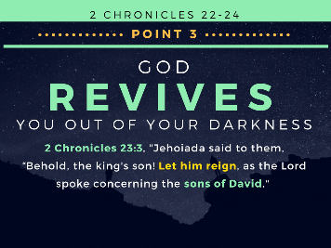
We turn to 2 Chronicles 23, and we have a very exciting chapter in the Bible.

Let David’s Son Reign
2 Chron 23:1-3, “But in the seventh year Jehoiada took courage and entered into a covenant with the commanders of hundreds… 2 And they went about through Judah and gathered the Levites from all the cities of Judah, and the heads of fathers' houses of Israel, and they came to Jerusalem. 3 And all the assembly made a covenant with the king in the house of God. And Jehoiada said to them, “Behold, the king's son! Let him reign, as the Lord spoke concerning the sons of David.”
So Jehoiada the priest, who is now about 91 years old boldly gathers the soldiers who guarded the Temple and the Levites from all over Judah to make a covenant and crown Joash king!

The Plan is Hatched
He hatches the plan in verses 4-7. They’ll cause a diversion, they’ll protect the king, and at the right time, they’ll crown Joash king.
2 Chron 23:4-11, “This is the thing that you shall do: of you priests and Levites who come off duty on the Sabbath, one third shall be gatekeepers, 5 and one third shall be at the king's house and one third at the Gate of the Foundation. And all the people shall be in the courts of the house of the Lord. 6 Let no one enter the house of the Lord except the priests and ministering Levites. They may enter, for they are holy, but all the people shall keep the charge of the Lord. 7 The Levites shall surround the king, each with his weapons in his hand. And whoever enters the house shall be put to death. Be with the king when he comes in and when he goes out.”
Look at verse 9, “And Jehoiada the priest gave to the captains the spears and the large and small shields that had been King David's, which were in the house of God. 10 And he set all the people as a guard for the king, every man with his weapon in his hand, from the south side of the house to the north side of the house, around the altar and the house.
11 Then they brought out the king's son and put the crown on him and gave him the testimony. And they proclaimed him king, and Jehoiada and his sons anointed him, and they said, “Long live the king.”
“12 When Athaliah heard the noise of the people running and praising the king, she went into the house of the Lord to the people. 13 And when she looked, there was the king standing by his pillar at the entrance, and the captains and the trumpeters beside the king, and all the people of the land rejoicing and blowing trumpets, and the singers with their musical instruments leading in the celebration. And Athaliah tore her clothes and cried, “Treason! Treason!” 14 Then Jehoiada the priest brought out the captains who were set over the army, saying to them, “Bring her out between the ranks, and anyone who follows her is to be put to death with the sword.” For the priest said, “Do not put her to death in the house of the Lord.” 15 So they laid hands on her, and she went into the entrance of the horse gate of the king's house, and they put her to death there.”

The King is Crowned and Given the Testimony
The King is crowned and a copy of the “Testimony” is given to him. He has a scepter in one hand and the Law of God in the other. He is a picture of the one true king that would come through his line: the Lord Jesus Christ. Verse 11, “Jehoiada and his sons anointed him.”

The People Running and Praising
We read (vs. 12) the people were running and praising. And “there was the king standing by his pillar at the entrance, and the captains and the trumpeters beside the king, and all the people of the land rejoicing and blowing trumpets, and the singers with their musical instruments leading in the celebration (vs. 13).

The Spiritual Winter of Athaliah is Over
What a scene! Athaliah cries out “Treason!” But it’s too late. She is put to death.
You can imagine the scene! Athaliah had been Queen over Judah for six years. She’s like the White Witch in Narnia, and it’s like there is a perpetual Spiritual Winter in Judah! But this is no fairy tale. This is real history.

LET HIM REIGN

Revival Begins: A Declaration from Jehoiada: LET HIM REIGN
The Revival in Judah began with a Declaration from Jehoiada: Let him reign! (Vs. 3). We need to let the Son of David reign today! That’s what revival is!

Andrew Murray Quote
Andrew Murray said it this way, “A TRUE REVIVAL means nothing less than a revolution, casting out the spirit of worldliness and selfishness, and making Christ and His love reign in your heart and life."

Effects of Revival (Cowper)
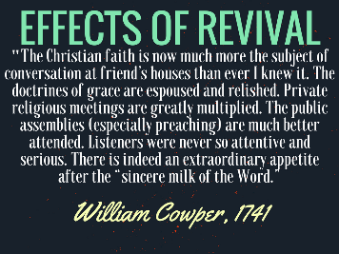
William Cowper (friend of John Newton who wrote Amazing Grace) was a young man when the First Great Awakening broke out and revival came with power to America. Cowper wrote what it was like to experience revival and its effects.
In 1741 Cowper wrote, “The Christian faith is now much more the subject of conversation at friend’s houses than ever I knew it. The doctrines of grace are espoused and relished. Private religious meetings are greatly multiplied. The public assemblies (especially preaching) are much better attended. Listeners were never so attentive and serious. There is indeed an extraordinary appetite after the “sincere milk of the Word.”

Is God Stirring?
Is God stirring in your life? Is He moving? Is he reviving you? God has promised to revive you, but you must stir yourself up to it. You must seek Him. You must want it more than you want the best things in life!
God is FAITHFUL! And so let us heed Hebrews 10:23-24, “Let us hold fast the confession of our hope without wavering, for he who promised is FAITHFUL. And let us consider how to stir up one another to love and good works.”

Great Changes Are Made in Revival
Let the Son of David reign! That’s when we see a renewal. And we read about all the good things that took place.
2 Chron 23:16 – They made a covenant. “And Jehoiada made a covenant between himself and all the people and the king that they should be the Lord's people.”
2 Chron 23:17 – They tore down their idols. “Then all the people went to the house of Baal and tore it down; his altars and his images they broke in pieces, and they killed Mattan the priest of Baal before the altars.”
2 Chron 23:18 – They offered Levitical sacrifices again and got the choir going. “And Jehoiada posted watchmen for the house of the Lord under the direction of the Levitical priests and the Levites whom David had organized to be in charge of the house of the Lord, to offer burnt offerings to the Lord, as it is written in the Law of Moses, with rejoicing and with singing, according to the order of David.”
2 Chron 23:21 – There was great joy! “So all the people of the land rejoiced, and the city was quiet after Athaliah had been put to death with the sword.”

Their whole way of pagan life was interrupted. Gone was Athaliah the wicked queen of Baal and daughter of Jezebel.
A whole new way of living had begun! This is what we should be seeking!

- God restores you after your darkness, (24:1-14).
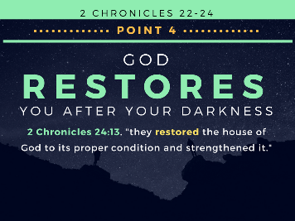
And now we see that after this great revival, they take up a great collection and restore the house of the Lord (vs. 1-14).

They Restored the House of the Lord
They put a chest outside the Temple and took a collection. 2 Chron 24:11-12, “And whenever the chest was brought to the king's officers by the Levites, when they saw that there was much money in it, the king's secretary and the officer of the chief priest would come and empty the chest and take it and return it to its place. Thus they did day after day, and collected money in abundance.
12 And the king and Jehoiada gave it to those who had charge of the work of the house of the Lord, and they hired masons and carpenters to restore the house of the Lord, and also workers in iron and bronze to repair the house of the Lord. 13 So those who were engaged in the work labored, and the repairing went forward in their hands, and they restored the house of God to its proper condition and strengthened it…”

Revival is Not Without Results
When revival comes it results in great sacrifice and work for the Lord!
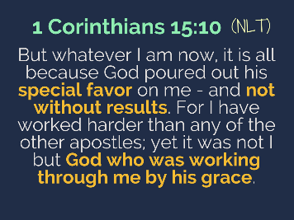
1 Corinthians 15:10 (NLT), “But whatever I am now, it is all because God poured out his special favor on me - and not without results. For I have worked harder than any of the other apostles; yet it was not I but God who was working through me by his grace.”
When God’s grace – His special favor and power – is upon you, it is never without results! It causes us to work hard.
Eze. 36:26 – God takes out the heart of stone and puts within us a heart of flesh – and the Bible says He puts His Spirit in us and “causes us to walk in His statutes and keep his judgements.”

God is Working in You
God is working in you! Remember what St. Paul says in Phil. 2:12-13. God is working in you! “...work out your own salvation with fear and trembling, for it is God who works in you, both to will and to work for his good pleasure.”

Andrew Bonar Quote
Revival has an effect on you and others. Andrew Bonar says, “Revivals begin with God's own people; the Holy Spirit touches their heart anew, and gives them new fervor and compassion, and zeal, new light and life. And after He has thus come to you, He next goes to the valley of dry bones...to bring people to life."
He goes on to say, “Oh, what responsibility this lays on the Church of God! If you grieve the Spirit of God away from yourselves, or hinder His visit, then the poor perishing world suffers sorely!”

Don’t resist the Lordship of Jesus in your life. It will be bad for you and bad for others!!

- God rescues you in the midst your darkness, (24:15-19a).
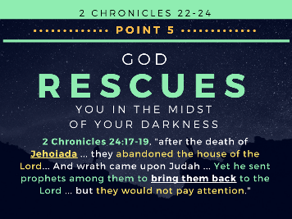

God Sends Prophets
2 Chron 24:15-16, “But Jehoiada grew old and full of days, and died. He was 130 years old at his death. 16 And they buried him in the city of David among the kings, because he had done good in Israel, and toward God and his house.”
They treated Jehoiada like a king, literally. They buried him among the kings. There is no higher honor.

2 Chron 24:17-19a, “Now after the death of Jehoiada the princes of Judah came and paid homage to the king. Then the king listened to them. 18 And they abandoned the house of the Lord, the God of their fathers, and served the Asherim and the idols. And wrath came upon Judah and Jerusalem for this guilt of theirs. 19a Yet he sent prophets among them to bring them back to the Lord…”

Jehoiadah’s Legacy
Just consider that this man Jehoiadah propped up Joash all those years. What a man!

But after Jehoiadah’s death, God sent prophets to care for the people’s souls since King Joash woud not.

God is Faithful even when We are Not
The revival lasted 39 years, but King Joash strayed. What do you do when people around you stray. It shakes you!

Remember 2 Timothy 2:13, “If we are faithless, He remains faithful. He cannot deny Himself.”

Always Faithful: Take Your Troubles to God
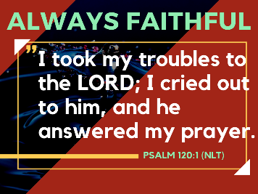
God is ready to rescue you right now. If you are backsliding or you feel you’ve wandered, God will grant you a holy anguish for your own soul.
Weep for your soul! Take your troubles to the Lord. That’s what David did.
“I took my troubles to the LORD; I cried out to him, and he answered my prayer” (Psalm 120:1 (NLT).

In Faithfulness God Afflicts Me
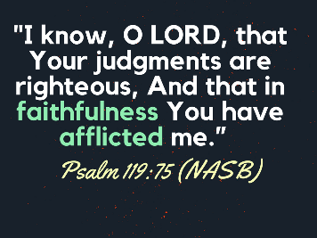
You may be afflicted and confused. Take it to Jesus. “I know, O LORD, that Your judgments are righteous, And that in faithfulness You have afflicted me.”
God afflicts you to bring you closer to Him. In other words, sometimes the best thing for you is to fee the chastening of the Lord so that you can eventually feel His comfort and favor.

Transition: What else does God do with our darkness?

- God judges you in the midst your darkness, (vs. 19b-27).
Finally, because God is holy, we find that He cannot leave it alone or neglect it. God is meticulous in His judgement against sin.

2 Chron 24:19b-22, “…19b These [prophets] testified against them, but they would not pay attention.
20 Then the Spirit of God clothed Zechariah the son of Jehoiada the priest, and he stood above the people, and said to them, “Thus says God, ‘Why do you break the commandments of the Lord, so that you cannot prosper? Because you have forsaken the Lord, he has forsaken you.’”
21 But they conspired against him, and by command of the king they stoned him with stones in the court of the house of the Lord. 22 Thus Joash the king did not remember the kindness that Jehoiada, Zechariah's father, had shown him, but killed his son. And when he was dying, he said, “May the Lord see and avenge!”

Joash Dies
And how did the Lord avenge? He brought King Joash’s life to an end. God brings a small Syrian army to show that He is in total control.
2 Chron 24:23-25, “At the end of the year the army of the Syrians came up against Joash. They came to Judah and Jerusalem and destroyed all the princes of the people from among the people and sent all their spoil to the king of Damascus. 24 Though the army of the Syrians had come with few men, the Lord delivered into their hand a very great army, because Judah had forsaken the Lord, the God of their fathers. Thus they executed judgment on Joash.
25 When they had departed from him, leaving him severely wounded, his servants conspired against him because of the blood of the son of Jehoiada the priest, and [the Syrian soldiers] killed him on his bed. So he died, and they buried him in the city of David, but they did not bury him in the tombs of the kings.”

For Christians No Condemnation
True believers like Joash are not condemned at the day of Christ. But he dies in the way of God’s discipline.
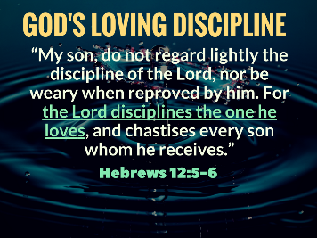
Take God’s discipline seriously. Hebrews 12:5-6, “My son, do not regard lightly the discipline of the Lord, nor be weary when reproved by him. For the Lord disciplines the one he loves, and chastises every son whom he receives.”
Takes God’s discipline seriously. Joash did not. God raised up prophets and even tried to touch his heart through the Zechariah, the son of Joash’s father-figure, Jehoiada the Priest.
But Joash did not listen, and the Lord took him.

God Judges Sin at the Cross
The ultimate judgement for sin is either at the Cross or in Hell forever. You have to pay for it or you have to have someone who is perfect pay for it on your behalf.
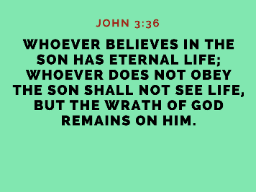
John 3:36, “Whoever believes in the Son has eternal life; whoever does not obey the Son shall not see life, but the wrath of God remains on him.”

Spurgeon Quote
I pray today that there will be a holy unrest when it comes to sin in our lives. Spurgeon was right when he said,
“I believe the holier a man becomes, the more he mourns over the unholiness which remains in him.” – Charles Haddon Spurgeon

St. Augustine Quote
I pray that we might call on God like St. Augustin did. He said:
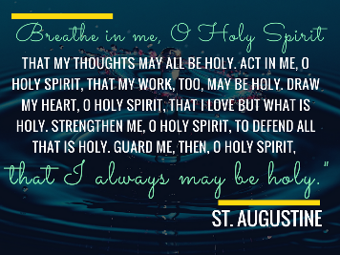
“Breathe in me, O Holy Spirit, that my thoughts may all be holy. Act in me, O Holy Spirit, that my work, too, may be holy. Draw my heart, O Holy Spirit, that I love but what is holy. Strengthen me, O Holy Spirit, to defend all that is holy. Guard me, then, O Holy Spirit, that I always may be holy. Amen.” – St. Augustine

Conclusion
Adoniram Judson was a missionary to the people of Burma. He was eager to reach them in their own language. He was translating the Bible from Hebrew and Greek. He saw very little fruit until a revival there in 1831.
There had been an enormous price to pay between the first convert in 1819 and this outpouring of God's power in 1831.
All westerners were viewed as spies and Adoniram was dragged from his home and on June 8, 1824 and put in prison. His feet were fettered and at night a long horizontal bamboo pole was lowered and passed between the fettered legs and hoisted up till only the shoulder and heads of the prisoners rested on the ground.
Ann was pregnant, but walked the two miles daily to the palace to plead that Judson was not a spy and that they should have mercy. She got some relief for him so that he could come out into a court yard. But still the prisoners got vermin in their hair amid the rotting food, and had to be shaved bald. Almost a year later they were suddenly moved to a more distant village prison, gaunt, with hollow eyes, dressed in rags crippled from the torture. There the mosquitoes from the rice paddies almost drove them mad on their bloody feet.
Their daughter, Maria, had been born by now and Ann was almost as sick and thin as Adoniram, but still pursued him with her baby to take care of him as she could. Her milk dried up, and the jailer had mercy on them and actually let Judson take the baby each evening into the village and beg for women to nurse his baby.
On November 4, 1825 Judson was suddenly released, but it was too late. Ann died on she died on October 24, 1826. And six months later their daughter died (April 24, 1827).
The psychological effects of theses losses were devastating. Self-doubt overtook his mind. He had a grave dug beside the hut, and sat on the edge of it wanting to die and be buried in it. That continued and all through the year 1830 Adoniram was climbing out of his darkness. In 1831 God sent revival.
By his death in 1850 the Bible translation was done. Hundreds of converts were leading the church. And today there are close to about 3,700 congregations of Baptists in Myanmar (Burma) who trace their origin to this man's labors of love.
All that to say, God means good to you even in the midst of great calamity and even evil. Turn your eyes to Him!
He has destroyed the darkness and evil of sin in the Cross of His Son Jesus Christ! Hallelujah!

Pratt, Richard. 1 and 2 Chronicles: A Mentor Commentary. 2 Chron 22:7.

