A Legacy to be Forgotten
2 Chronicles 21
___________________________________________
The King is Coming (2 Chronicles)

Prepared by: Matthew S. Black

Sunday, January 8, 2017, 10:30am at Living Hope Church of Roselle, Illinois

livinghopechurch.net

“May our Lord's sweet hand square us and hammer us, and strike off all kinds of pride, self-love, world-worship, and infidelity, so that He can make us stones and pillars in His Father's house.”
~ Samuel Rutherford
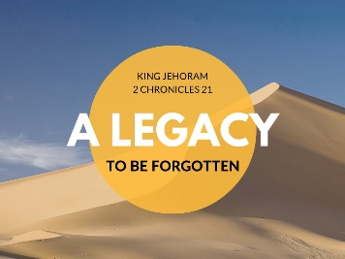

O
pen your Bible to 2 Chronicles. We are in a 15-message series in the book of 2 Chronicles entitled “The King is Coming.” This morning we are looking at a message number seven entitled: “Jehoram: A Legacy to be Forgotten.”

Proposition: Only one life, ‘twill soon be past, only what’s done for Christ will last.

Intro: Only What’s Done for Christ Will Last
How will you be remembered? This week we had a memorial for Harry Ehorn. It was a touching tribute for a precious man who put his faith in Christ at the end of his life. That’s what made Harry’s life count. Without Christ, we are nothing. Harry’s life counted because of Christ.
But in our passage today, we meet a king whose life meant nothing! One of the key verses is 2 Chronicles 21:20, where it says Jehoram “departed with no one's regret.”
One day we’re all going to have a “last day.” And we will leave a legacy. King Jehoram, son of Jehoshaphat was one who had a legacy to be forgotten. The Bible says he was so bad, people wanted to forget him! How sad!

Quote: CT Studd
I want to be remembered as a channel for Jesus Christ. I love the quote by CT Studd, missionary to China, India and Africa. He said,
“Only one life, ‘twill soon be past! Only what’s done for Christ will last!”

Legacy Quote
Someone said, “Legacy is not leaving something FOR people, but leaving something IN people.”
Our legacy must be: “Christ in you the hope of glory.”
Is Christ in you? Unless Christ is in you, you will have a legacy that is forgotten!
You say, “I want that legacy!” You may have it today. You may gain it through another – by faith in Christ.

Holy Scripture: 2 Chronicles 21:1-20
Jehoram’s Legacy of Disaster
“1 Jehoshaphat slept with his fathers and was buried with his fathers in the city of David, and Jehoram his son reigned in his place. 2 He had brothers, the sons of Jehoshaphat: Azariah, Jehiel, Zechariah, Azariah, Michael, and Shephatiah; all these were the sons of Jehoshaphat king of Israel. 3 Their father gave them great gifts of silver, gold, and valuable possessions, together with fortified cities in Judah, but he gave the kingdom to Jehoram, because he was the firstborn. 4 When Jehoram had ascended the throne of his father and was established, he killed all his brothers with the sword, and also some of the princes of Israel. 5 Jehoram was thirty-two years old when he became king, and he reigned eight years in Jerusalem. 6 And he walked in the way of the kings of Israel, as the house of Ahab had done, for the daughter of Ahab was his wife. And he did what was evil in the sight of the Lord.

God’s Legacy of Divine Grace
7 Yet the Lord was not willing to destroy the house of David, because of the covenant that he had made with David, and since he had promised to give a lamp to him and to his sons forever.

A Legacy of Decreasing Borders
8 In his days Edom revolted from the rule of Judah and set up a king of their own. 9 Then Jehoram passed over with his commanders and all his chariots, and he rose by night and struck the Edomites who had surrounded him and his chariot commanders. 10 So Edom revolted from the rule of Judah to this day. At that time Libnah also revolted from his rule, because he had forsaken the Lord, the God of his fathers.

A Legacy of Deviant Worship
11 Moreover, he made high places in the hill country of Judah and led the inhabitants of Jerusalem into whoredom and made Judah go astray.

Elijah’s Legacy of Correction
12 And a letter came to him from Elijah the prophet, saying, “Thus says the Lord, the God of David your father, ‘Because you have not walked in the ways of Jehoshaphat your father, or in the ways of Asa king of Judah, 13 but have walked in the way of the kings of Israel and have enticed Judah and the inhabitants of Jerusalem into whoredom, as the house of Ahab led Israel into whoredom, and also you have killed your brothers, of your father's house, who were better than you, 14 behold, the Lord will bring a great plague on your people, your children, your wives, and all your possessions, 15 and you yourself will have a severe sickness with a disease of your bowels, until your bowels come out because of the disease, day by day.’”
16 And the Lord stirred up against Jehoram the anger of the Philistines and of the Arabians who are near the Ethiopians. 17 And they came up against Judah and invaded it and carried away all the possessions they found that belonged to the king's house, and also his sons and his wives, so that no son was left to him except Jehoahaz, his youngest son.
18 And after all this the Lord struck him in his bowels with an incurable disease. 19 In the course of time, at the end of two years, his bowels came out because of the disease, and he died in great agony. His people made no fire in his honor, like the fires made for his fathers.

Jehoram’s Legacy to be Forgotten
20 He was thirty-two years old when he began to reign, and he reigned eight years in Jerusalem. And he departed with no one's regret. They buried him in the city of David, but not in the tombs of the kings.”

King Jehoshaphat was in a bind. He had made an alliance with one of God’s greatest enemies.

- A legacy of disaster, (vs. 1-6).
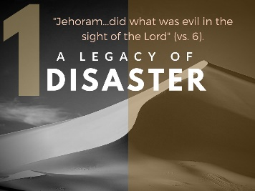

Jehoram’s Dirty Deeds
2 Chron 21:1-6, “Jehoshaphat slept with his fathers and was buried with his fathers in the city of David, and Jehoram his son reigned in his place. 2 He had brothers, the sons of Jehoshaphat: Azariah, Jehiel, Zechariah, Azariah [Azaryahu, NASB], Michael, and Shephatiah; all these were the sons of Jehoshaphat king of Israel.
3 Their father gave them great gifts of silver, gold, and valuable possessions, together with fortified cities in Judah, but he gave the kingdom to Jehoram, because he was the firstborn.
4 When Jehoram had ascended the throne of his father and was established, he killed all his brothers with the sword, and also some of the princes of Israel. 5 Jehoram was thirty-two years old when he became king, and he reigned eight years in Jerusalem.
6 And he walked in the way of the kings of Israel, as the house of Ahab had done, for the daughter of Ahab was his wife. And he did what was evil in the sight of the Lord.”

Had Everything and Lost it All
Jehoram had everything, but he lost it all by putting himself first. We all know about people who had everything, and lost it all.
    - Bernie Madoff
    - O.J. Simpson
    - Three governors of Illinois.
What do they have in common? They had everything but lost it all, because they put themselves first. We can add Jehoram to that list.

He Squanders His Riches
2 Chron 21:3-4, “Their father gave them great gifts of silver, gold, and valuable possessions, together with fortified cities in Judah, but he gave the kingdom to Jehoram, because he was the firstborn. 4 When Jehoram had ascended the throne of his father and was established, he killed all his brothers with the sword, and also some of the princes of Israel.”
And what does Jehoram do with his wealth? He uses it to advance Himself. And its disastrous. If a person continues to put themselves first, it will not end well.
Self-deception and blindness comes. Look at what happens. Later in the chapter, we find out he starts losing land and riches and Influence.

He Squanders His Family
Jehoram had a wonderful family, but he loses it because he is ruthless and insecure. His father set him up well with his brothers and many confidants to help Jehoram govern well. He had it all when it came to his family. But Jehoram put himself first and it led him to insecurity and jealousy.
For the sake of his own raging insecurity, Jehoram murders his six brothers along with anyone who might not support Jehoram. The list of names (unlike other kings where the names of sons are not recorded) accentuates the horror of the deed.
He eliminates all his rivals. Thus, Jehoram establishes his own kingdom (rather than God’s kingdom) by acting against his father’s kingdom.

He Squanders His Marriage
Jehoram has everything when it comes to seeking a bride. He’s rich – he’s got position, and he compromises his marriage for political advantage.
He seeks to bolster Judah’s external stability by a marriage alliance with Ahab’s daughter, Athaliah, who becomes famously wicked. What he doesn’t realize, she tries to destroy any heir from the line of David (which is the line of the Messiah).
Look at 2 Chron 22:10-11, “Now when Athaliah [Jehoram’s wife] the mother of Ahaziah saw that her son was dead, she arose and destroyed all the royal family of the house of Judah. 11 But Jehoshabeath, the daughter of the king, took Joash the son of Ahaziah and stole him away from among the king’s sons who were about to be put to death, and she put him and his nurse in a bedroom.”

Application. Put God first in your marriage – don't make a horrible mistake. As one woman told me, “if you think your lonely now being single – you have no idea the loneliness of being married to a man who does not love God.”

He Squandered His Position and Life
He had been given great gifts from his father King Jehoshaphat (vs. 3), and yet his whole life can be described with verse 6, “And he did what was evil in the sight of the Lord.”
Jehoram is the first king of Judah who is explicitly linked to the ways of the kings of Israel. He is the first truly evil king of Judah, and the reader is asking: Why does God let him live?

Depravity Quote from Spurgeon
Spurgeon said, “It is impossible to slander human nature; it is infinitely worse than words can paint it.”

No Good Thing
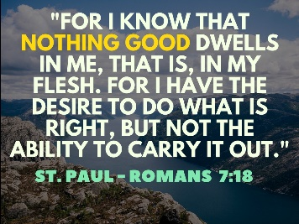
St. Paul said in Romans 7:18, “For I know that nothing good dwells in me, that is, in my flesh. For I have the desire to do what is right, but not the ability to carry it out.”
Jesus said, “Without me you can do nothing” (Jn 15:5).

Jehoram Squandered Everything
Jehoram wanted to live a life without God. It led him to squander all the good things that were given to him. And yet God is good. Look at verse 7

- A legacy of divine grace, (vs. 7).
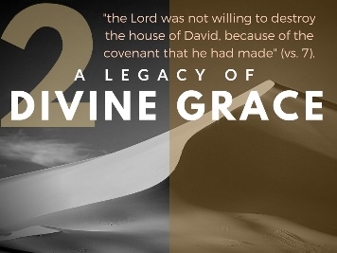
God’s Covenant Love
Despite our depravity, God is a God of love and kindness.
2 Chron 21:7, “Yet the Lord was not willing to destroy the house of David, because of the covenant that he had made with David, and since he had promised to give a lamp to him and to his sons forever.”
A burning lamp in the home would indicate its occupancy by a resident. To have a lamp suggests that life would continue and the home would be occupied. The promise was that the Davidic line would not be extinguished until the time of the Messiah, who would occupy the throne forever.

An Everlasting Love (Hesed)
Jeremiah (31:3) said it this way, “I have loved you with an everlasting love; therefore I have continued my faithfulness to you.”
Jehoshaphat (Jehoram’s father) remembered God’s love. Remember, he commanded the priests and singers in Judah to sing about his “steadfast love” and God not only gave the army a rest, the enemies’ armies turned on one another and imploded.
We should sing of God’s covenant love (hesed)! God’s grace is irresistible and unrelenting. It is his hesed, his loyal covenantal love, his love that never gives up and never stops pursuing you.

Why Does Jehoram Live?
Think about it – why should God allow Jehoram to live? He’s the first truly evil king of Judah. He begins with fratricidal murder to secure his position. His marriage brings the cult of Baal-Melqart to Judah. He reestablishes the high places and leads Judah into religious unfaithfulness. Only God’s loyalty to the Davidic covenant keeps Jehoram alive.

A B Simpson Quote
“Let us but feel that He has His heart set upon us, that He is watching us from those heavens with tender interest, that He is following us day by day as a mother follows her babe in his first attempt to walk alone, that He has set His love upon us, and in spite of ourselves is working out for us His higher will and blessing, as far as we will let Him – and then nothing can discourage us.”

Grace Abounding
Remember the words of St. Paul in Romans 5:20, “Where sin abounds, grace much more abounds.”
How can we ever get down or depressed if we hear these words?

St. Augustine Quote
St. Augustine describes this love that overtook him hard.
“You called, You cried, You shattered my deafness, You sparkled, You blazed, You drove away my blindness, You shed Your fragrance, and I drew in my breath, and I pant for You.” -St. Augustine

Even the aroma of Christ’s love plants life in deadness and light in darkness. Praise the Christ for the fragrance of His love!

Is God Calling You?
Is the Lord calling you? What are you waiting for? You are not going to get holier waiting. Jesus said, “I did not come to call the righteous, but sinners to repentance” (Luke 5:32).
Come to Christ today. You are commanded by God to come NOW.

Listen to God’s Call
- “Today, if you hear my voice, harden not your heart” (Hebrews 3:8).

- “I tell you, now is the time of God's favor, now is the day of salvation” (2 Cor 6:2).

- “Come to me, all who labor and are heavy laden, and I will give you rest. 29 Take my yoke upon you, and learn from me, for I am gentle and lowly in heart, and you will find rest for your souls. 30 For my yoke is easy, and my burden is light” (Mat. 11:28-30).

- A legacy of decreasing borders, (vs. 8-10).
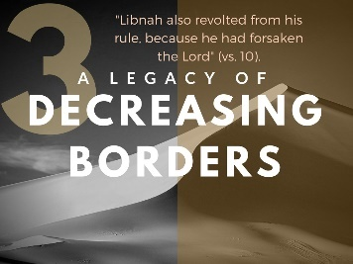
Sadly, King Jehoram did not seek the Lord. Instead, he put himself first. Not only did he squander his position, his riches, his family and his wife. He squandered the land of Israel. He began to lose the expanse of the borders of Israel.

Jehoram’s Loss of Land
2 Chron 21:8-10, “In his days Edom revolted from the rule of Judah and set up a king of their own. 9 Then Jehoram passed over with his commanders and all his chariots, and he rose by night and struck the Edomites who had surrounded him and his chariot commanders. 10 So Edom revolted from the rule of Judah to this day. At that time Libnah also revolted from his rule, because he had forsaken the Lord, the God of his fathers.”
We see that both Edom (from outside Judah) and Libnah (from within Judah) revolted. Jehoram’s selfishness cost Judah territory!

The Prayer of Jabez
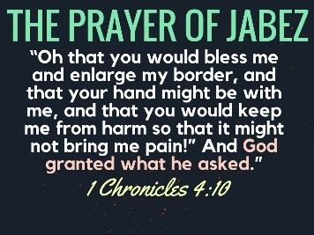
I love the prayer of Jabez in 1 Chron 4:10, “Jabez called upon the God of Israel, saying, “Oh that you would bless me and enlarge my border, and that your hand might be with me, and that you would keep me from harm so that it might not bring me pain!” And God granted what he asked.”

Ask According to His Will
Don’t misunderstand. While all things are yours in Christ, you must ask according to God’s will.
1 John 3:22, “whatever we ask we receive from him, because we keep his commandments and do what pleases him.”
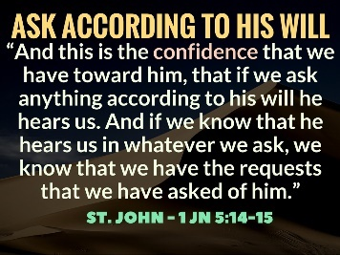
1 John 5:14-15, “And this is the confidence that we have toward him, that if we ask anything according to his will he hears us. 15 And if we know that he hears us in whatever we ask, we know that we have the requests that we have asked of him.”

What are You Holding on To?
What are you holding on to? In Christ we have everything. We are “heirs of God and joint-heirs with Christ!”

Give Up Your Life!
Matthew 10:39, “If you cling to your life, you will lose it; but if you give up your life for Me [Jesus Christ], you will find it.”
Jehoram clung to his life and lost everything! Come to Christ! Both whether you are God’s child or not, we need to be reminded of this.
- A legacy of deviant worship, (vs. 11).
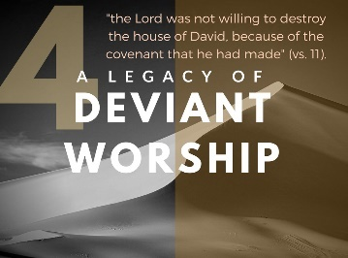
The High Places
2 Chron 21:11, “Moreover, he made high places in the hill country of Judah and led the inhabitants of Jerusalem into whoredom and made Judah go astray.”
Jehoram cozied up to idolatry. Purity for God’s people is not just some added bonus for pastors and elders and missionaries. Holiness is vital for all of God's people. Purity and holiness is what we strive after because we are meant to reflect God - to be holy as he is holy. Idolatry scraps purity and holiness on the altar of comfort.

Asherah and Baal Worship
Jehoram made high places – what were the high places? They were literally altars that were built on the tops of hills as tokens to pagan deities.
A reoccurring theme in Kings and Chronicles is that many kings even the good Kings did not take down these pagan shrines of fornication and idolatry.

Asherah and Baal Worship Described
Let me explain again what Ashteroth and Baal worship is.
Asherah is a female deity. At the shrine prostitution is promoted. Baal worship is also related to superstition in fertility – in these pagan rites the child conceived is put in the flaming mouth of the Baal (which looks like a bull) and well the drums play loudly and the child screams – the child is left to die a horrible death.
As outrageous as all of this sounds, Baal worship was so entrenched in the culture that they could not even see it as evil.

Glory Thieves
Do you realize we are all glory thieves? Isaiah 43:8, “I am the LORD; that is my name; my glory I give to no other, nor my praise to carved idols.”

Idolatry is about us taking the place of God. Really those idols were tools in people’s hands. They didn’t want to be controlled. They wanted to control the events of their life. We all want to steal the glory from God. That’s what idolatry is all about. Idols get me what I want, which is:
- My glory
- My pleasure
- Myself at the center
- My peace and calm

His Glory Above My Comfort
Now God is not against peace and calm, but we must put His glory above our comfort.

Confessions of a Glory Thief
Let me explain. Because I'm a sinner, I'm a glory thief. I want to be the center of my world. That's why when someone hurts me, I become indignant and angry. When things don't go my way, I battle until something changes. When people need help, I step in, valiantly, waiting for the pats on the back and the cheering crowds to recognize how great I am. I've stolen the glory from God and applied it pathetically on myself.

Paul Tripp Quote
Listen to Paul Tripp on the joy of living for God’s glory!
“The Redeemer has come so that glory thieves would joyfully live for the glory of Another. There is no deeper personal joy and satisfaction than to live committed to His glory. It is what we truly need.”

Ava’s Simple Catechism
This morning Ava came to me and she wanted to show me what she had learned. She said, “Daddy, I can say the word right.” “Thou… Thou… Thou…” It’s not “Dow…. It’s Thou…”
I said, “Thou what?”
She said, “Thou shalt have not other gods before Me!” Amen! If we could just learn that!

- A legacy of demise, (vs. 12-20).
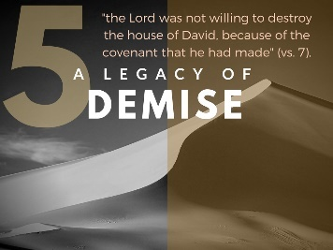
A Letter from Elijah
2 Chron 21:12-20, “12 And a letter came to him from Elijah the prophet, saying, “Thus says the Lord, the God of David your father, ‘Because you have not walked in the ways of Jehoshaphat your father, or in the ways of Asa king of Judah, 13 but have walked in the way of the kings of Israel and have enticed Judah and the inhabitants of Jerusalem into whoredom, as the house of Ahab led Israel into whoredom, and also you have killed your brothers, of your father's house, who were better than you, 14 behold, the Lord will bring a great plague on your people, your children, your wives, and all your possessions, 15 and you yourself will have a severe sickness with a disease of your bowels, until your bowels come out because of the disease, day by day.’”
16 And the Lord stirred up against Jehoram the anger of the Philistines and of the Arabians who are near the Ethiopians. 17 And they came up against Judah and invaded it and carried away all the possessions they found that belonged to the king's house, and also his sons and his wives, so that no son was left to him except Jehoahaz, his youngest son.
18 And after all this the Lord struck him in his bowels with an incurable disease. 19 In the course of time, at the end of two years, his bowels came out because of the disease, and he died in great agony. His people made no fire in his honor, like the fires made for his fathers.

Jehoram’s Legacy to be Forgotten
20 He was thirty-two years old when he began to reign, and he reigned eight years in Jerusalem. And he departed with no one's regret. They buried him in the city of David, but not in the tombs of the kings.”

Jehoram gets a letter. Most of you have probably heard of the prophet Elijah. You know a lot of wild stories about the miracles performed by Elijah and Elisha, but did you know that there was a letter from Elijah?! This is a hard letter to receive—and no doubt to write. It would be easy for us in the distance of millennia to say, “He’s a terrible king. Tell him off.” Or, “Anyone could post something this afternoon about what they don’t like about the governor or the president. No big deal!” No, this is the king, who can have you killed or banished at his word. It takes some guts for Elijah to write this letter.
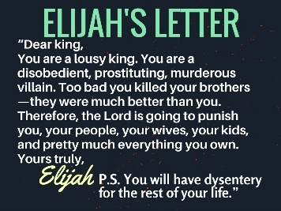
“Dear, king. You are a lousy king. You are a disobedient, prostituting, murderous villain. Too bad you killed your brothers—they were much better than you. Therefore, the Lord is going to punish you, your people, your wives, your kids, and pretty much everything you own. Yours truly, Elijah. P.S. You will have dysentery for the rest of your life.”
That’s the letter, and he meant every word of it.

Jehoram Could Have Repented
he could have repented. There was always an offer to repent. When Jonah went to Nineveh, he offered them, as far as we can tell, no good news. Forty days, and they would be wiped out. Even they understood that there was always an implicit appeal in the prophet’s message: “This threatened judgment can be changed if you repent.” They did; Jehoram didn’t.

God’s Promise to His People
We read this exact thing in Jeremiah 18:7-10. It lays out that, “If at any time my people would repent, I would forgive them.” You know the verse which is sometimes misapplied. People throw it up there and put an American flag behind it. It’s a fine thing for us to think about doing, but it’s not a specific promise for our country – It’s a promise for God’s People

“…if my people who are called by my name humble themselves, and pray and seek my face and turn from their wicked ways, then I will hear from heaven and will forgive their sin and heal their land.” 2 Chronicles 7:14

Jehoram Reaps what He Sows
Jehoram is reaping what he has sown. If you sow bad seeds in your life, you will eventually reap a bad harvest.
If you don’t even care about your parents, your name, your reputation, or any of that, maybe you would care about your own life. What you are sowing right now, I’m going to promise you, does not end well. That’s the point in Galatians 5-6. Some people reap destruction. God may withhold some of his deserved wrath, but we will eventually reap. You will get what that seed is.

Chris Wohlaib’s Pumpkin Seeds
The other day I was with Chris and Tiffany Wohllaib. He showed me his pumpkin patch by the side of his driveway. He just threw them down there. And guess what he got? Pumpkins!
If you put down pumpkin seeds, you get pumpkins. If you sow to the flesh, you reap destruction. What a mess Jehoram made for himself. In eight years, he unraveled the accomplishments of Jehoshaphat and Asa combined.

Seek First the Kingdom! Put God first!

Goldingay, J. (2012). 1 and 2 Chronicles for Everyone (p. 151). Louisville, KY; London: Westminster John Knox Press; Society for Promoting Christian Knowledge.
Hicks, J. M. (2001). 1 & 2 Chronicles (p. 394). Joplin, MO: College Press Pub. Co.
Hicks, 394-395.
Ibid.
Thompson, J. A. (1994). 1, 2 Chronicles (Vol. 9, p. 298). Nashville: Broadman & Holman Publishers.
Elwell, W. A. (1995). Evangelical Commentary on the Bible (Vol. 3, 2 Ch 21:4). Grand Rapids, MI: Baker Book House.
The problem is that Elijah apparently died during the reign of Jehoshaphat (cf. 2 Kgs 2–3). Thompson (299; cf. Selman, 2:435–436) suggests that the letter was written during Jehoram’s co-regency with Jehoshaphat (cf. 2 Kgs 1:17) when his tendencies were already well-known.

