A New Vision for the New Year
The Battle of King Jehoshaphat
2 Chronicles 20
___________________________________________
The King is Coming (2 Chronicles)

Prepared by: Matthew S. Black

Sunday, January 1, 2017, 10:30am at Living Hope Church of Roselle, Illinois

livinghopechurch.net

“True faith is man’s weakness leaning on God’s strength.”
~ D. L. Moody

O
pen your Bible to 2 Chronicles. We are in a 15-message series in the book of 2 Chronicles entitled “The King is Coming.” This morning we are looking at a message number six entitled: “Jehoshaphat: A New Vision for the New Year.”

Proposition: A new vison of God changes everything.

Intro: New Vision
Three years ago, I got two surgeries that changed my life. Some of you remember when I couldn’t see.
I had a disease in my left eye called Keratoconus. It’s when you have so many astigmatisms that your cornea looks like a mountain range.
I also had what’s called “Lazy Eye” and I need “Strabismus” surgery, where they would tighten the muscles of my eyes.
Before my surgery, I was practically blind. I remember having to stop and pull over on the side of the road at night to see road sign.
When I got those surgeries, I could finally see!

Was Blind but Now I See
Isn’t that what salvation is? Amazing grace how sweet the sound that saved a wretch like me, I once was lost but now am found, was blind but now I see!
This is John Newton describing faith and repentance. Repentance is the ability to see things from God’s perspective
Remember we learned last week that what repentance is.

Repentance Meaning
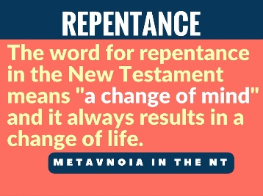
METANOIA: The word for repentance in the New Testament means "a change of mind" and it always results in a change of life.
This great king repented. I want to know…

IS YOUR LIFE CHARACTERIZED BY REPENTANCE? 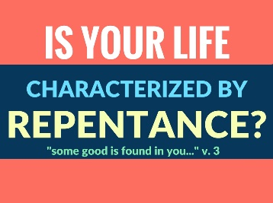
This morning we get to see how radical repentance is. Do you have mind and a heart that is changed because you see God? Do you have a vision of God this morning?

Some Good in Jehoshaphat
Jehoshaphat had sinned. He had made an evil alliance with wicked King Ahab and Queen Jezebel (18:1). He had made friends of God’s enemies. You can’t be a friend of the world and remain friends with God.
Jehoshaphat sinned. But He did not remain in his sin. He repented!
There was “some good” (vs. 3) in him. That good was the repentant work of the Holy Spirit in his heart.

Isaiah said (6:1), “I saw the Lord sitting upon a throne, high and lifted up…” It changed Isaiah.
The Bible says of Moses (Deut. 5:4), “The LORD spoke to you face to face at the mountain from the midst of the fire.” It changed Moses.
Are you living a repentant life? Don’t say you are God’s child unless you are constantly repenting and seeking the face of God.

Eight ways a new vision of God changes everything.
A new vision of God changes the way we see…
- our sin (2 Chr 19)
- our enemy (2 Chr 20:1-4)
- the power of prayer (vs. 5-11)
- our weakness (vs. 12)
- our battles (vs. 13-19)
- our leadership (vs. 20-21)
- our victory [faith in what God can do] (vs. 22-23)
- our blessing/praise! (vs. 24-29)
- Our warning – don’t rest in past victories! We need perseverance (vs. 35-37)

King Jehoshaphat was in a bind. He had made an alliance with one of God’s greatest enemies.

Jehoshaphat had a new vision. He had made an alliance with Ahab and Jezebel. He was a man that a heart for God. Yet he sinned by making the Lord’s enemies his friends.

- Our sin, (2 Chron 19).
Brought Judah Back to God
2 Chron 19:2-4, “But Jehu the son of Hanani the seer went out to meet him and said to King Jehoshaphat, “Should you help the wicked and love those who hate the Lord? Because of this, wrath has gone out against you from the Lord. 3 Nevertheless, some good is found in you, for you destroyed the Asheroth out of the land, and have set your heart to seek God.”
“4 Jehoshaphat lived at Jerusalem. And he went out again among the people, from Beersheba to the hill country of Ephraim, and brought them back to the Lord, the God of their fathers.”
The rest of the chapter explains how he raised up godly leadership and they DID SOMETHING ABOUT it! They changed the society of Judah.
They tore down the high places! This is a repentance that leads to revival. Repentance is a change of mind that leads to a change of life.

What are You Going to Do About Your Sin?
I want to ask you a question – what are you going to do about your sin? In my book you have
- Continue in it.
- Do nothing. Some of you are doing nothing about your sin.
- Do something yourself.
- God to God and let God do something about your sin.
The prophet Jehu said to King Jehoshaphat, “I see some good in you.” “I see a repentant heart in you. I see the work of the God the Holy Spirit in you. I see it! You have destroyed the Asherahs out of the land.” “And you know what else?” You “have set your heart to seek God.” (vs. 3).

How Are You Dealing with Your Sin?
Perhaps it’s friendships. You’ve got to break questionable friendships off. And you need to seek the Lord and ask him for godly friends.
Perhaps it’s your finances. You’ve got to put God first in all things. Give Him the first fruits. Give Him your tithe and offerings first before you pay any bills. Do you have the faith to seek God for what you are lacking? Seek God’s Kingdom and righteousness first! Put Him first.
Perhaps it’s your fellowship. Do you come to church on time? Are you forsaking the fellowship of the saints? Are you coming hungry? Or do you come in late? You can get to your work on time, but you can’t get to church on time. Put God first. Seek His face!
Perhaps it’s your purity. Is your mind pure? Is your heart pure? Don’t you know 1 John 1:8-9, “If we say we have no sin, we deceive ourselves, and the truth is not in us. 9 If we confess our sins, he is faithful and just to forgive us our sins and to cleanse us from all unrighteousness.”
1 Jn 2:1-2, “if anyone does sin, we have an advocate with the Father, Jesus Christ the righteous. 2 He is the propitiation for our sins, and not for ours only but also for the sins of the whole world.”

Repent! Turn to God’s Mercy and Love
God’s mercy is infinitely greater than our sin!

Sibbes Quote
“There is more mercy in Christ than sin in us.” -Richard Sibbes (puritan)
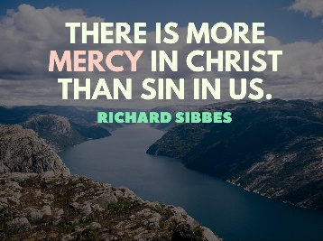
Chandler Quote
You might be thinking, “God doesn’t love me now, but He will love me when Christ comes for me and I am perfected.” I love what Matt Chandler said: “God doesn’t love a future version of you. He loves you.” – Matt Chandler (pastor)
Listen, God has loved you with an everlasting love. He does not love you less right now because of your sin. Do you understand you are positionally righteous in Christ right now?

- Our enemy, (2 Chron 20:1-4).

Jehoshaphat was Afraid
2 Chron 20:1-4, “After this the Moabites and Ammonites, and with them some of the Meunites, came against Jehoshaphat for battle. 2 Some men came and told Jehoshaphat, “A great multitude is coming against you from Edom, from beyond the sea; and, behold, they are in Hazazon-tamar” (that is, Engedi). 3 Then Jehoshaphat was afraid and set his face to seek the Lord, and proclaimed a fast throughout all Judah. 4 And Judah assembled to seek help from the Lord; from all the cities of Judah they came to seek the Lord.”

Look at verse 3 again, “Jehoshaphat was afraid.” Jehoshaphat had an army of 1.26 million soldiers. Yet he was AFRAID.
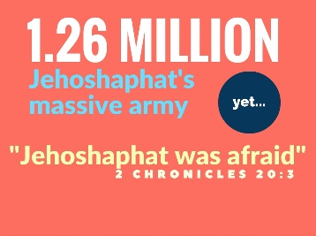

There were three armies. His enemies are greater than he is. What shall he do? Who shall he lean on? How shall he react. Thank God, the Lord gives Him the answer.
2 Chron 20:17, “You will not need to fight in this battle. Stand firm, hold your position, and see the salvation of the Lord on your behalf, O Judah and Jerusalem.’”

You Can’t Win on Your Own
God says, “No matter what you do, this is not a battle you can win on your own. You should not fight. You should not engage. This is a battle I’m going to fight. I don’t want you to troubleshoot! I want you to stand still and watch God fight you are.”

Afraid to win without God
Jehoshaphat was afraid! Afraid to WIN WITHOUT GOD. You ought to be afraid to try to win without God. The battle is too great for us.
I don’t care how compassionate of a husband or wife you need God to win the battle in your marriage.
I don’t care how great of a parent you are, you need God to raise your kids for God.
I don’t care how much of God’s Word you know, you need to God to live godly as a teenager in this post-modern, ungodly world.
It doesn’t matter how much you’ve been to church, you ought to be afraid of trying to win any battle without first seeking the Lord. God has to do it! “Unless the Lord build the house, they labor in vain who build it,” (Psalm 127:1).
Verses 3-4, “Then Jehoshaphat was afraid and set his face to seek the Lord, and proclaimed a fast throughout all Judah. 4 And Judah assembled to seek help from the Lord; from all the cities of Judah they came to seek the Lord.”

What Do You Do When You are Afraid?
What do you do when you are fearful? Do you try to win the battle yourself? What do you do when the enemies of God outnumber you?
Listen without God, you are going to fight your battles with:
- Worry
- Depression
- Self-righteousness and pride
- Unwise choices
- Bad counsel
Have you been afraid? Trying to fight without God? How’s that working for you?

The Fundamental Reason to Seek the Lord
The fundamental reason to seek the Lord is found in Psalm 145:3, “Great is the Lord, and greatly to be praised, and His greatness is unsearchable.”

Jehoshaphat was afraid!
- You should be afraid to face your trials without God.
- You should be afraid to go another step in your marriage without God
- You should be afraid, single person, to live a chaste single life without God
- What can you do apart from God? Jesus said, “Without Me, you can do NOTHING” (Jn 15:5). You will do nothing meaningful for eternity without God. Be afraid to move forward without God. You see if we lack wisdom we need to seek God, and we need to be afraid to move forward without His wisdom.

Jehoshaphat Chose to Seek the Lord
Jehoshaphat had a very purposeful desire and made a choice to seek the Lord. We need to be purposeful to see God. Purpose to put him first in your life by walking with Him, listening to Him. Put him first in your tithes and offerings.
There's a cost to seek God. They sought God by giving up food. What is it costing you to see God?
What repentance Jehoshaphat had! He had a new vision of His enemies. He was afraid to move against them without God! Don’t try to win against your enemies without God. It’ll never work.
Let’s move to the next thing getting a view of God changes for us.

- The power of prayer, (2 Chron 20:5-12).
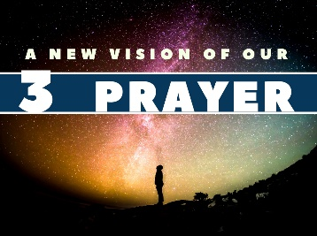
The God of Prayer
2 Chron 20:5-12, “And Jehoshaphat stood in the assembly of Judah and Jerusalem, in the house of the Lord, before the new court, 6 and said, “O Lord, God of our fathers, are you not God in heaven? You rule over all the kingdoms of the nations. In your hand are power and might, so that none is able to withstand you.”
7 Did you not, our God, drive out the inhabitants of this land before your people Israel, and give it forever to the descendants of Abraham your friend? 8 And they have lived in it and have built for you in it a sanctuary for your name, saying, 9 ‘If disaster comes upon us, the sword, judgment, or pestilence, or famine, we will stand before this house and before you—for your name is in this house—and cry out to you in our affliction, and you will hear and save.’ 10 And now behold, the men of Ammon and Moab and Mount Seir, whom you would not let Israel invade when they came from the land of Egypt, and whom they avoided and did not destroy— 11 behold, they reward us by coming to drive us out of your possession, which you have given us to inherit. 12 O our God, will you not execute judgment on them? For we are powerless against this great horde that is coming against us. We do not know what to do, but our eyes are on you.”

Oswald Chambers Quote
Oswald chambers said it this way: “We have to pray with our eyes on God, not on difficulties.”
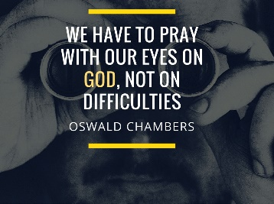
Where are your eyes? Are you trying to live this life without looking to God. That’s what prayer is! It’s seeing God high and lifted up as Lord of your life.

What is Prayer?
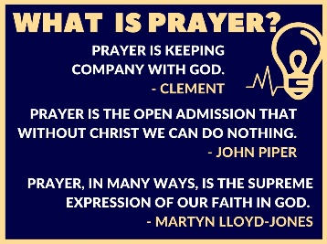
It’s keeping your eyes on God! ALL EYES ON GOD!
- Clement of Alexandria (150-215) said, “Prayer is keeping company with God.”
- John Piper said, “Prayer is the open admission that without Christ we can do nothing.”
- Martyn Lloyd-Jones said, “Prayer, in many ways is the supreme expression of our faith in God.

We try to fix things ourselves. We don’t want to trust God. We’ve got to trust Him! Ephesians 3:20-21, “Now to him who is able to do far more abundantly than all that we ask or think, according to the power at work within us, 21 to him be glory in the church and in Christ Jesus throughout all generations, forever and ever. Amen.”

Oswald Chambers Quote
We might think prayer will get us ready for the great work ahead in 2017.
Oswald Chambers got it right: “Prayer does not fit us for greater work; prayer is the greater work.”

- Our weakness, (2 Chron 20:12).
Look at this impossible situation. Then in verses 5-12, Jehoshaphat prays and the summary of that prayer is found in 20:12, “O our God, will you not execute judgment on them? For we are powerless against this great horde that is coming against us. We do not know what to do, but our eyes are on you.”

An Impossible Situation: 3 Massive Armies
Three massive armies are surrounding.
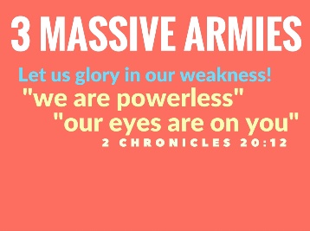

When I Am Weak, I am strong
Paul said in 1 Corinthians 10:13, “No temptation has overtaken you that is not common to man. God is faithful, and he will not let you be tempted beyond your ability, but with the temptation he will also provide the way of escape, that you may be able to endure it.”
He said again in 2 Corinthians 12:7-10, “So to keep me from becoming conceited because of the surpassing greatness of the revelations, a thorn was given me in the flesh, a messenger of Satan to harass me, to keep me from becoming conceited. 8 Three times I pleaded with the Lord about this, that it should leave me. 9 But he said to me, “My grace is sufficient for you, for my power is made perfect in weakness.” Therefore I will boast all the more gladly of my weaknesses, so that the power of Christ may rest upon me. 10 For the sake of Christ, then, I am content with weaknesses, insults, hardships, persecutions, and calamities. For when I am weak, then I am strong.”

Andrew Murray quote
Listen to Andrew Murray: “In trial and weakness and trouble, He seeks to bring us low, until we learn that His grace is all, and to take pleasure in the very thing that brings us and keeps us low. His strength is made perfect in our weakness. His presence fills and satisfies our emptiness.”

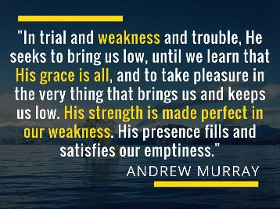

God Chooses the Weak so He Gets All the Glory
Hallelujah! I need to be weak so I don’t get confused who gets the glory! 1 Cor. 1:26 says God chose the foolish and the weak to confound the might so that no flesh should glory in His sight!” God will not share His glory with another. He is worthy of all the glory!
That’s why I need to rejoice in my weakness!

- Our battles, (2 Chron 20:13-19).
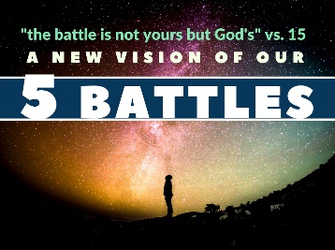
Jahaziel’s Sermon
Now the people of Judah, the families, the little ones, the men, they are all there gathered together for a sermon. Jahaziel’s sermon. Listen to it:
2 Chron 20:13-19, “Meanwhile all Judah stood before the Lord, with their little ones, their wives, and their children. 14 And the Spirit of the Lord came upon Jahaziel the son of Zechariah, son of Benaiah, son of Jeiel, son of Mattaniah, a Levite of the sons of Asaph, in the midst of the assembly. 15 And he said, “Listen, all Judah and inhabitants of Jerusalem and King Jehoshaphat: Thus says the Lord to you, ‘Do not be afraid and do not be dismayed at this great horde, for the battle is not yours but God's. 16 Tomorrow go down against them. Behold, they will come up by the ascent of Ziz. You will find them at the end of the valley, east of the wilderness of Jeruel. 17 You will not need to fight in this battle. Stand firm, hold your position, and see the salvation of the Lord on your behalf, O Judah and Jerusalem.’ Do not be afraid and do not be dismayed. Tomorrow go out against them, and the Lord will be with you.”
18 Then Jehoshaphat bowed his head with his face to the ground, and all Judah and the inhabitants of Jerusalem fell down before the Lord, worshiping the Lord. 19 And the Levites, of the Kohathites and the Korahites, stood up to praise the Lord, the God of Israel, with a very loud voice.”
What a sermon! So they all leave there and get up the next morning and they have to act on it!

I May Not Be Able to Beat the Moabites…
I may not be able to beat the Moabites but the Moabites can’t beat my God.
You may not be able to beat your problems (trials) but your problems (trials) can't beat your God.

The Battle is the Lord’s
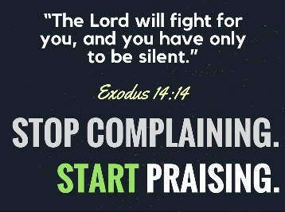
The battle is not mine. It’s the Lord’s God told Moses before He parted the Red Sea in Exodus 14:14, “The Lord will fight for you, and you have only to be silent.” I don’t know what you are struggling with, but the battle is the Lord’s. Stop complaining! Start Praising!
I wonder if there are some people here today that are tired of hearing themselves complain? I know I am. I struggle with complaining. But I have a God who is perfect. I have nothing to complain about. I can only offer praise to Him! He is worthy of our praise.
God stays stand silent. Stand still. Stop trying to solve your problems and praise me!

Fear Not: Isaiah 41:10
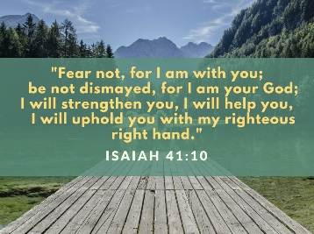
Isaiah 41:10, “fear not, for I am with you;
be not dismayed, for I am your God;
I will strengthen you, I will help you,
I will uphold you with my righteous right hand.”

- Our leadership, (2 Chron 20:20-21).
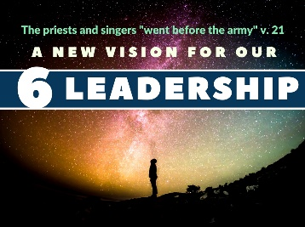
Jehoshaphat Repreaches the Sermon
Jehoshaphat has a million man army (2 Chron 18), but he refuses to use them. Now we see in the morning King Jehoshaphat reproaches the sermon. It’s amazing! It’s one thing to hear a sermon on Sunday, but what do you do the next day?
2 Chron 20:20, “And they rose early in the morning and went out into the wilderness of Tekoa. And when they went out, Jehoshaphat stood and said, “Hear me, Judah and inhabitants of Jerusalem! Believe in the Lord your God, and you will be established; believe his prophets, and you will succeed.”
But he doesn’t’ just re-preach the sermon; he acts on the sermon. He sets the singers and the priests in front of the army of Judah and has them sing and praise God for the victory.
2 Chron 20:21, “And when he had taken counsel with the people, he appointed those who were to sing to the Lord and praise him in holy attire, as they went before the army, and say,
“Give thanks to the Lord,
for his steadfast love endures forever.”

We Need True Leaders!
We need leaders who know how to worship! Here is a God-ordained, Holy Spirit touched leader / prophet named Jahaziel (vs. 14) who is a true friend. And you remember the prophet Jehu in chapter 19 who rebuked Jehoshaphat for his sin of allying with Ahab.
Faithful are the wounds of a friend.
When you're down and out you need more than just a stress killer or some motivational speech--you need words from the very mouth of God!

Out Ranked, but God is Greater!
And here is Jahaziel’s speech. He’s a real leader! And Jehoshaphat re-preaches it!
- I know you're out-ranked; I know you're outnumbered.
- I know you're afraid, but though they out rank you they don't out rank God.
- I want our couples to believe that when they're going through a hard time.
- I want our parents to believe that when our children are rebellious.

The Strategy: Pray and Sing
Here’s the strategy: Pray and sing!
2 Chron 20:21, “And when he had taken counsel with the people, he appointed those who were to sing to the Lord and praise him in holy attire, as they went before the army, and say,
“Give thanks to the Lord,
for his steadfast love endures forever.”

Sinclair Ferguson Quote
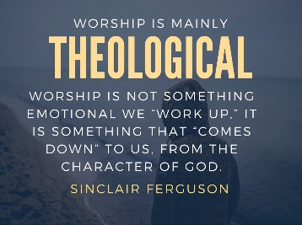
Listen, we need some leaders who will lead us in worship! It’s not mainly an emotional thing, but a theological thing. Worship is all about knowing God!
“Worship is theological. Worship is not something we “work up,” it is something that “comes down” to us, from the character of God.”

Sing a Love Song!
Jehoshaphat puts the priests and singers in front. He says: Sing! Sing this song about God’s unrelenting love!
“…they went before the army, and say,
“Give thanks to the Lord,
for his steadfast love endures forever.”
God’s HESED endures forever! His unrelenting love will never fail! Can you attest to that?
We need some leaders who will lead with the love of God and the worship of God and prayer to God and faith in God.

And then we will get the victory from God. That’s our next point.

- Our victory, (2 Chron 20:22-23).
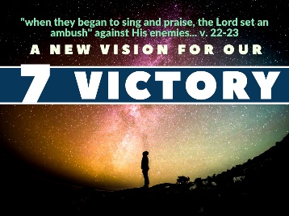

The Battle is the Lord’s!
So the priest go first and they sing! And the army is behind. They don’t need to fight. The battle is the Lord’s!
2 Chron 20:22-23, “And when they began to sing and praise, the Lord set an ambush against the men of Ammon, Moab, and Mount Seir, who had come against Judah, so that they were routed. 23 For the men of Ammon and Moab rose against the inhabitants of Mount Seir, devoting them to destruction, and when they had made an end of the inhabitants of Seir, they all helped to destroy one another.

Spurgeon Quote
Spurgeon said, “Faith is the surest of all sin-killers.” Your enemies are defeated!
God commands His people to praise Him BEFORE He gives them the victory!
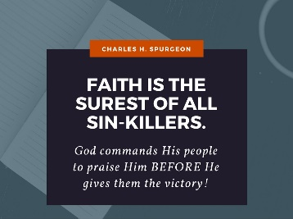

Jesus Has Already Won the Victory!
You want to know who your enemy is? It’s nothing you can defeat!
Your enemy is your sin.
Your enemy is Satan, the accuser.
Your enemy is the philosophies of this world.

Who has defeated our sins? Jesus! What can wash away my sin? Nothing but the blood of Jesus!
Who has defeated that great accuser of the brethren? Jesus has shut the mouth of Satan. He can roar but he cannot harm. Romans 8:1, “There is therefore now no condemnation to those who are in Christ Jesus.”

Warren Wiersbe Quote
REMEMBER: YOU ARE NOT FIGHTING FOR VICTORY, BUT FROM VICTORY, FOR JESUS CHRIST HAS ALREADY DEFEATED SATAN! JESUS IS OUR VICTOR!

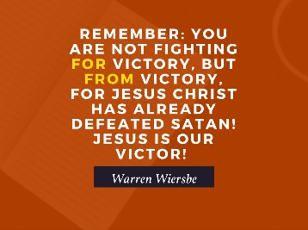

- Our blessing, (2 Chron 20:24-30).
2 Chron 20:24-30, “When Judah came to the watchtower of the wilderness, they looked toward the horde, and behold, there were dead bodies lying on the ground; none had escaped. 25 When Jehoshaphat and his people came to take their spoil, they found among them, in great numbers, goods, clothing, and precious things, which they took for themselves until they could carry no more. They were three days in taking the spoil, it was so much. 26 On the fourth day they assembled in the Valley of Beracah, for there they blessed the Lord. Therefore the name of that place has been called the Valley of Beracah to this day.
27 Then they returned, every man of Judah and Jerusalem, and Jehoshaphat at their head, returning to Jerusalem with joy, for the Lord had made them rejoice over their enemies. 28 They came to Jerusalem with harps and lyres and trumpets, to the house of the Lord. 29 And the fear of God came on all the kingdoms of the countries when they heard that the Lord had fought against the enemies of Israel. 30 So the realm of Jehoshaphat was quiet, for his God gave him rest all around.”

My Help Comes from the Lord
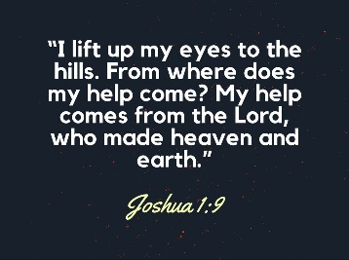

Psalm 121, “I lift up my eyes to the hills.
From where does my help come?
2 My help comes from the Lord,
who made heaven and earth.
3 He will not let your foot be moved;
he who keeps you will not slumber.
4 Behold, he who keeps Israel
will neither slumber nor sleep.

5 The Lord is your keeper;
the Lord is your shade on your right hand.
6 The sun shall not strike you by day,
nor the moon by night.
7 The Lord will keep you from all evil;
he will keep your life.
8 The Lord will keep
your going out and your coming in
from this time forth and forevermore.”

Where Does Your Help Come from?
Jeremiah 17:5, “Thus says the LORD: “Cursed is the man who trusts in man and makes flesh his strength, whose heart turns away from the LORD.”

Help!
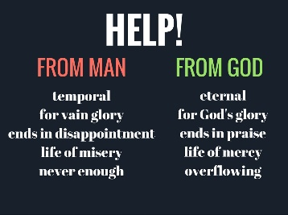
Man’s help is vain!
Help from man is temporal, for vain glory, ends in disappointment, leads to a life of misery, and is never enough.
Help from God is eternal, for God’s glory, ends in praise, leads to a life of mercy, and is more than sufficient and overflowing! His grace and help are enough!

- Our warning, (2 Chron 20:35-37).
2 Chron 20:35-37, “After this Jehoshaphat king of Judah joined with Ahaziah king of Israel, who acted wickedly. 36 He joined him in building ships to go to Tarshish, and they built the ships in Ezion-geber. 37 Then Eliezer the son of Dodavahu of Mareshah prophesied against Jehoshaphat, saying, “Because you have joined with Ahaziah, the Lord will destroy what you have made.” And the ships were wrecked and were not able to go to Tarshish.”

Unless the Lord Builds the House
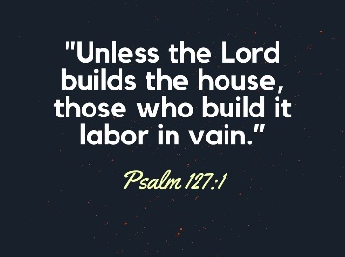
Psalm 127:1, “Unless the Lord builds the house, those who build it labor in vain.”

Conclusion
This past year I played softball at the church picnic, and finally I could hit the ball. The eye surgeries I received gave me my perspective back.
That’s good for my eyes, but what’s more important is this: Do you see God? Do you have a perpective of God that touches every part of your life?
May God grant us this new vision for the new year!

