A Heart for God
The Story of King Jehoshaphat
2 Chronicles 17-19
___________________________________________
The King is Coming (2 Chronicles)

Prepared by: Matthew S. Black

Sunday, December 18, 2016, 10:30am at Living Hope Church of Roselle, Illinois

livinghopechurch.net

“Prayer is an expression of submission to God and dependence upon Him. For that matter, prayer is arguably the most objective measurement of our dependence upon God. The things you pray about are the things you trust God to handle. The things you neglect to pray about are the things you trust you can handle on your own.”
~ H. B. Charles Jr.

O
pen your Bible to 2 Chronicles. We are in a 14-message series in the book of 2 Chronicles entitled “The King is Coming.” This morning we are looking at a message number five entitled: “Heart for God: The Story of King Jehoshaphat.”

Proposition: Good fruit always proceeds from a regenerated heart.

My Dog Yazmin
I had a dog named Yazmin growing up.
- Norwegian Elkhound
- Great protector
I would take my dog to the crick where we would jump from 60, 70 feet in the air. My dog would watch with wonderment. How can he fly like that?
I can’t fly. My dog can’t fly. It’s not in our nature.

When you take the bird out of the sky and swim the bird, you kill the bird. When you take the dog off the leash and drop him from the sky, you kill the dog. When you take the fish out of the water and walk the fish, you kill the fish. So the first humans, Adam and Eve, when they departed from the design of their maker, they destroyed themselves (and all after them). Christians, through the new birth, are redeemed and redesigned with a new nature that soars above the sinful world in the righteousness of Christ, which is the “perfect law, the law of liberty” (James 1:25).

Regeneration
This morning we are talking about regeneration of the heart. RE means new and GENESIS means beginning. Regeneration, re-genesis is a new beginning. We must be born again, having the very life of God in us if we are to enter the Kingdom of Heaven (Jn 3:3ff).
The message this morning is a demonstration of what a truly born again person looks like. Jehoshaphat was not a perfect person, but he was born again, and the chief characteristic of a person who is born again, is that he has a changed heart. He has a heart that is dedicated to the Lord.

Shedd on Regeneration
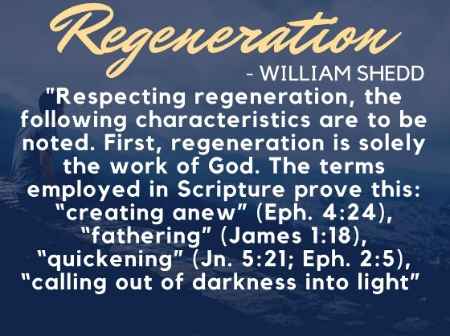
William Shedd (1820-1894), the well-known American systematic theologian, defined the biblical concept of regeneration in his work Dogmatic Theology:
Respecting regeneration, the following characteristics are to be noted. First, regeneration is solely the work of God. The terms employed in Scripture prove this: “creating anew” (Eph. 4:24), “fathering” (James 1:18), “quickening” (Jn. 5:21; Eph. 2:5), “calling out of darkness into light” (1 Pet. 2:9),

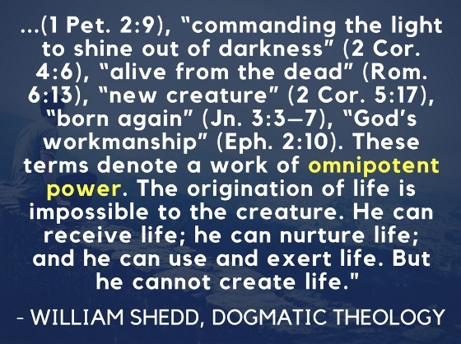
“commanding the light to shine out of darkness” (2 Cor. 4:6), “alive from the dead” (Rom. 6:13), “new creature” (2 Cor. 5:17), “born again” (Jn. 3:3–7), “God’s workmanship” (Eph. 2:10). These terms denote a work of omnipotent power. The origination of life is impossible to the creature. He can receive life; he can nurture life; and he can use and exert life. But he cannot create life.

Did you notice all the metaphors for regeneration?
- New creation
- Resurrection
- New birth

What do these things have in common? Man is passive.

- Man is in chaos, but God hovers over the fallen creation and makes a new creation.
- Man is dead in his sins, but God commands him to live.
- Man is like a helpless infant in a womb, and God gives the miracle of life and birth.

Again, what do these things have in common? Man is passive.
- I cannot create myself
- I cannot resurrect myself if I’m dead
- I cannot give birth to myself

I need the omnipotent God to make me alive.
This occurs through the Word of God. God’s Word is so powerful – it’s like a spiritual defibrillator – it shocks the spiritual heart back to life.
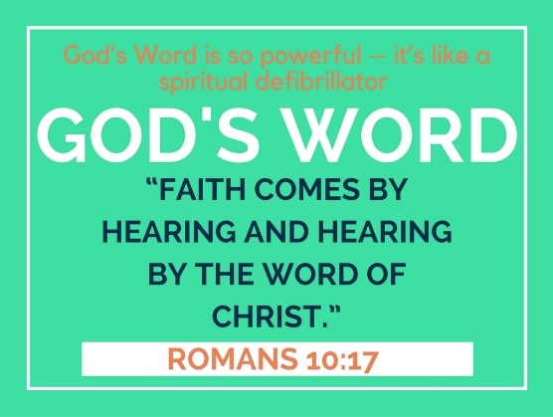
______________________________

“Faith comes by hearing and hearing by the Word of Christ.”
Romans 10:17
______________________________

That happened for King Jehoshaphat. We see the proof of it in 2 Chronicles 17-20. Four chapters are given to this king, more than any other in 2 Chronicles.

In Jehoshaphat’s life we see four episodes – four heartbeats if you will – of a new heart a new life! We ought to have (and we will have) our hearts beating for these things if we are truly born again. We are going to see them this morning…

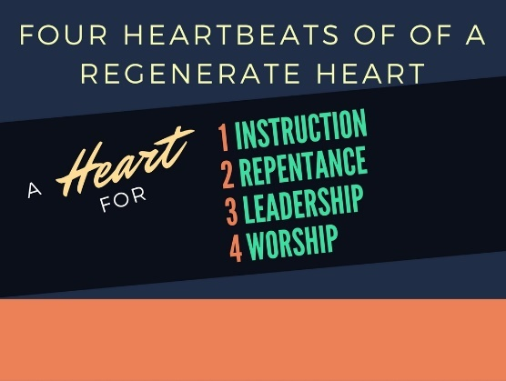

Four heartbeats of regeneration
- We will have a heart for Instruction, (2 Chron 17).
- We will have a heart for Repentance, (2 Chron 18).
- We will have a heart for Leadership, (2 Chron 19).
- We will have a heart for Worship, (2 Chron 20).

Certainly King Jehoshaphat’s spiritual heart was beating! And just as a heart sets the rhythm and energy for the life, so a new heart in Christ sets the rhythm for this King’s life and all of our lives as well.

- We will have a heart for Instruction, (2 Chron 17).

Episode 1: Instructing with the Word
In the first episode of Jehoshaphat’s life, we find that he commands the priests and Levites to go throughout Judah and instruct all the people. The king, like our King, was a good shepherd.
Great blessing came as a result of a people walking in obedience to the Lord. All of this came about because of the conversion language in this chapter. Jehoshaphat sought the Lord. As a result God touched His heart in some extraordinary ways.
Let’s read about it…

Jehoshaphat Set His Heart to Seek the Lord
2 Chron 17:1-6, “Jehoshaphat his son reigned in his place and strengthened himself against Israel. 2 He placed forces in all the fortified cities of Judah and set garrisons in the land of Judah, and in the cities of Ephraim that Asa his father had captured. 3 The Lord was with Jehoshaphat, because he walked in the earlier ways of his father David. He did not seek the Baals, 4 but [Jehoshaphat] sought the God of his father and walked in his commandments, and not according to the practices of Israel. 5 Therefore the Lord established the kingdom in his hand. And all Judah brought tribute to Jehoshaphat, and he had great riches and honor. 6 His heart was courageous in the ways of the Lord. And furthermore, he took the high places and the Asherim out of Judah.”

Jehoshaphat Had the People Instructed
2 Chron 17:7-9, “In the third year of his reign he sent his officials, Ben-hail, Obadiah, Zechariah, Nethanel, and Micaiah, to teach in the cities of Judah; 8 and with them the Levites, Shemaiah, Nethaniah, Zebadiah, Asahel, Shemiramoth, Jehonathan, Adonijah, Tobijah, and Tobadonijah; and with these Levites, the priests Elishama and Jehoram. 9 And they taught in Judah, having the Book of the Law of the Lord with them. They went about through all the cities of Judah and taught among the people.”

Statistic
Do you realize that only 38% of Christians read their Bible regularly (including church times).
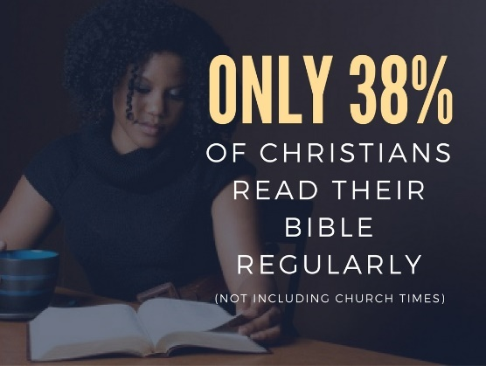
Oh, that God would return His people back to His Word!
Without the Word of God, we will most certainly fall into sin. Through the Word of God in Jehoshaphat’s kingdom, God’s deep and wonderful blessings came.
Are you experiencing God’s blessings, or are you backsliding and sinning?
______________________________

“Thy word have I hid in mine heart, that I might not sin against thee.”
Psalm 119:11
______________________________

Quote Whitefield
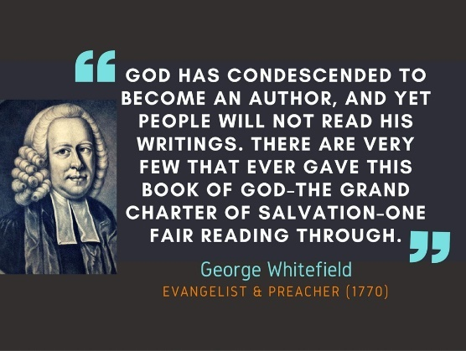
Evangelist George Whitefield lamented: “God has condescended to become an author, and yet people will not read his writings. There are very few that ever gave this Book of God, the grand charter of salvation, one fair reading through.”

Statistic
Did you know it takes only 71 hours to read the Bible out loud?
God Blesses Those Instructed and Obedient to His Word
2 Chron 17:10, “And the fear of the Lord fell upon all the kingdoms of the lands that were around Judah, and they made no war against Jehoshaphat.”
- The Philistines brought silver for taxes
- The Arabians brought sacrifices (7,700 rams and 7,700 goats).

2 Chron 17:12, “And Jehoshaphat grew steadily greater…”
- He built up fortress cities
- God gave him a million man army (actually 1,160,000 man army!)

- We will have a heart for Repentance, (2 Chron 18).
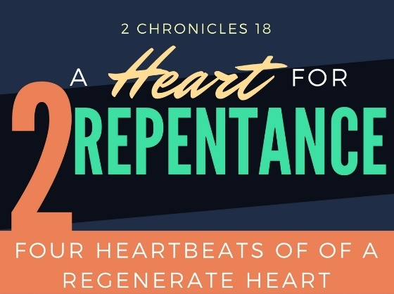
Episode 2: Jehoshaphat’s Evil Alliance
In the second episode of Jehoshaphat’s life, we find that God’s children can have such a big heart that they lack major discernment. Jehoshaphat made an alliance by having his son marry Ahab’s daughter. His big heart got him in trouble. He made an alliance with Ahab to fight Ben-hadad, King of Syria. He wanted to bring the kingdom back together again, but again his big heart gets in the way.
A big heart is good, but we must always have accountability because we are prone to lack discernment. Listen to this great big mess Jehoshaphat gets himself into.
2 Chronicles 18:1-3, “Now Jehoshaphat had great riches and honor, and he made a marriage alliance with Ahab. 2 After some years he went down to Ahab in Samaria. And Ahab killed an abundance of sheep and oxen for him and for the people who were with him, and induced him to go up against Ramoth-gilead. 3 Ahab king of Israel said to Jehoshaphat king of Judah, “Will you go with me to Ramoth-gilead?” He answered him, “I am as you are, my people as your people. We will be with you in the war.”
Sounds like a good thing! But we must always get under the surface.

Who is Ahab?
You know who Ahab is – one of the most wicked kings of Israel married to a high priestess of the idolatrous sex shrines, Jezebel. He was one of Israel's most powerful rulers. Many consider him the WORST ruler that ancient Israel ever had.
Jezebel was a pagan princess whose father was a man from Tyre named Ethbaal, who was a priest of the god Astarte (Asherah, later Isis).

A True Prophet
Good King Jehoshaphat asks for a true prophet of the Lord to see whether or not they should go into battle. It would be great if they could seek Elijah, but he was off the grid as it were. And of course, Ahab has his four hundred prophets of Baal (who Elijah is going to soon challenge and slay). So Jehoshaphat insists on hearing from a prophet of the LORD.
2 Chron 18:4-7, “And Jehoshaphat said to the king of Israel, “Inquire first for the word of the Lord.” 5 Then the king of Israel gathered the prophets together, four hundred men, and said to them, “Shall we go to battle against Ramoth-gilead, or shall I refrain?” And they said, “Go up, for God will give it into the hand of the king.” 6 But Jehoshaphat said, “Is there not here another prophet of the Lord of whom we may inquire?” 7 And the king of Israel said to Jehoshaphat, “There is yet one man by whom we may inquire of the Lord, Micaiah the son of Imlah; but I hate him, for he never prophesies good concerning me, but always evil.”

Do You Seek Truth? Few Micaiah’s Out There
I want to tell you, you can always find someone to agree with your own misguided or depraved opinion. But they are few and far between who will love you enough and love the Lord enough to tell you the truth.
There are plenty of people who will tell you what you want to hear. But I’m asking you this morning, are there people in your life who will tell you what you need to hear?
We need to hear the truth no matter how hard it is. No friend is a true friend unless they tell you the unadulterated truth. There aren’t very many people like that. Sadly, there aren’t too many Christians like that.
Are you a person that tells the truth? Are you a Micaiah?

Micaiah’s Warning
2 Chron 18:14-17, “And when he had come to the king, the king said to him, “Micaiah, shall we go to Ramoth-gilead to battle, or shall I refrain?” And he answered, “Go up and triumph; they will be given into your hand.” 15 But the king said to him, “How many times shall I make you swear that you speak to me nothing but the truth in the name of the Lord?” 16 And he said, “I saw all Israel scattered on the mountains, as sheep that have no shepherd. And the Lord said, ‘These have no master; let each return to his home in peace.’” 17 And the king of Israel said to Jehoshaphat, “Did I not tell you that he would not prophesy good concerning me, but evil?” The prophet was being sarcastic, but then boldly declared the truth: Ahab was going to die that day.
He reiterates this in verse 25.
2 Chron 18:25-27, “And the king of Israel said, “Seize Micaiah and take him back to Amon the governor of the city and to Joash the king's son, 26 and say, ‘Thus says the king, Put this fellow in prison and feed him with meager rations of bread and water until I return in peace.’” 27 And Micaiah said, “If you return in peace, the Lord has not spoken by me.” And he said, “Hear, all you peoples!”

Jehoshaphat Heard
Jehoshaphat heard Micaiah’s warning! The king of Israel, Ahab, is going to die today. Ahab didn’t believe it, but I believe Jehoshaphat did!

Jehoshaphat is Deceived – Sin’s Trouble
So Ahab being the conniver that he is convinces Jehoshaphat to go to war in full regalia while Ahab is undercover. Ahab’s plan was to make the Syrians kill Jehoshaphat as a decoy.
Sin gets us into trouble doesn’t it? And often we stay there. We get caught in the quicksand of our sin.
But God has a great delieverance if we just repent.

Jehoshaphat’s Repentance
So we see Jehoshaphat’s repentance in verses 31-34, “As soon as the captains of the chariots saw Jehoshaphat, they said, “It is the king of Israel.” So they turned to fight against him. And Jehoshaphat cried out, and the Lord helped him; God drew them away from him. 32 For as soon as the captains of the chariots saw that it was not the king of Israel, they turned back from pursuing him. 33 But a certain man drew his bow at random and struck the king of Israel between the scale armor and the breastplate. Therefore he said to the driver of his chariot, “Turn around and carry me out of the battle, for I am wounded.” 34 And the battle continued that day, and the king of Israel was propped up in his chariot facing the Syrians until evening. Then at sunset he died.”

Repentance and Revival
In chapter 19, we see the fullness of Jehoshaphat’s repentance. The prophet Jehu scolded Jehoshaphat for his alliance with Ahab. He declared God’s impending wrath but reminded him that early in his reign he had acted righteously (see 17:3). The king repented and personally led a revival among the people. He appointed judges who feared the Lord. These included Levites and priests, who taught Judah to love the Lord and fear His wrath.
2 Chron 19:2-4, “But Jehu the son of Hanani the seer went out to meet him and said to King Jehoshaphat, “Should you help the wicked and love those who hate the Lord? Because of this, wrath has gone out against you from the Lord. 3 Nevertheless, some good is found in you, for you destroyed the Asheroth out of the land, and have set your heart to seek God.”
4 Jehoshaphat lived at Jerusalem. And he went out again among the people, from Beersheba to the hill country of Ephraim, and brought them back to the Lord, the God of their fathers.”
The rest of the chapter explains how he raised up godly leadership and they DID SOMETHING ABOUT it! They changed the society of Judah.
They tore down the high places! This is a repentance that leads to revival. Repentance is a change of mind that leads to a change of life.

Repentance
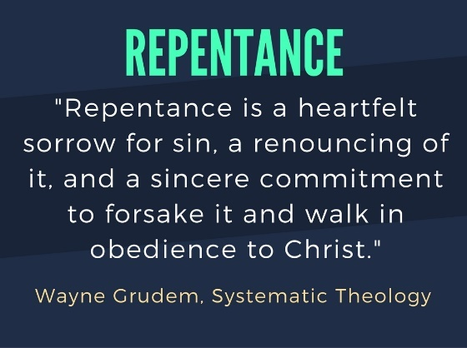
Wayne Grudem in his Systematic Theology defines repentance as “a heartfelt sorrow for sin, a renouncing of it, and a sincere commitment to forsake it and walk in obedience to Christ.”

Repentance Meaning
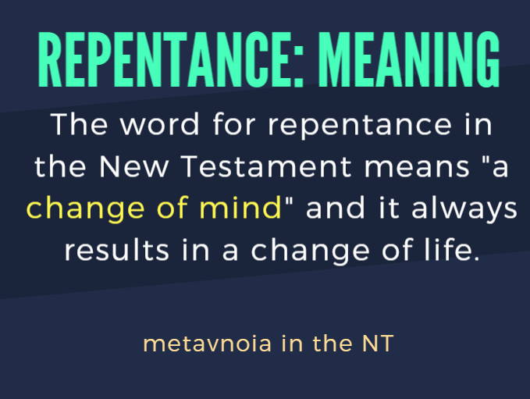
METANOIA: The word for repentance in the New Testament means "a change of mind" and it always results in a change of life.

Repentance Explained
The heart is involved through and through. Grudem goes on to explain that repentance touches every aspect of the human soul:
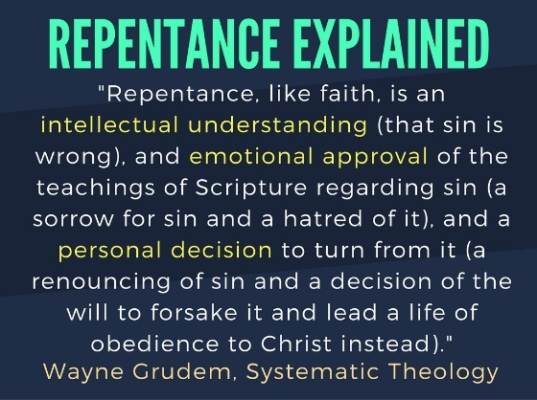

“Repentance, like faith, is an intellectual understanding (that sin is wrong), and emotional approval of the teachings of Scripture regarding sin (a sorrow for sin and a hatred of it), and a personal decision to turn from it (a renouncing of sin and a decision of the will to forsake it and lead a life of obedience to Christ instead).”

APPLICATIONS
God is Not Frustrated by Our Sin
Repentance has a primary place in the Christian life. Yet God is not frustrated at all by our waywardness or by Satan himself. Sometimes we think we can frustrate the plans of God. We can’t. Imagine how Peter must have felt when he denied Christ. He did sin greatly. There were awful consequences for his sins. Yet, Peter repented and was restored. We cannot frustrate the plan of God. He is absolutely sovereign. I love how John Piper puts it:

Quote Piper
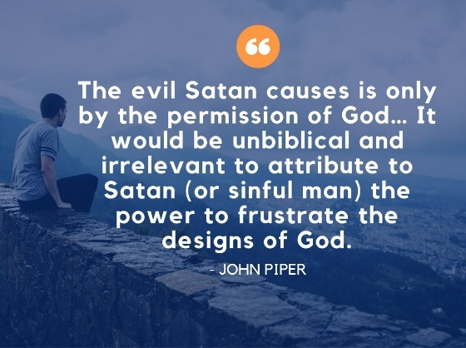
John Piper said, “The evil Satan causes is only by the permission of God… it would be unbiblical and irrelevant to attribute to Satan (or sinful man) the power to frustrate the designs of God.”

Quote Spurgeon: Deal Seriously!
One more application. Jehoshaphat dealt seriously with his sin. He called on God in the battle. He turned from his foolishness. He trusted in the Lord. The Lord rewarded that faith and protected with him.
Though we do sin, if we deal seriously with our sin, God will bless us. Spurgeon put it this way:
“When we deal seriously with our sins, God will deal gently with us.”
CHARLES HADDON SPURGEON
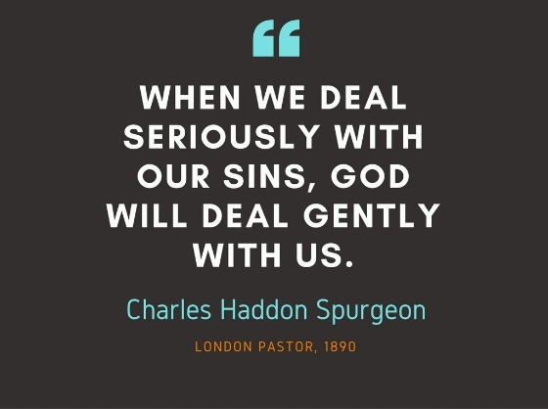

Let me ask you, do you have a heart for repentance? This is the regenerate, renewed heart. O how great is our sin, but O how much greater is the mercy of Christ.

- We will have a heart for Worship, (2 Chron 20).
We are Powerless
2 Chron 20:1-4, “After this the Moabites and Ammonites, and with them some of the Meunites, came against Jehoshaphat for battle. 2 Some men came and told Jehoshaphat, “A great multitude is coming against you from Edom, from beyond the sea; and, behold, they are in Hazazon-tamar” (that is, Engedi). 3 Then Jehoshaphat was afraid and set his face to seek the Lord, and proclaimed a fast throughout all Judah. 4 And Judah assembled to seek help from the Lord; from all the cities of Judah they came to seek the Lord.”
Look at this impossible situation. Then in verses 5-12, Jehoshaphat prays and the summary of that prayer is found in 20:12, “O our God, will you not execute judgment on them? For we are powerless against this great horde that is coming against us. We do not know what to do, but our eyes are on you.”

Jahaziel’s Sermon
Now the people of Judah, the families, the little ones, the men, they are all there gathered together for a sermon. Jahaziel’s sermon. Listen to it:
2 Chron 20:13-19, “Meanwhile all Judah stood before the Lord, with their little ones, their wives, and their children. 14 And the Spirit of the Lord came upon Jahaziel the son of Zechariah, son of Benaiah, son of Jeiel, son of Mattaniah, a Levite of the sons of Asaph, in the midst of the assembly. 15 And he said, “Listen, all Judah and inhabitants of Jerusalem and King Jehoshaphat: Thus says the Lord to you, ‘Do not be afraid and do not be dismayed at this great horde, for the battle is not yours but God's. 16 Tomorrow go down against them. Behold, they will come up by the ascent of Ziz. You will find them at the end of the valley, east of the wilderness of Jeruel. 17 You will not need to fight in this battle. Stand firm, hold your position, and see the salvation of the Lord on your behalf, O Judah and Jerusalem.’ Do not be afraid and do not be dismayed. Tomorrow go out against them, and the Lord will be with you.”
18 Then Jehoshaphat bowed his head with his face to the ground, and all Judah and the inhabitants of Jerusalem fell down before the Lord, worshiping the Lord. 19 And the Levites, of the Kohathites and the Korahites, stood up to praise the Lord, the God of Israel, with a very loud voice.”
What a sermon! So they all leave there and get up the next morning and they have to act on it!

Jehoshaphat Repreaches the Sermon
Now we see in the morning King Jehoshaphat reproaches the sermon. It’s amazing! 2 Chron 20:20-21, “And they rose early in the morning and went out into the wilderness of Tekoa. And when they went out, Jehoshaphat stood and said, “Hear me, Judah and inhabitants of Jerusalem! Believe in the Lord your God, and you will be established; believe his prophets, and you will succeed.” 21 And when he had taken counsel with the people, he appointed those who were to sing to the Lord and praise him in holy attire, as they went before the army, and say,

“Give thanks to the Lord,
for his steadfast love endures forever.”

The Battle is the Lord’s!
So the priest go first and they sing! And the army is behind. They don’t need to fight. The battle is the Lord’s!
2 Chron 20:22-30, “And when they began to sing and praise, the Lord set an ambush against the men of Ammon, Moab, and Mount Seir, who had come against Judah, so that they were routed. 23 For the men of Ammon and Moab rose against the inhabitants of Mount Seir, devoting them to destruction, and when they had made an end of the inhabitants of Seir, they all helped to destroy one another.
24 When Judah came to the watchtower of the wilderness, they looked toward the horde, and behold, there were dead bodies lying on the ground; none had escaped. 25 When Jehoshaphat and his people came to take their spoil, they found among them, in great numbers, goods, clothing, and precious things, which they took for themselves until they could carry no more. They were three days in taking the spoil, it was so much. 26 On the fourth day they assembled in the Valley of Beracah, for there they blessed the Lord. Therefore the name of that place has been called the Valley of Beracah to this day. 27 Then they returned, every man of Judah and Jerusalem, and Jehoshaphat at their head, returning to Jerusalem with joy, for the Lord had made them rejoice over their enemies. 28 They came to Jerusalem with harps and lyres and trumpets, to the house of the Lord. 29 And the fear of God came on all the kingdoms of the countries when they heard that the Lord had fought against the enemies of Israel. 30 So the realm of Jehoshaphat was quiet, for his God gave him rest all around.”

  - Great Faith in the Power of God. Look how weak and uncertain Goliath’s life is, even when he thinks he is invincible!
    - 1 John 5:4, “For whatsoever is born of God overcometh the world: and this is the victory that overcometh the world, even our faith.”

  - Then we have victory in the Name of Jesus. They conquered in the name of the Lord. They lived for His glory. They were not in it for their fame, but for YHWH’s fame. We must live for the Name of Jesus! Stand up for the Name of Jesus. If you deny the Name of Jesus, the Father will deny you! If you proclaim the Name of Jesus, the Father will receive you.

    - Matthew 10:32-33, “Whosoever therefore shall confess me before men, him will I confess also before my Father which is in heaven. 33 But whosoever shall deny me before men, him will I also deny before my Father which is in heaven”.

  - And then we have the Blood of Jesus. Revelation 12:11, “And they overcame him by the blood of the Lamb, and by the word of their testimony; and they loved not their lives unto the death.” On the BASIS of the blood, on what that blood accomplished 2000 years ago we have victory. The blood of Jesus testifies to the defeat of the enemy. The defeat of the enemy is guaranteed!

  - Then we have the Praise of Jesus. Jehoshaphat is interested in one thing. He wants all the earth to know there is a God in Israel. He wants all lift up the Name of the Lord!

  - Of course, we have the Word of Jesus.

Psalm 121, “I lift up my eyes to the hills.
From where does my help come?
2 My help comes from the Lord,
who made heaven and earth.
3 He will not let your foot be moved;
he who keeps you will not slumber.
4 Behold, he who keeps Israel
will neither slumber nor sleep.
5 The Lord is your keeper;
the Lord is your shade on your right hand.
6 The sun shall not strike you by day,
nor the moon by night.
7 The Lord will keep you from all evil;
he will keep your life.
8 The Lord will keep
your going out and your coming in
from this time forth and forevermore.”

The same is true for us! 2 Corinthians 10:3-5, “For though we walk in the flesh, we do not war after the flesh: 4 (For the weapons of our warfare are not carnal, but mighty through God to the pulling down of strong holds;) 5 Casting down imaginations, and every high thing that exalts itself against the knowledge of God, and bringing into captivity every thought to the obedience of Christ”. How do you cast down imaginations? With the Word of God. Satan says, Bow down and worship me! Jesus said, “It is written”! Cast down the imaginations that come from the wicked one.

Amy Carmichael Quote
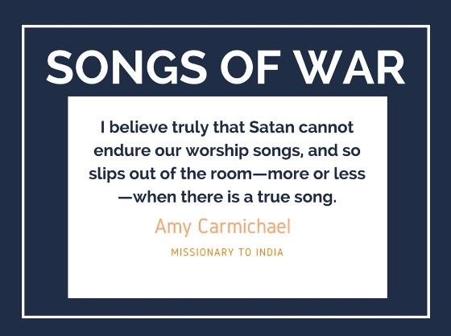
Amy Carmichael, missionary to India said, “I believe truly that Satan cannot endure our worship songs, and so slips out of the room – more or less – when there is a true song.”

Conclusion
Do you have a heart for God? You may feel defeated. You may have sinned. Get up and get going! God didn’t come to call the righteous but sinners to repentance.
Be instructed
Be repenting
Be worshipping!

William Greenough Thayer Shedd. Dogmatic Theology, 3rd ed. (Phillipsburg, N.J: Puritan and Reformed Publications, 2003), 764.
Mathews, K. A. (1998). The Historical Books. In D. S. Dockery (Ed.), Holman concise Bible commentary (p. 167). Nashville, TN: Broadman & Holman Publishers.

