Asa’s Ambition: Seeking God
2 Chronicles 14-16
___________________________________________
The King is Coming (2 Chronicles)

Prepared by: Matthew S. Black

Sunday, December 11, 2016, 10:30am at Living Hope Church of Roselle, Illinois

livinghopechurch.net

“We cannot find God without God. We cannot reach God without God. We cannot satisfy God without God—which is another way of saying that our seeking will always fall short unless God's grace initiates the search and unless God's call draws us to him and completes the search.”
~ Os Guinness

O
pen your Bible to 2 Chronicles. We are in a 14 message series in the book of 2 Chronicles entitled “The King is Coming.” This morning we are looking at a message number four entitled: “Asa’s Ambition: Seeking God.”

Proposition: We should seek the Lord because He is good and anything else is folly.

Lost and Found
The night I came to know the Lord, I said “Why didn’t someone tell me this before?” They actually did. As I recall there were likely around 15 times people gave me a clear presentation of the Gospel.
The truth is I wasn’t seeking after God, but He was seeking after me. God wasn’t lost; I was! But when God found me, He put in me a heart to seek after Him!
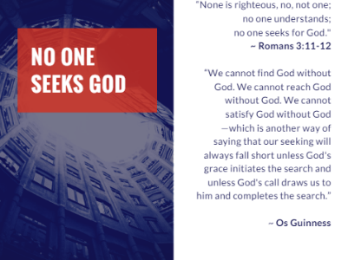
No One Seeks After God
“None is righteous, no, not one;
no one understands;
no one seeks for God.”
~ Rom 3:11-12. This is God’s Word.

Os Guinness said it this way:
“We cannot find God without God. We cannot reach God without God. We cannot satisfy God without God—which is another way of saying that our seeking will always fall short unless God's grace initiates the search and unless God's call draws us to him and completes the search.”

The Battle to Seek God, No Matter the Cost
That doesn’t mean no longer stray or backslide. You see there is a constant battle now between the flesh and the Spirit. My desire today is that God will raise up a people here at Living Hope that realize the fierceness of the battle and determine to seek the Lord no matter what the cost.

FROM ASA’S HOLY AMBITION TO HIS FOLLY
A thousand years before Jesus was born, David was the king of Israel, and the kingdom was united and prosperous. Then there was Solomon who prospered and Rehoboam who split the Kingdom.
When Rehoboam died, his son Abijah ruled for only three years. And after Abijah, his son Asa became king in Judah.
Asa ruled for 41 years, and 35 years of that reign were almost totally peaceful. God was with him and blessed him and protected him and prospered him in wonderful ways. But something happened in Asa's life over those years, and when trouble came, he no longer trusted God. He died under the Lord’s loving chastening.

Five Major Episodes in Asa’s Life
Asa teaches us to seek the Lord, and there are three episodes where Asa seeks the Lord, and He teaches us why we should seek the Lord. He teaches us how Worthy God is for us to seek Him.
But then we have two episodes in Asa’s life that teach us what happens when we stop seeking the Lord. Our best plans apart from the Lord are folly.
Outline
- Because He is Holy
- Because He is Mighty
- Because He is more Satisfying than life.
- Because He is Better than man-made folly.

- Seek the Lord because He is Holy. (2 Chron 14:1-8)

In vs. 1-8, we have the first of five episodes we see in Asa’s life. This episode is saturated in God’s holiness. It tells us that there is no one like God, so we should rid ourselves

Asa Did Right: Commanded Judah to Seek the Lord
2 Chron 14:1-8, “Abijah slept with his fathers, and they buried him in the city of David. And Asa his son reigned in his place. In his days the land had rest for ten years. 2 And Asa did what was good and right in the eyes of the Lord his God. 3 He took away the foreign altars and the high places and broke down the pillars and cut down the Asherim 4 and commanded Judah to seek the Lord, the God of their fathers, and to keep the law and the commandment. 5 He also took out of all the cities of Judah the high places and the incense altars. And the kingdom had rest under him. 6 He built fortified cities in Judah, for the land had rest. He had no war in those years, for the Lord gave him peace. 7 And he said to Judah, “Let us build these cities and surround them with walls and towers, gates and bars. The land is still ours, because we have sought the Lord our God. We have sought Him, and He has given us peace on every side.” So they built and prospered. 8 And Asa had an army of 300,000 from Judah, armed with large shields and spears, and 280,000 men from Benjamin that carried shields and drew bows. All these were mighty men of valor.”

The Summary of Asa’s Life (1-2)
“Asa did what was right in the eyes of the Lord” (vs 2). This is the summary of his life. I want that as the summary of my life. As we are going to see, he did not live a perfect life. His life ended on a low note.
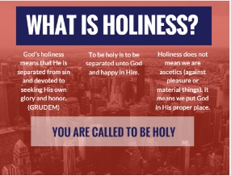
For 36 years, Asa sought the Lord. That’s amazing. He set Israel apart from the Canaanite deities. That’s the essence of holiness.

What is Holiness?

God’s holiness means that He is separated from sin and devoted to seeking His own glory and honor. (GRUDEM)
To be holy is to be separated unto God and happy in Him.
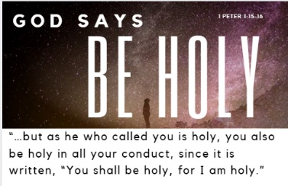
Holiness does not mean we are ascetics (against pleasure or material things). It means we put God in His proper place.

You are Called to be Holy!
1 Peter 1:15-16, “…but as he who called you is holy, you also be holy in all your conduct, since it is written, “You shall be holy, for I am holy.”
If holiness means God’s separation from this world, in what way is God separated from us? He’s separated from us in His vast greatness, and in His perfection, beauty and sinlessness. To be holy is to pursue God’s beauty! To be holy is to pursue His majesty and Lordship in my life!

Is God Awesome to You?

John Frame puts it this way: “Holiness [on a human level] is God's capacity and right to arouse our reverent awe and wonder. It is his uniqueness, his majesty, for God is like a great king, whom we dare not treat like other persons.”
Again: “God’s holiness shows his transcendence, his separation from us. God is above us, beyond us—not in the sense that he is far away, for he is intimately close; not in the sense that he is unknown or unknowable, for he clearly reveals himself to us; not in the sense that human language cannot describe him, for he describes himself to us in the human language of Scripture. God is beyond us, rather, as the supreme person, the universal King, the Lord of all, before whom we cannot help but bow in awe and wonder. And, since our fall into sin, God is also separate from us, because ethical purity must be separate from ethical depravity (Isa. 6:5; Luke 5:8).”

Asa’s Command: Seek the Lord (3-4)
Asa was pursing the beauty and majesty of God. So he did something. He took away the idols. Vs 3-4, “He took away the foreign altars and the high places and broke down the pillars and cut down the Asherim 4 and commanded Judah to seek the Lord…”
Seek the Lord! Why? Because He is holy! Vs 11 Asa says why, “O Lord, there is none like you to help.”

Asa basically says, you should seek the LORD, YHWH, the one True God because there is no one like Him.

The History of the Asherah and Baals
What were the Asherah and Baals? They were very much related to fertility and the worst kind of pornography and filthy living. The groves and the high places were sex shrines. Women who entered into this Canaanite cult became prostitutes for the gods.
Asherah went by many names, the most common is Isis, the "Queen of Heaven." Today she is the symbol of a popular coffee.
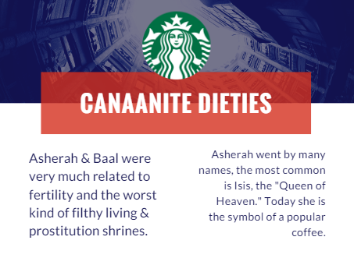
It was good that Asa tore these shrines down.

God is Holy, so Get Rid of Idols
God is holy, so we need to rid our lives of idols. An idol is anything you put in the place of Jesus in your life.
What high places do you need to tear down?

Asherahs in our Life Today
Saints, I must say we are naïve if we think we have no false gods among us today. There are plenty of high places that need to be torn down today. What high places do you need to tear down?
PRIDE
LUST
MATERIALISM
SELF
ENTERTAINMENT (Fixation on Media)
DECEPTION
RULES & RELIGION
PEOPLE'S OPINIONS
BITTERNESS
FEAR & WORRY

Tearing Down the High Places
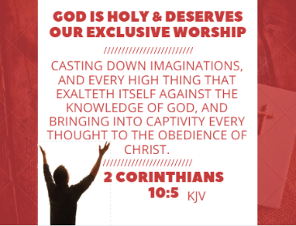
We could have a study on each one. Don’t leave these idols in your life. Tear them down. How do we tear them down? Recognize:

GOD IS HOLY & DESERVES OUR EXCLUSIVE WORSHIP
2 Corinthians 10:5, “Casting down imaginations, and every high thing that exalteth itself against the knowledge of God, and bringing into captivity every thought to the obedience of Christ…” The word “imaginations” means “arguments” or “reasonings.” St. Paul knew that the battle for idolatry always begins in the mind!
We come to a second episode in Asa’s reign, and realize another reason we should seek the Lord. Seek Him because He is holy. Seek Him by being holy. Are you finding your happiness in Him? Are you trusting Him instead of your idols? That’s holiness! Separate yourself from this world of idols set on self!

Just two choices on the shelf: pleasing God or pleasing self!
What will your choice be?

God Brings Blessing that Idols Can’t
We see that blessing that only comes from seeking God in holiness.
2 Chron 14:5-8, “He also took out of all the cities of Judah the high places and the incense altars. And the kingdom had rest under him. 6 He built fortified cities in Judah, for the land had rest. He had no war in those years, for the Lord gave him peace. 7 And he said to Judah, “Let us build these cities and surround them with walls and towers, gates and bars. The land is still ours, because we have sought the Lord our God. We have sought Him, and He has given us peace on every side.” So they built and prospered. 8 And Asa had an army of 300,000 from Judah, armed with large shields and spears, and 280,000 men from Benjamin that carried shields and drew bows. All these were mighty men of valor.”
God blesses them with:
- Rest for 36 years (vs. 5)
- Fortified cities (vs. 6-7)
- No wars / great peace throughout the land (vs. 7)
- An Army of 580,000 men, mighty men of valor (vs. 8)

Protected on Every Side
There is a relationship between holiness and God’s blessing. We are not talking mainly about material blessing, though that was there. The great blessing that we seek is God’s peace and His presence. With His peace and presence often come material and physical blessing, but the great strength that Asa had was metaphysical blessing.
God was protecting Him and the land of Judah on every side. Can I remind you of Isaiah’s words?
“No weapon formed against you shall prosper, And every tongue which rises against you in judgment, You [God] shall condemn [refute]. This is the heritage of the servants of the Lord, And their righteousness is from Me,” says the Lord.” Isaiah 54:17

- Seek the Lord because He is Mighty. (2 Chron 14:9-15)
A Million Man Army from Egypt
2 Chron 14:9-10, “Zerah the Ethiopian came out against them with an army of a million men and 300 chariots [like ancient tanks], and came as far as Mareshah. 10 And Asa went out to meet him, and they drew up their lines of battle in the Valley of Zephathah at Mareshah.”
So here come these 300 chariots, like ancient tanks. There is no human pathway toward victory. When there’s no human pathway, we need a superhuman pathway. When there’s no physical way forward, we need a metaphysical way forward.
We get the metaphysical power through prayer. That’s what Asa did. He prayed for metaphysical power. He had an impossible task in front of him.

What’s Your Million Man Army?
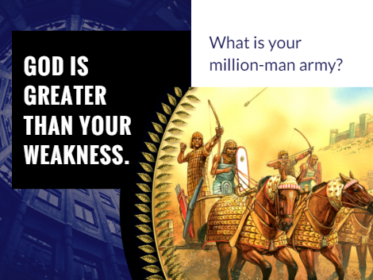
I don’t know what you are going through, but I can tell you this: God is greater than your weakness. Perhaps you don’t have a million-man army coming after you!
What are you struggling with? What is your impossible situation?
- Depression can often feel impossible
- A difficult marriage
- Singleness
- Battles with your habits of sin:
  - Gossip
  - Lust
  - Deceit
  - Anger / Bitterness
  - Ease / Laziness
- Health

Hiding Our Weaknesses
Do you have a strong public persona, but you hide that in private you struggle with so much weakness? Do you have a tendency to appear strong even when you are privately struggling? Do you ask for help as quickly as you should when you are struggling?
It’s easy to try and hide our weaknesses, but the truth is, we are all weak.

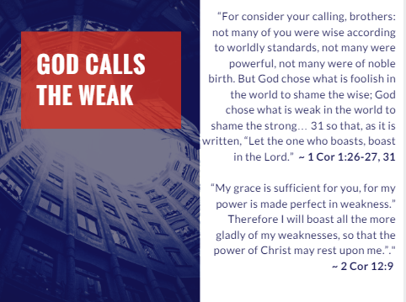1 Cor 1:26-27, 31, “For consider your calling, brothers: not many of you were wise according to worldly standards, not many were powerful, not many were of noble birth. But God chose what is foolish in the world to shame the wise; God chose what is weak in the world to shame the strong… 31 so that, as it is written, “Let the one who boasts, boast in the Lord.”

2 Corinthians 12:9, “My grace is sufficient for you, for my power is made perfect in weakness.” Therefore I will boast all the more gladly of my weaknesses, so that the power of Christ may rest upon me.”

A New Paradigm: Strength is Matured in Weakness
Everybody say it: “My strength is made perfect in weakness.” That’s the Christian’s paradigm. Our strength is matured in weakness!
We know that this is not the case with sin. It doesn’t matter how productive you are for the kingdom, your sin is like quicksand. It paralyzes you. Even though we are intentional about walking in the light, those sins will eventually emerge.
We want to get rid of sin in our lives, but we cannot get away from weakness. It’s the central thing that God uses to build His kingdom.
It seems to me that once Paul discovered that Jesus’ power is made perfect in weakness, he immediately shifts to his weaknesses as his primary power source for ministry. He writes his new paradigm, “For when I am weak, then I am strong.” Listen, if we are dependent on Jesus, we will have His strength.
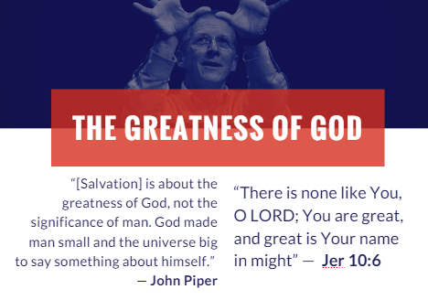
John Piper Quote
“[Salvation] is about the greatness of God, not the significance of man. God made man small and the universe big to say something about himself.” — John Piper
We need to confess with Jeremiah:
“There is none like You, O LORD; You are great, and great is Your name in might” (Jeremiah 10:6).

God is constantly putting us in circumstances where we can get an excellent glimpse of our weakness, because we have an extreme tendency to forget

Young Asa
Abijah was succeeded on the throne of Judah by his son, Asa, probably at the time a very young boy of only ten or eleven years at the time.
Often it is the weak and the young that have all the faith! Asa doesn’t have much experience or power, but He has a prayer life to a God who has infinite experience and power!

Asa’s Prayer
2 Chron 14:11, “ And Asa cried to the Lord his God,
“O Lord, there is none like you to help, between the mighty and the weak. Help us, O Lord our God, for we rely on you, and in your name we have come against this multitude. O Lord, you are our God; let not man prevail against you.”

Here comes a million-man army – an impossible situation – and what does Asa do? King Asa went straight to the top when he prayed to Jehovah God, the God who existed before eternity began, and the God who is bigger than anything we can comprehend.
Do you understand that you come to know and experience God as you trust Him and He accomplishes His work through you?
God is purposely showing you your weakness in order to highlight His infinite strength!

Weakness is a Helpful Tool
We have to realize that because our weakness drives us to prayer and to press into God, it is one of the most helpful tools for Christian growth!
Do you know what prayerless is? It’s us saying, “God is small!” When are we going to realize that God is infinitely bigger than our problems?

A.B. Simpson Quote

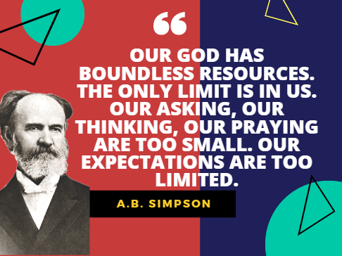
A. B. Simpson said it this way, “Our God has boundless resources. The only limit is in us. Our asking, our thinking, our praying are too small. Our expectations are too limited.”

The Lord’s Power
2 Chron 14:12-15, “So the Lord defeated the Ethiopians before Asa and before Judah, and the Ethiopians fled. 13 Asa and the people who were with him pursued them as far as Gerar, and the Ethiopians fell until none remained alive, for they were broken before the Lord and his army. The men of Judah carried away very much spoil. 14 And they attacked all the cities around Gerar, for the fear of the Lord was upon them. They plundered all the cities, for there was much plunder in them. 15 And they struck down the tents of those who had livestock and carried away sheep in abundance and camels. Then they returned to Jerusalem.”

The Storm
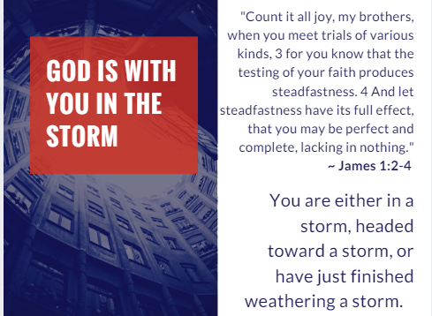
Seek the Lord! He is mighty! He puts us through these storms to demonstrate His power. I know none of us likes the storms. But remember this:
You are either in a storm, headed toward a storm, or have just finished weathering a storm.
“Count it all joy, my brothers, when you meet trials of various kinds, 3 for you know that the testing of your faith produces steadfastness. 4 And let steadfastness have its full effect, that you may be perfect and complete, lacking in nothing” (James 1:2-4).
When our eyes are upon the storm, we are cold, wet, and disillusioned. We are busy thinking about our circumstances. But when our eyes are upon God, we can go through the storm because we know our Redeemer lives. We can be still, know God, and exalt Him. We can have the peace of knowing that God is in control.

Fear Not
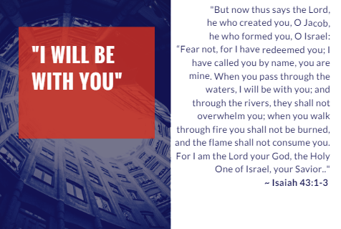
“Fear not, for I have redeemed you; I have called you by name, you are mine. When you pass through the waters, I will be with you; and through the rivers, they shall not overwhelm you; when you walk through fire you shall not be burned, and the flame shall not consume you. For I am the Lord your God, the Holy One of Israel, your Savior.” ~ Isaiah 43:1-3

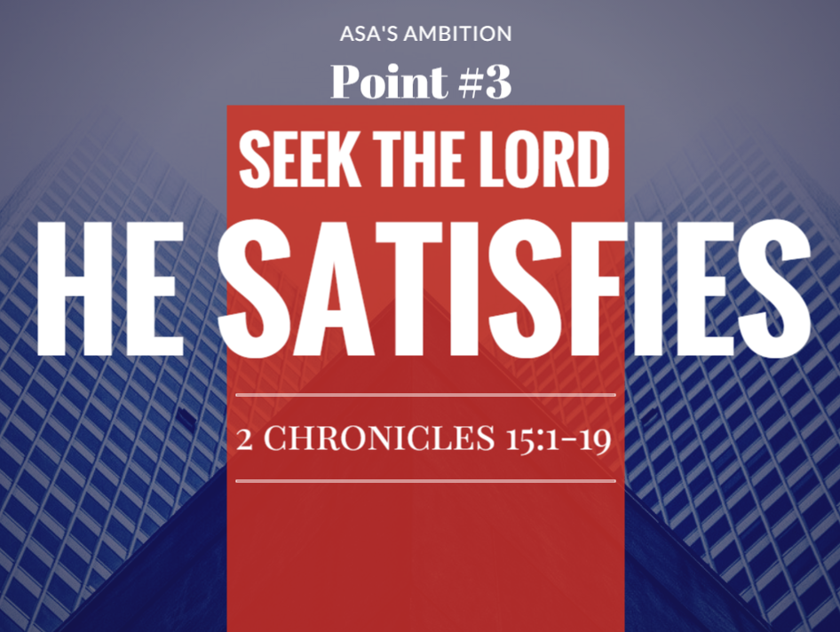
- Seek the Lord because He is more Satisfying than life. (2 Chron 15:1-19)

2 Chron 15:1-15, “The Spirit of God came upon Azariah the son of Oded, 2 and he went out to meet Asa and said to him, “Hear me, Asa, and all Judah and Benjamin: The Lord is with you while you are with him. If you seek him, he will be found by you, but if you forsake him, he will forsake you. 3 For a long time Israel was without the true God, and without a teaching priest and without law, 4 but when in their distress they turned to the Lord, the God of Israel, and sought him, he was found by them. 5 In those times there was no peace to him who went out or to him who came in, for great disturbances afflicted all the inhabitants of the lands. 6 They were broken in pieces. Nation was crushed by nation and city by city, for God troubled them with every sort of distress. 7 But you, take courage! Do not let your hands be weak, for your work shall be rewarded.”
8 As soon as Asa heard these words, the prophecy of Azariah the son of Oded, he took courage and put away the detestable idols from all the land of Judah and Benjamin and from the cities that he had taken in the hill country of Ephraim, and he repaired the altar of the Lord that was in front of the vestibule of the house of the Lord. 9 And he gathered all Judah and Benjamin, and those from Ephraim, Manasseh, and Simeon who were residing with them, for great numbers had deserted to him from Israel when they saw that the Lord his God was with him. 10 They were gathered at Jerusalem in the third month of the fifteenth year of the reign of Asa. 11 They sacrificed to the Lord on that day from the spoil that they had brought 700 oxen and 7,000 sheep. 12 And they entered into a covenant to seek the Lord, the God of their fathers, with all their heart and with all their soul, 13 but that whoever would not seek the Lord, the God of Israel, should be put to death, whether young or old, man or woman. 14 They swore an oath to the Lord with a loud voice and with shouting and with trumpets and with horns. 15 And all Judah rejoiced over the oath, for they had sworn with all their heart and had sought him with their whole desire, and he was found by them, and the Lord gave them rest all around.”

The Feast of Weeks (Pentecost)
Asa and all Judah celebrated the Feast of Weeks (Pentecost; Exod 23:16; 34:22; Lev 23:15–21), which is one of three pilgrim feasts of Israel. The third month would have been May/June of 895 B.C. The feast is a “sacred assembly” (Num 28:26) that celebrates the harvest (Exod 34:22; Deut 16:10). In this context, it also celebrates reform, victory, and rededication.

Like Asa and Judah, we need constant revival and a renewal of our covenant with God.

Execution of Rebels
We read that there was to be an execution of any rebels. I know this seems like such an extreme way to rejoice, but they basically said, the joy of the Lord is greater than life.
Psalm 63:3, “Because your steadfast love is better than life, my lips will praise you.”
You should seek the Lord because He is satisfying!
This also prefigures the new heaven and new earth where no rebel will be admitted entrance.

Paul & Silas in Philippian Jail
Remember Paul and Silas. They were jailed in the Philippian jailhouse. They had just been severely beaten. They had reason to cry, but instead they sang. They sang at midnight, and they literally brought the house down! The jailer and his family came to know Christ!
How about you? Have you stopped singing? Rejoice in the Lord always! Rejoice evermore. We’ve heard about praying without ceasing, but I want to challenge you to rejoice in Christ without ceasing! Don’t stop singing!

The Queen Mother
Now in verses 16-18, we have an interesting and powerful reminder that God is satisfying not just if you are mature in the faith, but if you are young in the faith.
Look at the powerful example of young Asa. He’s so young that he has a Queen mother. But look at the boldness of Asa.
2 Chron 15:16-18, “Even Maacah, his mother, King Asa removed from being queen mother because she had made a detestable image for Asherah. Asa cut down her image, crushed it, and burned it at the brook Kidron. 17 But the high places were not taken out of Israel. Nevertheless, the heart of Asa was wholly true all his days. 18 And he brought into the house of God the sacred gifts of his father and his own sacred gifts, silver, and gold, and vessels. 19 And there was no more war until the thirty-fifth year of the reign of Asa.”

Honor the Lord Above Even Family
We must seek satisfaction through loyalty to God first, even if it means disloyalty to family. Seeking the Lord means covenant loyalty supersedes family loyalty.
Matthew 10:34-39, “Do not think that I have come to bring peace to the earth. I have not come to bring peace, but a sword. 35 For I have come to set a man against his father, and a daughter against her mother, and a daughter-in-law against her mother-in-law. 36 And a person's enemies will be those of his own household. 37 Whoever loves father or mother more than me is not worthy of me, and whoever loves son or daughter more than me is not worthy of me. 38 And whoever does not take his cross and follow me is not worthy of me. 39 Whoever finds his life will lose it, and whoever loses his life for my sake will find it.”

- Seek the Lord because He is Better than Man-made folly. (2 Chron 16:1-14)

When we settle for a good thing, instead of the very best that God wants to give us, we are following in the steps of Asa.
After 36 years of trusting in the Lord and an almost completely peaceful reign, Asa stops trusting in the Lord. He is blinded by self-reliance and pride.
Asa ruled for 41 years, and 35 years of that reign were almost totally peaceful. God was with him and blessed him and protected him and prospered him in wonderful ways. But something happened in Asa's life over those years, and when trouble came, he no longer trusted God.
We read of two instances:
- (1) a plan to defeat Baasha who ruled over the Northern Kingdom of Israel. It was a brilliant plan (16:1-10).
- (2) a plan to seek physicians without seeking the Lord (16:11-12).

THE FAILED PLANS FOR BATTLE
2 Chron 16:1-10, “In the thirty-sixth year of the reign of Asa, Baasha king of Israel went up against Judah and built Ramah, that he might permit no one to go out or come in to Asa king of Judah. 2 Then Asa took silver and gold from the treasures of the house of the Lord and the king's house and sent them to Ben-hadad king of Syria, who lived in Damascus, saying, 3 “There is a covenant between me and you, as there was between my father and your father. Behold, I am sending to you silver and gold. Go, break your covenant with Baasha king of Israel, that he may withdraw from me.” 4 And Ben-hadad listened to King Asa and sent the commanders of his armies against the cities of Israel, and they conquered Ijon, Dan, Abel-maim, and all the store cities of Naphtali. 5 And when Baasha heard of it, he stopped building Ramah and let his work cease. 6 Then King Asa took all Judah, and they carried away the stones of Ramah and its timber, with which Baasha had been building, and with them he built Geba and Mizpah.
7 At that time Hanani the seer came to Asa king of Judah and said to him, “Because you relied on the king of Syria, and did not rely on the Lord your God, the army of the king of Syria has escaped you. 8 Were not the Ethiopians and the Libyans a huge army with very many chariots and horsemen? Yet because you relied on the Lord, he gave them into your hand. 9 For the eyes of the Lord run to and fro throughout the whole earth, to give strong support to those whose heart is blameless toward him. You have done foolishly in this, for from now on you will have wars.” 10 Then Asa was angry with the seer and put him in the stocks in prison, for he was in a rage with him because of this. And Asa inflicted cruelties upon some of the people at the same time.”

These plans failed.

God Has Better than Our Best Plans
God has better things in mind for you than your best plans. Seek wisdom. Seek doctors. Seek schooling. Seek financial stability. Nothing wrong with any of those things. But seek the Lord first!
Matthew 6:33, “But seek first the kingdom of God and His righteousness, and all these things will be added unto you.”
So many times, when we rely on ourselves and our own resources, things seem to go well for a season. But things are not well when we have stopped hoping in God and started hoping in what man can do. We miss tremendous blessings and we bring unnecessary hardship on ourselves. Look at the blessing Asa missed in verse 7b: “Because you relied on the king of Syria, and did not rely on the Lord your God, the army of the king of Syria has escaped you.”
God would not only have protected Asa from Baasha and Israel, he would given the entire Syrian army into the hand of Asa. But Asa threw it away by trusting in money and intrigue instead of God.
And look at the hardship that will now come into his peaceful life. Verse 9b: “You have done foolishly in this; for from now on you will have wars.”

God’s Ways are Better
Remember Isaiah 55:8-9, “For my thoughts are not your thoughts,
neither are your ways my ways, declares the Lord.
9 For as the heavens are higher than the earth,
so are my ways higher than your ways
and my thoughts than your thoughts.”

The Best Devised Plans Fail without the Lord
What are your battle plans? They will fail without the Lord. No matter how good your well constructed plans are, they will fail without the Lord.
Psalm 127:1, “Unless the Lord builds the house, those who build it labor in vain.”
When I first came to know Christ, I wanted to be a musician for the Lord. That’s a great calling for sure. But that’s not at all what I became.
God had better plans for me! His plans are always so much better than our plans. Stay close to Him and walk with Him. “Trust in the Lord with all your heart. Lean not to your own understanding. In all your ways acknowledge Him, and he shall direct your paths” (Prov 3:5-6).

THE FAILED PLAN FOR HEALTH
Sadly, King Asa’s life ends on a very tragic note.
2 Chron 16:11-14, “The acts of Asa, from first to last, are written in the Book of the Kings of Judah and Israel. 12 In the thirty-ninth year of his reign Asa was diseased in his feet, and his disease became severe. Yet even in his disease he did not seek the Lord, but sought help from physicians. 13 And Asa slept with his fathers, dying in the forty-first year of his reign.
14 They buried him in the tomb that he had cut for himself in the city of David. They laid him on a bier that had been filled with various kinds of spices prepared by the perfumer's art, and they made a very great fire in his honor.”

The Lord’s Chastening
The Lord loved King Asa. And “whoever the Lord loves He disciplines” (Heb 12:6). God is ready to bless Asa, but Asa wants to do it his own way.
When we trust in our own plans instead of seeking God, we miss God’s blessing.

God Wants to Bless You
We have a God and Father who loved us and gave His Son Jesus for us. This is the God who hears all your prayers. This is the God who created the universe and holds it all together. This is the God who stands in this room right now teaching through my teaching and calling you to trust him and call upon him for every need that you have.

Conclusion
Seek the Lord saints!
- He is Holy!
- He is Mighty!
- He is Satisfying!
- He is Better than your best plans!

Microsoft and Apple
Have you ever seen those Apple commercials? The Microsoft guy is all nerdy and clunky, and the Apple guy is smooth.
Pastor Michael and I used to joke. I loved my Microsoft Windows computer. But he finally got me to switch to Mac. Mac does all the Microsoft stuff, but it does a whole lot more. And its stable. No more viruses. No more blue screens. Why did I wait so long to switch?

Application. Sometimes after I backslide, I wonder, why did I wait so long to seek the Lord? The way of the transgressor is hard. Why wait? Seek the Lord with all your heart. Seek Him now! Don’t wait!
Seeking the Lord is so much better than your own ways. He is better than the best life has to offer. He’s got so much He wants to give you. Seek the Lord! Put aside your own plans. Seek the Lord! You will never regret it!

John Piper. Sermon: Asa’s Folly, accessed at - http://www.desiringgod.org/messages/asas-folly.
Frame, J. M. (2008). The Doctrine of the Christian Life (p. 20). Phillipsburg, NJ: P&R Publishing.
Edersheim, A. (1975). Bible History: Old Testament (Vol. 5, p. 161). Grand Rapids, MI: William B. Eerdmans Publishing Company.
Kirkbride, Wayne. When God Says Yes: The Prayer of King Asa (p. 18). Strang Communications - A. Kindle Edition.
Hicks, J. M. (2001). 1 & 2 Chronicles (pp. 349–350). Joplin, MO: College Press Pub. Co.
Hicks, 351.
Piper, Asa’s Folly.
Ibid.

