MATT BLACK, Sun, September 6, 2020
livinghopechurch.net

9 | JOSHUA 8
Leaving Failure Behind
Victory is Guaranteed for the Child of God who Waits on God
Outline
1. Momentum is Regained (8:1-9)
Momentum Begins with Worship
Victory is Already Yours!
A Different Strategy
Follow the Spirit of the Lord
2. Waiting is Rewarded (8:10-23)
Rewarded with Provision
Rewarded with Power
Examples of a Second Chance
3. Failure is Repurposed (8:24-35)
Repurposed for Humility
Repurposed for Worship
The Place of Worship: Rocky Ebal and Green Gerazim
The Pondering of our Worship
The Point of our Worship

Call to Worship
The steps of a good man are ordered by the Lord, And He delights in his way. ²⁴ Though he fall, he shall not be utterly cast down; For the Lord upholds him with His hand. – Psalm 37:23-24
Songs
I Stand Amazed
Guide Me O Though Great Jehovah
Jesus Strong and Kind
Surrender All
Whom Shall I Fear (Angel Armies)

ANNOUNCEMENTS
WELCOME: Welcome visitors
GIVING: You can still give over Zelle through your bank with no fees (use secretary@livinghope.net). We also have a collection box on the Welcome Center.
DADDY-DAUGHTER BBQ: Sept 12, Saturday, 3pm.
MEN’S RETREAT: October 2-3. Friday, Oct 2, 4pm Check-in. Saturday, Oct 3, 7pm dismissal. In Lake Geneva. Cost is $83.50 per man or boy and includes lodging, two dinners, a breakfast, a lunch, and snacks throughout.

Introduction
We continue in a series in the book of Joshua called “Footsteps of Faith.” Our title this morning is: “Leaving Failure Behind”.

Key thought: Your worst failure can be the beginning of great humility and amazing usefulness for the Lord.
For Joshua and the people of Israel, they had gotten a great victory, and as is the case among all of us at times, pride entered in. And they went to a much smaller city, Ai, and lost. They give God the leftovers. They sent a tiny contingent of men (3000) and ended up turning tail in defeat. What do you do after a defeat? God wants you to get up, and keep going!
Whether it’s a director on a movie set, a coach on a athletic field, or a conductor in an orchestra pit, the best leaders have an ability to know how to get the best out of those they lead. They can tell the difference between someone who is just going through the motions and someone who is giving all their heart. A good leader doesn’t just want the mere technicalities and mechanics, but true heart and commitment.
God wants us to not settle for mere mechanics in the Christian life. He wants your whole heart’s worship. You can’t do that if you give up in your failures and sins. Don’t settle for Christian mediocrity! Leave your sins and failures behind. God wants to use you.
Don’t be afraid when you fail. Get up!
Though a righteous person falls seven times, he will get up, but the wicked will stumble into ruin. –Proverbs 24:16 (CSB)
Repentance means you get up and fix your eyes on Jesus. Repentance can bring revival where some amazing things happen. The first thing that happens when we repent is:

Momentum is Regained (8:1-9)

Momentum Begins with Worship
There’s all this failure in Ai. They hadn’t sought the Lord. They gave the Lord the leftovers instead of giving the Lord their best. They send 3000 to fight. They put confidence in the flesh.
We are the circumcision, who worship by the Spirit of God and glory in Christ Jesus and put no confidence in the flesh. –Philippians 3:3

What happens when you put confidence in the flesh? God starts talking to them. They start worshipping and momentum is regained. They stop going according to their own plan and God gives them his perfect plan.
Joshua 8:1-2a│ And the Lord said to Joshua, “Do not fear and do not be dismayed. Take all the fighting men with you, and arise, go up to Ai. See, I have given into your hand the king of Ai, and his people, his city, and his land. ²And you shall do to Ai and its king as you did to Jericho and its king…
Momentum begins with worship. Whatever failure you’ve endured, look for the Lord to be gracious and kind. He’s no longer your judge. He’s your heavenly Father. Achan was judged because he was caught. As God’s children we need to learn to worship the Lord even in our failures. Look for the Lord to be close behind any sin and failure in your life.

Victory is Already Yours!
And, God now says, “Since you’ve dealt with your sin…” “I have given into your hand the king of Ai.” And, notice what God says: “You shall do to Ai and its king as you did to Jericho and its king.” Just as I gave you Jericho, I’ll give you Ai. In other words, the same God who defeated Jericho is going to defeat Ai.

Momentum Starts with Willingness
But God gives Joshua a different strategy. They marched around the walls of Jericho, gave a shout and the walls came down. But, this time God says, “You’re going to Ai by a strategy, you’re going to take them by an ambush.”

Joshua 8:3-9 │ So Joshua and all the fighting men arose to go up to Ai. And Joshua chose 30,000 mighty men of valor and sent them out by night. ⁴ And he commanded them, “Behold, you shall lie in ambush against the city, behind it. Do not go very far from the city, but all of you remain ready. ⁵ And I and all the people who are with me will approach the city. And when they come out against us just as before, we shall flee before them. ⁶ And they will come out after us, until we have drawn them away from the city. For they will say, ‘They are fleeing from us, just as before.’ So we will flee before them. ⁷ Then you shall rise up from the ambush and seize the city, for the Lord your God will give it into your hand. ⁸ And as soon as you have taken the city, you shall set the city on fire. You shall do according to the word of the Lord. See, I have commanded you.” ⁹ So Joshua sent them out. And they went to the place of ambush and lay between Bethel and Ai, to the west of Ai, but Joshua spent that night among the people.
Joshua was to take a group of men about thirty thousand, put them up in the mountains behind Ai, and then Joshua came up with the rest of the army in front of Ai. And, when the men of the city of Ai came out against Joshua, Joshua fled out into the wilderness, drew the men out. The men up in the mountain by an ambush came down into the city and burned the city. The men of Ai turned around, saw their city burning, went around and tried to flee back, but the men came out of the city. And, those men who’d been fleeing from Ai turned around, and they caught them and crushed them, and they were destroyed. It was a marvelous strategy.
As a matter of fact, did you know that they study the campaigns of Joshua in the military archives and schools of Israel today? They study what Joshua did because it was a great strategy. God gave Jericho to the Israelites and God gave Ai to the Israelites. But, God did it in two separate ways.

Follow the Spirit of the Lord
Now, you see so many times we need to learn a lesson and it is this lesson. It’s a lesson of radical obedience. God works at different times and in different ways. The methods of God often change. The who is a whole lot more important than the how and sometimes we get hung up on the how. Sometimes we think God has to do the same thing in the same way, and we get uncomfortable if God doesn’t do it exactly tomorrow like he did it yesterday. One day God says “March around Jericho.” The next day he gives a military strategy to defeat Ai.
God uses methods and programs and all the mechanical stuff, but that’s not the main thing. The main thing is that God is in it. One of the worst things that can happen a Christian or a church is to fall into a rut? We must not trust in programs or methods but in the Living God. Someone said, “Do you know what the seven last words of the church are?” “We never did it that way before.” Just because God does something a certain way before, he is not bound to do it that way always. Our God is a dynamic God and meets each culture in fresh new ways.
Now somethings must not change: who God is, who Jesus is, the work of Christ, the Gospel. But God does things in different ways. we get into an argument with people over methods. You see, the important thing is not how God does it. The important thing is that God does it, right? God’s methods change. God’s methods change, but God’s personality, and God’s character, and God’s principles never change. And, I want you to notice three things in this passage of Scripture, not about the method of God, but about the character of God. The methods change, but the character of God never changes.

Waiting is Rewarded (8:10-23)

God’s people in Joshua 7 were a wayward people. They disobeyed the Lord and yet God pardoned them. God forgave them and God gave them a brand-new fresh start. And, I want to tell you it is the nature of God to forgive sin. Isn’t that wonderful? And look what victory God gave. There’s a little detail in verse 2 that is important to catch.

Rewarded with Provision
Joshua 8:2│ “…And you shall do to Ai and its king as you did to Jericho and its king. Only its spoil and its livestock you shall take as plunder for yourselves. Lay an ambush against the city, behind it.”
They get the spoil. Had Achan have waited, he could have had the gold and the silver and the Babylonian coat. God’s not stingy. But you have to learn a major principle of faith. You have to wait on the Lord. All those who wait on the Lord will be rewarded. We know this principle. We have to put God first. Israel put God first at Jericho, and all but Achan gave the spoil to the Lord. And in Ai, God says, now that you are worshipping me and you’ve put me first, all the spoil is now yours. God rewards those who put him first and wait on him.
Seek first the kingdom of God and his righteousness, and all these things will be added to you. –Matthew 6:33

Rewarded with Power
So they get all the spoils. And look at this: they get the king and the victory. They have their spiritual power restored. No one from Ai escapes this time. No one from Israel dies! Look at Joshua 8:10-23.
Joshua 8:10-23│ Joshua arose early in the morning and mustered the people and went up, he and the elders of Israel, before the people to Ai. ¹¹ And all the fighting men who were with him went up and drew near before the city and encamped on the north side of Ai, with a ravine between them and Ai. ¹² He took about 5,000 men and set them in ambush between Bethel and Ai, to the west of the city. ¹³ So they stationed the forces, the main encampment that was north of the city and its rear guard west of the city. But Joshua spent that night in the valley. ¹⁴ And as soon as the king of Ai saw this, he and all his people, the men of the city, hurried and went out early to the appointed place toward the Arabah to meet Israel in battle. But he did not know that there was an ambush against him behind the city. ¹⁵ And Joshua and all Israel pretended to be beaten before them and fled in the direction of the wilderness. ¹⁶ So all the people who were in the city were called together to pursue them, and as they pursued Joshua they were drawn away from the city.¹⁷ Not a man was left in Ai or Bethel who did not go out after Israel. They left the city open and pursued Israel. ¹⁸ Then the Lord said to Joshua, “Stretch out the javelin that is in your hand toward Ai, for I will give it into your hand.” And Joshua stretched out the javelin that was in his hand toward the city. ¹⁹ And the men in the ambush rose quickly out of their place, and as soon as he had stretched out his hand, they ran and entered the city and captured it. And they hurried to set the city on fire. ²⁰ So when the men of Ai looked back, behold, the smoke of the city went up to heaven, and they had no power to flee this way or that, for the people who fled to the wilderness turned back against the pursuers. ²¹ And when Joshua and all Israel saw that the ambush had captured the city, and that the smoke of the city went up, then they turned back and struck down the men of Ai. ²² And the others came out from the city against them, so they were in the midst of Israel, some on this side, and some on that side. And Israel struck them down, until there was left none that survived or escaped. ²³ But the king of Ai they took alive, and brought him near to Joshua.
Those who wait on God are rewarded! You know, so many times we think of God as being so stern, so unyielding, and sometimes we may think holds a grudge. But as we see God’s forgiveness and victory at Ai, we must understand that there is no one like God! We ask with the Prophet Micah:
Who is a God like you, pardoning iniquity and passing over transgression for the remnant of his inheritance? He does not retain his anger forever, because he delights in steadfast love. –Micah 7:18
God is the God of a second chance. God is the God of grace. God is a God of forgiveness. God is a God of beginning again. Look at the great victory at Ai.
I want to tell you that failures are not fatal and failures are not final as long as there’s a God in Heaven. He’s a God who wants to give you another chance. And, here in Joshua 8:1 we read where God said to Joshua: Joshua, I’m giving you another chance. I’m giving you another day. You failed at Ai. Don’t give up. You disobeyed before. I forgive you. Let’s do this again.
Do you know there are some people who have failed and because they failed they just simply quit? They just quit and they’re always going around moaning, groaning, talking about, “What a fool I was.” The Bible says we are to forget “... those things which are behind...” past guilt and past glory (Phil 3:13). Forget your success at Jericho and your failure at Ai. Forget those things. There’s a land out here to be conquered and the same God who wants to give you a second chance will give you a second chance.

Examples of a Second Chance
He gave Samson another chance didn’t he? Do you remember how Samson got his hair cut in the devil’s barbershop? Lost his power and yet Samson said, “Oh God, hear me one more time.” And, he was more victorious in his death than he was in his life.
He gave Jacob a second chance. Do you remember Jacob went to Bethel? There he met the Lord, he saw a ladder descending out of Heaven (Gen 28). He made vows with God, and then later on he got away from God, and fled from Esau in fear. But, the Bible says, “He went back to Bethel” (Gen 35). He got a new name. God changed his name from Jacob to Israel: Prevailer with God. God gave him a second chance.
He gave John Mark a second chance. Paul said, “Mark, he’s been a failure, he’s been a deserter.” And, yet God gave him a second chance. And, he wrote the Gospel of Mark.
He gave Peter a second chance. Simon Peter cursed, and swore, and denied Christ. And, yet Simon Peter was a great preacher on the day of Pentecost. Aren’t you glad that God is the God of a second chance?
And, I want to tell you right now that you bring your sin to him, if you confess your sin he will forgive your sin. He will give you a brand new start and after you get this new start you may serve him better than ever because you’ve learned a lesson. You’ve known the thrill of victory, and the agony of defeat, and now you’re ready to serve the Lord with all power that you never had before.
Let me give you a great verse. Turn to Lamentations 3. What a great verse it is. “It is of the Lord’s mercies that we are not consumed, because his compassions fail not. They are new every morning: great is thy faithfulness” (Lam 3:22-23). Aren’t you glad that regardless of what happened yesterday that today ”... is the day which the Lord has made, let us rejoice and be glad in it” (Psa 118:24)? Aren’t you glad that he’s the God of a second chance? Aren’t you glad that he’s the God of a fresh start? I’ll tell you there’s something about the nature and character of God we see in Joshua 8:1. And, it is that the God who judges failure is also the God who is willing to forgive sin when it’s confessed, repented of, forsaken and put away. God will give us a second chance.

Failure is Repurposed (8:24-35)

Now, as in the lives of all who repent, we see the failure of Israel is repurposed. Instead of being stained with failure they are washed in victory. They are now known as overcomers. And their failure is completely repurposed.

Repurposed for Humility
One of the things that happens in victory is we get proud. We forget to give God the glory. If you haven’t learned that lesson, you have a lot of crushing failure coming your way.
God resists the proud but gives grace to the humble. –James 5:5
Here we see this failure of Israel keeping them humble and sober in their victory.
Joshua 8:24-29│ When Israel had finished killing all the inhabitants of Ai in the open wilderness where they pursued them, and all of them to the very last had fallen by the edge of the sword, all Israel returned to Ai and struck it down with the edge of the sword.²⁵ And all who fell that day, both men and women, were 12,000, all the people of Ai. ²⁶ But Joshua did not draw back his hand with which he stretched out the javelin until he had devoted all the inhabitants of Ai to destruction. ²⁷ Only the livestock and the spoil of that city Israel took as their plunder, according to the word of the Lord that he commanded Joshua. ²⁸ So Joshua burned Ai and made it forever a heap of ruins, as it is to this day. ²⁹ And he hanged the king of Ai on a tree until evening. And at sunset Joshua commanded, and they took his body down from the tree and threw it at the entrance of the gate of the city and raised over it a great heap of stones, which stands there to this day.
Joshua utterly destroyed all the inhabitants. What a stark contrast we have here. Not only is it God’s nature to pardon sin, it is also God’s nature to punish sin. There’s no contradiction. “If we confess our sin he’s faithful and just to forgive us our sin” (1 Jn 1:9). But, if we don’t he is faithful and just to judge our sin. We need to learn this about the nature of God. Oh, both the goodness and the severity of God (Rom 11:22).
Sometimes pastors who will preach the wrath of God. Leaving out the love of God, he’ll preach in terms about sin, and judgment, and damnation, and Hell, and terror. What they preach is true, but it’s not good news unless it has the Gospel and redemption. Without the Gospel, people get a hopeless idea about God.
Then some other pastors will come with all sweetness, and sugar, and honey, and syrup, and just sort of spray that sweetness all over the congregation. And, he’ll talk about the goodness of God, and the gentleness of God. But people can’t appreciate the good news unless they hear the bad news first. We need to understand that on the one hand it is God’s nature to pardon, but on the other hand it is God’s nature to punish if we refuse to be pardoned. Both the goodness and the severity of God we see here.
Now, I know that some people think that what Joshua did to Ai was very severe, but I want you to remember that Joshua did not instigate this. These people had their chance. They had an opportunity to repent, but they passed it up.
The Amalekites were part of these Canaanite people. They refused mercy, so they get wrath. That’s the only two options. Pardon or wrath. The Amalekites chose to reject God’s pardon, so the Bible says,
“The Lord will war against Amalek from generation to generation” (Exo 17:16); He says, “I will blot out the memory of Amalek” (Exo 17:14).
The Amalekits were the first to attack Israel after the exodus (Num 24:20). Israel won the initial battle (Exo 17:8–16), but later were driven back into the Sinai wilderness by a coalition of Amalekites and Canaanites (Num 14:39–45). Thereafter the Amalekites and Canaanites, and surely some from Ai and the surrounding cities, waged a barbaric guerrilla war against Israel (Deut 25:17–19). Fighting continued after Israel settled in Canaan. John Milton describes the Amalekites:
The Amalekites delighted in oppressing weaker people. Their wars were wars of ambush against the weak, the aged, the helpless. They would wait until a neighbor’s crops were ready for harvest then they would invade his land, driving the herds before them. In war the Amalekites were especially cruel. They tortured captives by hacking off limbs, knocking out teeth, and gouging out eyes. The women and the children they drove ahead of them as slaves. They burned cities and destroyed objects of art and things sacred to the people of the land. For hundreds of years they harassed and plagued the people of God. And, in their fights with Israel they would mutilate the bodies of the captives. They would cut off parts of men while these men were still alive and hurl those pieces of flesh into the sky as they jeered at Israel’s God.
How awful. Yet God gave people like this space to repent. Judgment comes for the Amalekites and all the Canaanites, including those at Ai. Why? They would not repent.
But God is gracious to Israel. They repented, and their failure is completely repurposed. They are humble as they see the mighty hand of God working great things for them.
What a contrast: mercy for Israel. Judgment for Canaan. What’s the difference? Simply the humility of repentance. When we come to God humbly in our sin, he exalts us, and uses us.
I want you to learn this about the nature of God. We know that he pardons iniquity, but he also punishes it. When you fail as a Christian, it is not God condemning you. It is God crushing you. You want that sin: you are going to get failure and misery until you come to him anew and afresh. He’s crushing you. He’s humbling you.
Humble yourselves before the Lord, and he will exalt you. –James 4:10

Repurposed for Worship
When you fail, and you get up and look to the Lord for mercy, you can expect an increased life of worship. Deep rich worship comes to those who have been forgiven much. Do you know how much you’ve been forgiven?
What did Jesus say to the sinful streetwalking woman, whom he had forgiven so much?
“I tell you, her sins—and they are many—have been forgiven, so she has shown me much love. But a person who is forgiven little shows only little love.” –Luke 7:47
So it is with Israel. They had been forgiven so much. They got up in humility and got a great victory. In response to this great victory, Joshua teaches the people how to worship. Let’s read Joshua 8:30 through 35.
Joshua 8:30-35│ At that time Joshua built an altar to the Lord, the God of Israel, on Mount Ebal,³¹ just as Moses the servant of the Lord had commanded the people of Israel, as it is written in the Book of the Law of Moses, “an altar of uncut stones, upon which no man has wielded an iron tool.” And they offered on it burnt offerings to the Lord and sacrificed peace offerings. ³² And there, in the presence of the people of Israel, he wrote on the stones a copy of the law of Moses, which he had written.³³ And all Israel, sojourner as well as native born, with their elders and officers and their judges, stood on opposite sides of the ark before the Levitical priests who carried the ark of the covenant of the Lord, half of them in front of Mount Gerizim and half of them in front of Mount Ebal, just as Moses the servant of the Lord had commanded at the first, to bless the people of Israel. ³⁴ And afterward he read all the words of the law, the blessing and the curse, according to all that is written in the Book of the Law. ³⁵ There was not a word of all that Moses commanded that Joshua did not read before all the assembly of Israel, and the women, and the little ones, and the sojourners who lived among them.

The Place of Worship: Rocky Ebal and Green Gerazim
Suddenly, the war movie is cut and we are left looking at a slide of a worship service. We are wrenched from conquest to covenant. Let’s look at the historical background and the geographical background. After conquering Jericho and then Ai, God’s people came to a beautiful valley town called Shechem. In Shechem, are two mountains: Mount Gerizim and Mount Ebal. Mount Ebal is a big mountain in a sense, but rocky and barren nothing much wants to grow on Mount Ebal looks foreboding.
Then there’s a valley of about five hundred yards of beautiful green verdant with a stream running through it. It’s actually a natural amphitheater. God is going to have Joshua teach the people how to worship in that valley.
On one side, you have rocky Mount Ebal. And on the other side green Mount Gerizim. Now, Mount Gerizim is very fruitful, beautiful, green lush mountain, and a lot of vegetation grows on Mount Gerizim, even to this day. There’s a valley in between. Joel 3:14 says, “Multitudes, multitudes, in the valley of decision! For the day of the LORD is near in the valley of decision.” That’s what the city of Shechem was. It lay between Mount Ebal and Mount Gerazim. It was a valley of decision. What we do with God determines everything.
Mount Ebal is considered the mountain of cursing and Mount Gerizim is called the mountain of blessing. God gave these two mountains as visual illustrations knowing that the mountains would be there as long as the children of Israel were there. And, every time they looked at these two mountains it reminds them that God is the God who gives them a choice. God says, “I’ve set before you this day “the blessing and the curse”(8:34). I’ve set before you this day death and life. The Lord wanted to reinforce this so much that he just divided the people in half.

Discovery in 1980
Now Joshua, in putting together that altar, and in writing out the law, was fulfilling a command in the law of Deuteronomy 27. It’s fascinating. Let’s read about it.
On the day you cross over the Jordan to the land that the Lord your God is giving you, you shall set up large stones and plaster them with plaster. ³ And you shall write on them all the words of this law, when you cross over to enter the land that the Lord your God is giving you, a land flowing with milk and honey, as the Lord, the God of your fathers, has promised you. ⁴ And when you have crossed over the Jordan, you shall set up these stones, concerning which I command you today, on Mount Ebal, and you shall plaster them with plaster. ⁵ And there you shall build an altar to the Lord your God, an altar of stones. You shall wield no iron tool on them; ⁶ you shall build an altar to the Lord your God of uncut stones. And you shall offer burnt offerings on it to the Lord your God, ⁷ and you shall sacrifice peace offerings and shall eat there, and you shall rejoice before the Lord your God. ⁸ And you shall write on the stones all the words of this law very plainly.” –Deuteronomy 27:2-8

In 1980, the famous archeologist Adam Zertal, discovered this very altar. It was made of unhewn stones, just as the Joshua and Deuteronomy accounts say. Charred animal bones and ash were found inside this altar. There was also a lot of pottery that matched to the date of the time of Joshua. It was so fascinating to him that he went from being an atheist to a monotheistic Jew. He stayed and studied that altar for almost ten years (1982-1989).
The altar they found on Mount Ebal is a prototype, almost an exact replica of the altars for Solomon’s temple as well as the second temple of Jesus’ day.
How did this altar survive? Likely in Joshua’s own lifetime, the altar was covered with stones to decommission it. It stayed in that state until 1980 when archeologist Adam Zertal discovered it.
This is what they found in 1980.
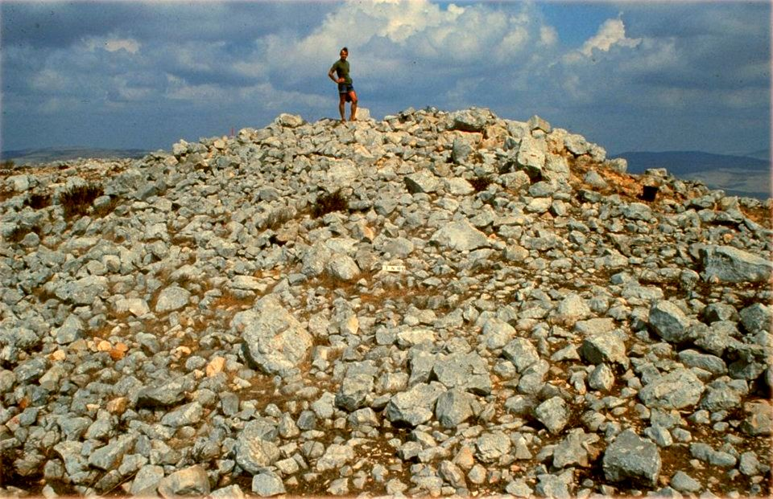

Rock by rock they carefully uncovered this altar over a period of years. By 1989, this is what they found underneath the pile of rocks.
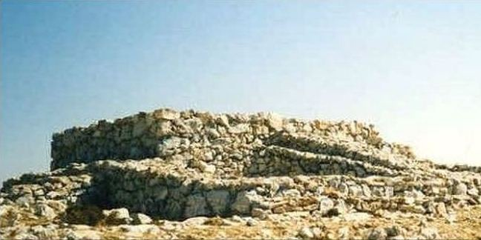

Rock by rock they carefully uncovered this altar over a period of years. By 1989, this is what they found underneath the pile of rocks. Absolutely incredible. As I said,this altar is identical to the descriptions and measurements of the altars in Solomon’s temple and the Temple of Jesus’ day, as well as the altar to the golden calf that is still standing (in tel Dan).
One of the archeologists that worked with Zertal on site said this:
“There were more than three thousand animal bones. These bones had been burnt on an open flame, and many had butcher marks, implying that at least parts of them had been eaten.” – Zvi Koenigsberg
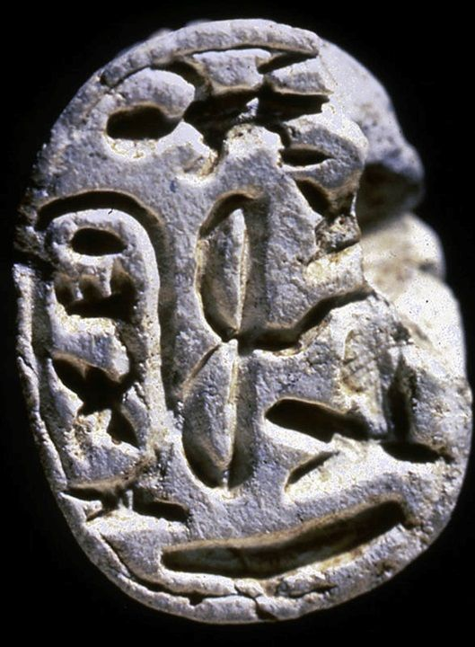
In fact all the animal bones were kosher. That is, they all those specific animals prescribed by the Levitical law, all those typical of what a Jew would bring to offer.

Scarab Valuable Medals
Not only did they find animal bones, but Egyptian royal medals with the royal marking of Pharoah Thutmoses III. These were valuables (with Thutmoses’ royal imprint of the scarab—beetle) that are from the very time of the Exodus. These little limestone beetles were given out at Pharoah Thutmoses III’s wedding. He was either the Pharoah of the Exodus, or just before the Exodus. So this commemoration was found around the Mt. Ebal altar. Again, the Bible is not mythology, but history.

Gilgal Camp
Another amazing fact is that Joshua made this altar as part of a new Gilgal camp, like the one they made by the Jordan River. So if you look at this from the sky, the wall around it is in the shape of a shoe. This is another testimony to their faith that “
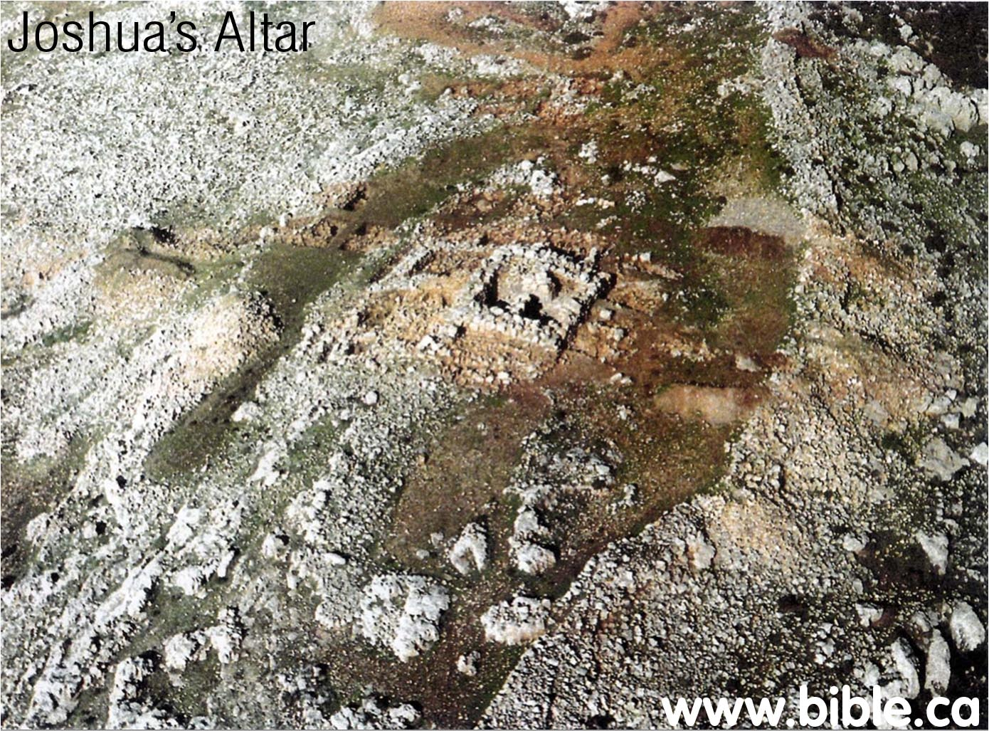

You can see the clear footprint in the photo. Why make another Gilgal camp? There are five mentioned in the Bible and five that Zertal discovered. The reason Joshua made another camp in the shape of a foot was because of the promise of God in Joshua 1:3.
Every place that the sole of your foot will tread upon I have given to you, just as I promised to Moses. –Joshua 1:3

The Pondering of our Worship
Now after this victory at Ai, Joshua reads the Law of Moses, the first five books of the Bible, just as he was commanded to do when he enters the land. So Joshua writes the Law down on stone, and then he reads it. In it’s entirety.

The people are to go to these two mountains: half on Mount Ebal, and half on Mount Gerazim. Ebal is rocky, representing the curse of sin. Mount Gerazim is green, representing the blessing of life in God.
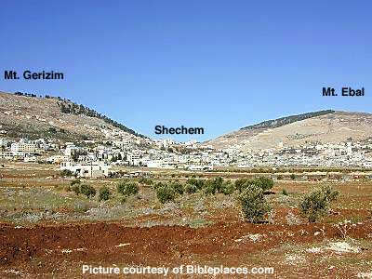

God said, “I want half of you to go up here on Mount Ebal, the mountain of misery. And, then I want half of you to go up here on Mount Gerizim, the mountain of mercy.” And, then Joshua said, “I’m going to be down here in the valley in between them.” And, he said, “I’m going to begin to read the law of the Lord as Moses gave it. I’m going to read both the blessings and the cursing, and as I read the blessings and the cursing.” I want you to say, “Amen.”
Now, those mountains come down in terraces, they’re almost like benches. It’s one of the world’s greatest natural amphitheaters and these voices could be heard resounding all around that valley. It must have been something to see.
What did they read? They read the entire Law, and Joshua put specific emphasis on the blessings and the cursings. For example, they most certainly read Deuteronomy 27:13-19,
And these shall stand on Mount Ebal for the curse: Reuben, Gad, Asher, Zebulun, Dan, and Naphtali. ¹⁴ And the Levites shall declare to all the men of Israel in a loud voice:
¹⁵ “‘Cursed be the man who makes a carved or cast metal image, an abomination to the Lord, a thing made by the hands of a craftsman, and sets it up in secret.’ And all the people shall answer and say, ‘Amen.’
¹⁶ “‘Cursed be anyone who dishonors his father or his mother.’ And all the people shall say, ‘Amen.’
¹⁷ “‘Cursed be anyone who moves his neighbor's landmark.’ And all the people shall say, ‘Amen.’
¹⁸ “‘Cursed be anyone who misleads a blind man on the road.’ And all the people shall say, ‘Amen.’
¹⁹ “‘Cursed be anyone who perverts the justice due to the sojourner, the fatherless, and the widow.’ And all the people shall say, ‘Amen.’
And that went on right on, there are a lot of cursings. Let’s go on and get some of the blessing because I want to hear from Mount Gerizim. I’d a lot rather hear from Mount Gerizim than Mount Ebal. So listen to these blessings in Deuteronomy 28:1-15, 10.
“And if you faithfully obey the voice of the Lord your God, being careful to do all his commandments that I command you today, the Lord your God will set you high above all the nations of the earth. ² And all these blessings shall come upon you and overtake you, if you obey the voice of the Lord your God. ³ Blessed shall you be in the city, and blessed shall you be in the field. ⁴ Blessed shall be the fruit of your womb and the fruit of your ground and the fruit of your cattle, the increase of your herds and the young of your flock…
¹⁰ And all the peoples of the earth shall see that you are called by the name of the Lord, and they shall be afraid of you. - Deuteronomy 28:1-15, 10

There is Joshua with an altar on Mount Ebal representing the cross of the Lord Jesus Christ, and there he is reading the Word of God, and there he is saying, “It is God’s mercy to pardon and it is God’s justice to punish.” Which will you have? It is God’s nature to pardon, and God’s nature to punish. It is God’s nature to bless the forgiven and it is God’s nature to curse in unrepentant. And, it all depends what you do with God. Will you surrender in childlike faith? That’s not just a one-time thing, it’s a way of life.

The Point of our Worship: Ebal and Gerazim
Now what’s the point of all this? It’s not the animals sacrificed at Mount Ebal. Those pointed forward to Jesus. John the Baptist said,
Behold the Lamb of God who takes away the sin of the world. –John 1:29
You’ve got to embrace the Christ of Mount Ebal: that rocky foreboding mountain. It is there that the sacrifices are made. It is there that the curses are read. It is representative of curse that Jesus took on another Mountain: Mount Calvary –Golgotha, the place of the skull. There it was that our Lord became a curse for us!
God wants us to go on in victory after we have failed. Jesus became the curse for us on that Mount Ebal, so that we could live on Mount Gerazim. This is our covenant. It’s a covenant of grace from beginning to end. If you’ve failed, remember your covenant with Jesus.

Conclusion
The Bible says, “Today, if you’ll hear His voice, harden not your heart” (Heb 3:8). God loves you. The Lord wants to save you. But, I want to tell you one day your heart can get so hard that you will so insult the Holy Spirit that he won’t speak to you any longer.
Alexander MacLaren said, “Christ has last knocks.” You may be here without Christ. Turn to him today.
God has put you in a valley, a mountain of mercy, and a mountain of misery, and you can go to the north or to the south. You can choose life or you can choose death. Choose life. I beg you in the name of Jesus, with all of the unction and function of my soul, come to Jesus Christ and do it today.

A. Colin Day, Collins Thesaurus of the Bible (Bellingham, WA: Logos Bible Software, 2009).
LeBron Matthews, “Amalekite,” ed. Chad Brand et al., Holman Illustrated Bible Dictionary (Nashville, TN: Holman Bible Publishers, 2003), 54.
See John Milton. Complete Works (Hastings, East Sussex, UK: Delphi Classics, 2015) – reprint.
See: https://www.biblicalarchaeology.org/daily/ancient-cultures/ancient-israel/biblical-altar-mt-ebal-israelite-footprints/
Dale Ralph Davis, Joshua: No Falling Words, Focus on the Bible Commentary (Scotland: Christian Focus Publications, 2000), 71.
Adam Zertal. "Shechem and Mount 'Ebal in the Bible: Is this indeed Joshua's altar?". University of Haifa.
Zvi Koenigsberg. (2020, September 3). Joshua's Altar on Mount Ebal: Israel's Holy Site Before Shiloh. Retrieved September 06, 2020, from https://www.thetorah.com/article/joshuas-altar-on-mount-ebal-israels-holy-site-before-shiloh
Stephen Gabriel Rosenberg. (2015, April 01). Who was the pharaoh of the Exodus? Retrieved September 06, 2020, from https://www.jpost.com/opinion/who-was-the-pharaoh-of-the-exodus-395885

