 | Winning Over Fleshly Passions
 | MATT BLACK, Sun, Aug 20, 2017
livinghopechurch.net | 1 Peter 2:11-12, “Joy in Suffering” series

Introduction: Open your Bible to 1 Peter 2:11-12. We are continuing in a series in 1 Peter called “Joy in Suffering.” This morning’s study is entitled: “Winning Over Fleshly Passions.”

ANNOUNCEMENTS
- Welcome to our Visitors!

“Do you mortify; do you make it your daily work; be always at it while you live; cease not a day from this work; be killing sin or it will be killing you.”
~ John Owen

Grandpa Charles Cunningham Black
My Grandfather Charles Cunningham Black enlisted in the Scottish army during WWI when he was 15 years old in 1914. His sister lied and said he was of age.
You know the training they had to have. They had to listen to orders. They had to keep their ears open. They had to have their clothing and their weapons in order. They couldn’t be tangled up playing games.
As Christians we are also at war, and it’s easy to get tangled up in the things of this life.

If you are in a battle, you can’t get tangled up in earthly pursuits. Paul said that in 2 Tim 2:4, “No soldier gets entangled in civilian pursuits, since his aim is to please the one who enlisted him.”
Peter said it in 1 Peter 1:13, “Therefore, preparing your minds for action, and being sober-minded, set your hope fully on the grace that will be brought to you at the revelation of Jesus Christ.”

Scripture
1 Peter 2:11-12, “Beloved, I urge you as sojourners and exiles to abstain from the passions of the flesh, which wage war against your soul. 12 Keep your conduct among the Gentiles honorable, so that when they speak against you as evildoers, they may see your good deeds and glorify God on the day of visitation.”

You are Called to be Citizens of Heaven!
We are not from this world. We’ve been born again.

- Remember your homeland, vs. 11a – act as sojourners & exiles
1 Peter 2:11, “Beloved, I urge you as sojourners and exiles to abstain from the passions of the flesh…”
The Bible tells you what you are, and that’s what you are indeed. Martin Luther once said, “The word of a human being is a little thing. It flies up into the air and is gone. But the Word of God is heavier than heaven and earth.” The Word of God tells us what we are.
The Bible says, “Heaven and earth will pass away, but my words will never pass away.” Jesus says, “… one jot or one tittle shall in no wise pass from the law …”
There are so many places that testify to your identity in the Scriptures.
- You are in Christ. Therefore…
- You are an overcomer over the world.
- You will persevere to the end.
- You have the righteousness of Christ placed upon your account.
- Your sins have been placed upon Christ’s account and can never be held against you.
- For you there is no condemnation.
- You have been predestined to be conformed to God’s Son.
- No weapon formed against you shall prosper.
- All things, both good and bad, will work together for your good and God’s glory.
- You are now citizens of heaven. You don’t fit into this world.

Sojourners
We are sojourners. That means we are citizens of another country. We are immigrants. Brothers and sisters, we are sojourners and exiles when it comes to this world. Peter has already told us that we are “elect exiles.” We don’t fit in here. We belong to another place. We don’t fit in because we are “citizens of heaven” (Phil 3:20). You should be living your life not as citizens of this earth, but citizens of heaven. The Christian is “a temporary resident in a world that is not his home, for his true homeland is in heaven.”
The most famous example was, of course, Paul. Paul was a citizen of Rome. Citizens of Rome (just to give you one little instance) could not be imprisoned without a trial. That was one of the rules.
What does it mean to be a Christian? It means the moment you become a Christian your citizenship is transferred from this world to the next. You’re living in the future. You now have rights and privileges that belong to the citizen of heaven.

How to Become a Citizen of Heaven?
How does one become a citizen of heaven? All the rights and privileges of Christ have to be transferred to you by faith. You are trusting Jesus as your king. You believe that Jesus is the Christ, the King of kings, the Son of God. There is no other way. Who is your King?
This is not a process. I’m not saying moving to the day of your conversion is not a process. Yes, that’s a process. But conversion is not a process. You either are or you are not a Christian. You either are or are not a citizen of the US. That’s offensive to people. They say, you know “I’m in the process of becoming a Christian.” Well, sir or mam, you either are or you are not. There is no process in conversion. Conversion is a miracle.
Once you see things from God’s perspective (repentance) and put your trust in Christ (faith) you are born again! You are a citizen of heaven. You no longer

Exiles
We are exiles. That means because we are from somewhere else, we don’t fit into this household or paradigm anymore.

Elves from Lord of the Rings
It’s like in the Lord of the Rings trilogy. We are kind of like the little tiny elves. They are not originally the most glorious creatures. But they align themselves with these angelic warriors, called the holy ones. They go and they fight tremendous battles. They win honor and glory on the battlefield. They go through tremendous difficulties and adventures.
And when they come back to their own homeland, they become leaders, because they have a new perspective. They see things that the people who stayed there never can see. They laugh louder now. They sing better. They cry more. They’re just bigger people. They’re greater people. They have depths that their fellow citizens of their old homeland don’t understand. They sing their elven song:
We still remember, we who dwell
In this far land beneath the trees
The starlight on the Western Seas.
That’s how we are as Christians. God has allowed us to touch his garment. We’ve seen things with our spiritual eyes that lost people can never see. We love our homeland – our family, our culture. But this land is so dry and dead compared to the land we travel to when we are with our Christian brothers and sisters.
We realize we really don’t belong here anymore. We have this complex relationship. We love our homeland, and yet our homeland can’t understand us because they realize our true land is in heaven. Jesus Christ tells his disciples, “I’m sending you into the world, and yet the world will hate you because you’re not of the world anymore, but I have chosen you out of the world…. As the Father has sent me into the world, so send I you.” (Jn 15:29; 20:21).
Your lost friends and family can’t understand you. You have seen another universe. You have seen Christ’s universe of love and mercy and joy that is not from this world.
You have known infinite forgiveness. You have been made holy. The Almighty God, the Living God has made himself at home in your heart.

Moses
Or like Moses in the Old Testament. He’s raised in Egypt. He kills a man and is a shepherd in the desert for 40 years. But then he’s transformed by a burning bush. That shepherd no longer fits into Egypt. He delivers God’s people and meets God on the side of the mountain, and when he comes down, his face glows with the glory of God. It’s so uncomfortable that the people ask him to veil his face.
That’s what we’ve undergone. We have the same living God that appeared to Moses. We are now exiles here. We’ve seen too much. We know too much. The glory of God shines from out lives.

- Remember your victory, vs. 11b – be free from controlling passions

The Meaning: Controlling, Enslaving Passions
1 Peter 2:11, “Beloved, I urge you as sojourners and exiles to abstain from the [enslaving] passions of the flesh, which wage war against your soul.” Peter is later going to tell us to have one passion that should enslave us: to glorify God. That ought to be our controlling passion.
But Peter tells us to abstain from the “passions of the flesh.” What is that? Literally translated it is an “over-desire” or a “desire that controls you” – something that absorbs you. It’s an idolatrous passion. It’s something you want to put in the place of God, and it wars to have possession of your soul. There is something about the sinful heart that wants to take other things instead of God and put them in the center. That’s a controlling passion.
The reason you’re so excited sometimes and so depressed sometimes and you get so bitter, the reason you’re all over the map emotionally is because of over-desires, good things that have become too important. Inordinate desires is another way to put it.

This isn’t just sex, money and power. It could be those things, but it’s often more subtle than that. It’s anything that is an “over-desire” – a controlling thing in your mind. What is it that you feel you must have to be happy? These controlling passions have the potential to dominate you.

Examples of Controlling Desires
Paul says the exact same thing in 1 Corinthians 6:12, “All things are lawful for me… but I will not be dominated by anything.”
John says it this way in the last verse of 1 John (5:21), “Little children, keep yourselves from idols. Amen.”
A controlling passion is anything I'm willing to SIN in order to get or to get rid of.
It could be emotions, relationship, fashion, social media, control.

A controlling passion is any expectation that you have which if you don't get them you willing to punish the other party, or if you didn't get what you want you exalt them.

And this happens something either is your master or your savior.
A controlling passion could be
- Emotions
- Relationship
- Fashion
- social media
- control and manipulation to get your way

It’s any expectations that you have which if you don't get them you willing to punish the other party. Or if you didn't get what you want you exalt them. It’s something if you don’t get you get bitter. This often is true in close relationships or marriage. You have certain expectations. They get dashed. You are looking to something or someone and it doesn’t deliver. An idol has taken over your heart.
Don’t depend that way on anything or anyone in this world. They will always let you down. Only Jesus is the Savior.
Let me give you a few more examples of controlling desires. You are not to be a slave to any of these.

FEAR / NEGATIVE EMOTIONS / DEPRESSION
Fear can be one of these controlling passions. I want the fear gone. I want the fear gone. I’ll do anything to get the fear gone. There’s nothing wrong with wanting to live in peace. But if you are willing to sin to have peace, then you have a controlling passion.

MARRIAGE
Marriage can be a controlling passion. I need a spouse to be happy. Or perhaps you are married, and you say, “I need a certain kind of spouse to be happy.” That’s all hogwash. Your spouse is not your savior. You need Jesus to be happy. God often calls us to live happily in marriage with someone who is very different than us.
Our problem is we think real love is to be served. That’s not love. You like being treated well. Real love is laying your life down for your spouse. You can do that for whoever you are married to.
There are those who think, well I married the wrong person. I hear this all the time. But do you realize there is no one out there that can be Jesus. Only Jesus can do that. No spouse can be just what you need.
Your controlling passion must be to please Jesus. That person you are looking for to make you happy. His name is Jesus! What is dominating you right now?

ACCEPTANCE
Does acceptance dominate you? Are you co-dependent? Do you need people to affirm your worth? Are you living as a people pleaser? That’s a controlling desire.

MATERIALISM
Does materialism dominate you? It’s not wrong to have material things, but perhaps the reason you are in debt today or you don’t give to your local church is because you are afraid to be without. Or you need to have this or that. Don’t fool yourself. Materialism may have its grip around your neck. It’s killing your relationship with God.
It’s not wrong to have stuff. How do you know if it’s an idol? If I love it too much. Someone confronts you about it and you get mad.

PLEASURE
Porn is a controlling desire for some who fall into it. And it wages war against their soul. God created sex. But if you are going and looking at another human being in an intimate situation, you are killing your soul. You are sinning against the person you are looking at. You are killing your relationship with God. God created pleasure. He says it’s so precious you need to guard it for marriage.
Some of you young people are going to be tempted to throw your purity away. Don’t do it. Don’t kill your soul. Don’t throw your relationship with God away.
Let Jesus be your joy. Let Jesus give you the strength to be pure and clean for the one he’s preserving for you.
This isn’t just for singles. Married people – God invented pleasure. But your spouse is never going to be able to satisfy your needs. Are you thinking you could be happier with someone else? Stop right there. You are putting marriage in the place where only God should be. God is the only one that can fulfill your needs.

COULD BE “GOOD” THINGS!
Calvin said, “The heart is an idol making factory. Anything could be an enslaving passion. It could be a good thing, like a certain philosophy of child-rearing. You have to have it “this” way or “that” way.
It could be that you that you are convinced of a certain kind of schooling: home-schooling or Christian schooling or public school. Let me say that none of those things is the Savior.
It could be that natural medicine or traditional medicine. Look live free in Christ, but don’t think that any of those things is the Savior.
It could be food! I love food. Food is a great thing to serve to show your love to people. We need food to live, but food can’t be our savior. I’m preaching to myself now!

As believers we are to be free from all these passions and to have one guiding passion: Jesus Christ.

Review: What is a Controlling Passion?
What is a controlling desire? It’s slavery to anything but God. “Anything you feel like you have to have has your soul by the neck. It’s trying to dominate the soul. It’s waging war against the soul. It wants to be your salvation. It wants to capture your soul. That’s why it’s warring against it. It’s trying to capture it. It’s trying to storm it. It’s trying to take it.”

War in Your Soul
There is a war going on in your soul.
Don’t be controlled by your passions. This could be translated, “controlling passions.” Paul says it similarly, “All things are lawful for me,” but not all things are helpful. “All things are lawful for me, but I will not be dominated by anything” (1 Cor 6:12).
Peter says something similar in 1 Peter 2:16, “Live as people who are free, not using your freedom as a cover-up for evil, but living as servants of God.”
Brothers and sisters, we are not servants of the flesh, but servants of God.

VICTORY OVER CONTROLLING DESIRES
Now I want to engrain this in all of us. As Christians, we were made to serve God with a holy and infinite passion. You cannot love him too much. And all our sin and idolatry is simply revealing a lack of love for God.
God tells us we are to love him wholly and completely, with everything we’ve got.

You Have the Power Over Sin – Five promises
You have been freed from controlling passions. You have no other goal, no other passion than to glorify God. You are victorious over sin. You have the power already over sin, but will you use it?

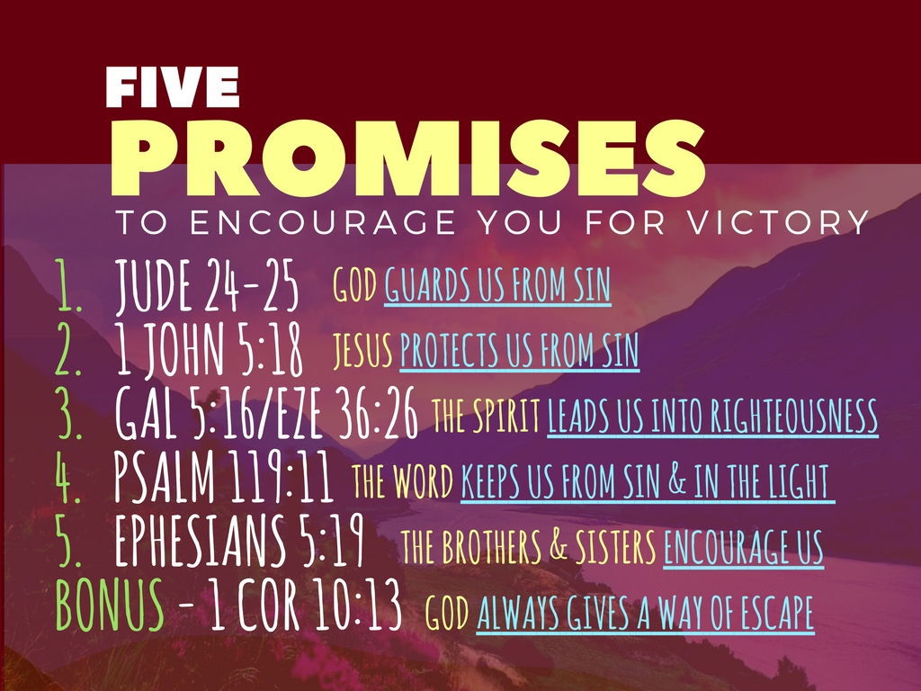

- God guards us from sin. Jude 24-25, “Now to him who is able to keep you from stumbling and to present you blameless before the presence of his glory with great joy, 25 to the only God, our Savior, through Jesus Christ our Lord, be glory, majesty, dominion, and authority, before all time and now and forever. Amen.”

- Jesus protects us from sin. 1 John 5:18, “We know that everyone who has been born of God does not keep on sinning, but he who was born of God protects him, and the evil one does not touch him.”

- The Spirit leads us into righteousness. Galatians 5:16, “walk by the Spirit, and you will not gratify the desires of the flesh.” Ezekiel 36:26-27, “And I will give you a new heart, and a new spirit I will put within you. And I will remove the heart of stone from your flesh and give you a heart of flesh. 27 And I will put my Spirit within you, and cause you to walk in my statutes and keep my judgments.”

- The Word keeps us from sin and helps us walk in the light. Psalm 119:11, “Your Word have I treasured in my heart, that I might not sin against You.” Psalm 119:105, “Your word is a lamp to my feet and a light to my path.”

- Brothers and Sisters encourage us. Ephesians 5:18-19, “And do not get drunk with wine, for that is debauchery, but be filled with the Spirit, 19 addressing one another in psalms and hymns and spiritual songs, singing and making melody to the Lord with your heart…”

Bonus: God always gives a way of escape. 1 Cor. 10:13, “No temptation has overtaken you that is not common to man. God is faithful, and he will not let you be tempted beyond your ability, but with the temptation he will also provide the way of escape, that you may be able to endure it.”

Don’t get tangled up in the mess of controlling and enslaving passions. Don’t do it.
Hebrews 12:1-2, “since we are surrounded by so great a cloud of witnesses, let us lay aside every weight, and the sin which so easily ensnares us, and let us run with endurance the race that is set before us, 2 looking unto Jesus, the author and finisher of our faith, who for the joy that was set before Him endured the cross, despising the shame, and has sat down at the right hand of the throne of God.”

- Remember your mission, vs. 12 – glorify God; prepare Gentiles
1 Peter 2:12, “Keep your conduct among the Gentiles honorable, so that when they speak against you as evildoers, they may see your good deeds and glorify God on the day of visitation.”

Peter tells us the obvious, “Keep your conduct among the Gentiles honorable.” Ok. We should do that. Why?
“…so that when they speak against you as evildoers, they may see your good deeds and glorify God on the day of visitation.”

Day of Visitation
This is often used as a way of talking about Christ’s Second Coming or of Judgment Day. But commentators have said this phrase could be translated both “the day” or “a day.” Interesting. Many commentators believe this is referring to the day when God saves the lost people that are persecuting you or speaking evil of you.

Your Mission
So what is your mission? It is to glorify God. To live in a way that is honorable before the lost world. You are to bring glory to God in every way. Why? Because you are being watched. God has saved you to give the lost a reason to look to him.
You are to be God’s mirror. Are you a mirror of his love?
You can’t be a mirror if you are all tangled up with enslaving desires. You need to live as a free person. You are free in Christ! You are victorious!

Prepare the Lost
You need to be careful of your conduct, because through it, you are preparing the lost for judgment day.
You need to be a living example of a citizen from another world. God will use it to get at their heart. “they may see your good deeds and glorify God on the day of visitation.” (vs. 12).
Jesus said, Mt 5:16, “Let your light so shine before men, that they may see your good works, and glorify your Father which is in heaven.”

Win Over Sin – Don’t Get Distracted! Conclusion
I am a distracted person by nature. I’ve often been taken off course with the simplest distraction.
Driving is a big example.
Twice I was driving friend from the airport in Bilbao, Spain, and we ended up in France because of I was so immersed in our conversation.
Once we were headed to Indiana as a family, and we ended up in Michigan (where 90 and 94 split).
All I’m saying is our mission is to glorify God and to point people to Christ. Don’t let anything distract you or control you and enslave you, in order to keep you from your mission and your destination.

Keller, T. J. (2013). The Timothy Keller Sermon Archive. New York City: Redeemer Presbyterian Church, “Practicing Faith in a Pagan World, Part 2.”
Grudem, W. A. (1988). 1 Peter: an introduction and commentary (Vol. 17, p. 122). Downers Grove, IL: InterVarsity Press.
Keller, Sermon Archive, “Practicing Faith, Part 2.”
Ibid.
Keller, ibid. “Passions, Pt 2.”

